0656-三脚架云台的3D打印生产记录
Tripod Head
🖨️ SLA光固化
🖥️ 打印机: Stratasys
📦 材料: SLA光固化树脂
在YouTube上，有人因为难以找到合适的三脚架云台而找上我们，想要一款精致且功能强大的产品。
On YouTube, someone reached out to us because they were having difficulty finding a suitable tripod head and wanted a product that is both exquisite and powerful.
________________________________________________________________________________
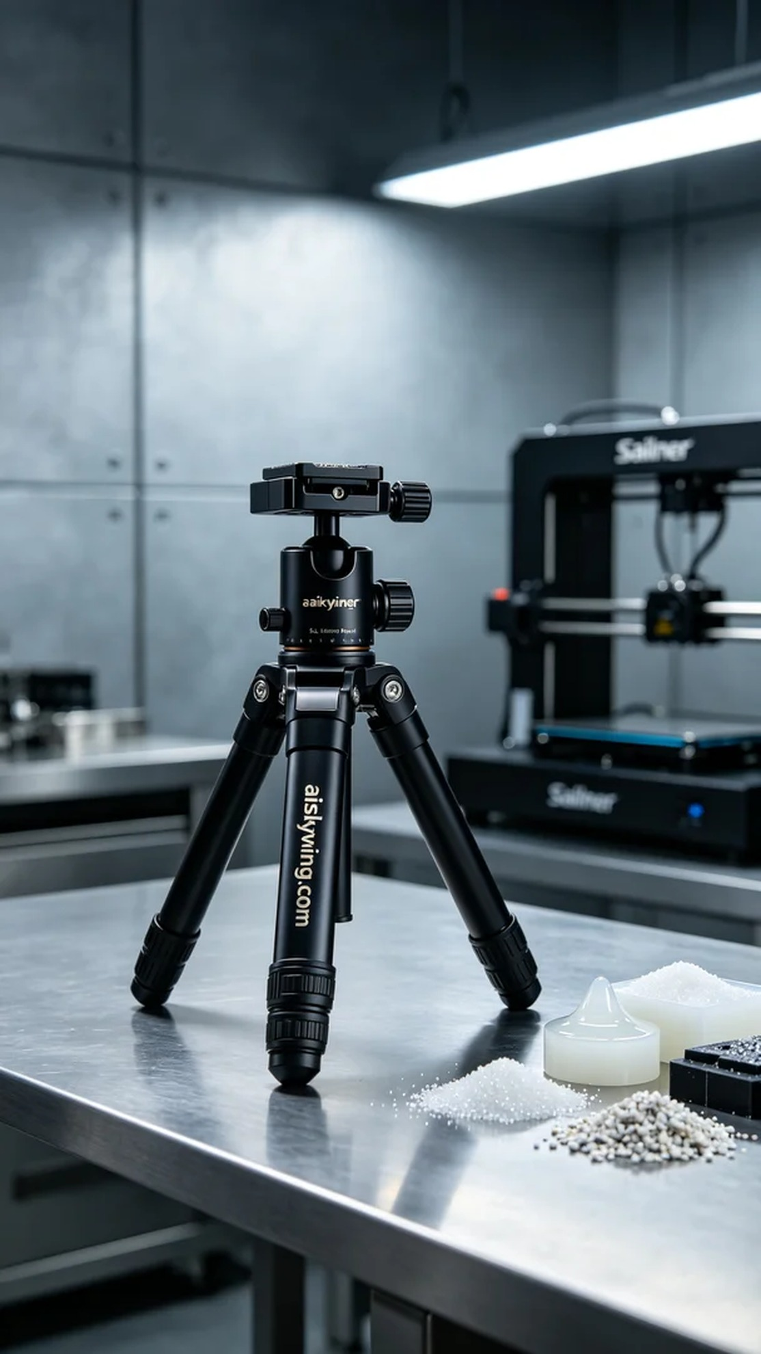
We received a special order aimed at solving a problem shared by a user on YouTube—his need for a stable and adjustable tripod head for video shooting. Our task is to print a high-quality tripod head to support his video creation.
For production, we used SLA photopolymer resin as the material. This material provides excellent gloss and strength, allowing us to achieve exceptional clarity in the details. We utilized a Stratasys 3D printer, setting the printing parameters to a layer thickness of 0.05mm, maintaining a printing temperature of 25°C, setting the power to 80%, and adjusting the speed to 40mm/s. The entire printing process is expected to take about 5 hours.
During printing, the equipment operated smoothly in a clean environment. We checked the printing progress regularly to ensure no layer misalignment or bubbles appeared. The SLA resin cured layer by layer under laser exposure, precisely presenting every detail. As the printing progressed, our quality control became increasingly stringent, ensuring every aspect of the product met expectations.
After printing, the post-processing work began. First, the formed tripod head was placed in isopropyl alcohol for cleaning to remove excess resin from the surface. After cleaning, we used fine sandpaper to polish the surface, ensuring a smooth finish. Finally, it was cured under UV light to enhance durability and gloss. After thorough inspection, we confirmed that the product met the predetermined quality standards.
After a series of meticulous processes, we successfully completed the printing of this tripod head, looking forward to its outstanding performance in the user's creations.
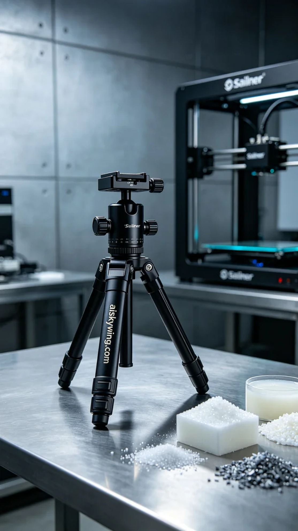
我们接到一个特别的订单，旨在解决一个用户在社交平台YouTube上分享的烦恼——在视频拍摄中，缺少稳定、易于调节的三脚架云台。于是，我们的任务就是为他打印出一款高质量的三脚架云台，为他的视频创作提供支持。
在生产过程中，我们采用了SLA光固化树脂作为原材料。这种材料具有优异的光泽度和强度，能够在细节上达到极致的清晰度。为确保打印的精度，我们使用了Stratasys品牌的3D打印机，设置打印参数为0.05mm的层厚，打印温度保持在25°C，功率设置在80%以及速度调整为40mm/s。整个打印过程预计耗时约5小时。
打印的过程中，设备平稳运行，整个打印环境保持在洁净状态。我们定时检查打印进度，确保没有出现任何的层错位或气泡。SLA树脂在激光照射下逐层固化，每个细节都被精准呈现。随着打印的深入，我们对质量的把控也愈加严格，确保产品的每一处细节都符合预期。
打印完成后，后处理工作开始了。首先，我们将成型的三脚架云台置于异丙醇中进行清洗，以去除表面多余的树脂。清洗后，使用细砂纸对表面进行打磨，确保光滑度。最后，在UV灯下进行固化，以增强其耐用性和光泽感。经过全面的检验，我们确认产品达到了预定的质量标准。
经过一系列精细的工序，我们成功地完成了这款三脚架云台的打印，期待它能在用户的创作中大放异彩。
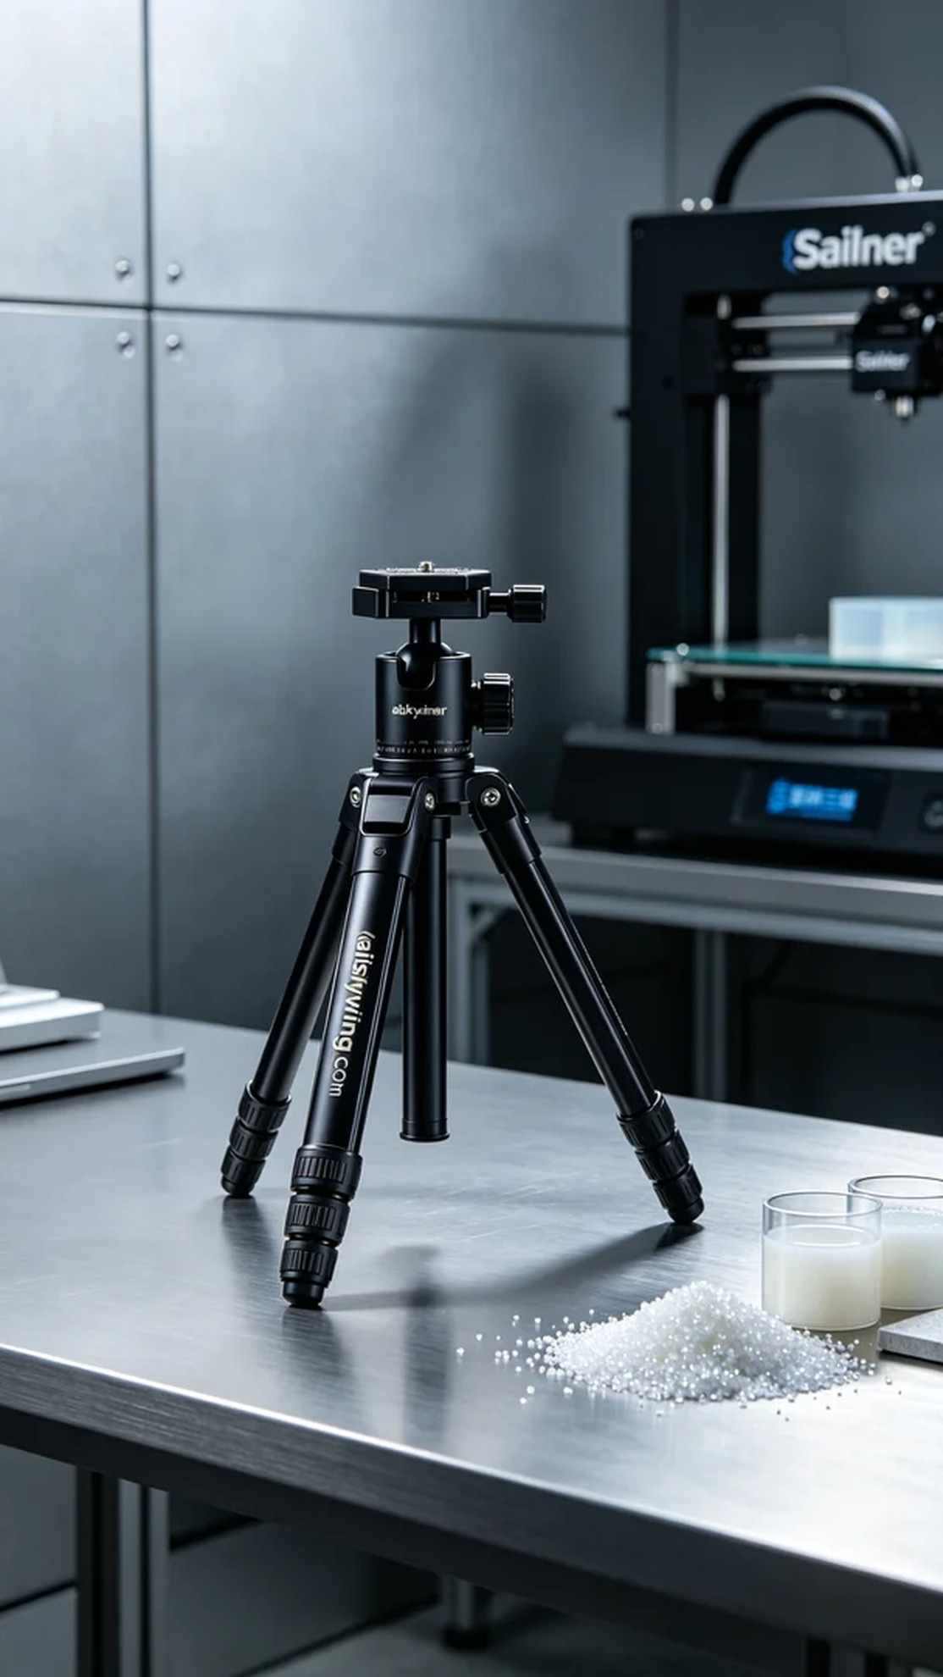
Aiskywing Industrial 3D Printing
Tripod Head


