0657-中继器外壳生产记录
Receptor shell
🖨️ SLA光固化
🖥️ 打印机: Mimaki
📦 材料: SLA光固化树脂
人生就像3D打印，困难重重却能成就精致的作品。就如这款中继器外壳置于画面正中央的项目，让我们一起迈出坚实的一步。
Life is like 3D printing, filled with challenges yet capable of creating exquisite works. Just like this relay shell placed at the center of the scene, let us take a solid step forward together.
________________________________________________________________________________
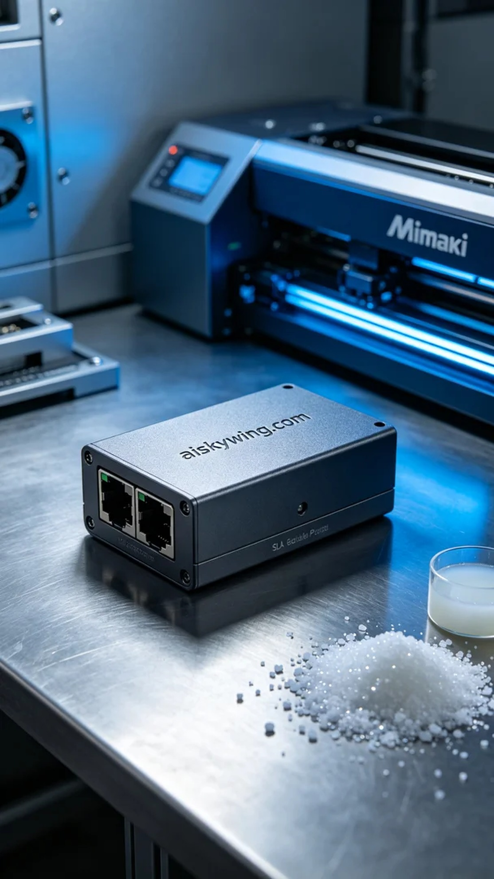
Recently, someone contacted us through YouTube with a request to produce a relay case. Their problem was that existing materials and processes couldn't meet the precision and durability required, so they needed us to utilize SLA curing technology for this project.
The material we used is high-quality SLA curing resin, known for its excellent flow and curing properties, making it ideal for fine printing. Additionally, preparing the Mimaki printer is crucial. When setting the printing parameters, we chose a layer thickness of 0.05mm, maintained a printing temperature of 25 degrees Celsius, set the power at 80%, and controlled the speed at 50mm per hour, estimating a total print time of around 6 hours.
During the printing process, the Mimaki printer operated smoothly, with the resin injection and curing happening as expected. We continuously monitored the print quality to ensure each layer adhered perfectly. As the printing progressed, the contours of the relay case became increasingly clear, and the engraved "aiskywing.com" text stood out, exuding a rich technological vibe.
Once printing was finished, we moved on to the post-processing phase. First, we cleaned the printed parts using an ultrasonic cleaner to remove any residual resin; then, we proceeded with sanding to ensure a smooth, fine surface. Next, we cured the parts under UV light to enhance their strength and durability. Each step was rigorously inspected to ensure the case met our quality standards.
In the end, this relay case was completed on schedule, showcasing a finely textured matte feel combined with a stark industrial aesthetic. It was satisfying results, and with each project, we gain invaluable experience, looking forward to taking on the next challenge.
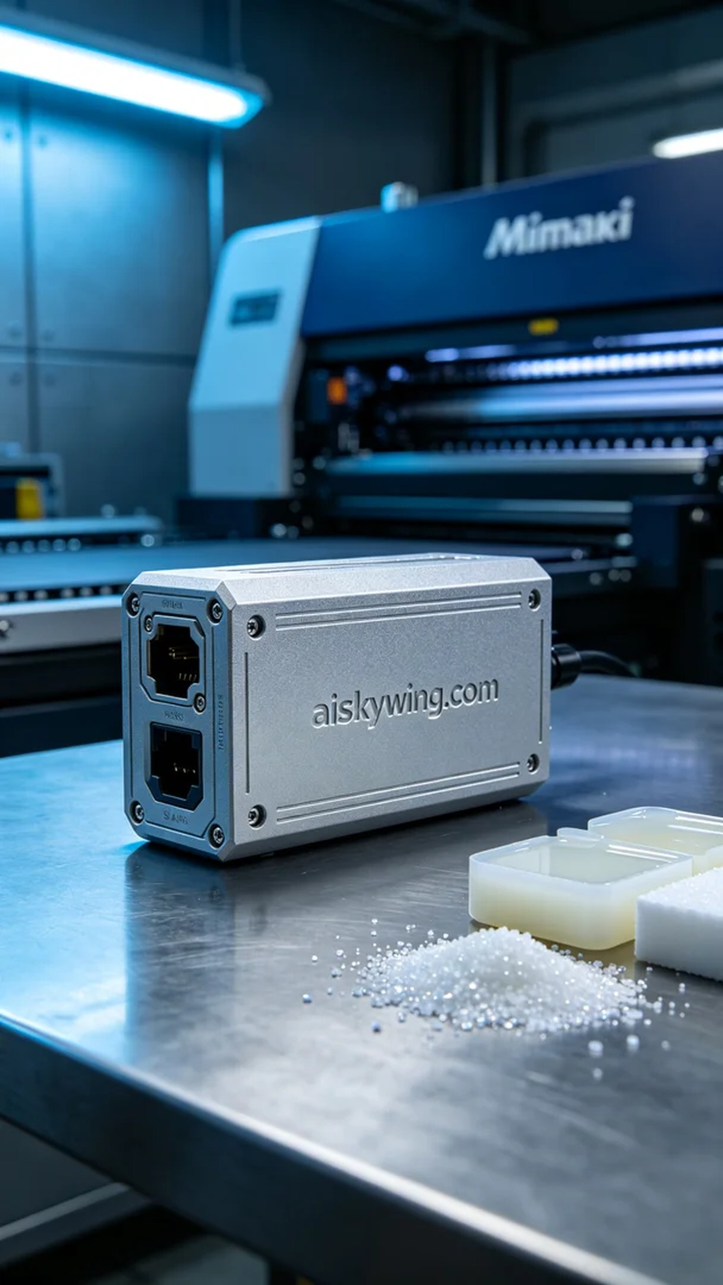
最近，有人通过YouTube找到了我们，希望能制作一款中继器外壳。他们碰到的问题是，现有的材料和工艺无法满足产品的精度与耐用性，因此需要我们运用SLA光固化技术来完成这个任务。
我们使用的材料是高质量的SLA光固化树脂，这种材料具有优异的流动性和固化性能，适合精细打印。同时，Mimaki打印机的准备工作也相当关键。设定打印参数时，我们选择了0.05毫米的层厚，打印温度保持在25摄氏度，功率设定为80%，速度则控制在每小时50毫米，总打印时间预估在6小时左右。
打印过程中，Mimaki打印机的运行非常稳定，树脂注入和光固化过程都如预期进行。我们随时监控打印质量，确保每一层都能够完美附着。随着打印的推进，中继器外壳的轮廓逐渐清晰，表面雕刻的“aiskywing.com”字样也愈加清晰可见，给人一种饱满的科技感。
完成打印后，我们进入后处理阶段。首先是清洗，利用超声波清洗机去除残留的树脂；接着进行打磨，确保外壳表面光滑细腻；然后是固化，将成品放入UV灯下固化，进一步增强其强度和耐用性。每一步都经过严格检验，确保外壳达到预期的质量标准。
最终，这款中继器外壳如期完成，细腻的磨砂手感与冷峻的工业风格相得益彰，令人满意。每一次的实践，都为我们积累了宝贵的经验，期待下一次再接再厉。
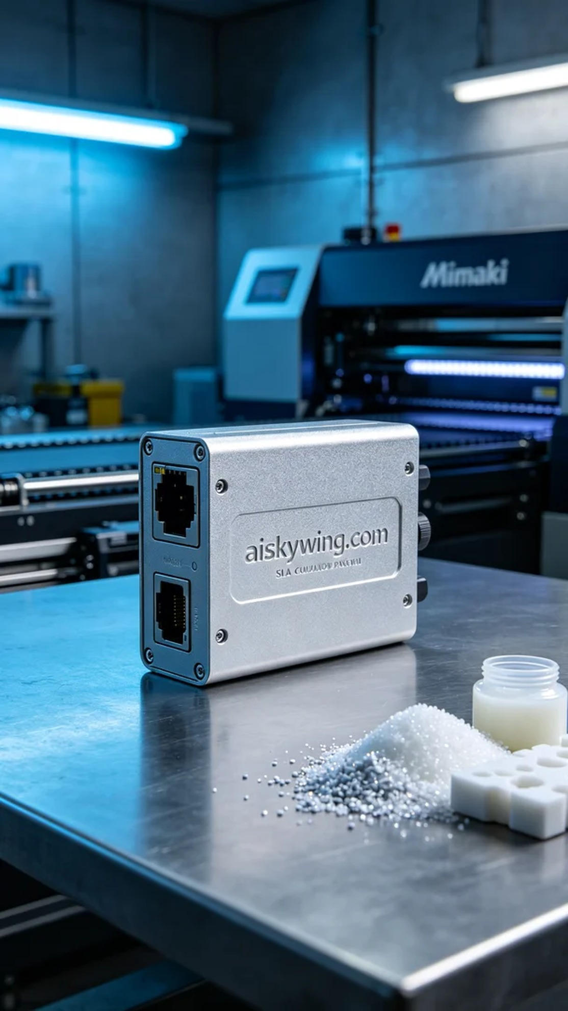
Aiskywing Industrial 3D Printing
Receptor shell


