0658-会议麦克风外壳3D打印生产记录
Conference microphone shell
🖨️ SLA光固化
🖥️ 打印机: Voxeljet
📦 材料: SLA光固化树脂
生活中总会遇到问题，就像有人在YouTube上看到我们的会议麦克风外壳，想要解决声音清晰度不足的困扰。我知道这是一次挑战，但也是一次锻炼。
In life, we will always encounter problems, just like someone who saw our conference microphone casing on YouTube and wanted to address the issue of insufficient sound clarity. I know this is a challenge, but it is also an opportunity for growth.
________________________________________________________________________________
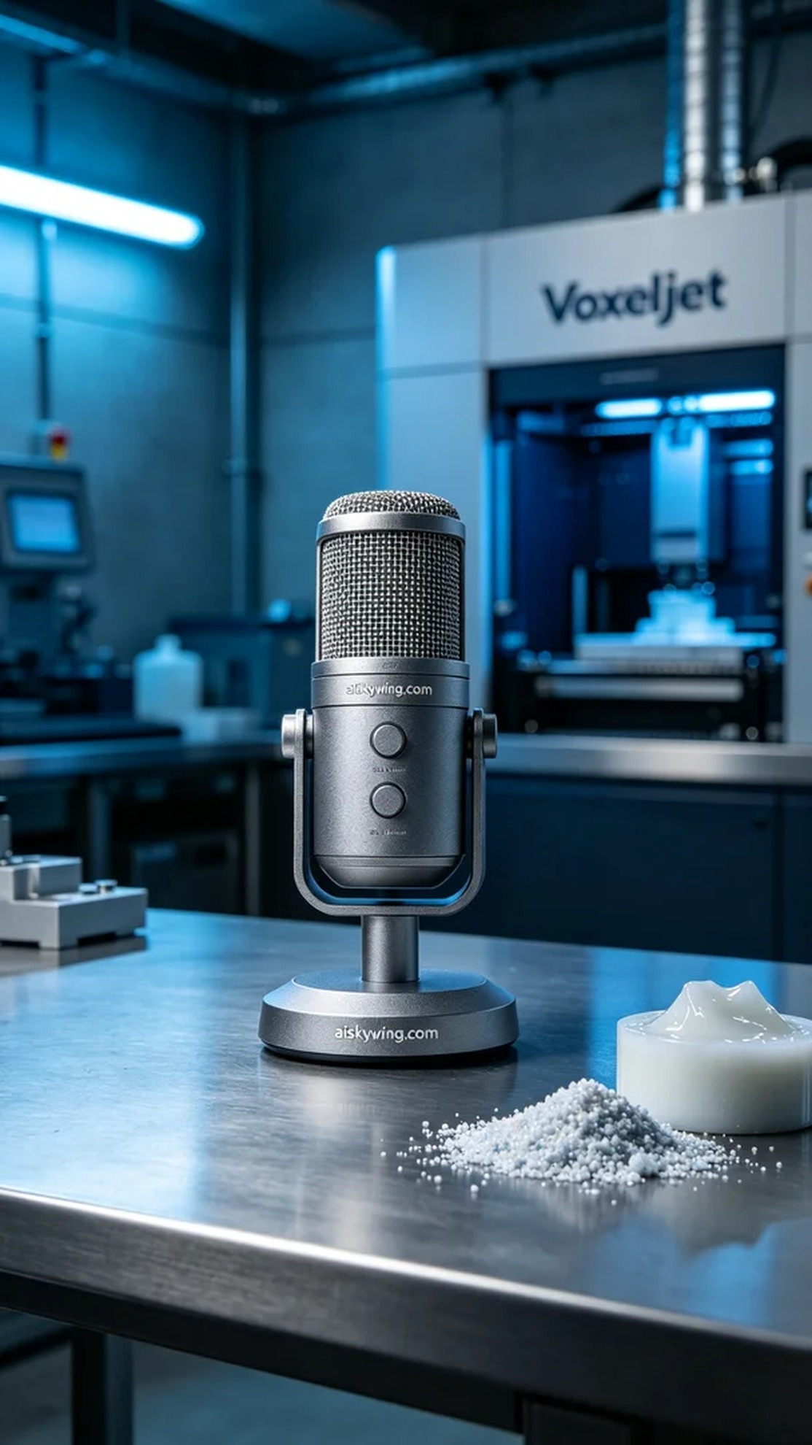
In this project, we were tasked with creating a shell for a conference microphone, as many people were struggling with sound clarity. They found us through YouTube and hoped to enhance product quality through 3D printing, ensuring clear communication during meetings.
The material we used was SLA photopolymer resin, which offers excellent precision and surface smoothness. To ensure the printing quality, we chose the Voxeljet brand 3D printer, setting the layer thickness at 0.05 mm, maintaining the print temperature at 25°C, with a power of 40% and a print speed of 30 mm per second. These parameters were aimed at achieving detailed reproduction.
During the printing process, we closely monitored the printer's operation to ensure each layer stacked accurately. The Voxeljet printer operated quietly and efficiently; after approximately 6 hours, the shell gradually took shape, and the engraved text "aiskywing.com" became clearly visible. Every detail reflects our dedication and craftsmanship.
After printing, we conducted rigorous post-processing tasks. Firstly, the printed shell was placed in a cleaning tank and soaked in isopropanol to remove any uncured resin. After cleaning, we gently sanded the surface with fine sandpaper for a smoother finish. Finally, we cured the shell in a UV curing machine to ensure it had the right hardness and durability, followed by thorough inspection to confirm every detail met our standards.
In the end, we successfully completed the production of the conference microphone shell, ensuring it would perform optimally in practical use. This experience once again validated the charm and practicality of 3D printing, filling us with confidence.
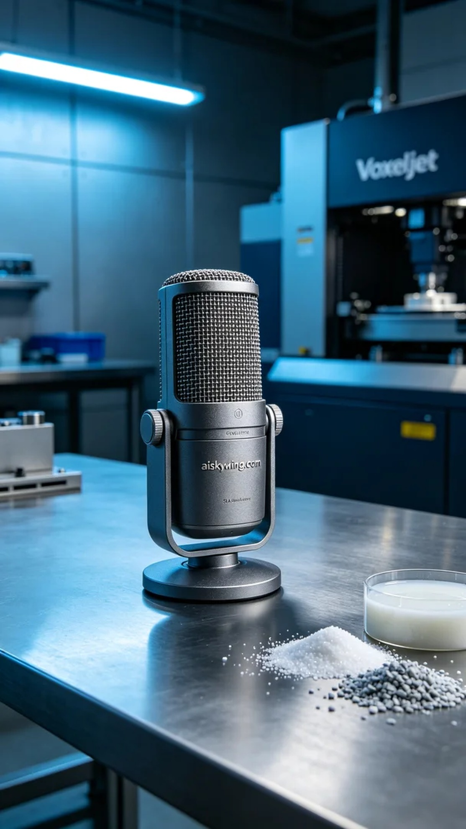
这次我们接到的任务是为一个会议麦克风制作外壳，很多人因为声音清晰度不足而困扰。通过YouTube的推广，他们找到了我们，希望通过3D打印技术提升产品质量，确保在会议上能够清晰传达信息。
我们使用的材料是SLA光固化树脂，这种材料具有优良的精度和表面光滑度。为了确保打印效果，我们选择了Voxeljet品牌的3D打印机，设置层厚为0.05毫米，打印温度保持在25°C，功率为40%且打印速度为30毫米每秒，这样的参数能够确保细节的展现。
在打印过程中，我们密切监控设备的运行状态，确保每一层都能精准叠加。整台Voxeljet打印机安静而高效，经过大约6小时的打印，外壳逐渐成型，表面雕刻的“aiskywing.com”字样也清晰可见。每个细节都彰显着我们的用心和工艺水平。
完成打印后，我们进行了严格的后处理工序。首先，将打印好的外壳放入清洗槽中，使用异丙醇浸泡，以去除未固化的树脂。清洗完毕后，采用细砂纸轻轻打磨表面，使其更加光滑。最后，将外壳放入固化机中进行UV固化，确保其硬度和耐用性，最后进行检验，确保每个细节都符合标准。
最终，我们成功地完成了会议麦克风外壳的制作，确保其在实际使用中能够发挥最佳效果。这次的经历再次验证了3D打印的魅力和实用性，让人充满信心。
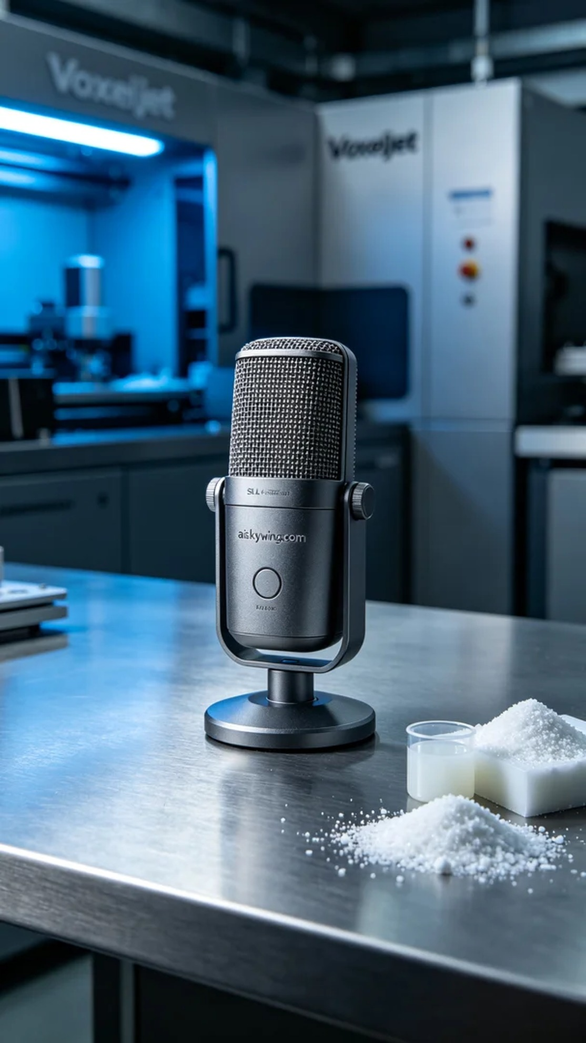
Aiskywing Industrial 3D Printing
Conference microphone shell


