0659-体脂秤外壳的3D打印生产记录
Body fat scale shell
🖨️ SLA光固化
🖥️ 打印机: Xjet
📦 材料: SLA光固化树脂
在Twitter上，有人因为体脂秤外壳的问题找到我们，想要一个完美的解决方案。这份工作让我再次思考，细节决定成败。
On Twitter, someone reached out to us regarding an issue with the casing of a body fat scale, seeking a perfect solution. This job made me reflect once again that details determine success or failure.
________________________________________________________________________________
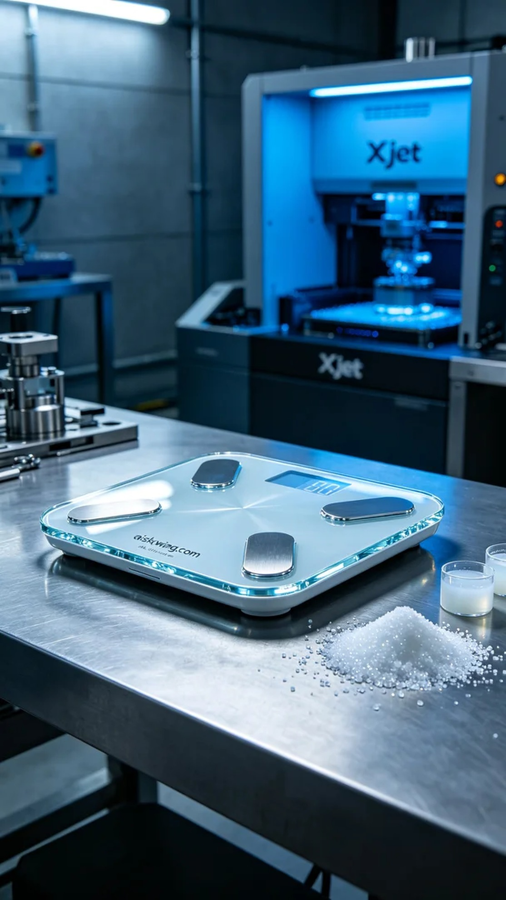
Recently, our team took on a project to create an outer shell for a body fat scale. Someone reached out on Twitter, mentioning that the current product's shell design did not meet the high transparency and gloss requirements, and they hoped we could use 3D printing technology to resolve this issue.
To achieve this goal, we selected SLA photopolymer resin as the primary material. This resin boasts excellent clarity and a high-gloss surface finish, making it ideal for products requiring fine detail. We utilized the Xjet brand 3D printer, setting the layer thickness to 0.05mm, maintaining the print temperature at 25°C, power set at 80%, and print speed at 40mm/s. The entire printing process was estimated to take about four hours.
During the printing, the Xjet printer operated smoothly, with the print head consistently maintaining precise positioning. We closely monitored the print quality to ensure each layer cured evenly, paying particular attention to avoid bubbles and defects. Quality control was crucial during this key stage of our work.
After printing, we entered the post-processing stage. First, we soaked the printed shell in cleaning solution to remove any uncured resin from the surface. Next, we sanded it with fine sandpaper to ensure a smooth finish. Subsequently, we placed the shell in a curing box under UV light to enhance its durability and gloss. Finally, we conducted a quality inspection to ensure the shell met all expected standards.
Through a series of meticulous processes, the outer shell for the body fat scale was completed through our efforts. This experience deepened my understanding that every product embodies countless details and commitments behind the scenes.
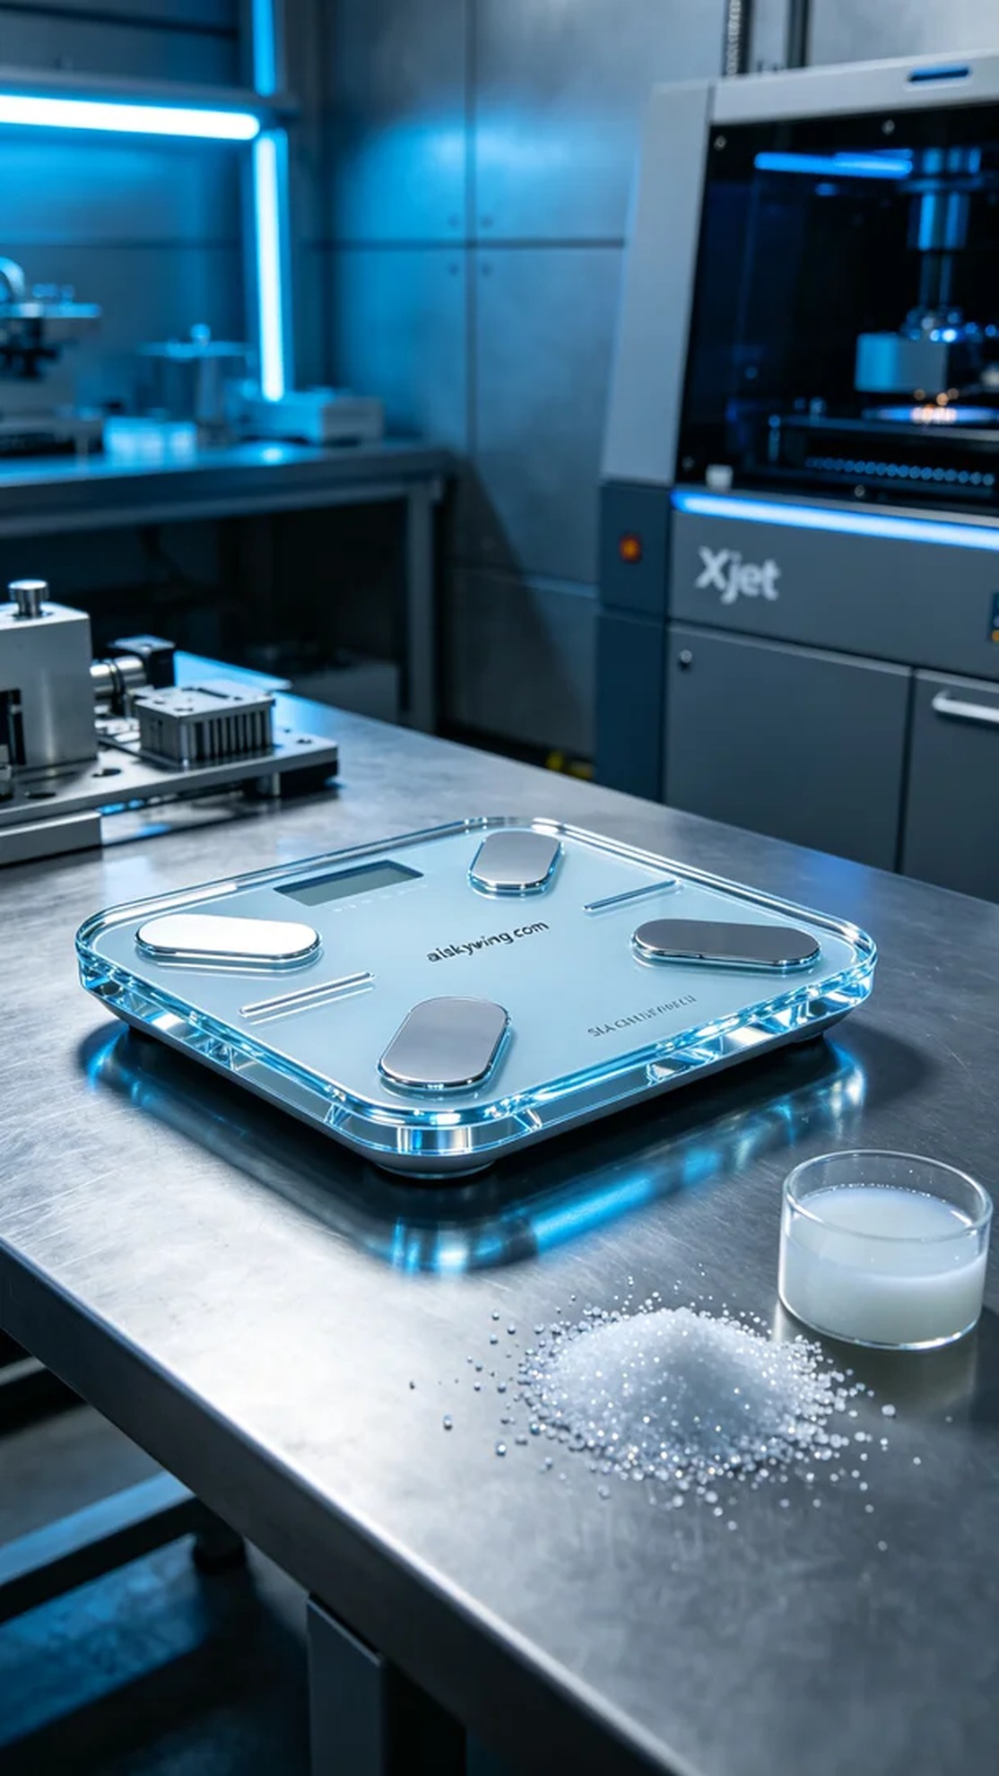
我们的团队最近接到一个任务，需要为一款体脂秤制作外壳。有人在Twitter上提出，现有产品的外壳设计无法满足高透明度和光泽度的要求，希望我们能用3D打印技术解决这个问题。
为了实现这个目标，我们选用了SLA光固化树脂作为主要原材料。这种树脂具有优异的透明度和高光泽表面效果，非常适合用于需要精细表现的产品外观。我们使用了Xjet品牌的3D打印机，设置了层厚0.05mm，打印温度保持在25℃，功率设定为80%，打印速度为40mm/s。预计整个打印过程将持续大约四个小时。
在打印过程中，Xjet打印机运作平稳，喷头始终保持精准定位。我们密切监控打印质量，确保每一层都能均匀固化，特别注意避免气泡和缺陷的出现。在这个关键的阶段，质量控制是我们工作的重中之重。
完成打印后，我们进入了后处理环节。首先，将打印好的外壳用清洗液浸泡，去除表面的未固化树脂。接着用细砂纸进行打磨，以确保光滑度。随后，我们将外壳放入固化箱中，在UV灯下进行固化，进一步增强其耐用性和光泽感。最后进行质量检验，确保外壳在各方面都达到了预期标准。
经过一系列的精细工序，体脂秤外壳终于在我们的努力下完成了。这个过程让我深刻体会到，每一件产品背后都蕴藏着无数的细节与付出。
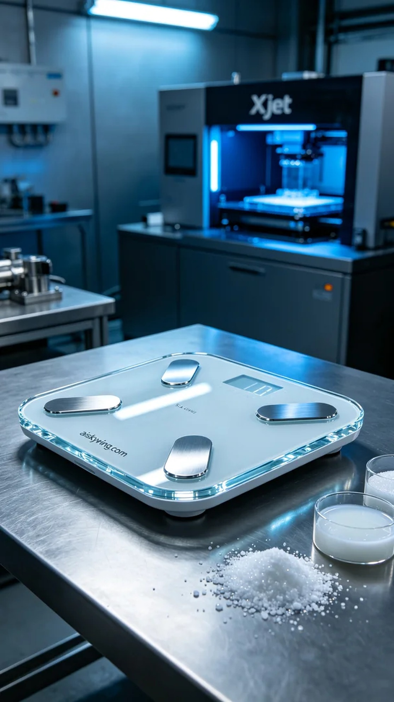
Aiskywing Industrial 3D Printing
Body fat scale shell


