0660-便携投影仪外壳3D打印制作记录
Portable projector casing
🖨️ SLA光固化
🖥️ 打印机: Rize
📦 材料: SLA光固化树脂
在这个快节奏的时代，便携投影仪外壳的制作不只是技术活，更是我们对生活选择的一种坚持，就像有人在TikTok上寻求完美的解决方案。
In this fast-paced era, the production of portable projector shells is not just a technical task, but also a commitment to our choices in life, much like those seeking the perfect solution on TikTok.
________________________________________________________________________________
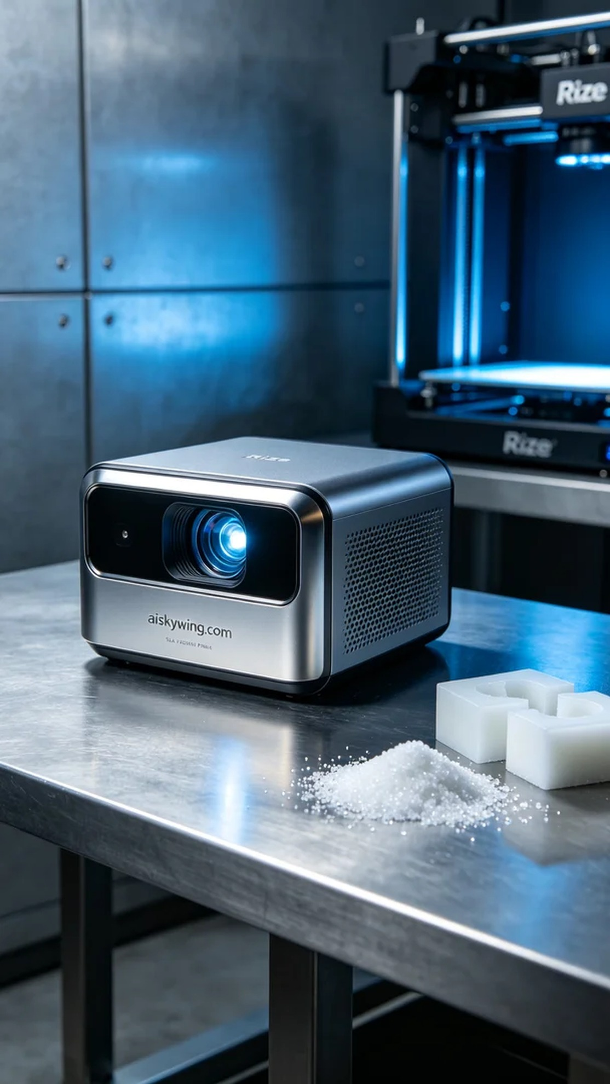
Recently, someone approached us due to the need for a portable projector housing. They were looking for a design that combined aesthetics and functionality, particularly focusing on the shine and detail of the surface. Our task was to utilize the Rize printer and advanced SLA resin technology to meet their expectations.
For our materials, we chose SLA light-sensitive resin, known for its ability to capture fine details and provide an excellent surface gloss. The printer settings were set to a layer thickness of 0.1mm, maintaining a temperature of 25 degrees Celsius, a power setting of 50 milliwatts, and a speed of 80 millimeters per second. This configuration ensured that our print quality would be optimal, allowing the portable projector housing to showcase intricate patterns and reflective properties.
During the printing process, the Rize printer operated smoothly, with the liquid resin curing layer by layer to form the desired housing shape. After each layer was completed, we monitored the quality to ensure there were no bubbles or defects. The entire printing process took about six hours, and seeing the housing gradually take shape filled us with a sense of accomplishment.
Once printing was completed, we carried out the necessary post-processing steps. First, we removed the housing from the print platform and cleaned it with isopropyl alcohol to eliminate any residual resin. Next, we sanded the surface with fine sandpaper to ensure smoothness and delicacy. Finally, we cured it under UV light to enhance its strength and durability, with the last inspection ensuring that every detail met our standards, confirming there were no light leaks.
After a series of processing steps, the portable projector housing was finally complete. Its surface exuded a metallic sheen, with clear details, achieving the expected results. This production process was not just a technical challenge, but also a successful collaboration for the team.
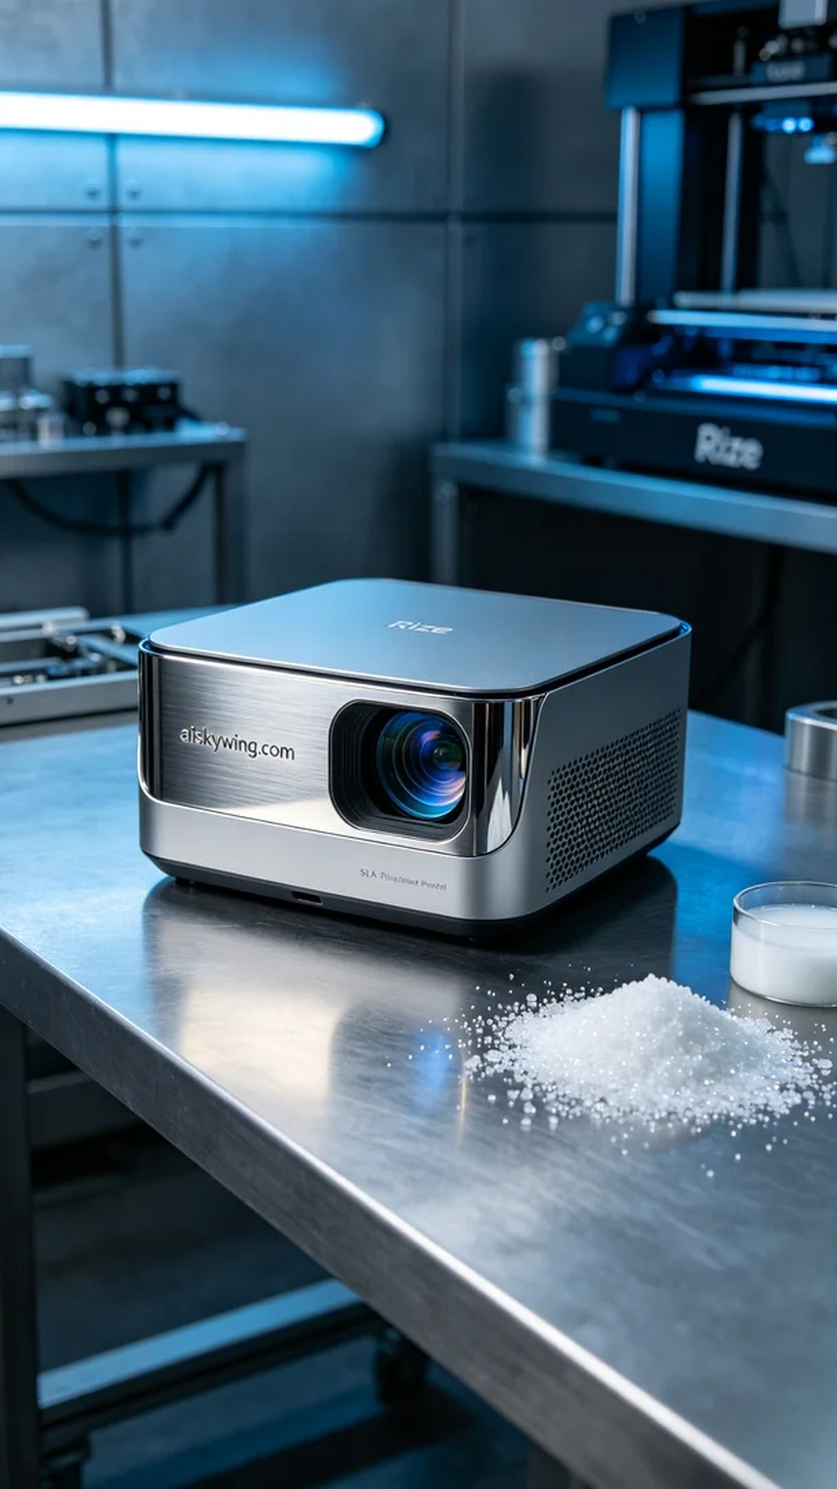
最近，有人因为便携投影仪外壳的生产问题找上我们。他们希望能制造出一款兼具美观与实用的外壳，尤其对表面的光泽感和细节要求较高。我们的任务就是用Rize打印机，借助先进的SLA光固化技术，满足他们的需求。
在准备材料时，我们选用了SLA光固化树脂，这种材料的优点在于能够呈现精细的细节和良好的表面光泽。打印机的层厚设置为0.1毫米，温度保持在25摄氏度，功率设定为50毫瓦，速度控制在80毫米每秒。这样的参数配置能够确保我们的打印效果达到最优，让便携投影仪外壳在图案雕刻和反射效果上都表现出色。
打印的过程中，Rize打印机运转顺畅，液态树脂逐层固化，形成了我们期待的外壳形状。每当一层打印完成，都会对成品的质量进行监控，确保没有气泡和缺陷。整个打印过程耗时约六小时，看到外壳逐渐成型，心中充满了成就感。
打印完成后，我们进行了必要的后处理工序。首先是将外壳从打印平台上取下，然后用异丙醇对其进行清洗，以去除残余的树脂。接着，使用细砂纸对表面进行打磨，确保光滑细腻。最后，经过UV灯进行固化，以增强其强度和耐用性，最后的检验则是确保每一个细节都符合标准，确保无漏光现象。
经过一系列的工序处理，便携投影仪外壳终于完成。它的表面散发着金属质感，细节清晰，达到了预期效果。这次的制作过程，不仅是一次技术上的挑战，也是一次团队协作的圆满成功。
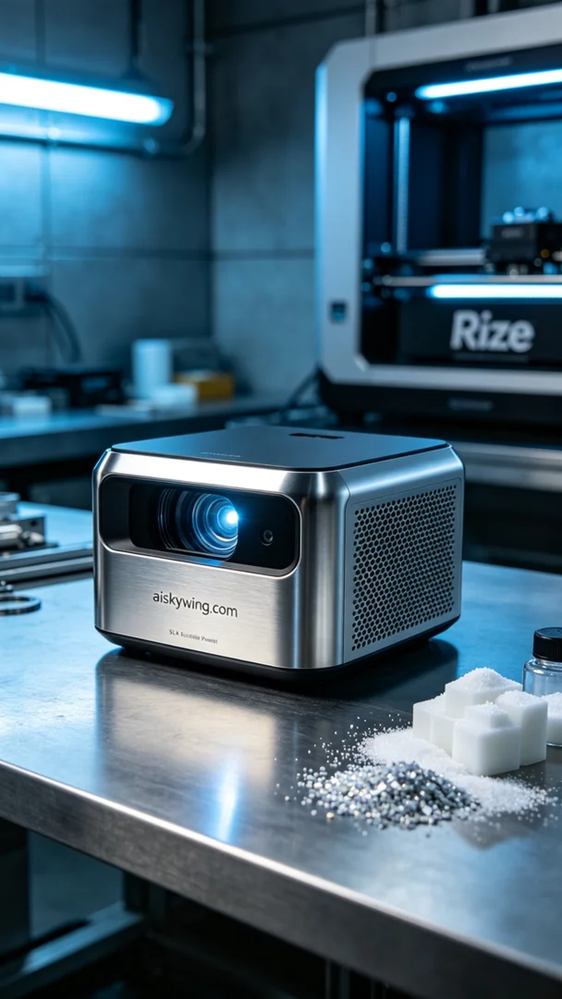
Aiskywing Industrial 3D Printing
Portable projector casing


