0661-3D保护罩的生产记录
3D protective cover
🖨️ 全彩3DP
🖥️ 打印机: Rize
📦 材料: 全彩3DP
在TikTok上，有人因寻找一个能够有效保护设备的解决方案找上我们。于是，这个3D保护罩应运而生。
On TikTok, someone reached out to us in search of a solution that could effectively protect their device. Thus, this 3D protective cover was born.
________________________________________________________________________________
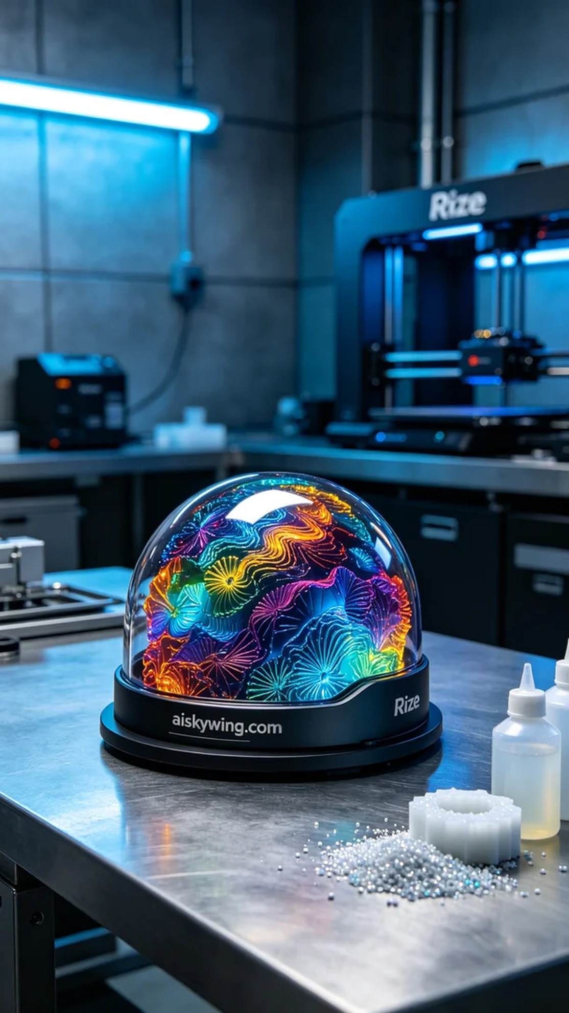
In the process of making this 3D protective cover, we used full-color 3DP material, which not only has a rich color palette but also showcases exquisite textures. To ensure a smooth printing process, we prepared a Rize brand 3D printer. We set the layer thickness to 0.1mm, maintained a printing temperature of 60 degrees Celsius, adjusted the power to 80%, and the printing speed to 30mm per second, with an estimated printing time of about 4 hours.
During the printing process, the Rize printer operated smoothly. Through the monitoring system, we kept a close eye on the print quality, ensuring that the color gradients and details met our standards. The slight sound emitted by the printer during operation gave me peace of mind, indicating that everything was proceeding steadily.
Once printing was complete, we moved on to the post-processing steps. First, we performed a wash using an ultrasonic cleaner to deeply clean the surface of the protective cover and remove any excess resin residue. Next, we carried out sanding to ensure all edges were smooth and free of burrs. The curing process was also essential; we used UV light to cure the protective cover, ensuring its durability and stability. Finally, we conducted a thorough inspection to make sure every detail was perfect.
After a series of rigorous procedures, the 3D protective cover was finally completed. Its color and texture made me very satisfied, and I believe this product will successfully meet people’s needs.
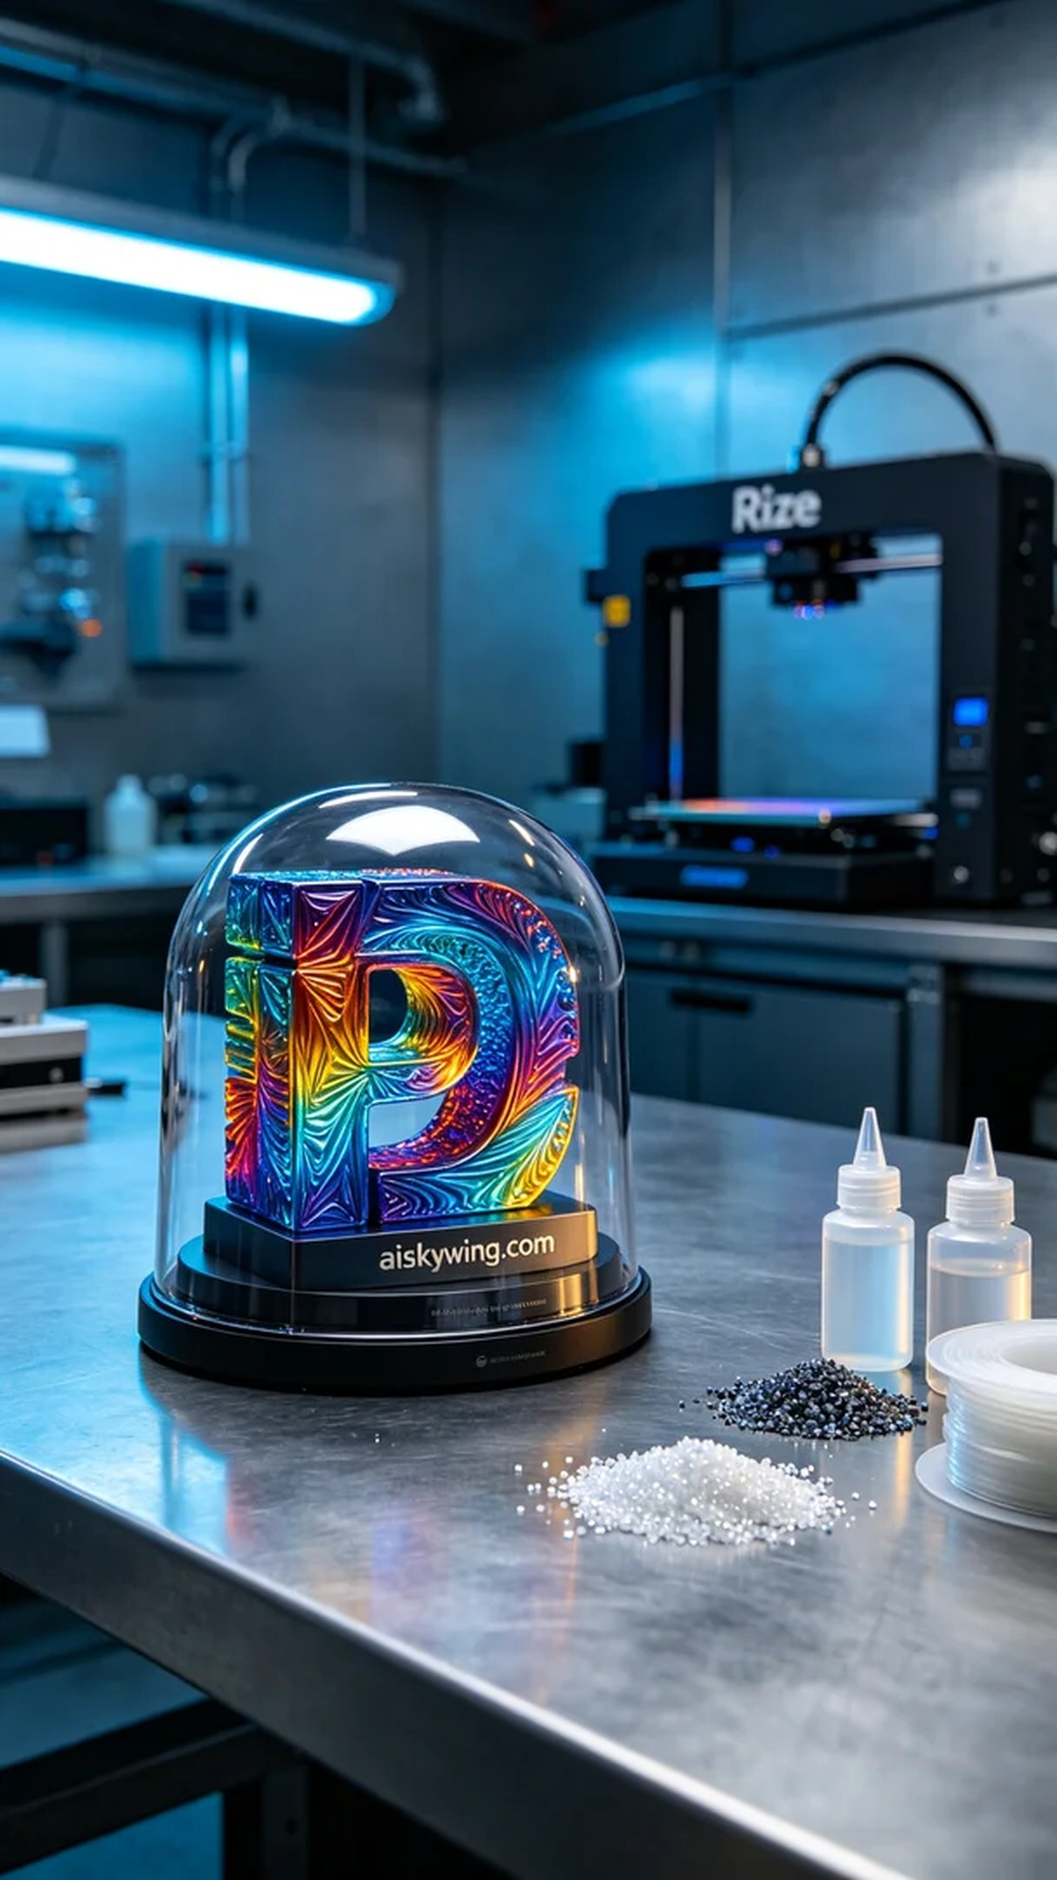
制作这个3D保护罩的过程中，我们使用了全彩3DP材料，这种材料不仅色彩丰富，而且能展现出细腻的质感。为了确保打印的顺利进行，我们准备了Rize品牌的3D打印机。我们设定了层厚为0.1毫米，打印温度保持在60摄氏度，功率调至80%，打印速度为30毫米每秒，预计打印时间大约为4小时。
在打印过程中，Rize打印机的运行平稳。通过监控系统，我们时刻关注着打印质量，确保色彩渐变和细节呈现都符合标准。打印机工作时发出的轻微声响也让我感到安心，这意味着一切正在按部就班地进行。
打印完成后，我们开始了后处理工序。首先是清洗，使用超声波清洗机将保护罩表面进行深度清洁，去除多余的树脂残留。接着，我们进行了打磨，确保每个边角都光滑无毛刺。固化过程也是必不可少的，使用UV灯对保护罩进行固化，确保其耐用性和稳定性。最后，我们仔细检验了一遍，确保每一个细节都尽善尽美。
经过一系列严格的工序，这个3D保护罩终于完成。它的色彩和质感都令我感到满意，相信这个产品能够成功满足人们的需求。
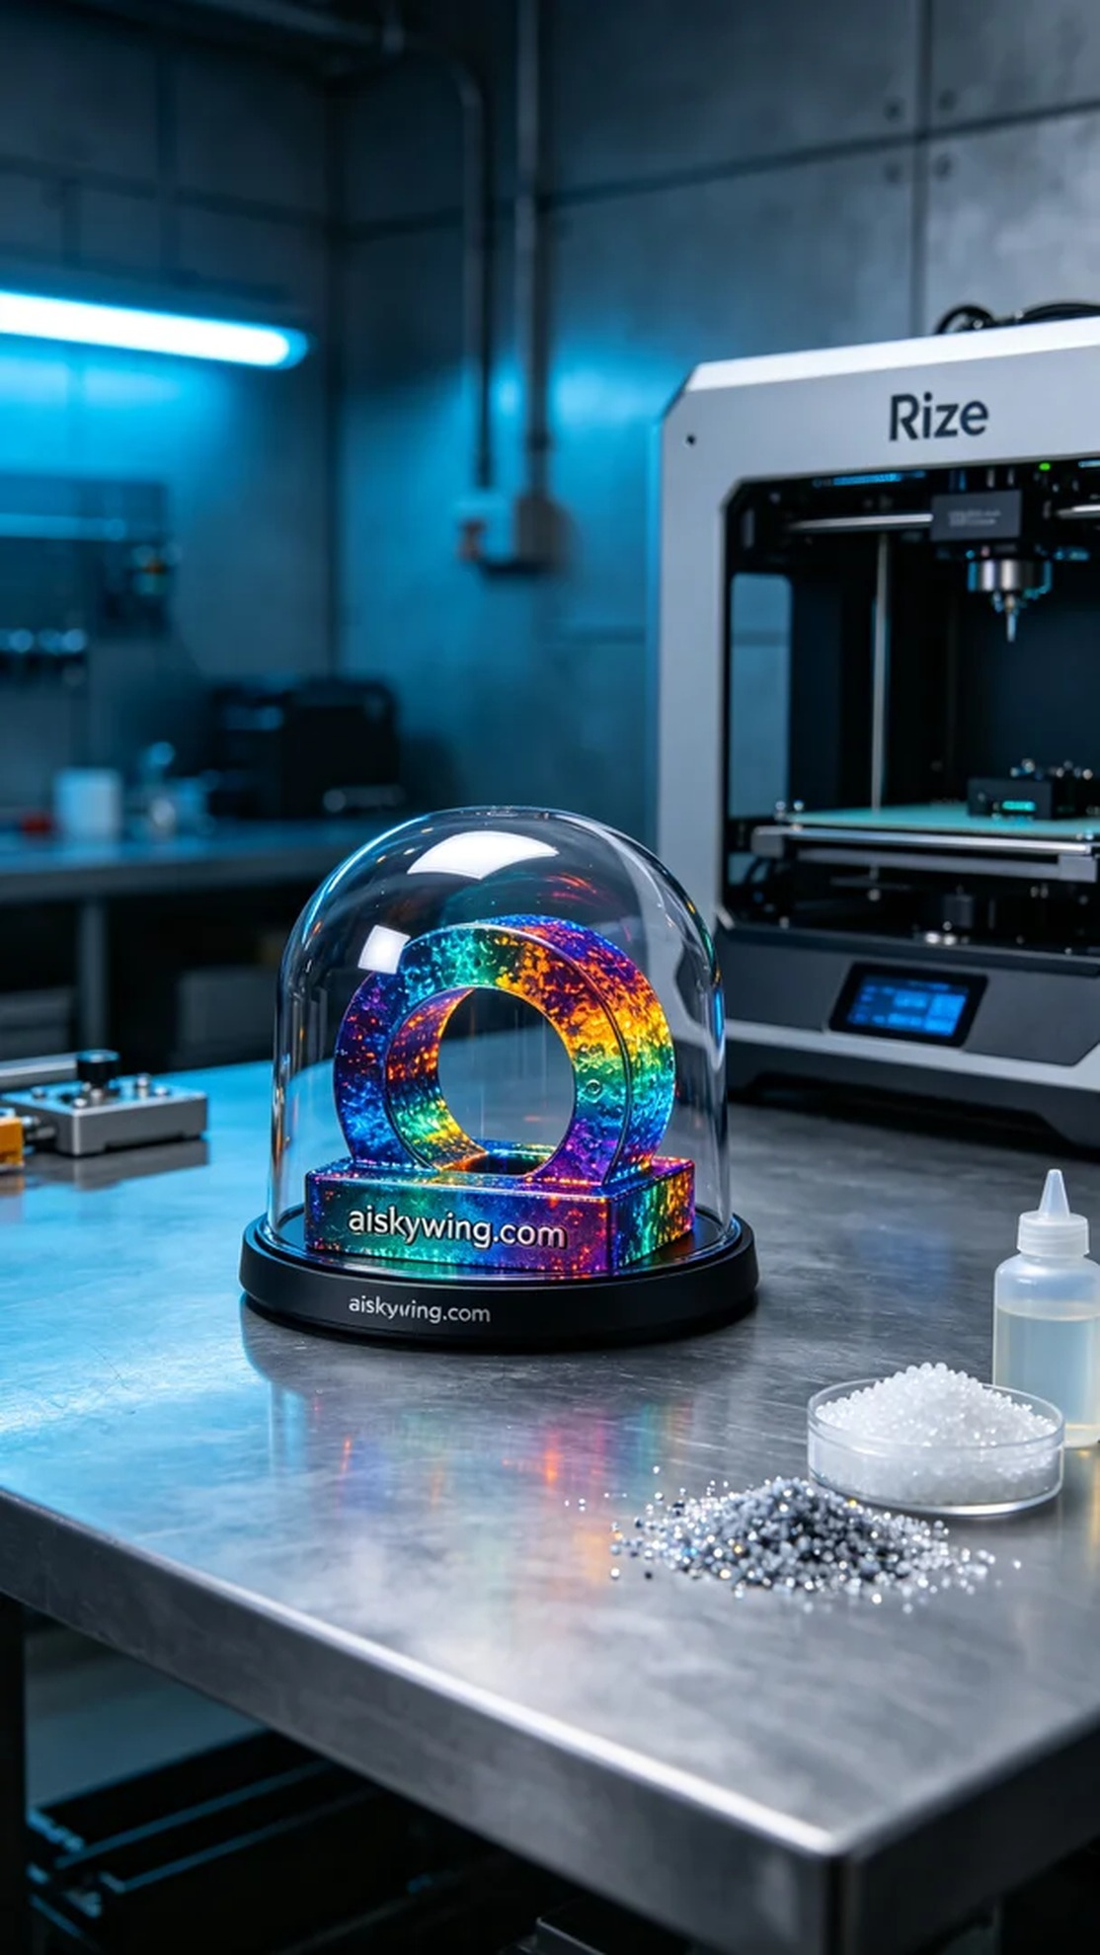
Aiskywing Industrial 3D Printing
3D protective cover


