0662-3D外壳的生产记录
3D shell
🖨️ 全彩3DP
🖥️ 打印机: Stratasys
📦 材料: 全彩3DP彩色打印
生活再难，也别停下脚步。就像接下这个3D外壳的单子，有人因为对色彩和细节的极致追求找到了我们。
No matter how difficult life gets, don't stop moving forward. Just like when we took on this 3D shell project, someone found us because of their relentless pursuit of color and detail.
________________________________________________________________________________
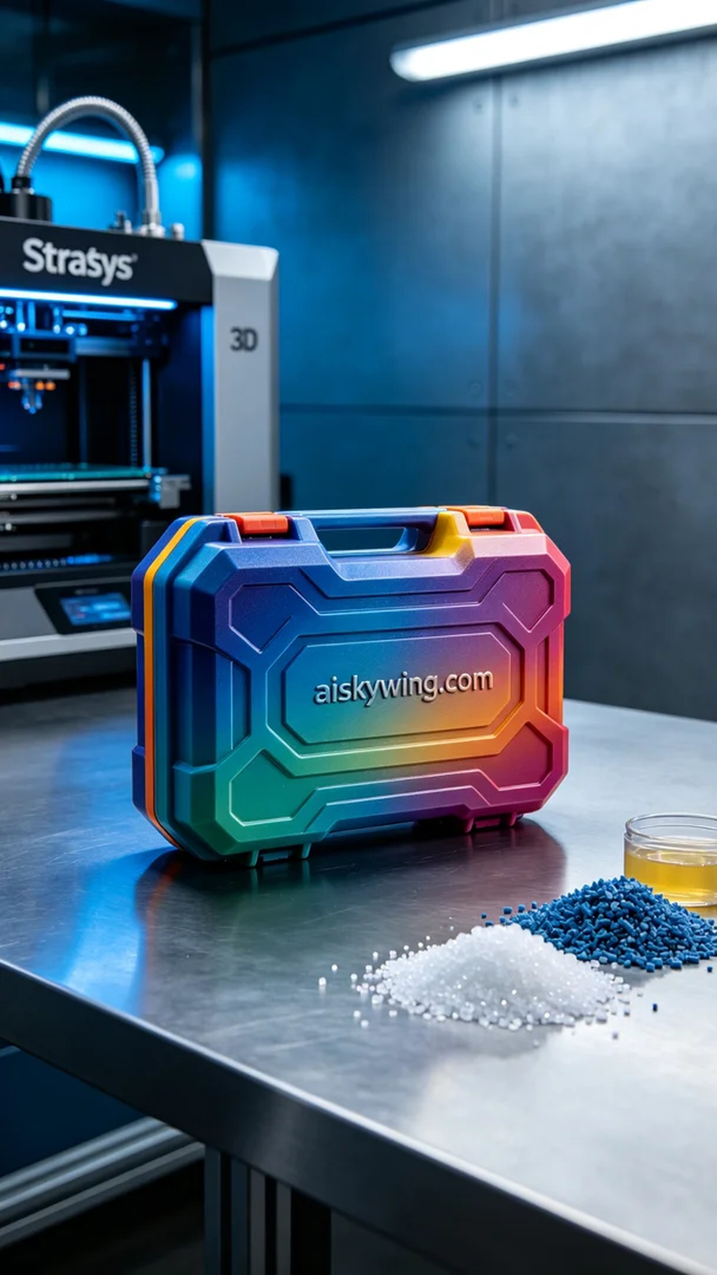
Life can be tough, but we must keep moving forward. Just like when we took on this 3D shell project, someone reached out to us through Twitter, seeking a product that demands extreme attention to color and detail.
In preparation for today's production, we decided to use the full-color 3DP printing technique with liquid photopolymer resin. We set up the Stratasys 3D printer for this task. The printing parameters were established with a layer thickness of 0.2 mm, a printing temperature of 25°C, power set to 80W, and a speed of 30mm/s to ensure the quality and fidelity of the final product.
During printing, the machine ran smoothly, and we closely monitored the progress in real time. To guarantee precision in each layer, we conducted regular checks to ensure the nozzle was clear and that the resin was flowing properly. This diligence helped maintain the high-quality standards we aimed for.
Once printing was complete, the post-processing phase began. We first placed the printed shell into a cleaning station with an appropriate solvent to remove any residual resin. Following that, we sanded the surface to achieve a smooth finish. We then cured the model to enhance its strength and durability, followed by a rigorous inspection to ensure every detail met our standards.
All of this effort resulted in a vibrant, intricately detailed 3D shell that perfectly fulfilled the client's expectations for perfection. This achievement reflects not just technical proficiency but also the collective dedication of our team.
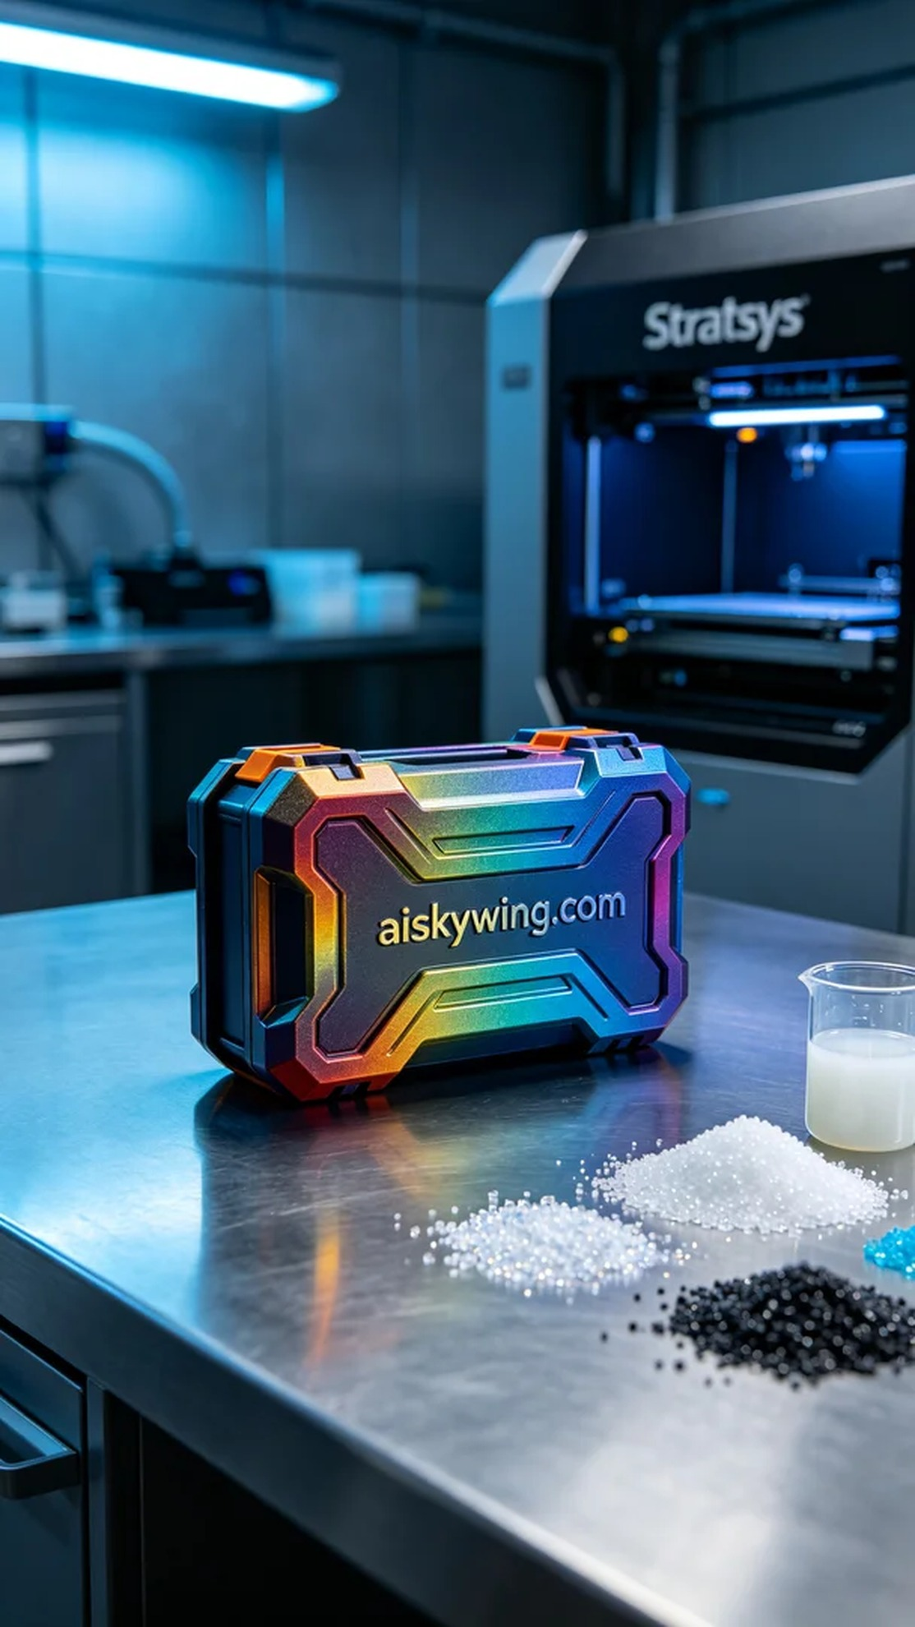
在今天的工作中，有人通过Twitter联系到我们，想要制作一个全彩3D外壳。这个项目的特别之处在于，客户对成品的色彩丰富性和细节呈现有很高的要求，因此我们决定使用全彩3DP彩色打印，这无疑是最佳选择。
为了确保生产顺利进行，我们准备了全彩3DP彩色打印的液态光敏树脂原材料，并选择了Stratasys品牌的3D打印机进行操作。打印参数上，我们设定了层厚为0.2毫米，打印温度控制在25°C，功率设置为80W，打印速度为30mm/s，这样的设置旨在保证最终成品的质量与细节。
在打印过程中，设备运行相对平稳，监控系统实时跟踪打印进展。我们确保每个细节在逐层堆叠时都能得到准确呈现，因此在关键点时会定期检查喷头是否堵塞，树脂是否流畅，确保打印质量达到预期。
打印完成后，后处理环节同样重要。首先，我们将打印好的外壳放入清洗槽中，使用适当的清洗液去除残留的树脂。接着，对外壳进行打磨，确保表面光滑无瑕。随后，我们将其固化，以增强材料的强度和耐用性，最后进行严格的检验，确保每个细节都符合标准。
这一切的努力，最终为我们带来了一个色彩丰富、细节精致的3D外壳，完美契合了那个追求完美的要求。这样的成就，既是技术的体现，也是团队共同努力的结果。
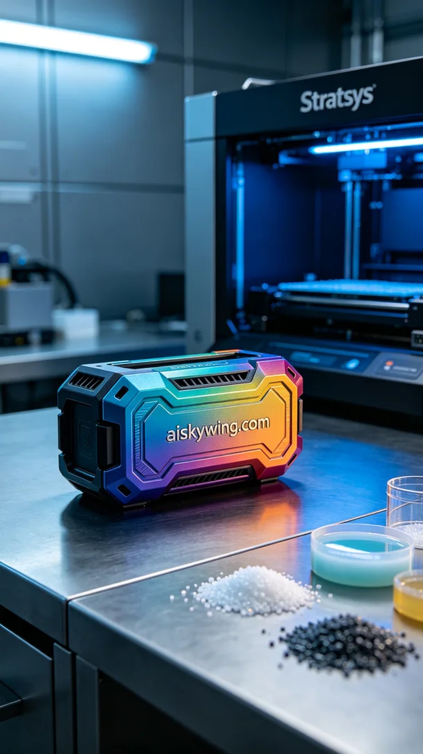
Aiskywing Industrial 3D Printing
3D shell


