0663-3D底座制作生产记录
3D base
🖨️ 全彩3DP
🖥️ 打印机: HP
📦 材料: 摆放着未成型的液态光敏
生活就像3D打印一样，每一步都要精准。有人在Twitter上询问，想制作一个3D底座，要求色彩丰富且细节清晰。
Life is like 3D printing, where every step needs to be precise. Someone asked on Twitter about wanting to create a 3D base that is colorful and has clear details.
________________________________________________________________________________
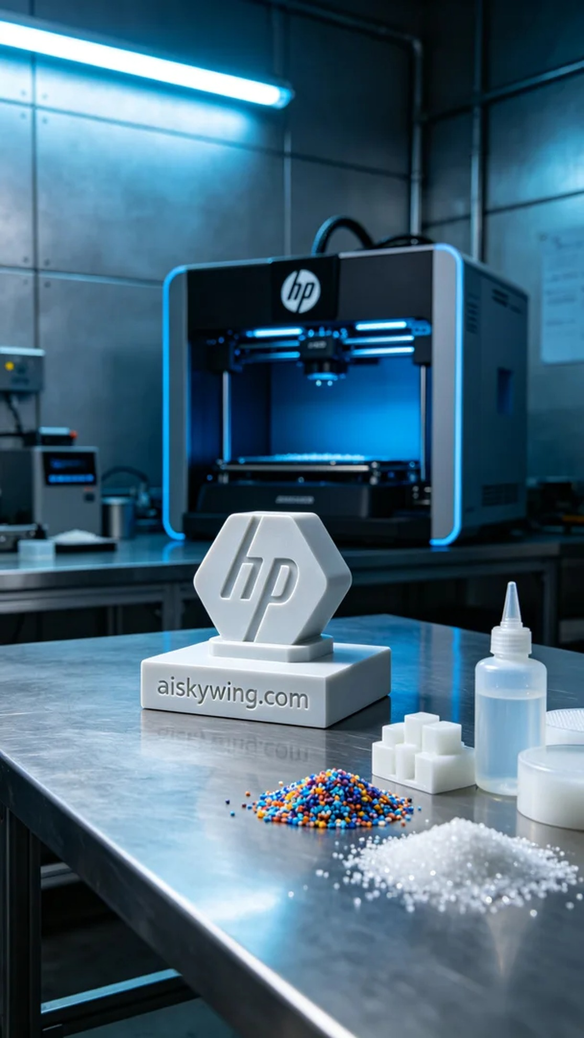
Life is like 3D printing; every step must be precise. Someone reached out on Twitter, looking to create a 3D base, emphasizing rich colors and detailed surfaces.
This order came from a social media platform, where someone wanted us to create a 3D base that focuses on realistic color reproduction and meticulous surface treatment. As it is an important display product, we need to consider every detail carefully to ensure the final outcome is perfect.
We chose liquid photopolymer resin as the primary raw material. This material can showcase very high resolution and fine surface results during the photopolymerization process. Using an HP 3D printer, we set the printing parameters: a layer thickness of 0.1mm, a temperature of 25°C, a power level of 60%, and a print speed of about 30mm/s. These settings are designed to ensure the model's color gradients and detail presentations reach their best.
During the printing process, the machine operated smoothly, and the liquid photopolymer resin flowed adequately, ensuring that each layer could be evenly covered. We continuously monitored the print quality, keeping a close eye on the progress to ensure the resin's curing time was accurate. The entire process took about five hours, and seeing the base gradually take shape filled me with anticipation.
After printing, the base entered the post-processing stage. First, we washed the model with water to remove any residual photopolymer resin, then proceeded to sand it down to ensure a smooth surface. Next, we placed the base in a UV curing box to solidify it, ensuring every detail was securely fixed. Finally, after strict quality inspection, we verified that each detail met the standards.
In the end, this 3D base, processed through multiple stages, presented a rich and delicate effect, perfectly embodying the design intent. Seeing it shine on the industrial tabletop made me reflect on the beautiful fusion of technology and art.
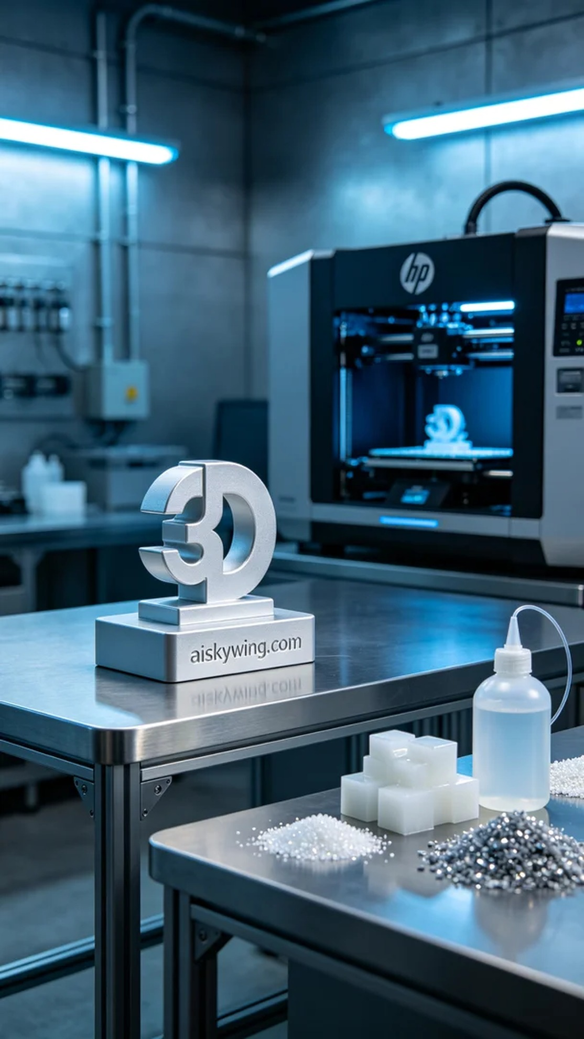
这次的订单来自社交平台Twitter，有人希望我们为他们制作一个3D底座，注重色彩的真实还原和细腻的表面处理。作为一项重要的展示产品，我们需要仔细考虑每个细节，确保最终效果达到完美。
我们选择了液态光敏树脂作为主要原材料，这种材料在光敏固化过程中能够展现出非常高的分辨率与细腻的表面效果。同时，使用HP品牌的3D打印机，设置了打印参数：层厚0.1mm，温度保持在25°C，功率控制在60%，打印速度约为30mm/s。这些设置都是为了确保模型的色彩渐变和细节表现达到最佳。
打印过程中，设备运转良好，液态光敏树脂充分流动，确保每一层都能均匀覆盖。我们持续监控打印质量，保持对进展的关注，确保材料的固化时间准确。整个过程大约耗时五个小时，看到底座逐渐成型的样子，心中满是期待。
打印完成后，底座进入了后处理工序。首先，我们用清水清洗模型以去除残留的光敏树脂，然后进行打磨，以确保表面光滑细腻。接下来，我们将底座放入紫外线固化箱中固化，确保每个细节都能牢牢固定。最后，经过严格的质量检验，确保每个细节都符合标准。
最终，这个3D底座在多重工序处理后，呈现出色彩丰富且细腻的效果，完美的体现了设计初衷。看到它闪耀在工业桌面上，心中不禁感慨，这就是科技与艺术的结合。
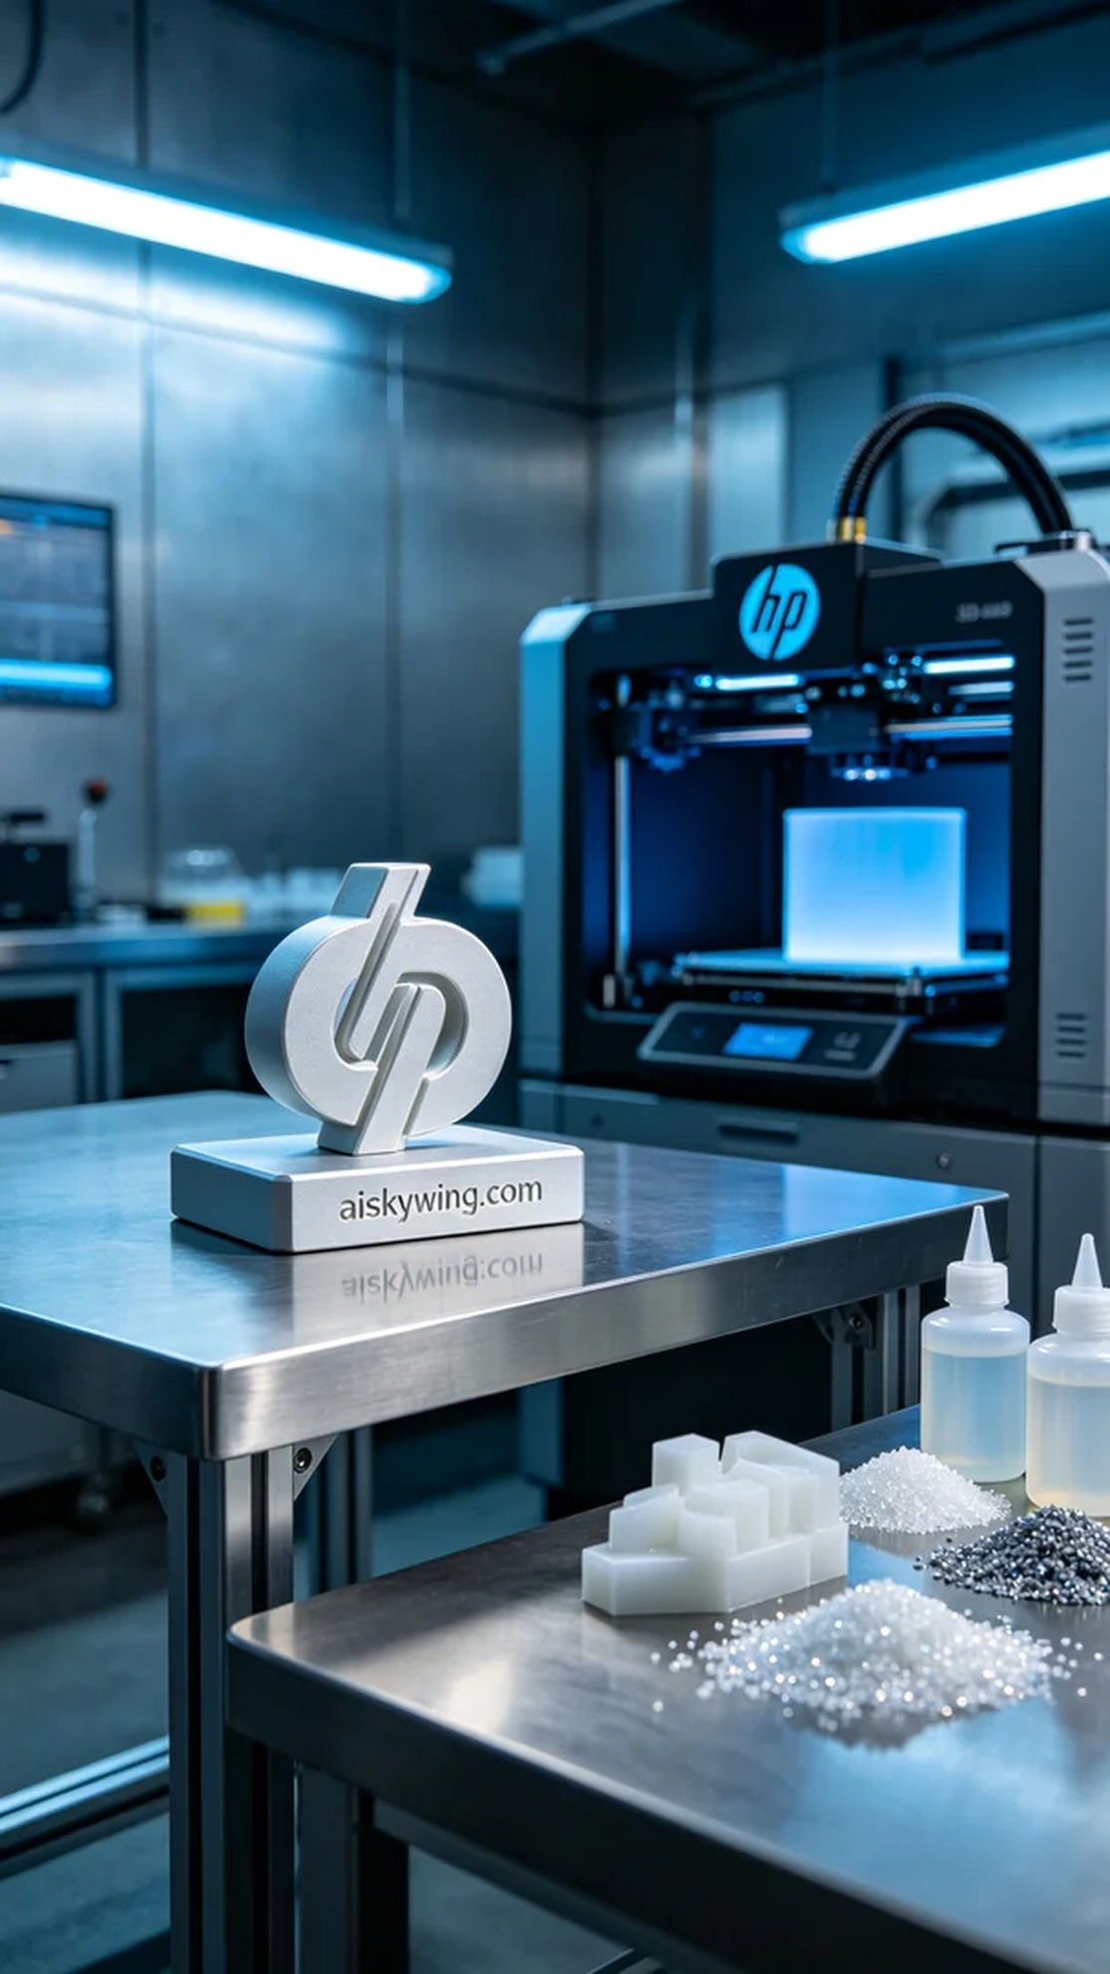
Aiskywing Industrial 3D Printing
3D base


