0664-高品质3D手柄生产记录
3D handle
🖨️ 全彩3DP
🖥️ 打印机: EOS
📦 材料: 全彩3DP彩色树脂
在Twitter上，有人提到需要一款独特的3D手柄，以突出他们的品牌形象。这让我想起了我们的3D手柄置于画面正中央的项目，让我倍感振奋。
On Twitter, someone mentioned the need for a unique 3D controller to highlight their brand image. This reminded me of our project featuring the 3D controller placed right in the center of the screen, which excited me greatly.
________________________________________________________________________________
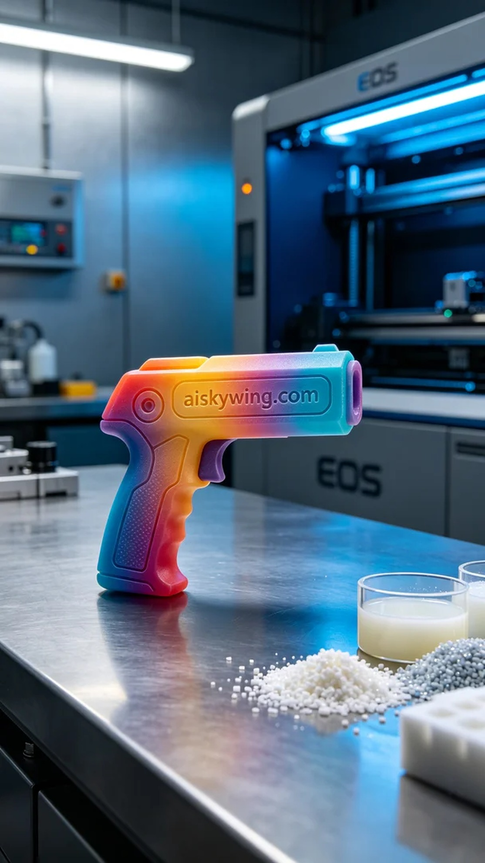
On Twitter, someone reached out to us looking for a unique 3D handle to enhance their brand image. This reminded me of our project, the 3D handle placed at the center of the frame, and filled me with excitement.
We chose full-color 3DP resin as our material due to its rich and vivid colors, ideal for showcasing gradient effects. The material's hardness and flexibility met our standards. To prepare for printing, we utilized the EOS 3D printer, setting a layer thickness of 0.1 mm, a printing temperature of 30°C, a power setting of 50W, and a printing speed of 60 mm/s, with an estimated print time of three hours.
During the printing process, the EOS printer operated smoothly, while the quality monitoring system continuously checked the printing status to ensure that every layer was perfectly rendered. We kept a close eye on the printer's operation, promptly recording anything that might affect quality. As the print progressed, the intricate details and color gradients of the handle gradually emerged, bringing us joy.
Once printing was complete, we meticulously processed the handle. First, we placed the finished product in a cleaning tank, using alcohol to remove excess resin. Next, we sanded the surface with fine sandpaper to ensure a smooth finish. We then placed the handle in a UV curing machine for 20 minutes to enhance its durability. Finally, we conducted a thorough inspection to ensure that every detail met our expected standards.
After a series of production steps, we successfully created a high-quality 3D handle that was visually striking. The completion of this project not only brought us a sense of accomplishment but also laid a foundation for our further exploration in the 3D printing field.
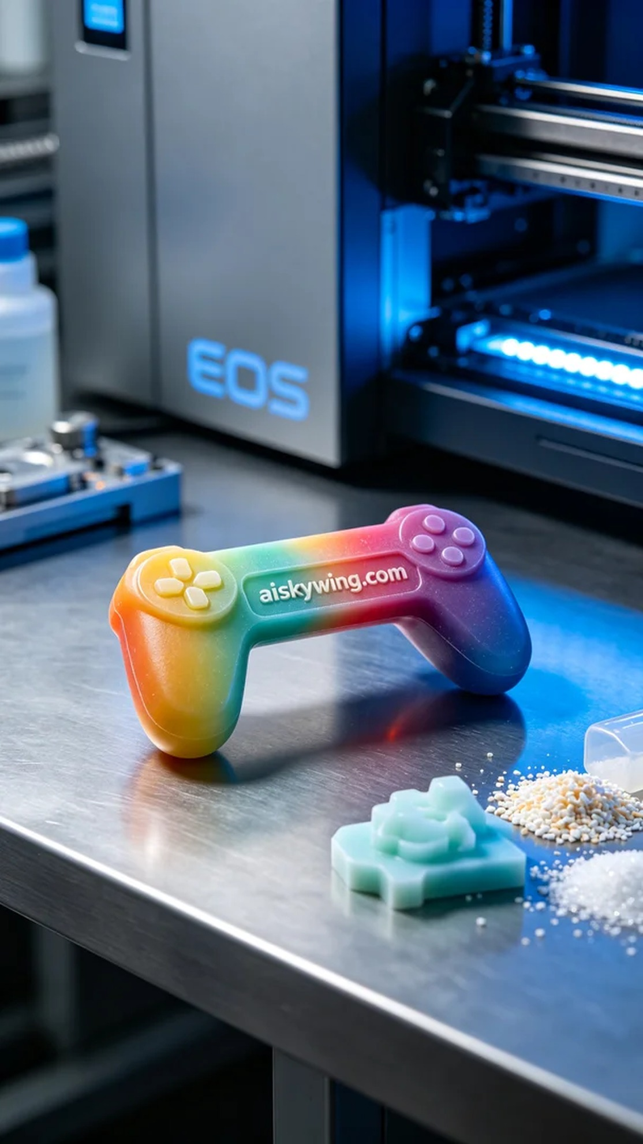
在Twitter上，有人因为产品展示的需求而找上我们，希望能够制作一款具有视觉冲击力的3D手柄置于画面正中央。他们希望这款手柄的设计和颜色能更好地吸引客户的目光。于是，我们开始了这个令人兴奋的项目。
我们选择了全彩3DP彩色树脂作为原材料，因其色彩丰富且逼真，适合展示渐变效果。材料的硬度和柔韧性也都符合我们的标准。为了准备打印，我们使用EOS品牌的3D打印机，设置了层厚为0.1毫米，打印温度为30°C，功率设定在50W，打印速度则选择了60mm/s，估计整个打印过程需要三个小时完成。
在打印过程中，EOS打印机运转平稳，质量监控系统不断检测打印状态，确保每层细节都完美呈现。我们持续观察着打印机的运行，及时记录任何可能影响质量的情况。打印过程中，手柄的复杂细节和色彩渐变逐渐显现，令人欣喜。
打印完成后，我们对手柄进行了细致的后处理。首先，我们将成品放入清洗槽，用酒精清洗掉多余的树脂。接着，我们用细砂纸进行打磨，确保表面光滑。随后，将手柄放入紫外线固化机中，固化时间为20分钟，增强其耐用性。最后，我们对成品进行检验，确保每个细节都达到预期标准。
经过一系列的生产工序，我们成功制作出了高质量的3D手柄，让人眼前一亮。这个项目的圆满完成，不仅为我们带来了成就感，也为我们在3D打印领域的进一步探索打下了基础。
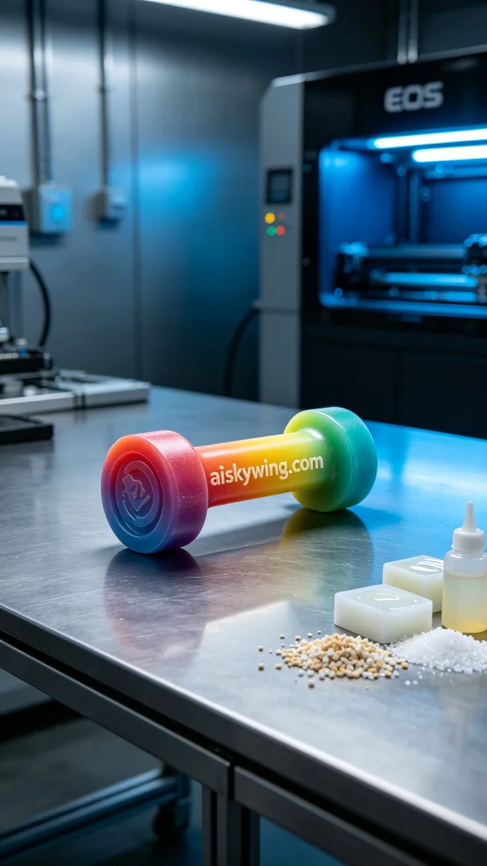
Aiskywing Industrial 3D Printing
3D handle


