0665-3D支架的打印与后处理记录
3D bracket
🖨️ 全彩3DP
🖥️ 打印机: Voxeljet
📦 材料: 摆放着未成型的液态光敏
生活中的每一步都在塑造未来。就像在Twitter上，有人找我们制作这个3D支架时，给我们带来了新的挑战与机遇。
Every step in life shapes the future. Just like when someone on Twitter approached us to create this 3D stand, it brought us new challenges and opportunities.
________________________________________________________________________________
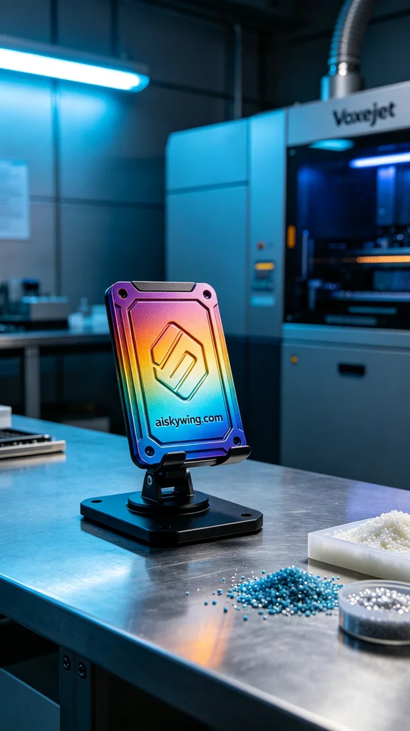
Every step in life shapes the future. Just like on Twitter, someone reached out to us for a precise 3D support, bringing us new challenges and opportunities.
We used liquid photopolymer resin as the primary material. This material was carefully selected for its excellent fluidity and adhesion, allowing for high-precision printing. To ensure print quality, we employed the Voxeljet printer, setting a layer thickness of 0.1 mm, maintaining a printing temperature of 25°C, setting the power to 80%, and adjusting the speed to 50 mm per hour, with the entire print expected to take about 8 hours.
As the printing process began, the equipment ran smoothly, and we continuously monitored the print quality and progress. With Voxeljet's efficient performance, we ensured that every detail was accurately represented. During the entire printing process, the machine operated flawlessly, showcasing satisfying color gradients and texture.
After printing, we moved on to the post-processing stage. First, we performed an initial wash with clean water to remove any residual resin on the surface of the support. We then meticulously sanded the surface with specialized tools to ensure smoothness and feel. Finally, we conducted a curing process, exposing the support to UV light for 10 minutes to ensure the material was fully cured and stable. After inspection, the quality of the support met our expectations.
This project of printing and post-processing the 3D support allowed us to witness the fusion of technology and art while experiencing the power of teamwork. Every detail reflects our dedication and persistence.
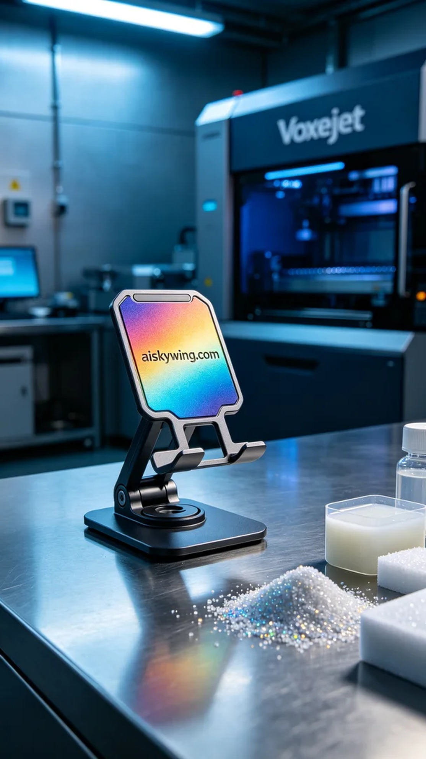
在Twitter上，有人因为需要一个精确的3D支架而联系到我们。他们希望这个支架能够展现出细腻的色彩和优秀的细节，能够在工业环境中更好地使用。这种需求促使我们开始了这项全彩3DP的项目。
我们使用的是液态光敏树脂作为主要原材料。这种材料经过精心选择，具有优良的流动性和粘合性，能够实现高精度的打印效果。为了确保打印质量，我们使用了Voxeljet打印机，设置了层厚为0.1毫米，打印温度保持在25℃，功率设定在80%，速度调整为每小时50毫米，整个打印预计需要8小时才能完成。
打印过程开始后，设备稳定运行，我们时刻监控打印进度和质量。通过Voxeljet的高效性能，我们能够确保每个细节都能得到精准呈现。在整个打印过程中，机器的工作状态始终良好，色彩渐变和质感都呈现出令人满意的效果。
打印完成后，我们进入后处理环节。首先，我们用清水对支架进行初步清洗，去除表面残留的树脂。接着，使用专业工具对支架表面进行细致的打磨，以确保它的光滑度和手感。最后，我们对支架进行固化处理，使用UV灯照射10分钟，确保材料完全固化，保持稳定性。经过检验后，支架的质量达到了预期的标准。
这次3D支架的打印与后处理工作，不仅让我们看到了科技与艺术的结合，也让我们体会到了团队合作的力量。每一个细节都蕴含着我们的努力与坚持。
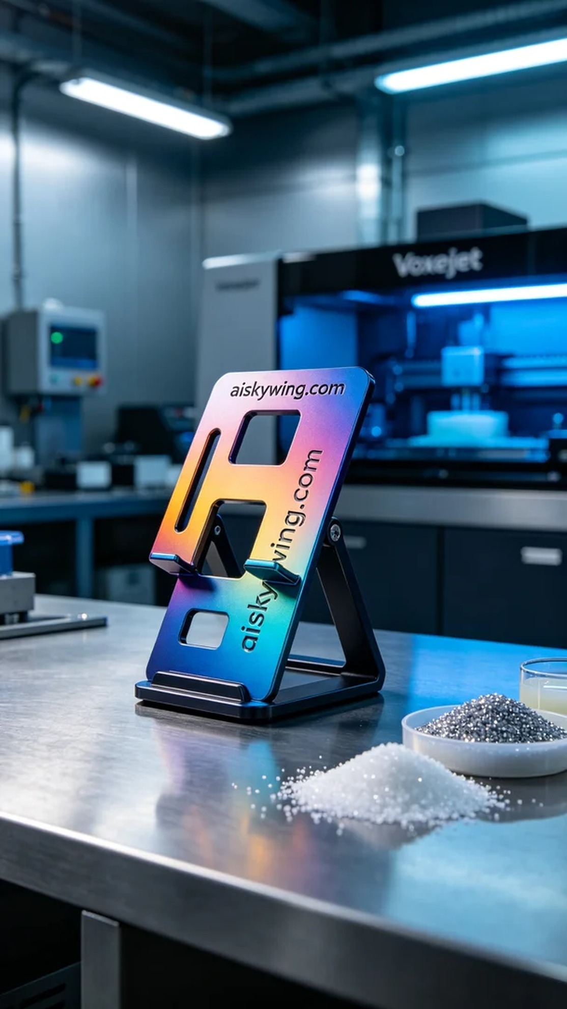
Aiskywing Industrial 3D Printing
3D bracket


