0666-3D框架的打印与制作
3D framework
🖨️ 全彩3DP
🖥️ 打印机: Mimaki
📦 材料: 全彩3DP彩色打印
在这个快节奏的时代，记住每一步都不简单。就像我们接下这个3D框架的单子，挑战与机遇并存。
In this fast-paced era, it's not easy to remember every step. Just like when we took on this 3D framework project, challenges and opportunities coexist.
________________________________________________________________________________
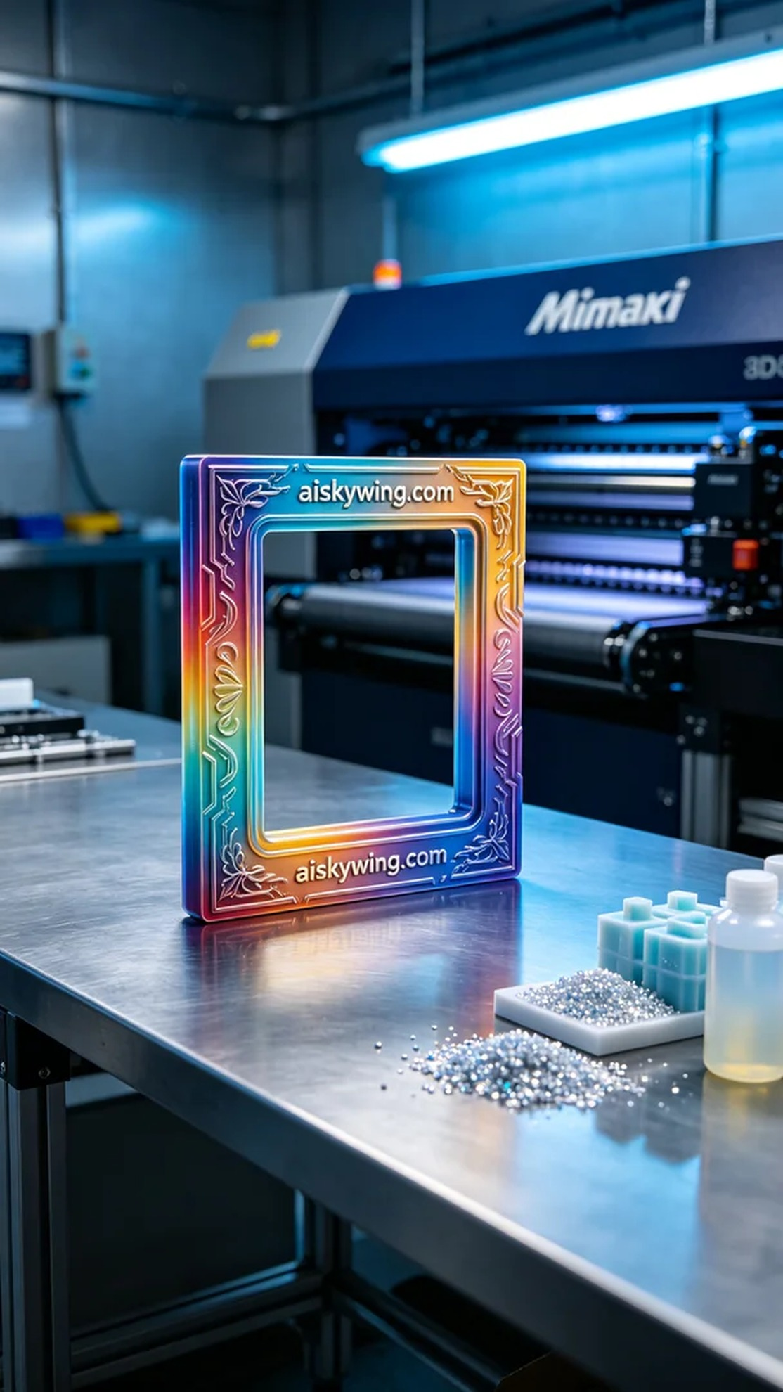
In today’s fast-paced world, it’s essential to remember that every step counts. Just like when we took on the project for a 3D frame, where challenges and opportunities coexist.
First, we prepared the liquid photopolymer resin required for the full-color 3DP printing. This material exhibits excellent color representation and detail capability, enabling the creation of highly realistic models. To ensure printing quality, we used a Mimaki 3D printer, setting a layer thickness of 0.1mm, a printing temperature of 30°C, a power setting of 60%, a printing speed of 30mm/s, with an estimated printing time of 12 hours.
Next, the printing process officially began. Once the Mimaki printer started, it began constructing the model layer by layer. During the printing process, we continuously monitored the operation of the device, ensuring that every detail was perfectly presented. The cold industrial light reflected off the model's surface, showcasing the high-fidelity color gradients while reminding us to keep a close eye on the printer's operation to avoid any possible flaws.
After completing the print, we entered the post-processing phase. First, we cleaned the printed model to remove any excess material on the surface. Subsequently, we meticulously sanded the model to ensure that every corner was smooth and flawless. Finally, the model was placed in a curing unit to undergo curing treatment, ensuring its structural stability. After a thorough inspection, the model met our expected quality standards.
Through this project, we not only delivered a perfect 3D frame but also felt the charm of 3D printing once again. Each success encourages us to keep moving forward, creating even better works.
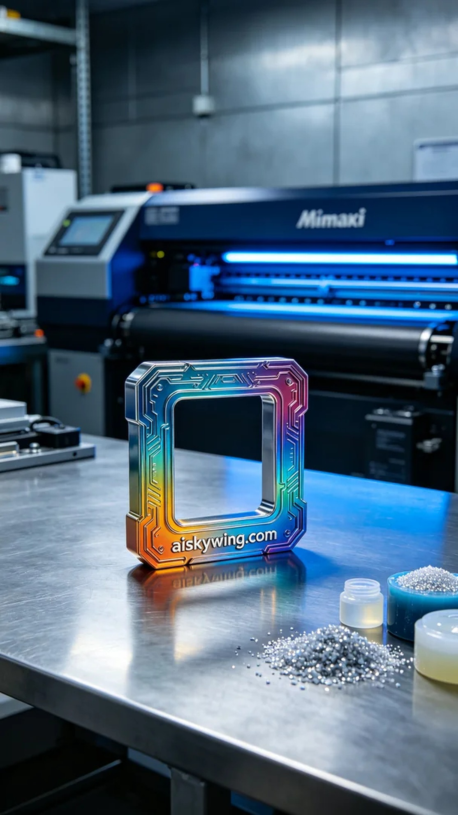
在我们的Instagram上，有人因为需要制作一个独特的3D框架而联系到我们。他们希望这个框架不仅要美观，而且要充分展现出全彩3DP的丰富色彩和高度细腻的细节。于是，我们决定为他们提供最好的解决方案，开始了这个项目。
首先，我们准备了全彩3DP彩色打印所需的液态光敏树脂。这种材料具备了优异的色彩表现力和细节展现能力，能够生成高保真的模型。为了确保打印质量，我们使用了Mimaki品牌的3D打印机，设置了层厚0.1mm、打印温度为30℃、功率设置为60%、打印速度为30mm/s，预计打印时间为12小时。
接下来，打印过程正式开始。Mimaki打印机启动后，开始逐层构建模型。在打印的过程中，我们不断监控设备的运行状态，确保每个细节都能完美呈现。冷色调的工业光线反射在模型表面，显示出高保真的色彩渐变，却也让我们意识到必须时刻关注打印机的运行，以避免任何可能的瑕疵。
完成打印后，进入后处理工序。首先，我们将打印好的模型进行清洗，以去除表面的多余材料。随后，我们进行了细致的打磨，确保每个角落都光滑无瑕。最后，模型被放入固化设备中进行固化处理，确保其结构稳定。经过全面的检验后，模型达到了我们预期的质量标准。
通过这次项目，我们不仅交付了一个完美的3D框架，也再次感受到3D打印的魅力。每一次的成功都在鼓励我们不断前行，创造更美好的作品。
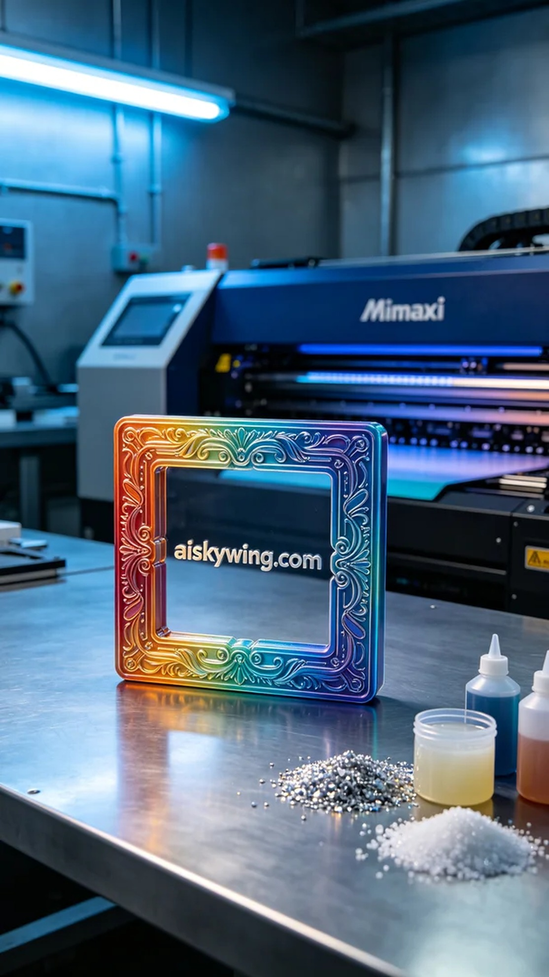
Aiskywing Industrial 3D Printing
3D framework


