0667-3D模块生产记录
3D Module
🖨️ 全彩3DP
🖥️ 打印机: EOS
📦 材料: 全彩3DP彩色树脂
生活就像3D打印，过程繁琐但每一步都值得珍惜。最近有人在Facebook上找到我们，希望制作一个3D模块，以解决他们的创意问题。
Life is like 3D printing; the process is complicated, but every step is worth cherishing. Recently, someone found us on Facebook, hoping to create a 3D module to solve their creative problem.
________________________________________________________________________________
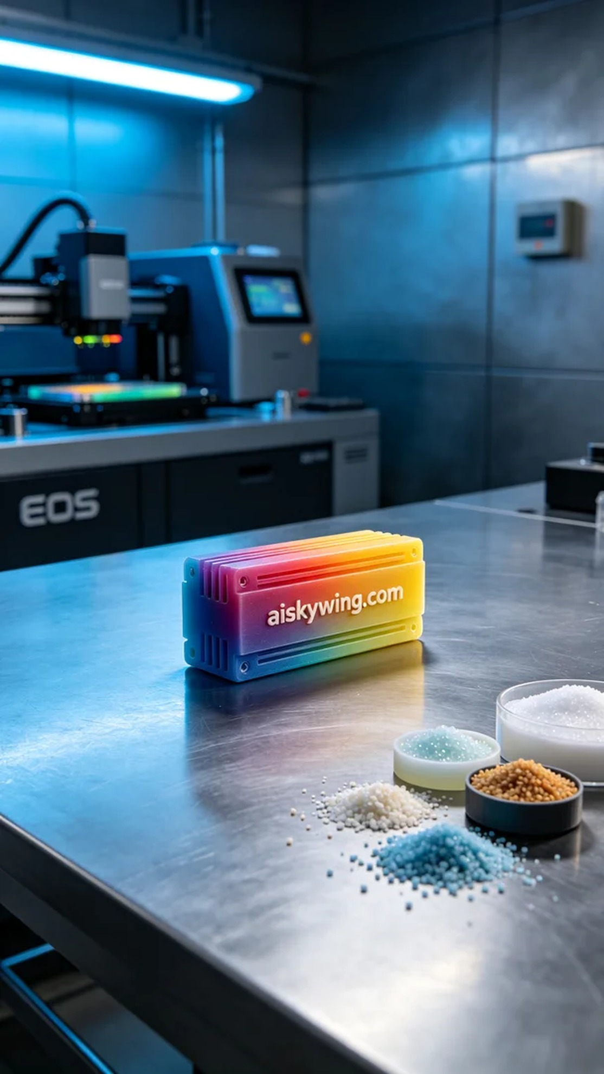
Life is like 3D printing; it’s a complicated process, but each step is worth cherishing. Recently, someone reached out to us on Facebook, looking to create a 3D module to solve their creative challenges.
This time, our task is to produce a full-color 3D module. The client mentioned on Facebook that they wanted to showcase vibrant colors and intricate details. We immediately recognized that the full-color 3DP resin could perfectly meet their needs.
First, we prepared the full-color 3DP resin, a high-quality material known for its vivid and saturated colors, ideal for intricate printing work. When using the EOS 3D printer, we set the layer thickness to 0.1mm, maintained a printing temperature of 25°C, set the power to 80W, and the printing speed at 40mm/s. The entire print is expected to take about 12 hours, ensuring perfect detail presentation and color gradients.
As the printing process began, the EOS printer operated steadily, and I kept a close eye on the machine's status. Each print is like an artistic creation, with the machine continuously pouring colored resin, constructing a complex and beautiful shape layer by layer. During the process, we conducted regular quality checks to ensure the adhesion and color accuracy of each layer.
Upon completing the print, we moved into the post-processing stage. First, we placed the entire model in the cleaning machine, using a special cleaning solution to thoroughly remove any uncured resin from the surface. Next, we meticulously sanded the surface of the model to eliminate any potential flaws and burrs. After that, we placed it under a UV curing lamp to ensure the model’s strength and durability. Finally, we conducted a comprehensive inspection of the finished product to ensure it met the required standards.
With these steps completed, we successfully created a vibrant, detail-rich 3D module. This final product not only met the user's expectations but also brought us a sense of accomplishment in our work.
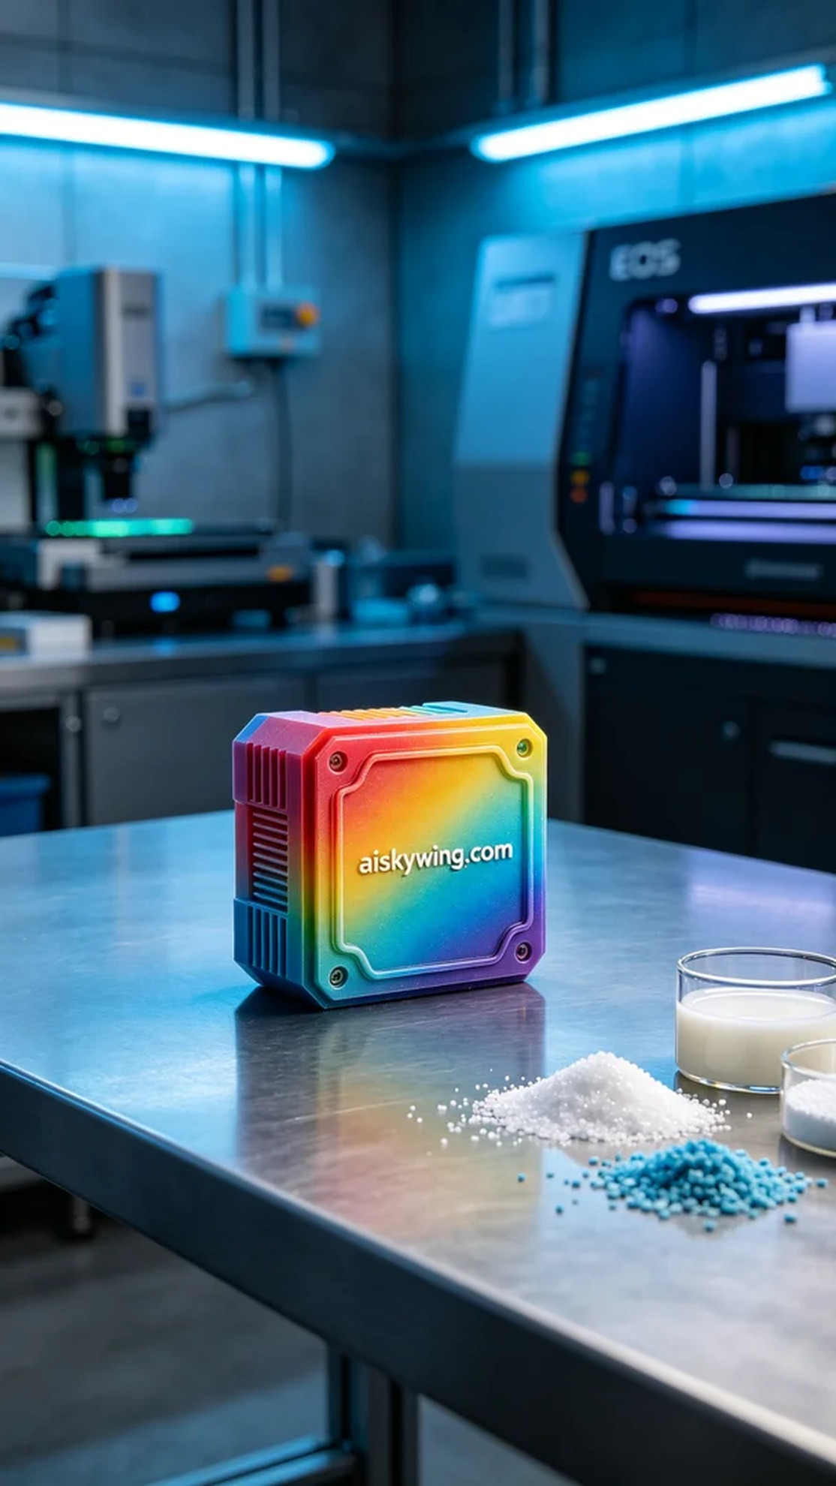
我们这次的任务是生产一个全彩3DP的3D模块，客户在Facebook上提到希望能够展现丰富的色彩和细节。这个需求让我们立即意识到，全彩3DP彩色树脂的特性能够完美满足他们的要求。
首先，我们准备了全彩3DP彩色树脂，这是一个具有鲜艳饱和色彩的高品质材料，非常适合精细的打印工作。在使用EOS品牌的3D打印机时，我们设定了层厚为0.1毫米，打印温度保持在25°C，功率设定在80W，打印速度为40mm/s。整个打印预计将耗时约12小时，这样的参数组合可以确保模型的细节呈现和颜色渐变的完美融合。
打印过程开始后，EOS打印机稳定运转，我时刻关注着设备的运行状态。每一次打印都如同一场艺术创作，机器在不断地浇注着彩色树脂，逐层构建出既复杂又美观的形状。整个过程中，我们定期进行质量检查，确保每一层的贴合性和色彩的准确性。
完成打印后，我们进入了后处理阶段。首先，将整个模型放入清洗机中，使用专用的清洗液彻底去除表面未固化的树脂。接着，我们对模型表面进行了细致的打磨，以去除任何可能的瑕疵和毛刺。之后，将其置于固化灯下进行紫外线固化，确保模型的强度和耐用性。最后，对成品进行了全面检验，确保它达到预定的标准。
经过这些步骤，我们成功制作出了一个色彩丰富、细节完美的3D模块。这份成品不仅满足了用户的需求，也为我们的工作带来了成就感。
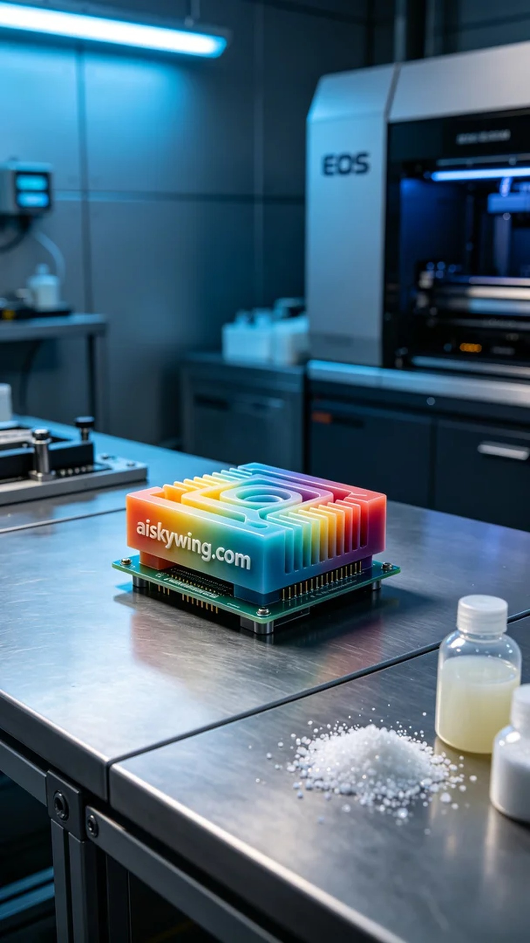
Aiskywing Industrial 3D Printing
3D Module


