0669-书架支撑架的3D打印生产记录
Bookshelf support bracket
🖨️ SLS尼龙烧结
🖥️ 打印机: Carbon
📦 材料: 摆放着未成型的液态光敏
生活就像3D打印，有时需要耐心和细致。最近，有人通过Twitter找到我们，希望我们能为他们制作一个书架支撑架，解决他们的存储难题。
Life is like 3D printing; sometimes it requires patience and attention to detail. Recently, someone reached out to us via Twitter, hoping we could create a bookshelf support for them to solve their storage problem.
________________________________________________________________________________
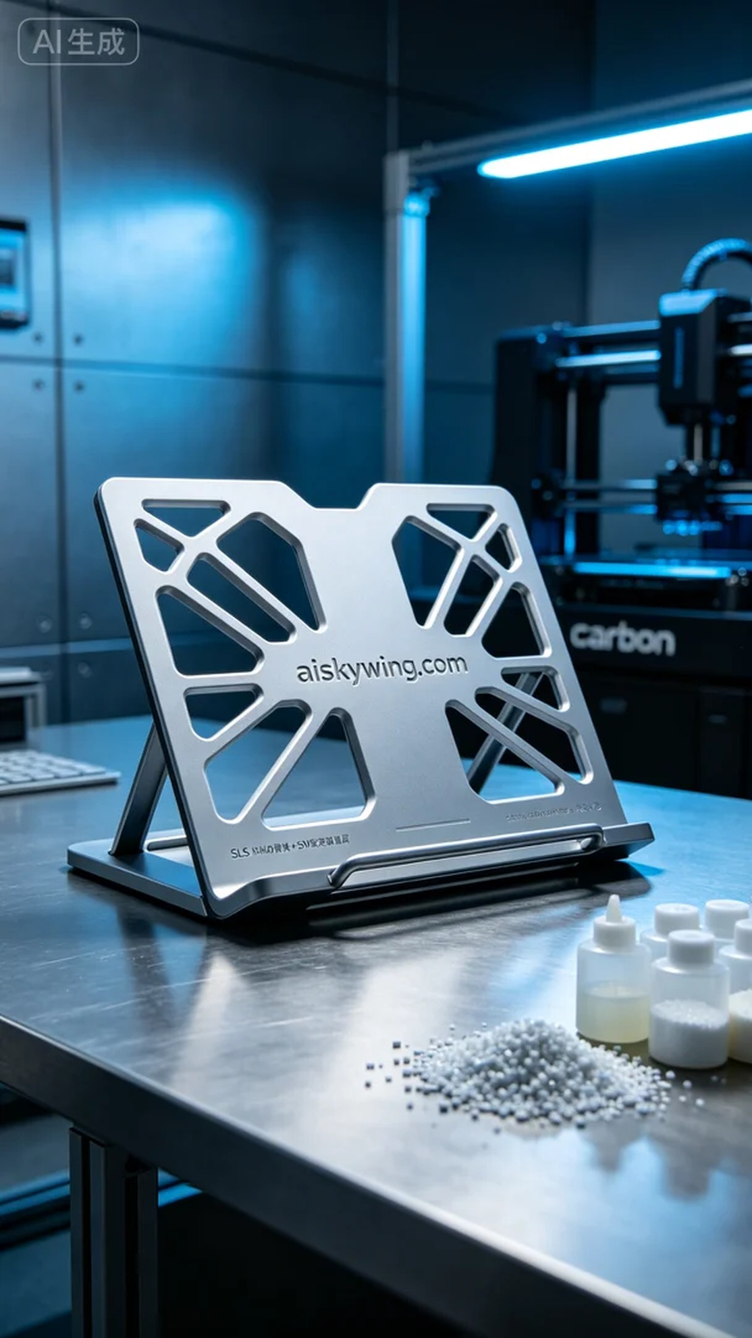
Life is like 3D printing; it takes patience and attention to detail. Recently, someone reached out to us via Twitter, hoping we could create a bookshelf support bracket to solve their storage issues.
We chose unformed liquid photopolymer resin as our raw material. This material has excellent flowability and forming performance, making it suitable for detailed structure printing. For the equipment, we used a Carbon printer, setting parameters at a layer thickness of 0.1 mm, a printing temperature of 25°C, a power setting of 60W, and a printing speed of 80 mm per hour, ensuring a balance of strength and detail in the printed support bracket.
During the printing process, the Carbon printer operated smoothly, and we closely monitored the print quality to ensure each layer spread evenly. At every stage of the print, we would observe and make immediate adjustments if any irregularities appeared. After approximately six hours of printing, the structure of the support bracket gradually emerged, and the intricate textures became increasingly defined.
Once the printing was complete, we moved into the post-processing stage. First, we cleaned the support bracket to remove any residual resin from the surface and then sanded it down to ensure a smooth feel. Next, we placed the bracket in a curing device for light curing to ensure the material's strength met the standards. Finally, we conducted a comprehensive inspection to ensure every detail met the required standards before concluding the process.
In the end, this bookshelf support bracket not only achieved the expected strength but also looked quite refined. Through this project, we once again demonstrated the charm and precision of 3D printing, solving practical problems for the user while feeling quite satisfied ourselves.
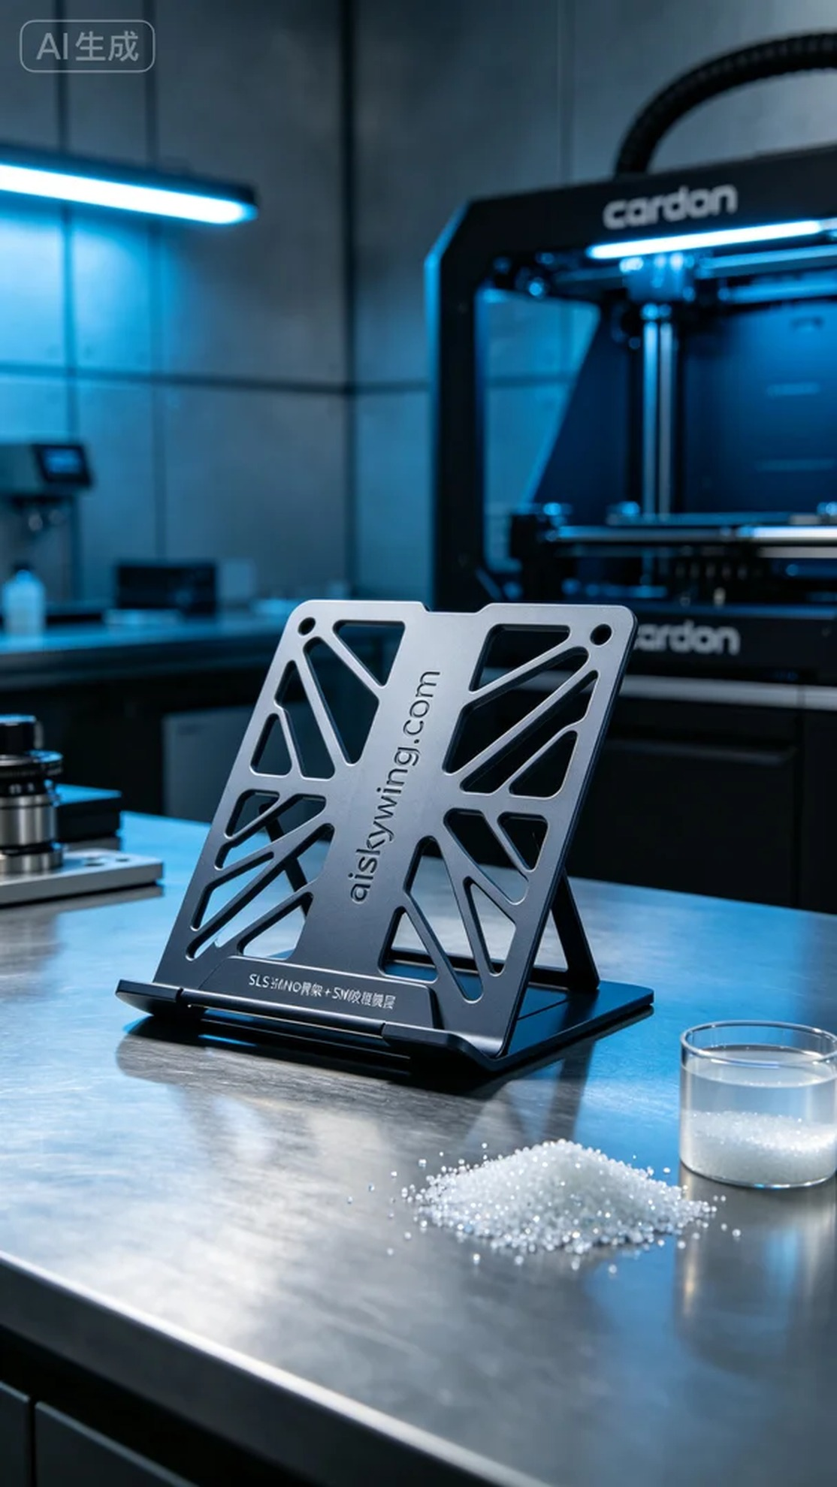
这次的工作任务是制作一个书架支撑架，客户在Twitter上提到他们家里的书架不够稳固，需要一个高质量的支撑架来增强结构。于是我们接下了这个单子，希望能给他们带来更好的使用体验。
我们选择了未成型的液态光敏树脂作为原材料，这种材料具有出色的流动性和成型性能，非常适合精细结构的打印。设备方面，我们使用了Carbon的打印机，设置参数为层厚0.1毫米，打印温度保持在25°C，功率则设定为60W，打印速度为每小时80毫米，这样可以确保打印出的支撑架在强度和细节上都有不俗的表现。
打印过程中，Carbon打印机运转非常平稳，我们全程监控打印质量，确保每一层都能均匀铺展。在打印的每个阶段，我们都会进行观察，若发现任何异常的地方会立刻调整。经过大约6个小时的打印，支撑架的结构逐渐显现，细腻的纹理也变得愈发清晰。
完成打印后，我们进入了后处理阶段。首先是对支撑架进行清洗，去除表面的残留树脂，然后用磨砂纸对其进行打磨，确保触感光滑。接下来，我们将支撑架放入固化设备中进行光固化，确保材料的强度达标。最后，我们进行了全面的检验，确保每一处细节都符合标准，合格后才算完成。
最终，这个书架支撑架不仅达到了预期的强度，同时在外观上也十分精致。通过这次的实践，我们再次证明了3D打印的魅力和精确度，为客户解决了实际问题，心里也感到很满足。
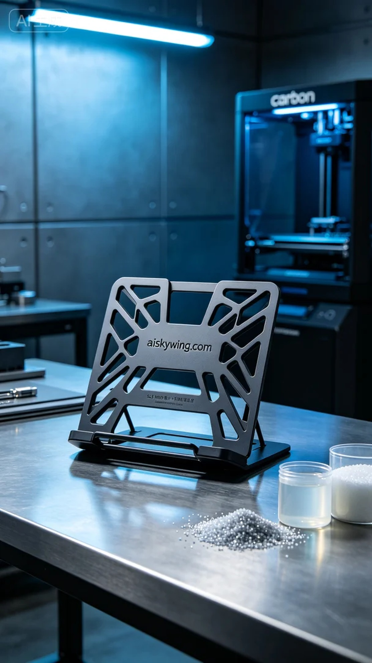
Aiskywing Industrial 3D Printing
Bookshelf support bracket


