0670-书架装饰条的3D打印生产记录
Bookshelf decorative strips
🖨️ SLM金属打印
🖥️ 打印机: Carbon
📦 材料: 摆放着未成型的液态光敏
生活再难，也别停下脚步。就像接下这个书架装饰条的单子，有人因为空间不足而希望找到更好的收纳方案。
No matter how difficult life gets, don't stop moving forward. Just like taking on this order for bookshelf decorative strips, some people hope to find better storage solutions due to limited space.
________________________________________________________________________________
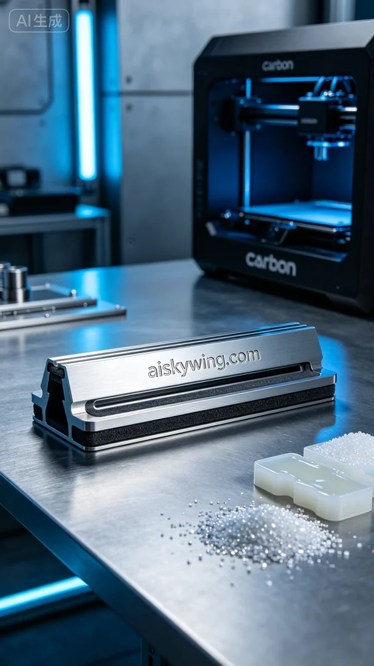
Life can be tough, but we should never stop moving forward. Just like when we took on the project for the bookshelf decorative strip, someone reached out for a better storage solution due to space constraints.
On LinkedIn, someone needed a suitable bookshelf decorative strip that is both beautiful and functional, enhancing the overall structure while improving aesthetics. After discussing, we decided to utilize 3D printing technology to create this decorative strip to meet their expectations.
To ensure a successful print, we chose liquid photopolymer resin as our material, known for its excellent fluidity and forming capability, ideal for complex structures. We prepared a Carbon brand 3D printer and set the printing parameters: layer thickness at 0.1mm, printing temperature at 25℃, power at 60W, and print speed of 50mm per hour. These settings provided solid support during the printing process.
Throughout the printing, the machine operated smoothly, layering the photopolymer resin precisely. We monitored the print quality continuously to ensure every layer completed accurately. The process took about 8 hours, during which the machine performed as expected, delivering a stable quality with a smooth surface, ultimately resulting in a perfect bookshelf decorative strip.
After the printing was completed, we moved on to post-processing. The printed parts were first placed in a cleaning device, using a specialized solvent to remove any excess resin from the surface. Next, we gently sanded the edges for a smoother finish. Then, the parts were placed in a curing chamber for UV curing, ensuring the materials reached their strongest state. Finally, we conducted a thorough quality inspection to ensure there were no defects.
After all these procedures, we successfully completed the production of the bookshelf decorative strip. This was not just a successful print, but also an ideal solution for those in need.
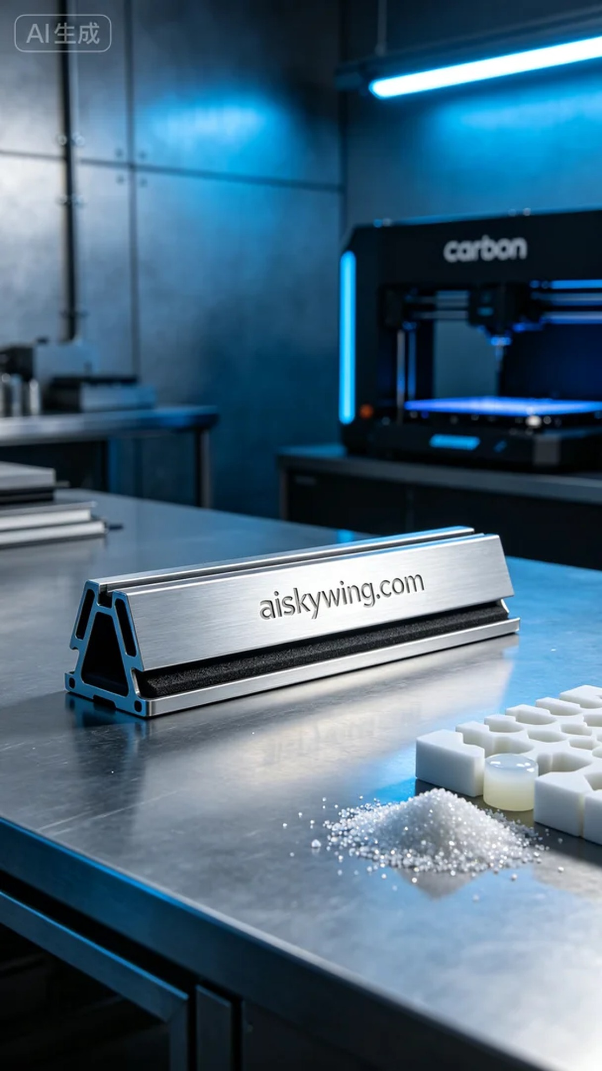
在LinkedIn上，有人因为缺少合适的书架装饰条而找到了我们。他们需要一个既美观又实用的产品，能在提升书架外观的同时，增强整体结构的稳定性。经过沟通，我们决定采用3D打印技术来制作这款书架装饰条，力争达到他们的期望。
为了确保打印的成功，我们决定使用液态光敏树脂作为原材料，这种材料具有很好的流动性和成型性，适合复杂结构的打印。我们准备了一台Carbon品牌的3D打印机，设置了打印参数：层厚0.1毫米，打印温度设定在25℃，功率控制在60W，打印速度为每小时50毫米。这些设置为我们在打印过程中提供了良好的支持。
在打印过程中，机器运行平稳，光敏树脂不断被层层叠加。我们全程监控打印质量，确保每一层都能准确无误地完成。打印进行了大约8个小时，在这段时间里，机器的表现符合预期，质量稳定，表面光滑，最终形成了一个完美的书架装饰条。
待打印完成后，我们开始了后处理工序。首先将打印好的部件放入清洗设备中，用专用溶剂清洁，以去除表面的多余树脂。之后，使用打磨工具轻轻打磨边缘，使其更加光滑。接下来，我们将其放入固化箱中，进行UV固化，确保材料达到最坚固的状态。最后，我们对成品进行了一次全面的质量检验，确保没有任何瑕疵。
经过这一系列工序，我们终于完成了书架装饰条的生产。这不仅是一次成功的打印，更是为那些需要帮助的人提供了一个理想的解决方案。
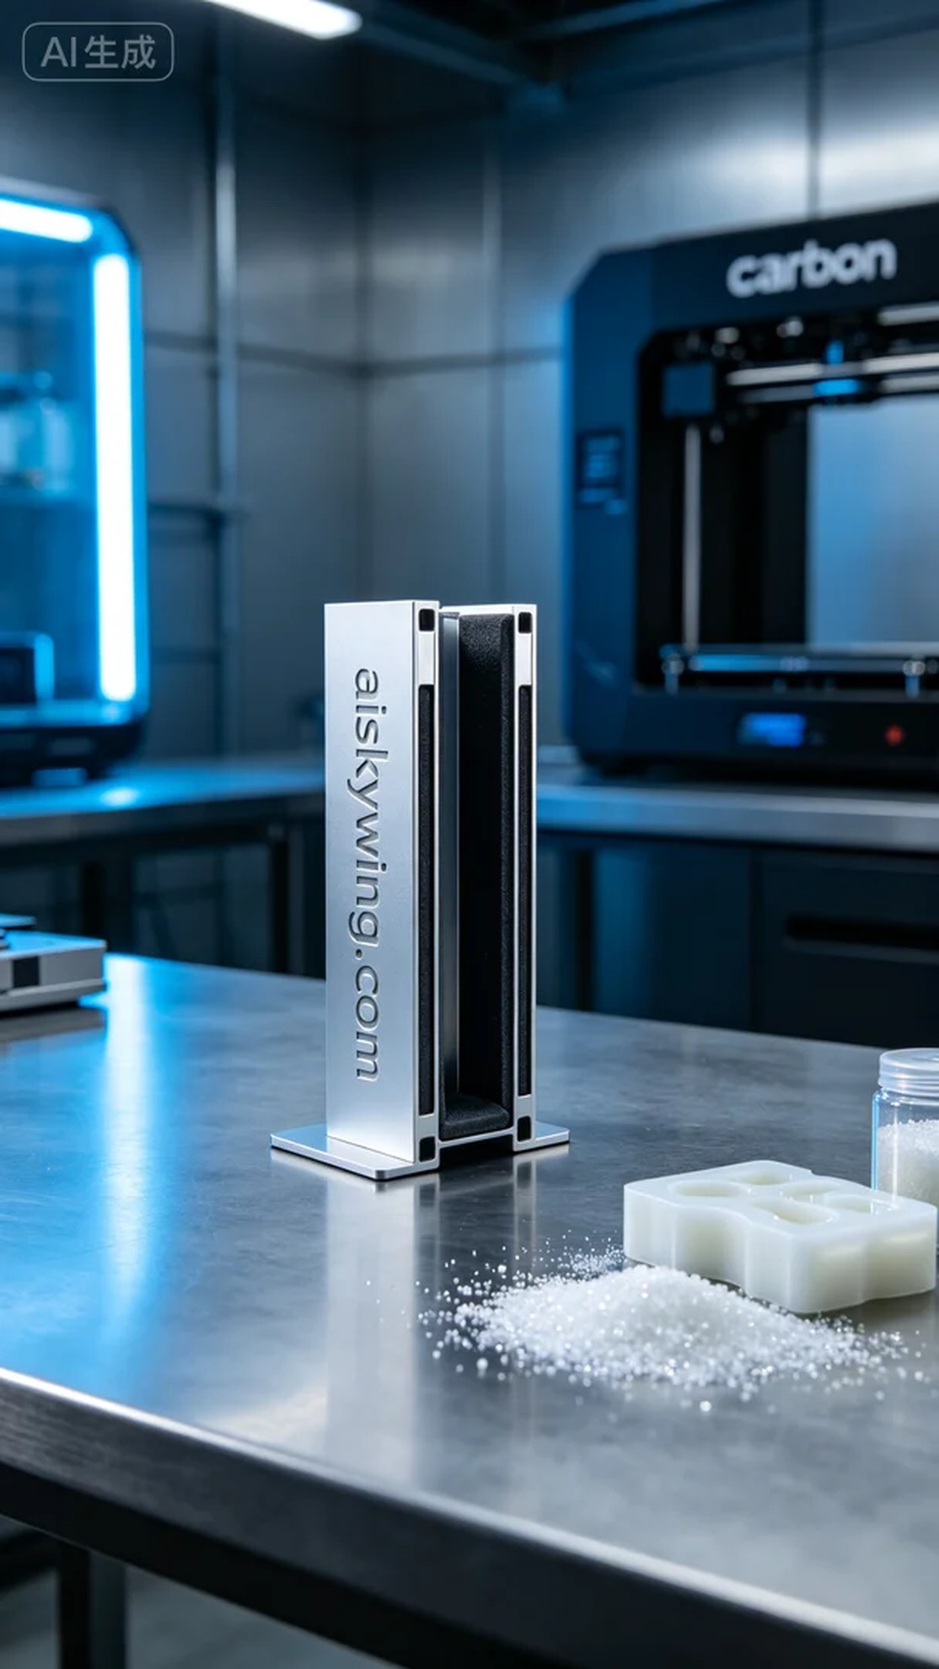
Aiskywing Industrial 3D Printing
Bookshelf decorative strips


