0671-书架连接件3D打印生产记录
Bookshelf connector
🖨️ SLA光固化
🖥️ 打印机: Voxeljet
📦 材料: SLA
生活再难，也别停下脚步。就像接下这个书架连接件的单子，有人因为缺少合适的连接解决方案来找我们。
No matter how difficult life gets, don't stop moving forward. Just like taking on this order for a bookshelf connector, there are people who come to us because they lack suitable connection solutions.
________________________________________________________________________________
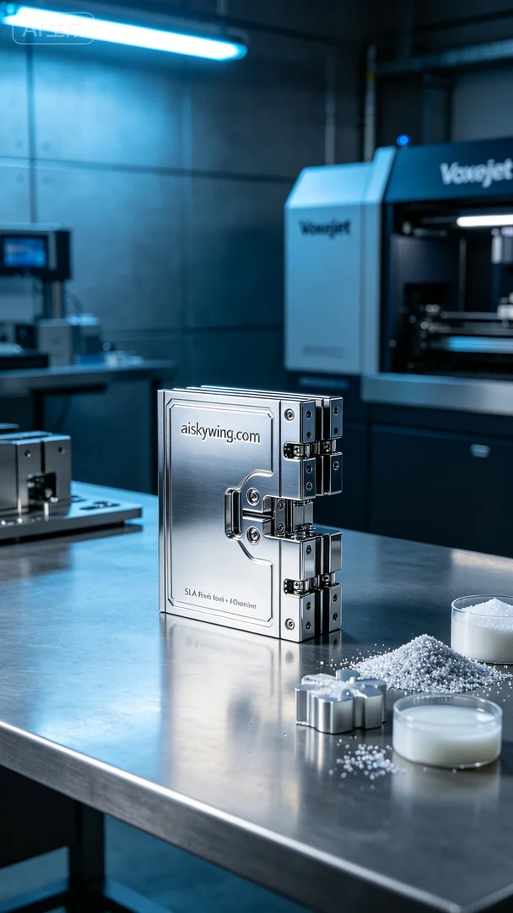
Life can be tough, but don't stop moving forward. Just like when we took on this order for a bookshelf connector; someone reached out to us for a reliable solution to their structural design needs.
The order came from a designer on LinkedIn, who needed a bookshelf connector to solve stability issues they faced in their project. They requested a solution that was both aesthetically pleasing and sturdy, perfectly aligning with their design vision.
For this project, we chose SLA photopolymer resin as the raw material due to its high precision and smooth surface finishing capabilities. Utilizing a Voxeljet printer, we set the layer thickness to 0.05 mm, maintained a printing temperature of 25 degrees Celsius, adjusted the power to 40%, and set the print speed to 30 mm per second, anticipating a total printing time of about six hours.
During the printing process, the Voxeljet printer operated smoothly, with the quality monitoring system continuously checking each layer's progress. We paid attention to the light reflections, ensuring that every detail was perfectly captured. After approximately six hours of printing, the bookshelf connector was successfully completed, featuring a smooth surface and clearly engraved "aiskywing.com" text.
After printing was completed, we conducted thorough post-processing procedures. The printed piece was first placed in a cleaning tank to remove excess resin, followed by sanding to enhance surface smoothness. Next, we performed UV curing to ensure material strength, and finally conducted an extensive quality inspection to guarantee that every detail was flawless.
Overall, this project for the bookshelf connector went smoothly, meeting the designer's expectations and delivering a high-quality 3D printed piece.
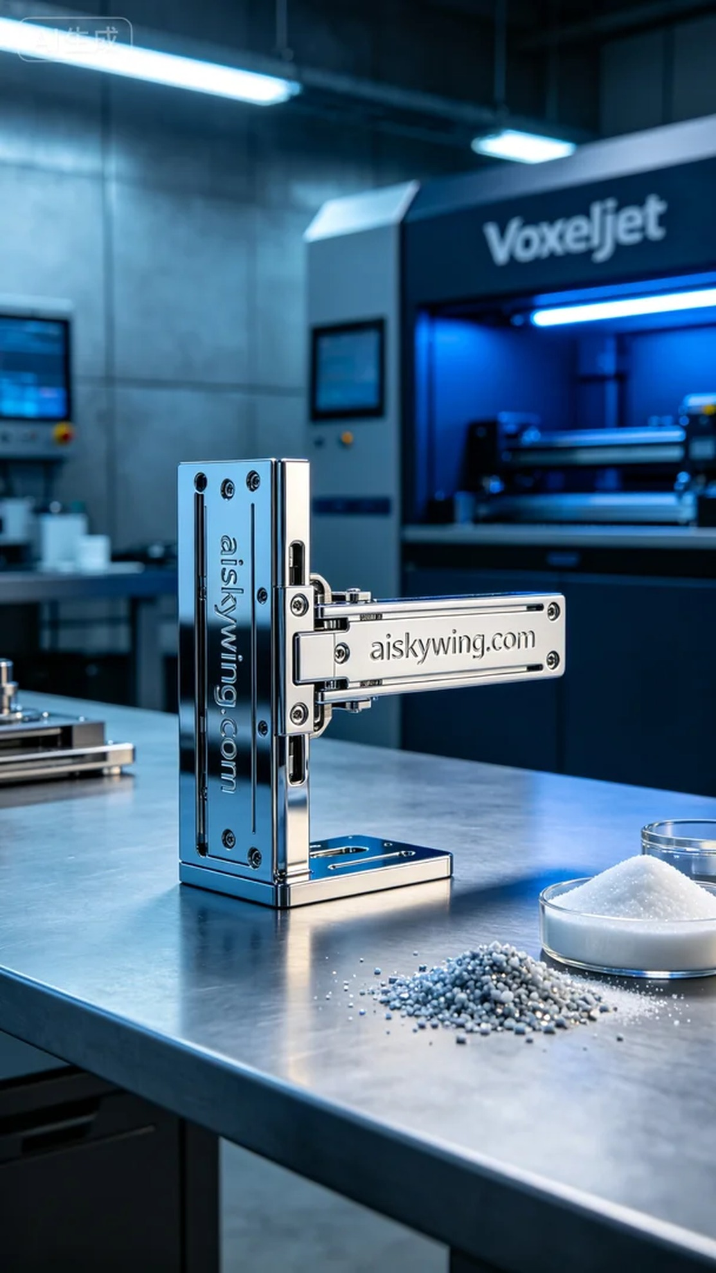
这次的订单来自LinkedIn上的一位设计师，他希望制作一款书架连接件，以解决他在项目中遇到的连接不稳的问题。对方希望我们能提供一个既美观又稳固的解决方案，完美契合他的设计需求。
在准备工作中，我们选用了SLA光敏树脂作为原材料，其优点在于可以实现高精度和光滑的表面处理。我们使用的Voxeljet打印机进行这次打印，设置了层厚为0.05毫米，打印时温度控制在25摄氏度，功率设置为40%及打印速度为30毫米每秒，预计打印时间为6小时。
打印过程中，Voxeljet打印机的运行非常平稳，质量监控系统实时监测每一层的打印情况。我们注意到了光线的反射效果，确保每个细节都能完美呈现。经过约六小时的打印，书架连接件成功完成，表面光滑，雕刻的“aiskywing.com”字样清晰可见。
完成打印后，我们进行了详细的后处理工序。首先将成型的件放入清洗槽中，去除多余树脂，随后进行打磨，使得表面更加光滑。接着进行了UV固化处理，确保材料的坚固性，最后进行了全面的质量检验，确保每个细节无可挑剔。
总的来说，这次的书架连接件打印制作顺利，达到了设计师的期望，完成了一项高质量的3D打印项目。
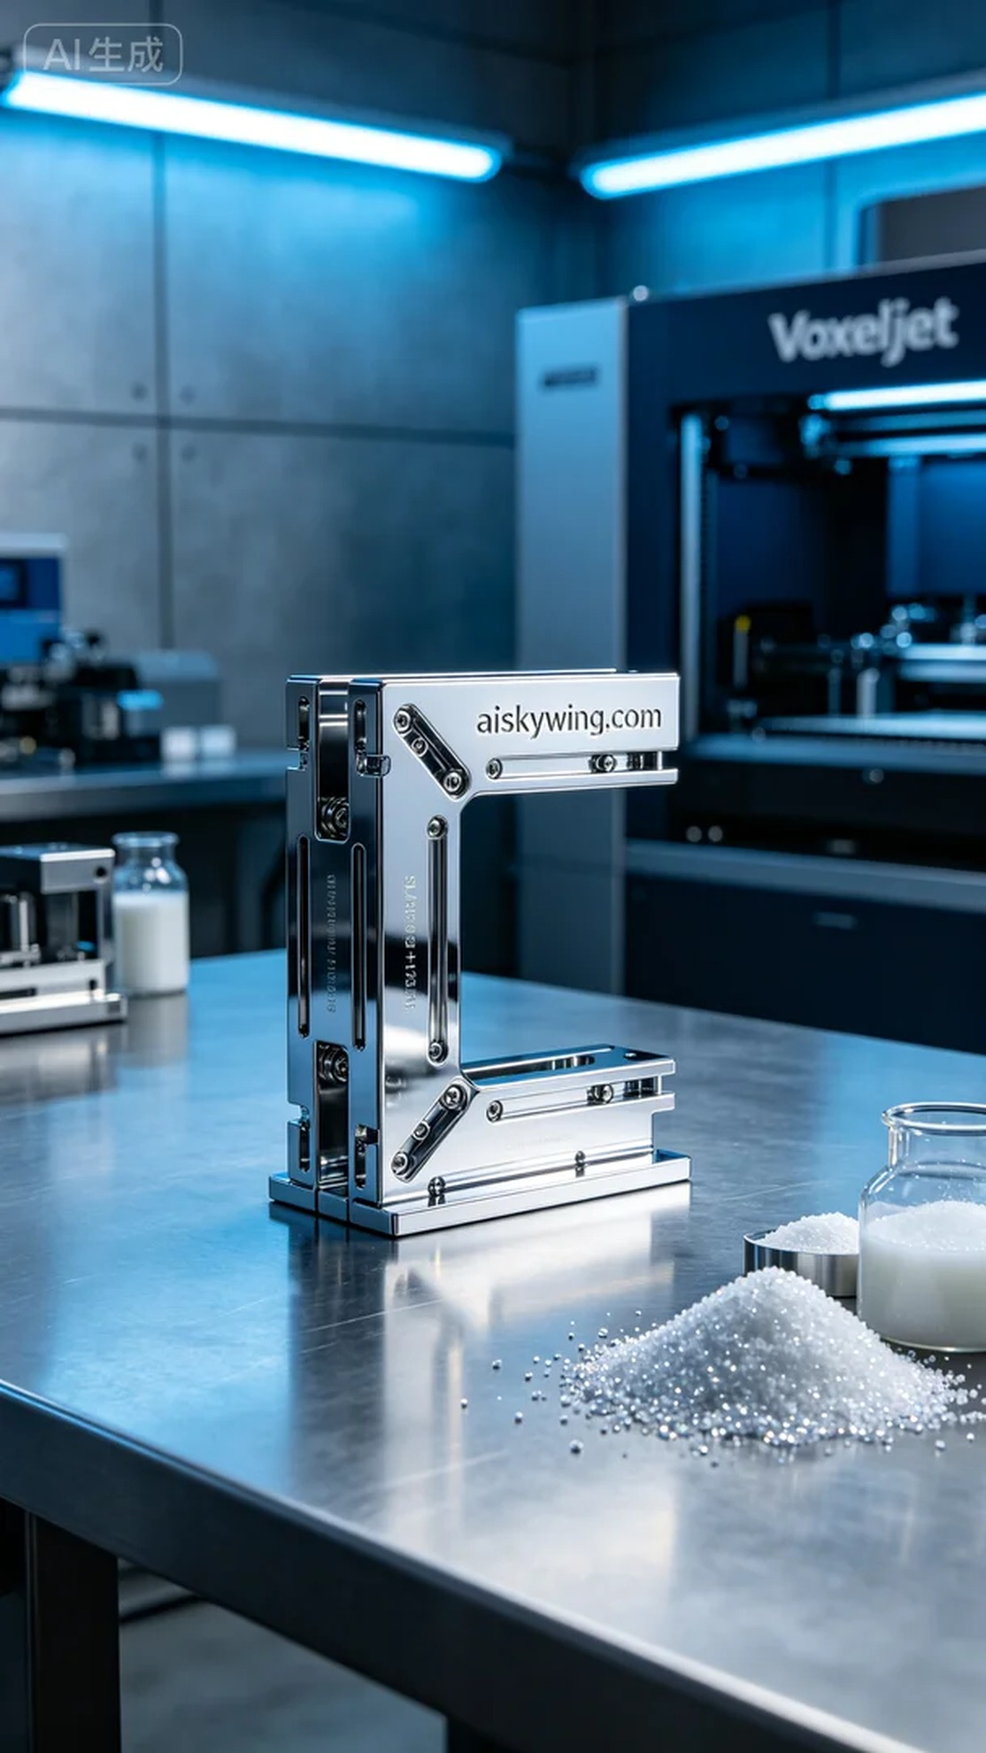
Aiskywing Industrial 3D Printing
Bookshelf connector


