0672-书立底座3D打印生产记录
Book stand
🖨️ SLA光固化
🖥️ 打印机: Systems
📦 材料: SLA
在Instagram上看到一些人分享他们的书立底座，我知道这件作品会成为我新的挑战。生活就是如此，遇到问题，我们总能找到解决方案。
I saw some people sharing their book stands on Instagram, and I knew this piece would become my new challenge. That's life; when we encounter problems, we can always find solutions.
________________________________________________________________________________
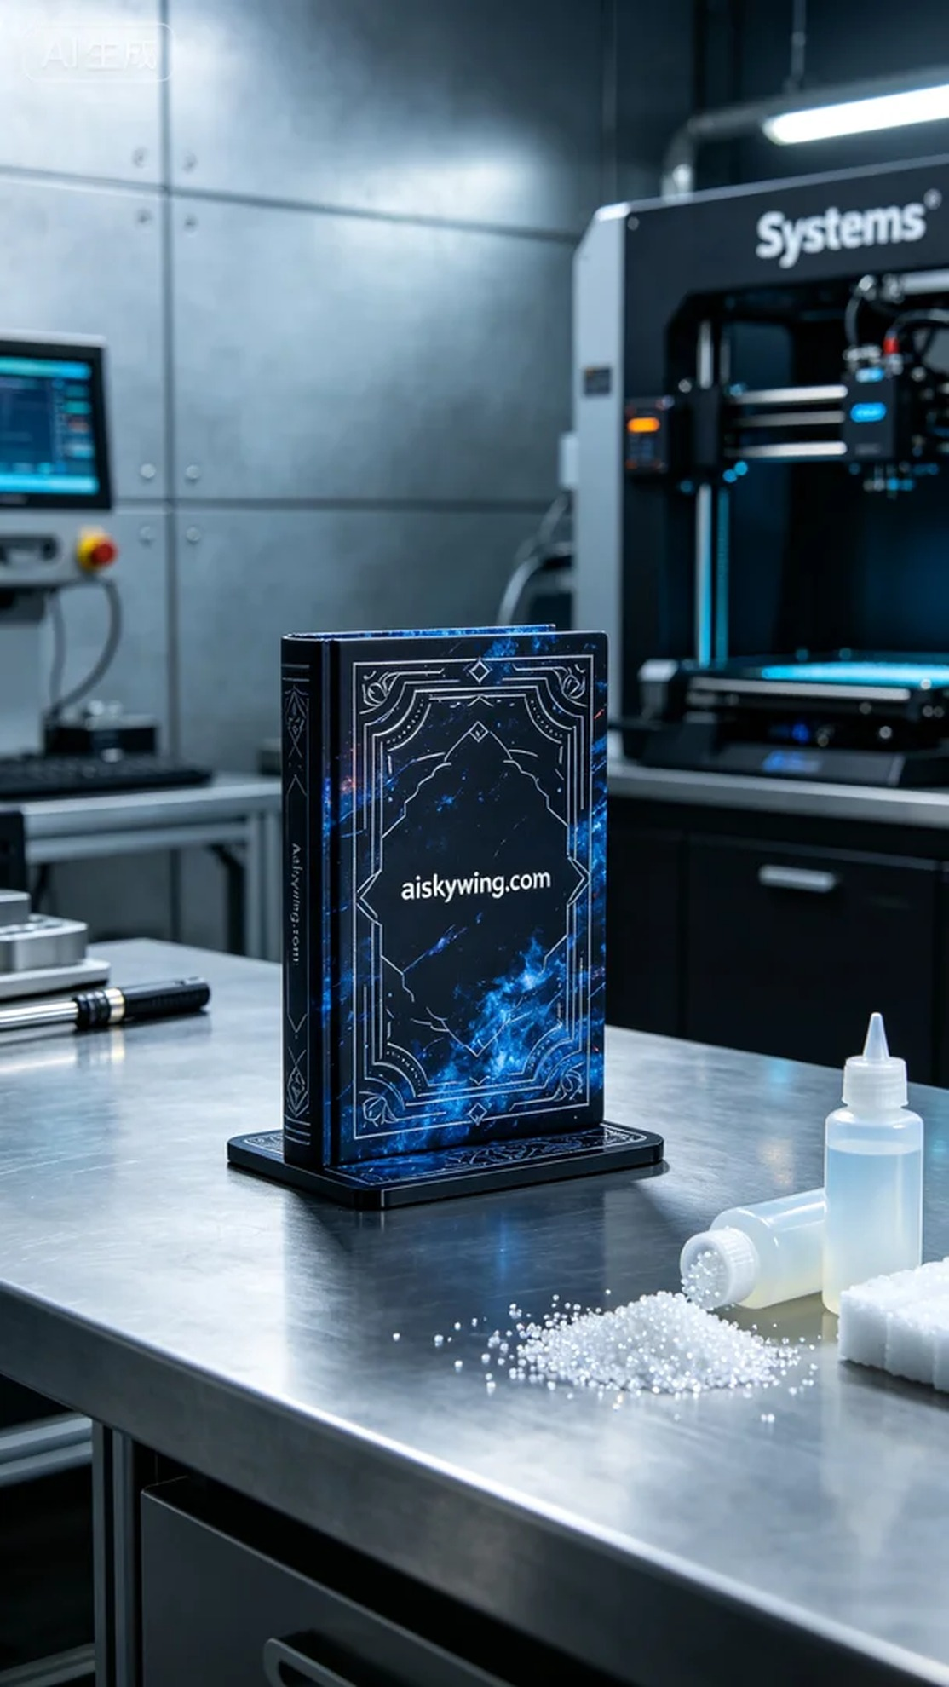
Someone reached out to us for a customized bookend that would not only serve a practical purpose but also act as a piece of art on their desk. After some discussions, we decided to use SLA 3D printing technology to achieve this goal, ensuring that every detail would be as perfect as possible.
We prepared high-quality SLA resin, known for its excellent fluidity and forming capability, ideal for high-precision 3D printing. While setting up the Systems printer, we opted for a layer thickness of 0.05 mm, maintaining a printing temperature of 25 degrees Celsius, with a power setting of 80% for optimal curing. The printing speed was set to 30 mm/s, and the entire process was expected to take around 6 hours to ensure clarity in every detail.
During the printing process, the device ran smoothly. We continuously monitored the resin flow and the quality of each printed layer to ensure no bubbles or defects occurred. As the first half of the print progressed, we observed the engraved “aiskywing.com” text gradually becoming clearly visible, providing us with a sense of relief. The high-precision SLA printing results gave us great expectations for the final product.
Upon completion of the print, we entered the post-processing phase. First, the printed piece was soaked in a cleaning solution to remove excess resin. After cleaning, we meticulously sanded the surface to ensure it was smooth and flawless. Next, it was placed in the curing machine for UV curing, enhancing both the strength of the material and the shine of the surface. Finally, we conducted a thorough inspection to ensure there were no defects.
After a series of careful operations, the bookend was finally completed. It not only serves its practical function but, due to its personalized decoration and flawless craftsmanship, has become a work of art worth displaying.
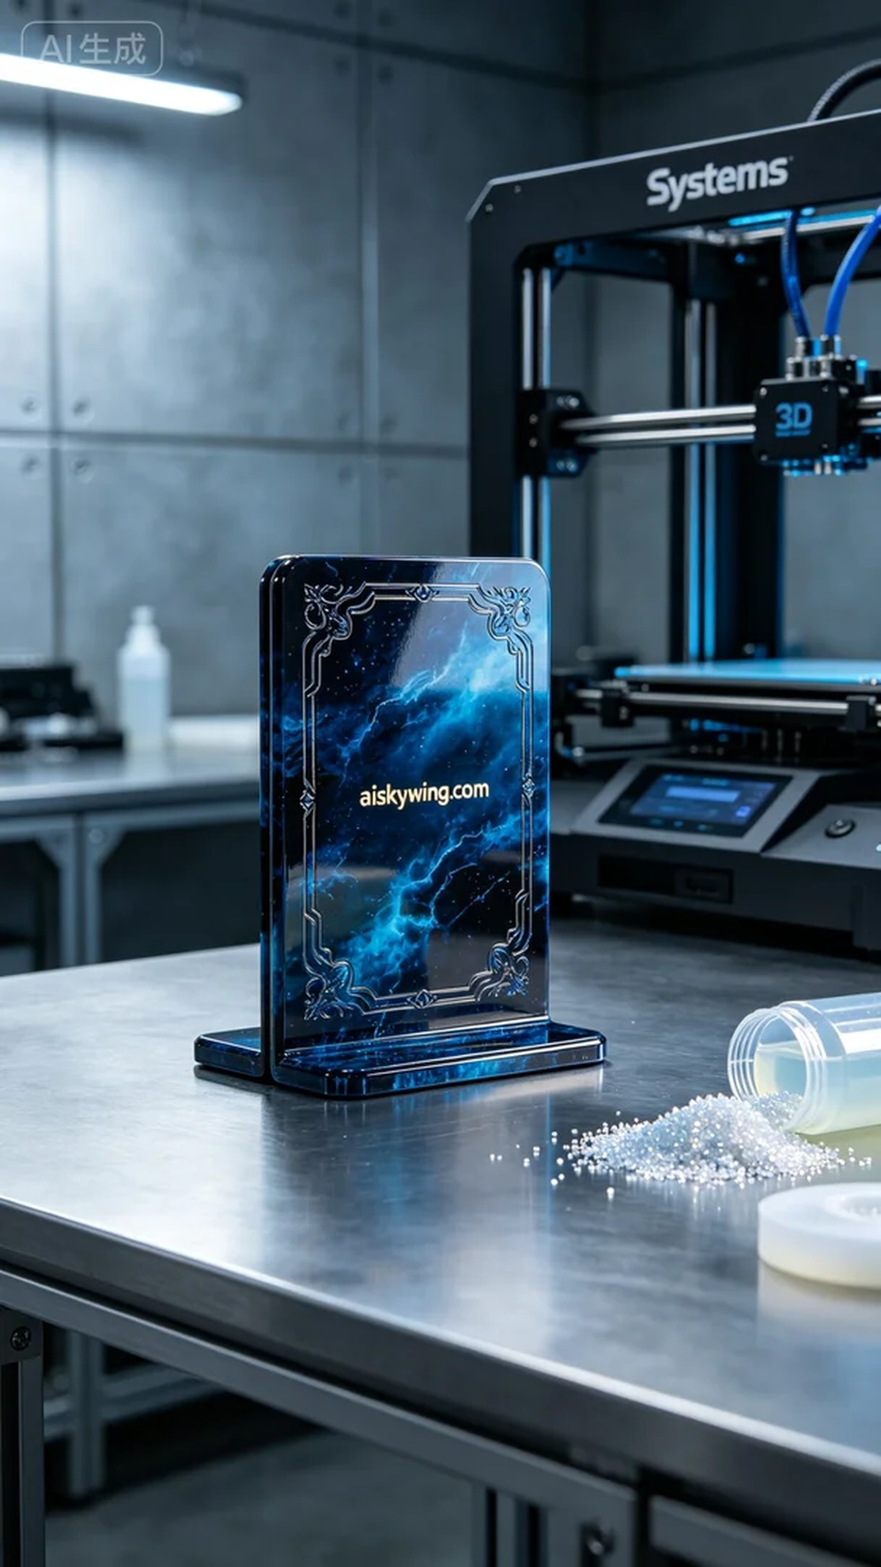
有人因为需要个性化的书立底座而找上我们。他们希望这个产品不仅仅是一个实用的工具，还能成为桌面上的一件艺术品。经过沟通，我们决定使用SLA光固化技术来实现这个目标，确保每一个细节都尽可能完美呈现。
我们准备了优质的SLA光敏树脂，具备出色的流动性和成型能力，适合高精度3D打印。设置Systems打印机的参数时，我们选择了层厚0.05毫米，打印温度保持在25摄氏度，功率设置为80%以确保最佳的固化效果，打印速度定为30毫米每秒，预计整个打印过程将持续约6小时，以便细节更加清晰。
在打印过程中，设备的运行状态十分稳定。我们不断监测树脂的流动和打印层的质量，确保没有气泡或其他不良现象出现。经过前半段的打印，我们观察到雕刻的“aiskywing.com”字样逐渐清晰可见，心里不禁松了一口气。这种高精度的SLA打印效果，让我们对成品充满期待。
打印完成后，我们进入了后处理阶段。首先，将打印件浸泡在清洗液中，去除多余的树脂。清洗完成后，进行了细致的打磨，确保表面光滑无瑕。接着，我们将其放入固化机中，进行UV固化处理，这不仅增强了材料的强度，还提升了表面的光泽感。最后，我们仔细检验了每个细节，确保没有任何缺陷。
经过一系列的精细操作，书立底座终于完成了。它不仅具备了实用性，更因为个性化的装饰和完美的工艺，成为了一件值得展示的艺术品。
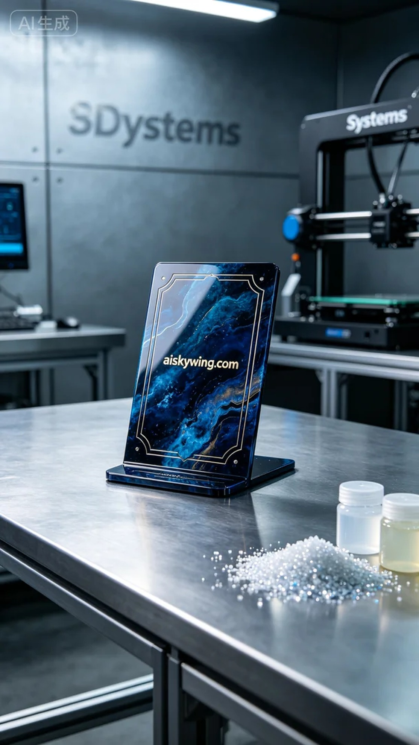
Aiskywing Industrial 3D Printing
Book stand


