0673-储物箱垫脚的3D打印过程记录
Storage box foot pad
🖨️ SLA光固化
🖥️ 打印机: Mimaki
📦 材料: SLA
在Instagram上，有人因为缺乏一个合适的储物方案而找到我们。正是这个储物箱垫脚，让我们在细节中展现出专业和用心。
On Instagram, someone reached out to us due to a lack of a suitable storage solution. It is this storage box that showcases our professionalism and attention to detail.
________________________________________________________________________________
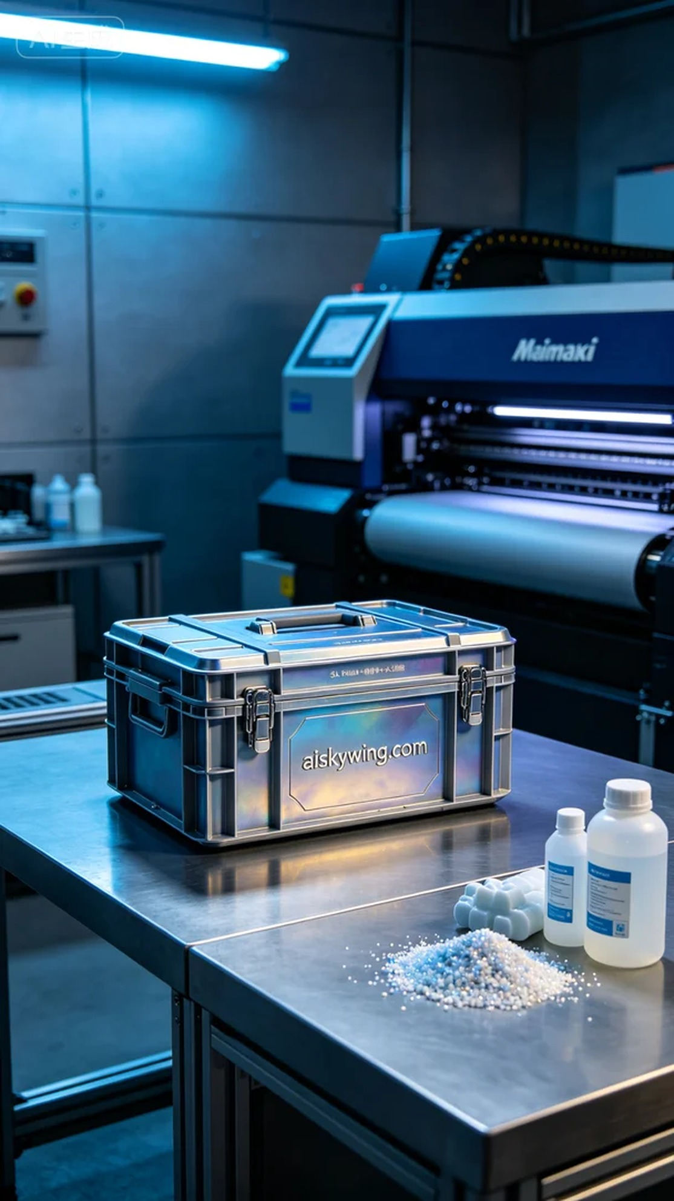
Recently, someone approached us via Instagram, seeking a practical storage solution for their industrial workspace. We created a customized storage box foot to provide a neat and convenient way to store small items. This product is not only functional but also showcases unique aesthetics through personalized design.
For this project, we opted for SLA (Stereolithography) printing using high-quality SLA resin. To ensure the best printing results, we set the parameters to a layer thickness of 0.1mm, maintained the temperature at 25°C, and adjusted the power to 50%. The printing speed was set at 40 mm per second, with an estimated total print time of about 6 hours. We conducted multiple adjustments to the parameters to guarantee that every detail would be perfectly captured.
During the printing process, the Mimaki 3D printer operated steadily, with the resin being precisely dispensed layer by layer. We continuously monitored the print quality to avoid air bubbles or defects, and the machine’s real-time feedback kept us informed about the printing progress.
Once printing was complete, the post-processing steps became critical. First, we immersed the printed piece in a cleaning solution to thoroughly remove any residual resin. After that, we meticulously sanded it down to ensure a smooth surface. The piece was then placed in a UV curing machine to harden, enhancing its strength and durability. Finally, we conducted a comprehensive inspection to ensure every detail met our quality standards.
In the end, this storage box foot not only addressed the user's practical needs but also demonstrated our expertise in the 3D printing field. Each production experience feels rewarding, pushing us to improve with every detail.
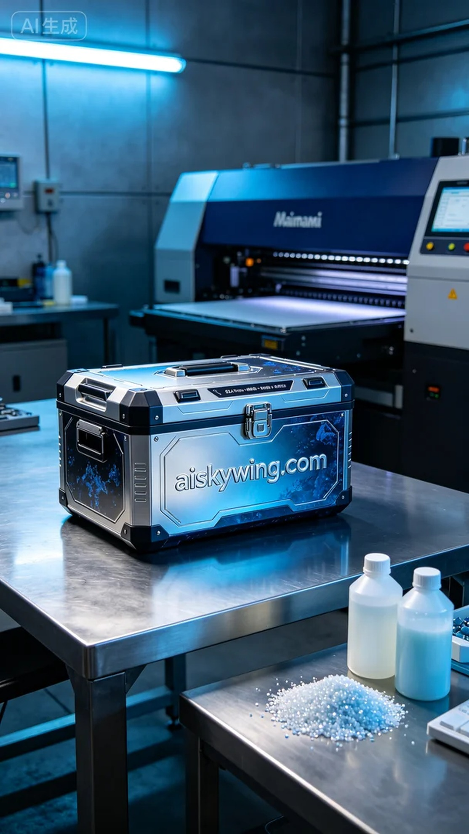
这次的项目是为了解决有人在使用工业桌面时所面临的储物问题，特别是存放小物件的需求。我们为他们定制了一款储物箱垫脚，旨在提供一个更为整洁和方便的存储解决方案。这个产品不仅实用，还能通过个性化定制在外观上展现独特风格。
我们选择了SLA光固化工艺，使用的材料是高质量的SLA光敏树脂。为确保打印效果，设备设置为层厚0.1毫米，温度控制在25℃，功率调整到50%。打印速度设定在40毫米每秒，整个打印过程预计耗时约6小时。为了确保每个细节都完美呈现，我们还进行了多次参数调试。
在打印过程中，Mimaki品牌的3D打印机始终稳定运行，喷头喷射的树脂均匀细腻，使得每一层都能精准叠加。我们持续监控打印质量，确保没有出现任何气泡或瑕疵，同时，机器的实时反馈也使我们对打印进程了如指掌。
完成打印后，后处理工序是至关重要的一环。首先，我们将打印件放入清洗槽中，使用专门的清洗溶剂彻底清除表面的残留树脂。接着，经过细致的打磨，确保表面光滑无瑕。然后，将其放置在UV固化设备中进行固化，确保打印件的强度和耐用性。最后，进行全面的检验，确保每个细节都符合品质标准。
最终，这个储物箱垫脚不仅解决了使用者的实际需求，也展示了我们在3D打印领域的专业能力。每一次的制作都让人感受到成就，让我们在细节中不断进步。
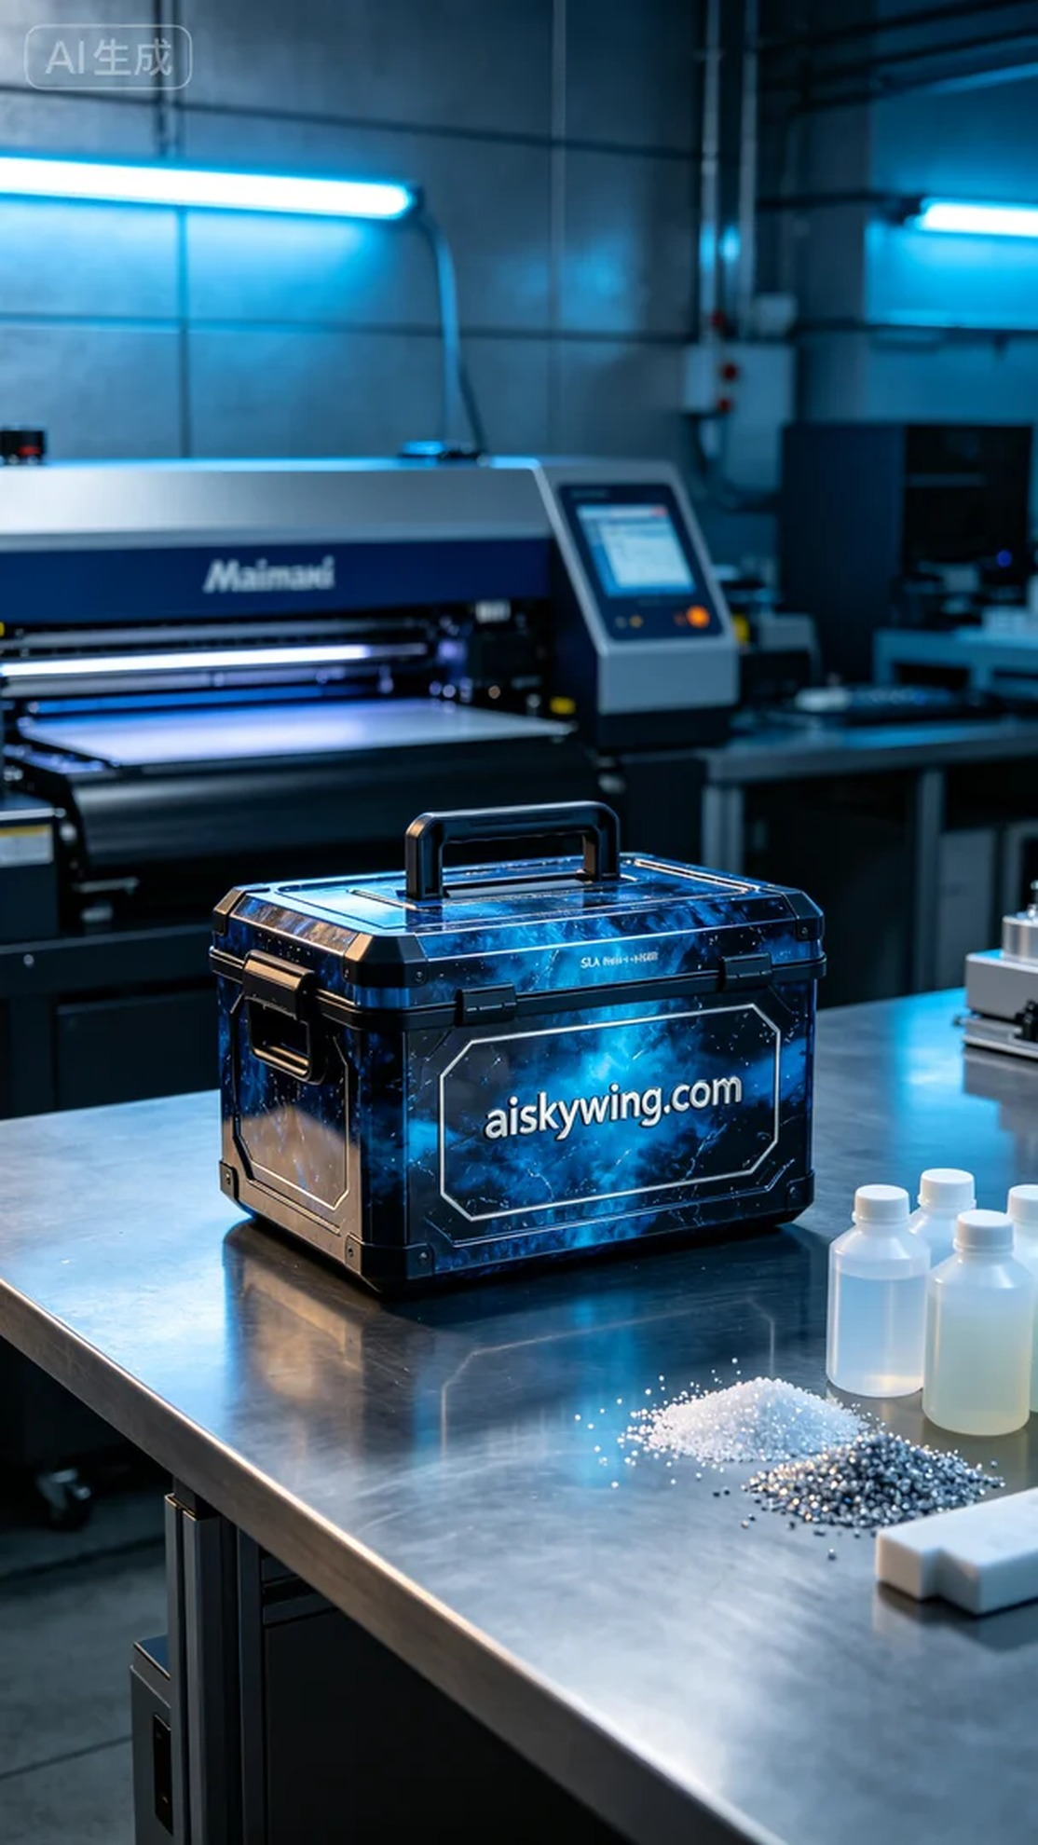
Aiskywing Industrial 3D Printing
Storage box foot pad


