0674-储物箱提手的3D打印记录
Storage box handle
🖨️ SLA光固化
🖥️ 打印机: Systems
📦 材料: SLA
生活就像一场3D打印的旅程，总有些人因问题而寻找帮助。最近，有人因为急需一个储物箱提手而联系了我们。
Life is like a journey of 3D printing, where some people seek help due to problems. Recently, someone reached out to us because they urgently needed a handle for a storage box.
________________________________________________________________________________
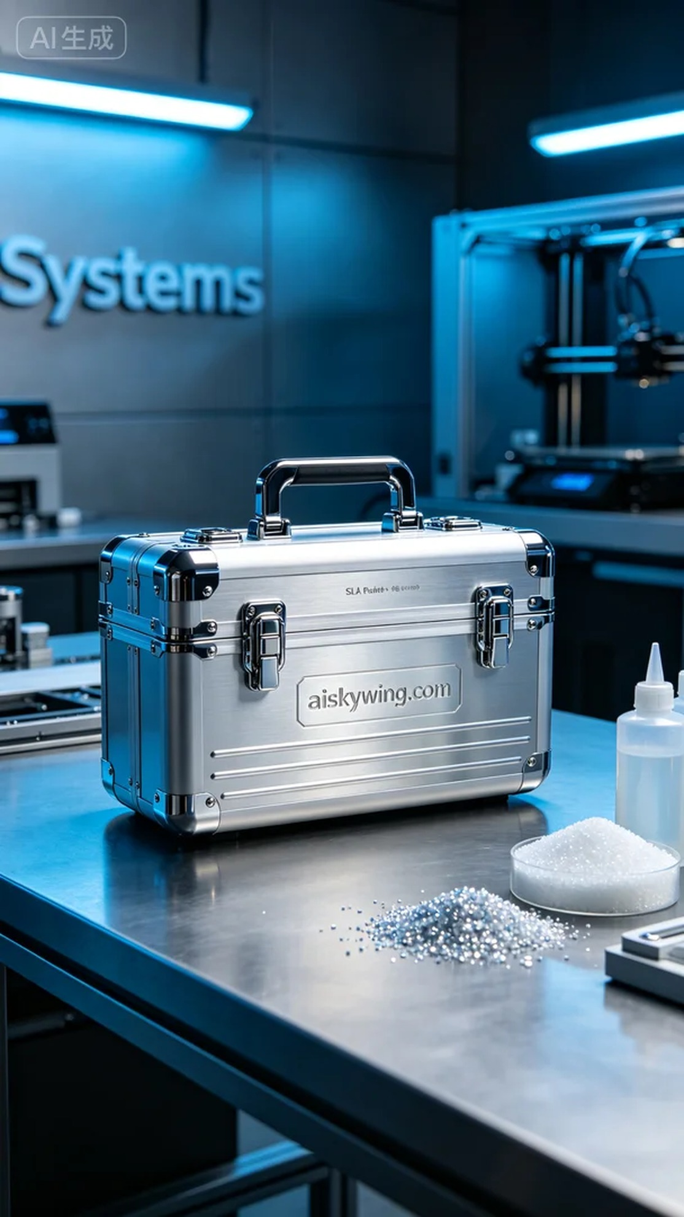
Life is like a 3D printing journey; there are always those who seek help with their problems. Recently, someone reached out to us in need of a storage box handle.
In terms of materials, we selected high-quality liquid photopolymer resin, known for its excellent detail and smooth surface. The Systems printer we used was set with parameters of a layer thickness of 0.05 mm, a printing temperature of 25 degrees Celsius, and a power setting of 80%. The printing speed was maintained at 50 mm per hour, with an estimated print time of 4 hours.
As the printing process began, the Systems printer operated smoothly, with the liquid resin curing layer by layer under UV light. We monitored the print quality throughout, keeping an eye out for any layer misalignment or bubbles to ensure perfect adhesion for each layer.
Once printed, we moved into the post-processing stage. We first submerged the printed part in cleaning solution to remove uncured resin from the surface, then sanded it with fine sandpaper for a smooth finish. Next, we placed it in a curing chamber to ensure even light exposure to every corner, and finally inspected it to confirm that the shape and dimensions met our requirements.
In the end, this storage box handle was successfully printed, achieving the expected quality and aesthetics, providing a solution for someone in need. We look forward to creating more high-quality 3D printed works in the future.
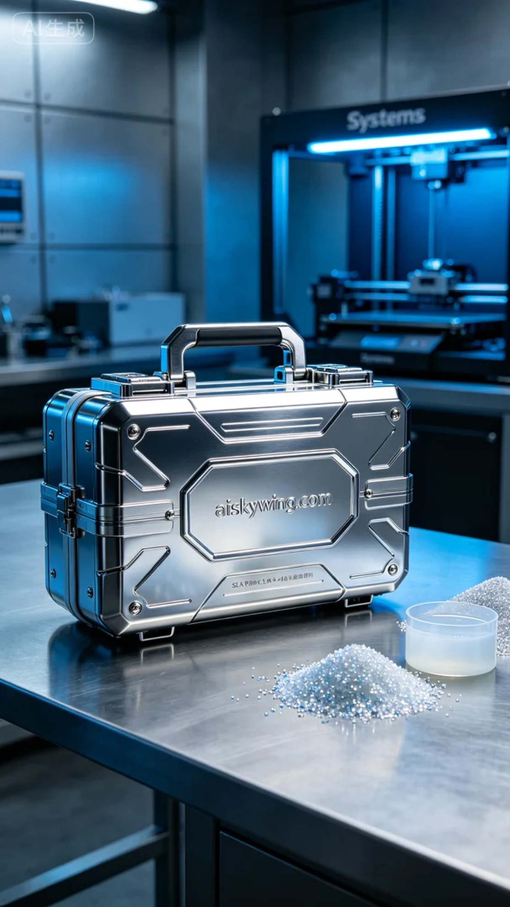
在Twitter上，有人因为急需一个储物箱提手而找到我们，表示希望能快速生产出一款既耐用又美观的产品。经过沟通，我们决定采用SLA光固化技术来实现这个需求。
原材料方面，我们选择了高品质的液态光敏树脂，具备优良的细节表现和表面光滑度。使用的Systems打印机，设置参数为：层厚0.05毫米，打印温度保持在25摄氏度，功率设置为80%。打印速度保持在每小时50毫米，预计打印时间为4小时。
打印过程开始后，Systems打印机平稳运行，液态树脂在紫外光的照射下逐层固化。我们全程监控打印质量，注意观察是否出现任何层次偏移或气泡，确保每一层都能完美贴合。
打印完成后，进入后处理阶段。我们首先将打印成品浸泡在清洗液中，清除表面未固化的树脂，然后使用细砂纸进行打磨，确保表面光滑。接着，将其放入固化箱中进行光固化，确保每一个角落都能得到均匀的光照，最后经过检验，确认形状和尺寸都符合要求。
最终，这个储物箱提手成功打印完成，质量和美观度都达到了预期，为有人解决了实际问题。期待在未来的日子里继续做出更多优质的3D打印作品。
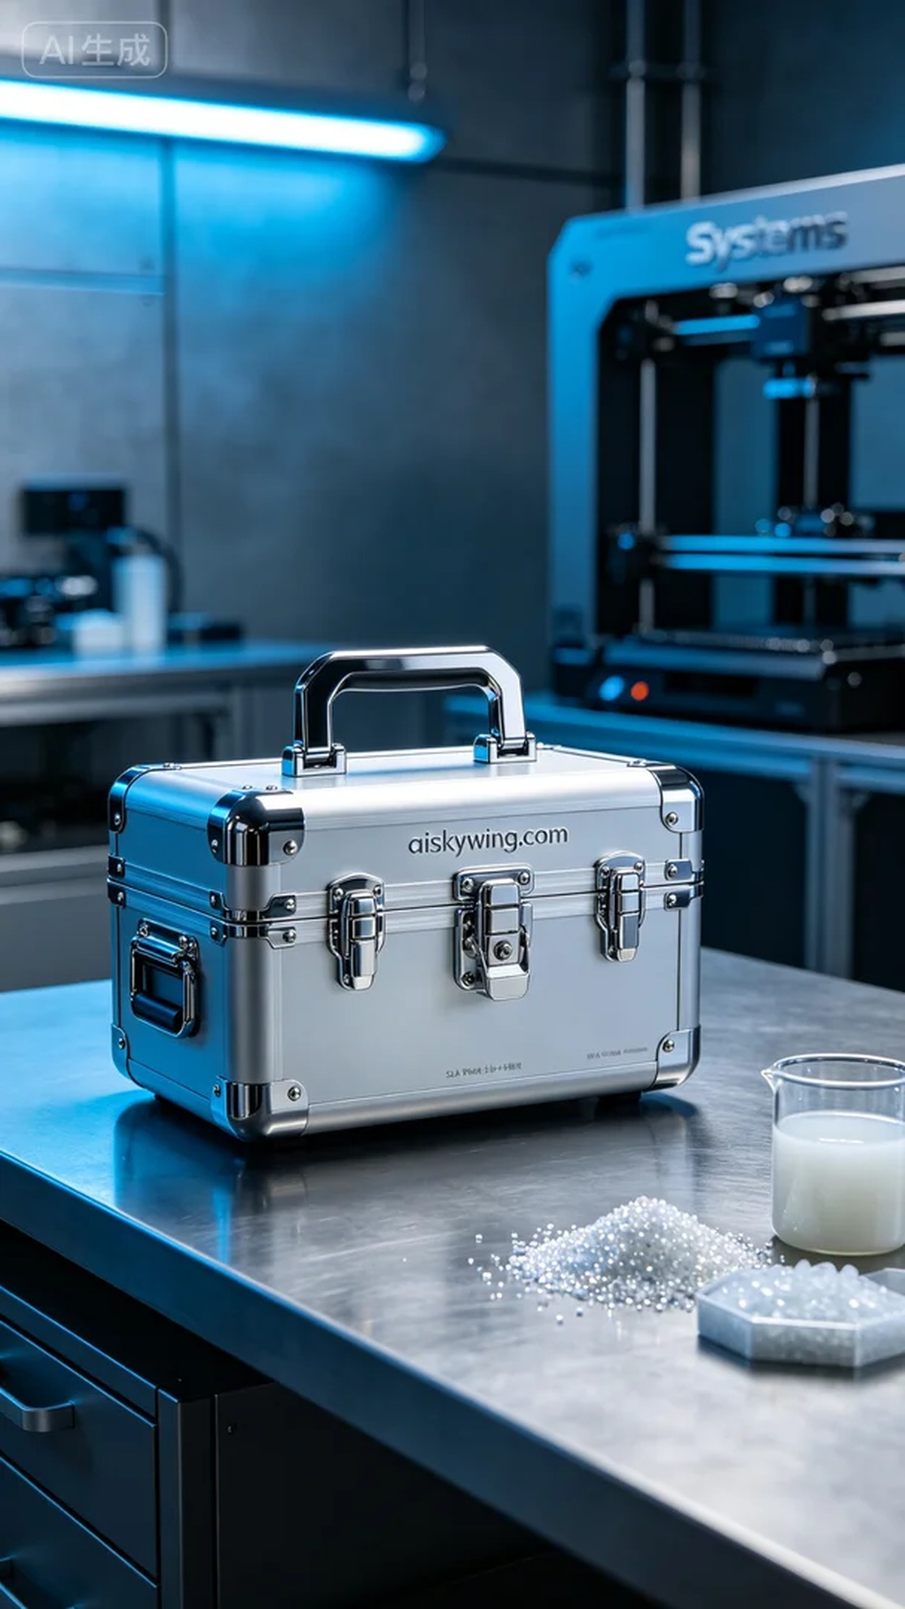
Aiskywing Industrial 3D Printing
Storage box handle


