0675-储物箱铰链3D打印生产记录
Storage box hinge
🖨️ SLM金属打印
🖥️ 打印机: EOS
📦 材料: 摆放着未成型的液态光敏
在YouTube上，有人因储物箱铰链的设计需求找上我们。生活中的每一次挑战，都是我们提升技术的机会。
On YouTube, someone approached us with a design requirement for a storage box hinge. Every challenge in life is an opportunity for us to enhance our technology.
________________________________________________________________________________
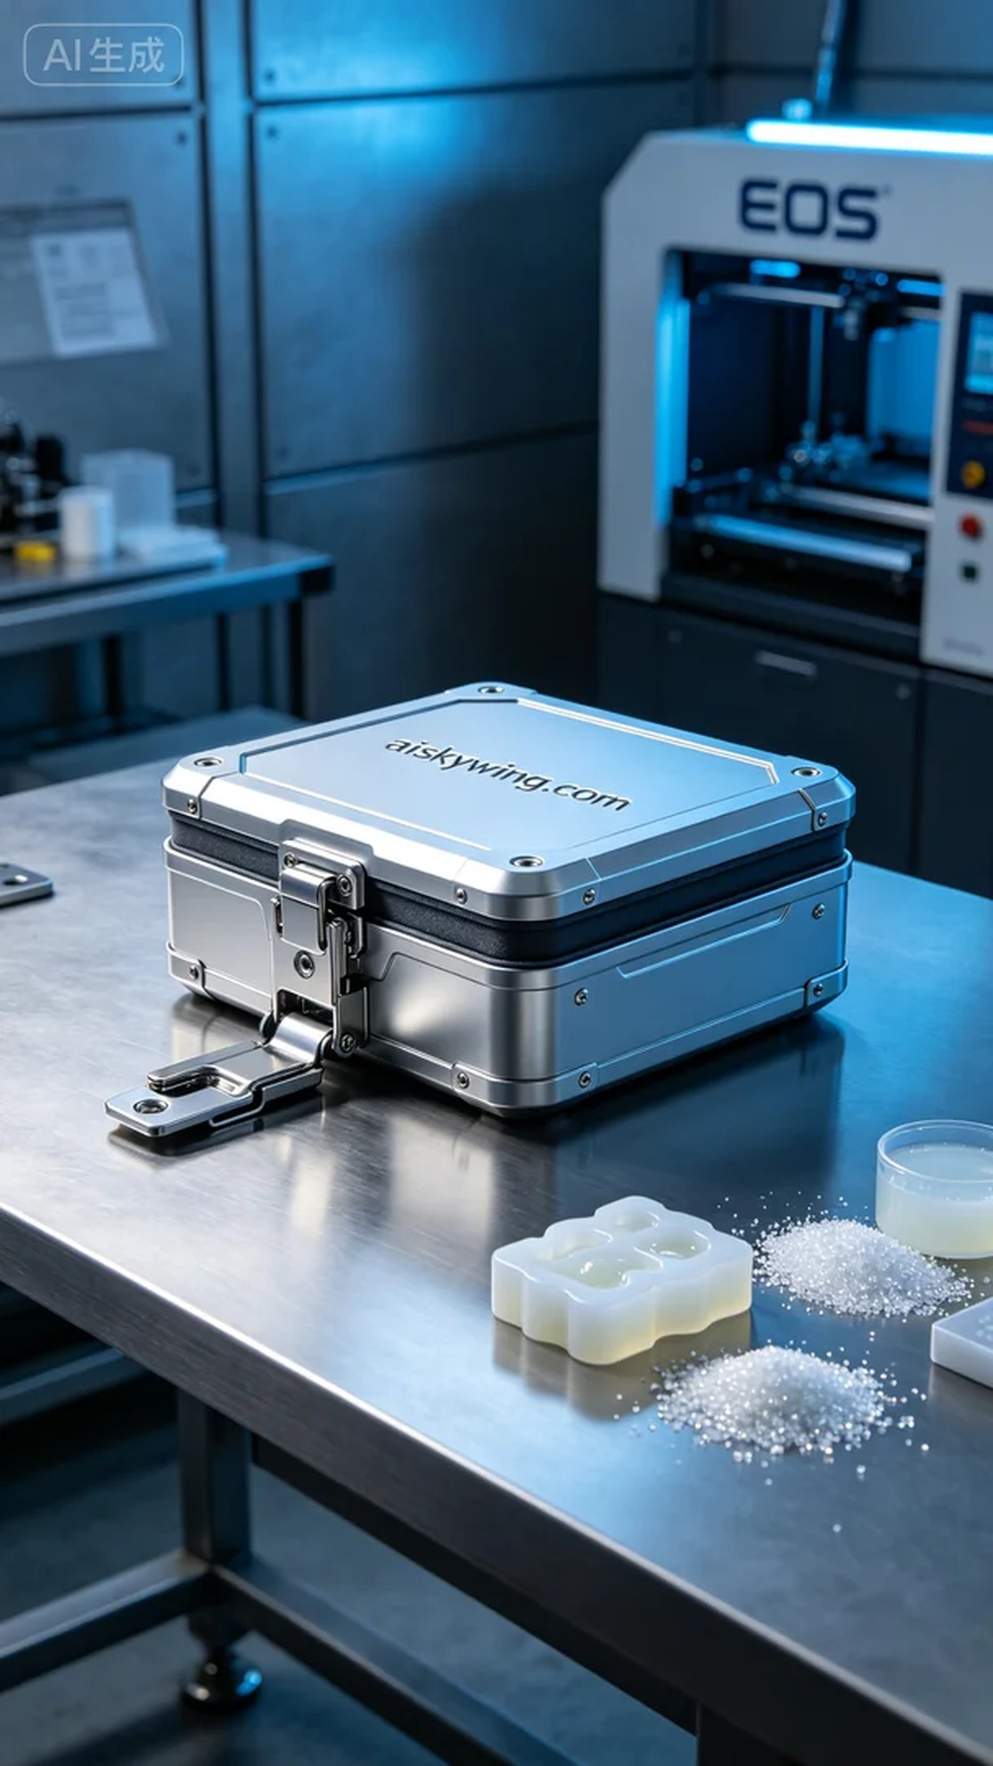
Recently, we took on an interesting project to produce a storage box hinge. The person who approached us expressed a need for a hinge that would be not only durable but also aesthetically representative of industrial design. Thus, we began this task.
To ensure the quality and durability of the hinge, we opted to use unformed liquid photopolymer resin as the raw material, with the EOS 3D printer playing a crucial role. We set the printing parameters: layer thickness of 50 microns, temperature at 25°C, power adjusted to 85%, printing speed at 30mm/s, and an expected printing time of 8 hours.
As the printing process commenced, the EOS printer operated smoothly. The liquid photopolymer resin solidified layer by layer under UV light, forming precise hinge components. We monitored the machine's operation throughout, ensuring each layer fused perfectly and avoiding any defects. After several hours of continuous printing, the outline of the hinge finally emerged.
Once printing was complete, we moved on to the post-processing phase. We first cleaned the hinge using specialized equipment to remove any uncured resin. Then, we polished the surface to ensure it was smooth. Finally, we placed the hinge into a curing machine, exposing it to UV light for a set amount of time to ensure its strength met our expectations. After all these steps, we conducted a thorough inspection of the finished product to ensure it met our standards.
In the end, the storage box hinge gleamed with a stark metallic sheen under the sunlight, fully showcasing the beauty of industrial design. Every step was crucial, and it is these details that keep us at the forefront of the industry.
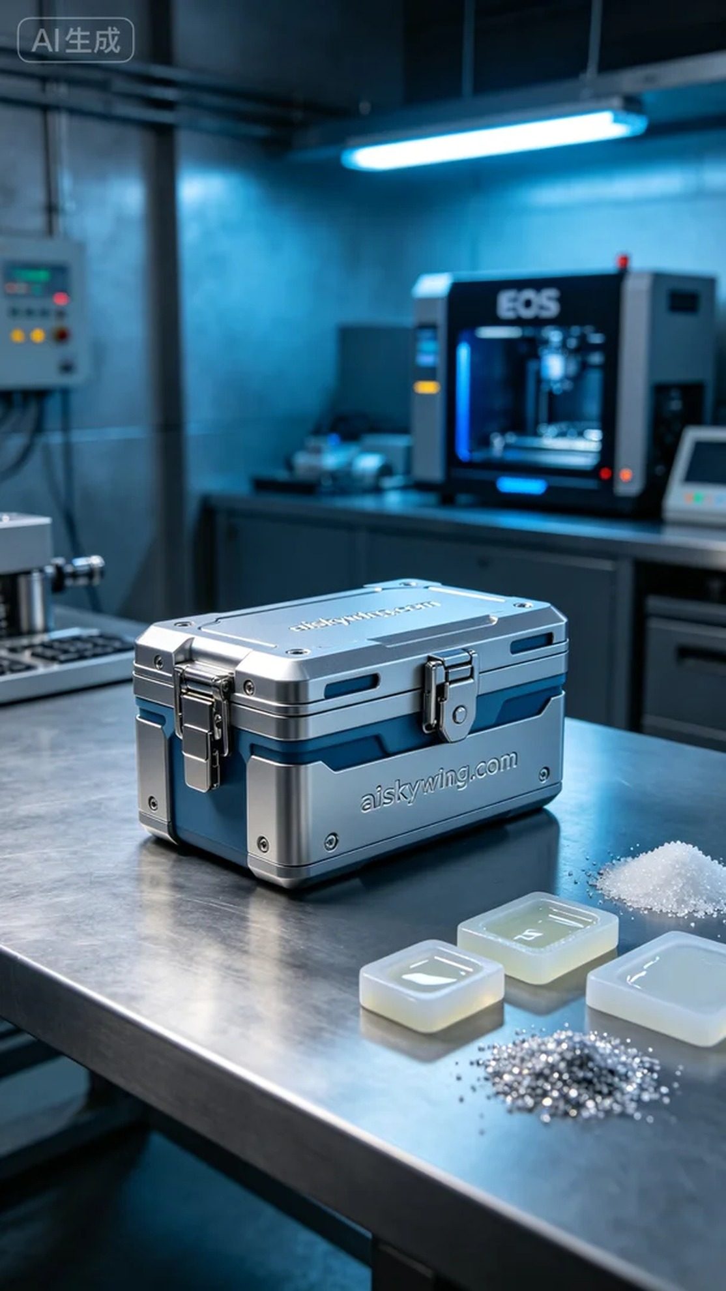
我们最近接到一个有趣的项目，需求是制作一个储物箱铰链。这位找我们的人表示，希望这个铰链不仅要坚固耐用，还要在外观上能体现出工业风的美感。于是，我们开始了这项工作。
为了确保铰链的质量和耐久性，我们选择了使用未成型的液态光敏树脂作为原材料，经过精心调试的EOS 3D打印机将发挥重要作用。我们设置了打印参数：层厚为50微米，温度保持在25°C，功率调整至85%，打印速度为30mm/s，预计打印时间为8小时。
打印过程开始后，EOS打印机运转得非常平稳。液态光敏树脂在紫外线照射下逐层固化，形成了一个个精准的铰链部件。我们全程监控设备的运行状态，确保每一层都能够完美融合，避免出现任何缺陷。经过几个小时的持续打印，铰链的雏形终于显现出来。
在打印完成后，我们进入了后处理环节。首先对铰链进行清洗，使用专门的清洗设备，将未固化的树脂彻底清除。接着通过打磨处理，确保表面光滑。最后，将铰链放入固化机中，经过一定时间的紫外线照射，确保其强度达到预期标准。所有工序完成后，我们对成品进行了严格检验，确保符合我们的标准。
最终，这个储物箱铰链在阳光下闪耀着金属的冷峻光泽，充分展现了工业设计的美感。每一个环节都不容忽视，正是这些细节让我们在行业中立于不败之地。
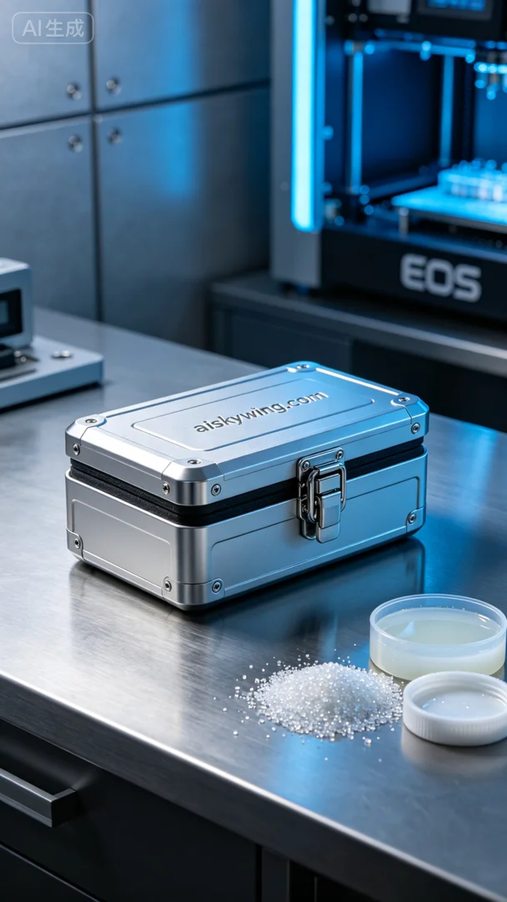
Aiskywing Industrial 3D Printing
Storage box hinge


