0676-储物箱锁扣的3D打印日记
Storage box latch
🖨️ SLS尼龙烧结
🖥️ 打印机: Mimaki
📦 材料: 摆放着未成型的液态光敏
生活就像3D打印一样，需要耐心和精确。最近，有人通过Instagram找到了我们，想定制一个储物箱锁扣来解决他们的存储问题。
Life is like 3D printing; it requires patience and precision. Recently, someone found us through Instagram and wanted to customize a storage box latch to solve their storage problem.
________________________________________________________________________________
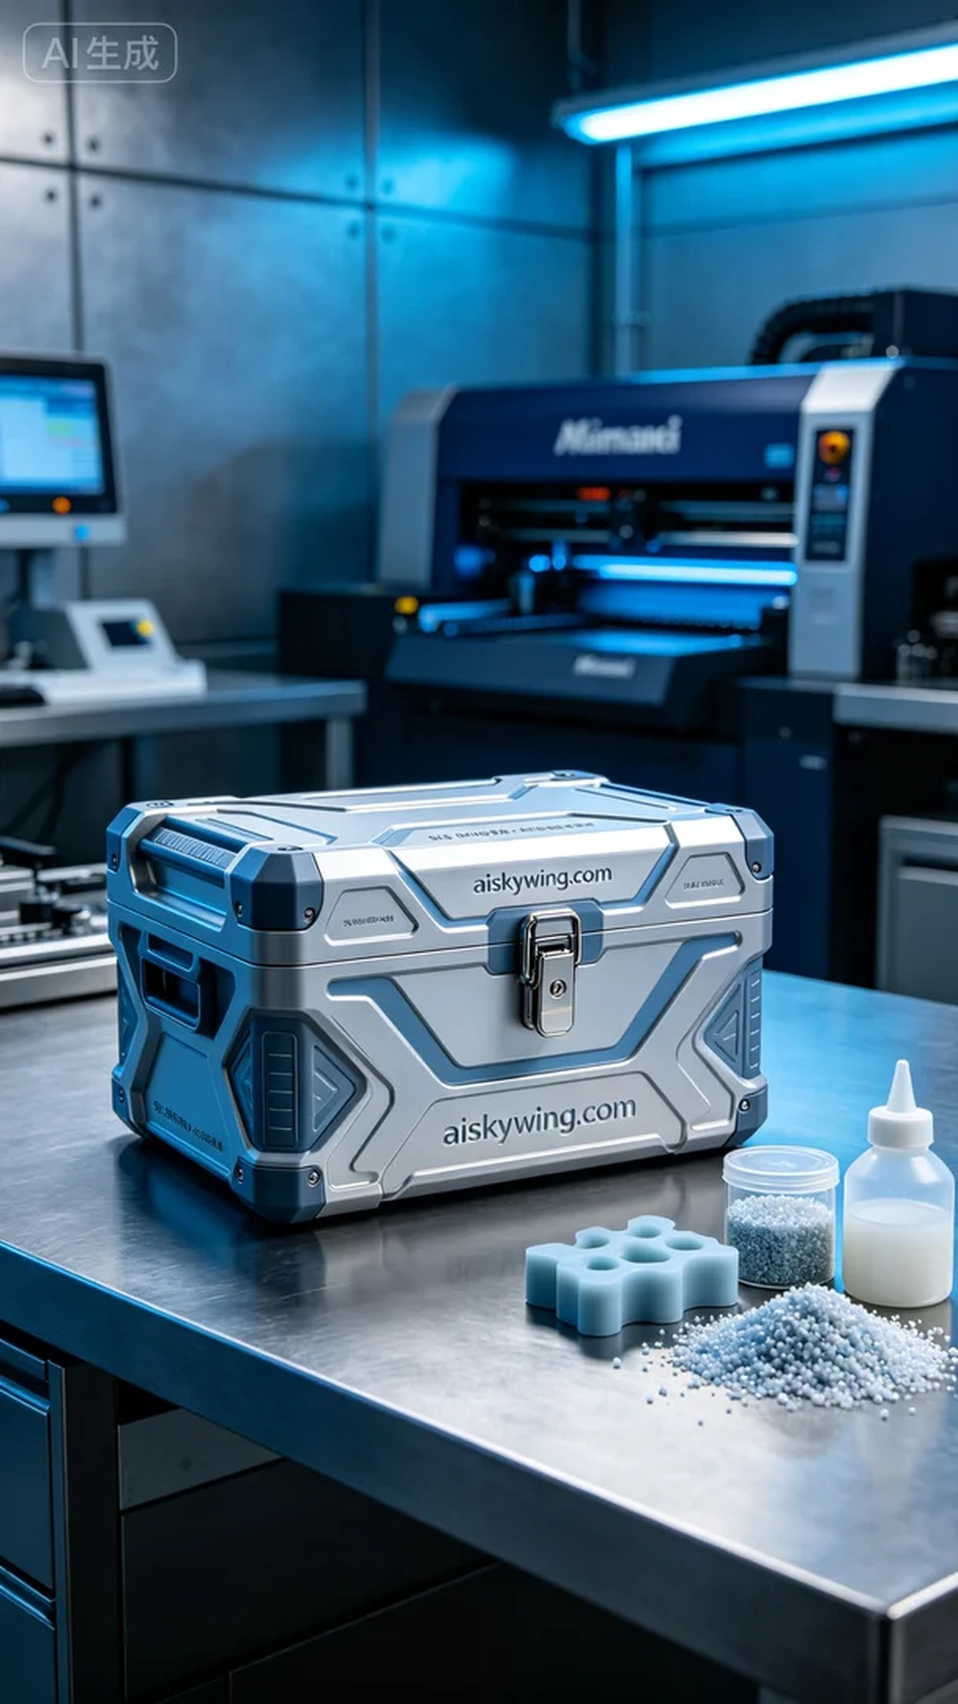
Life is like 3D printing, requiring patience and precision. Recently, someone reached out to us through Instagram, looking for a high-quality storage box latch to solve their storage issues.
For this project, we chose unformed liquid photopolymer resin as our material, which exhibits excellent fluidity and detail. We utilized the Mimaki 3D printer, setting the layer thickness to 0.1mm, temperature at 25 degrees Celsius, power at 100W, and speed at 30mm per second, with an expected printing time of 4 hours.
During the printing process, the Mimaki equipment ran steadily, and we monitored the quality in real-time to ensure every detail was perfectly presented. As the printing progressed, the latch's shape gradually appeared, with its streamlined design making the product look both modern and practical.
After printing, we moved on to the post-processing steps. First, we cleaned the latch by soaking it in a cleaning solution to remove excess resin from the surface. Next, we sanded the latch with fine sandpaper to achieve a smoother finish. Finally, we cured it under UV light to ensure the material's strength and stability, passing strict inspections to ensure the final product met expectations.
In summary, this storage box latch project was a success, fulfilling the requirements and showcasing the charm of 3D printing technology. We look forward to the next challenge coming our way.
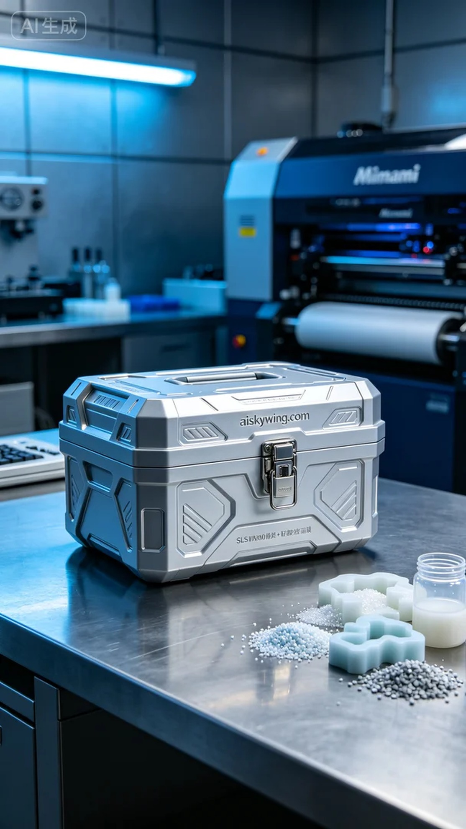
这次的工作源自于有人在Instagram上寻求帮助，他们想要一个高质量的储物箱锁扣，可以完美契合他们的需求。我们立刻着手设计和准备，确保这款锁扣不仅美观，还能提供良好的使用体验。
原材料方面，我们选择了未成型的液态光敏树脂，这种材料具有优异的流动性和细节表现能力。为了确保打印质量，我们使用Mimaki 3D打印机，设置了层厚0.1毫米，温度控制在25摄氏度，打印功率为100W，速度设定为30毫米每秒。整个打印过程预计需要4小时来完成。
在打印过程中，Mimaki设备稳定运行，我们实时监控打印质量，确保每个细节都能完美呈现。随着打印的进行，锁扣的形状逐渐显现，流线型的设计让整个产品看起来既现代又实用。
打印完成后，我们进入后处理工序。首先是清洗，将打印出来的锁扣在清洗液中浸泡，去除表面的多余树脂；接着是打磨，使用细砂纸对锁扣表面进行打磨，使其更加光滑。最后，进行固化处理，通过紫外线灯照射，确保材料的强度和稳定性。经过严格的检验，最终产品达到预期的标准。
总的来说，这次的储物箱锁扣项目很成功，既满足了需求，又展示了3D打印技术的魅力。我们期待下一次的挑战再度来临。
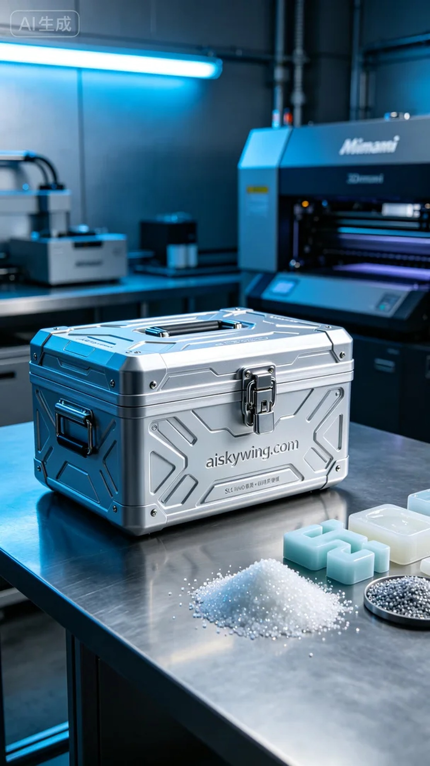
Aiskywing Industrial 3D Printing
Storage box latch


