0677-冰箱门把手的3D打印生产日志
Refrigerator door handle
🖨️ SLM金属打印
🖥️ 打印机: Voxeljet
📦 材料: 摆放着未成型的液态光敏
在TikTok上，有人因为缺少合适的冰箱门把手而苦恼。接到这个单子，我们决心用3D打印技术来解决这个问题。
On TikTok, someone was frustrated due to the lack of a suitable refrigerator door handle. Upon receiving this order, we decided to use 3D printing technology to solve the problem.
________________________________________________________________________________
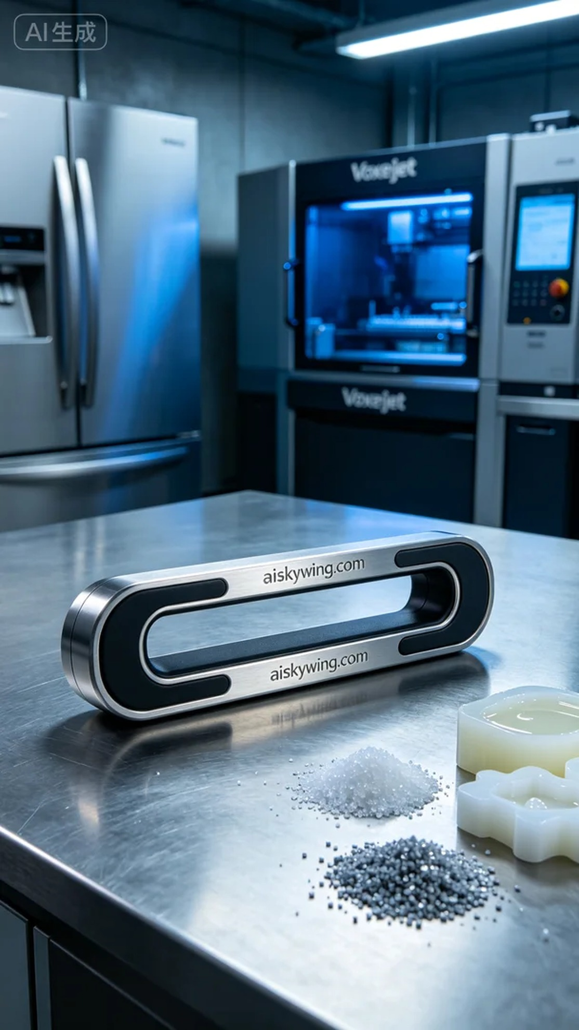
On TikTok, someone expressed their frustration over not having a suitable refrigerator handle. Upon receiving this order, we are determined to solve the issue using 3D printing technology.
To begin, we need to prepare the raw materials. For this production, we are using unformed liquid photopolymer resin, which offers excellent fluidity and photosensitive properties to ensure fine details in the printed output. We have chosen the Voxeljet printer for this 3D printing task due to its renowned precision and reliability.
In terms of printing parameters, we set the layer thickness to 50 microns, maintained a temperature of 25 degrees Celsius, with a laser power of 200 milliwatts and a printing speed of 60 millimeters per second. The entire printing process is expected to take 6 hours, ensuring each layer is accurately formed to showcase the complex structure and intricate textures of the refrigerator handle.
During the printing process, the equipment runs steadily, with cool-toned industrial lighting casting bright and clear shadows on the workbench. We closely monitor the quality of each layer, ensuring there are no bubbles or defects, as the observed details perfectly match the design requirements, filling us with anticipation for the finished product.
After printing, we move into the post-processing phase. First, we clean the printed parts to remove any uncured resin, followed by sanding to ensure a smooth surface. Then, we cure the handle using ultraviolet light, allowing every detail to be fully illuminated, and finally conduct a quality inspection to ensure the refrigerator handle's strength and aesthetics.
After a series of meticulous processes, we have successfully completed this refrigerator handle, combining practicality with a sense of advanced technology, making this a truly satisfying production experience.
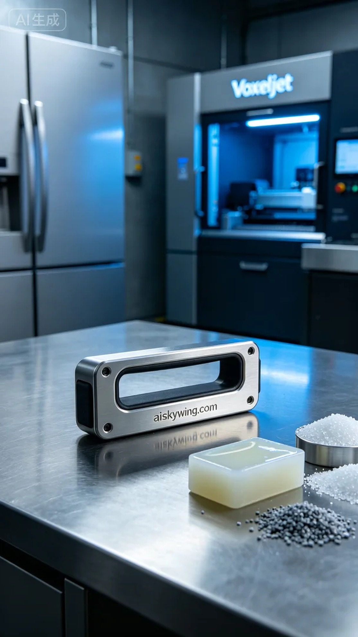
首先，我们需要准备好原材料。此次生产使用的是摆放着未成型的液态光敏树脂，具有优良的流动性和光敏性能，能够确保打印出精细的细节。同时，我们选择了Voxeljet打印机进行这次的3D打印，以其高精度和可靠性而闻名。
在打印参数设置方面，我们将层厚设置为50微米，温度保持在25摄氏度，激光功率为200毫瓦，打印速度设定在60毫米每秒。整个打印过程预计需要6小时，确保每一层都能精确成型，展现出冰箱门把手的复杂结构和细腻纹理。
打印过程中，设备稳定运行，冷色调的工业灯光在工作台上投射出明亮而清晰的影子。我们对每一层的质量进行监控，确保没有气泡和瑕疵，观察到的细节完美契合设计要求，让我们对成品充满期待。
打印结束后，进入后处理阶段。首先进行清洗，将未固化的树脂冲洗干净，然后进行打磨，确保表面光滑。接着，在紫外线固化设备中固化，每个细节都被充分照亮，最后进行质量检验，确保冰箱门把手的强度和美观。
经过一系列精细的工艺处理，我们终于完成了这款冰箱门把手，既具实用性又充满科技感，真是一次令人满意的生产体验。
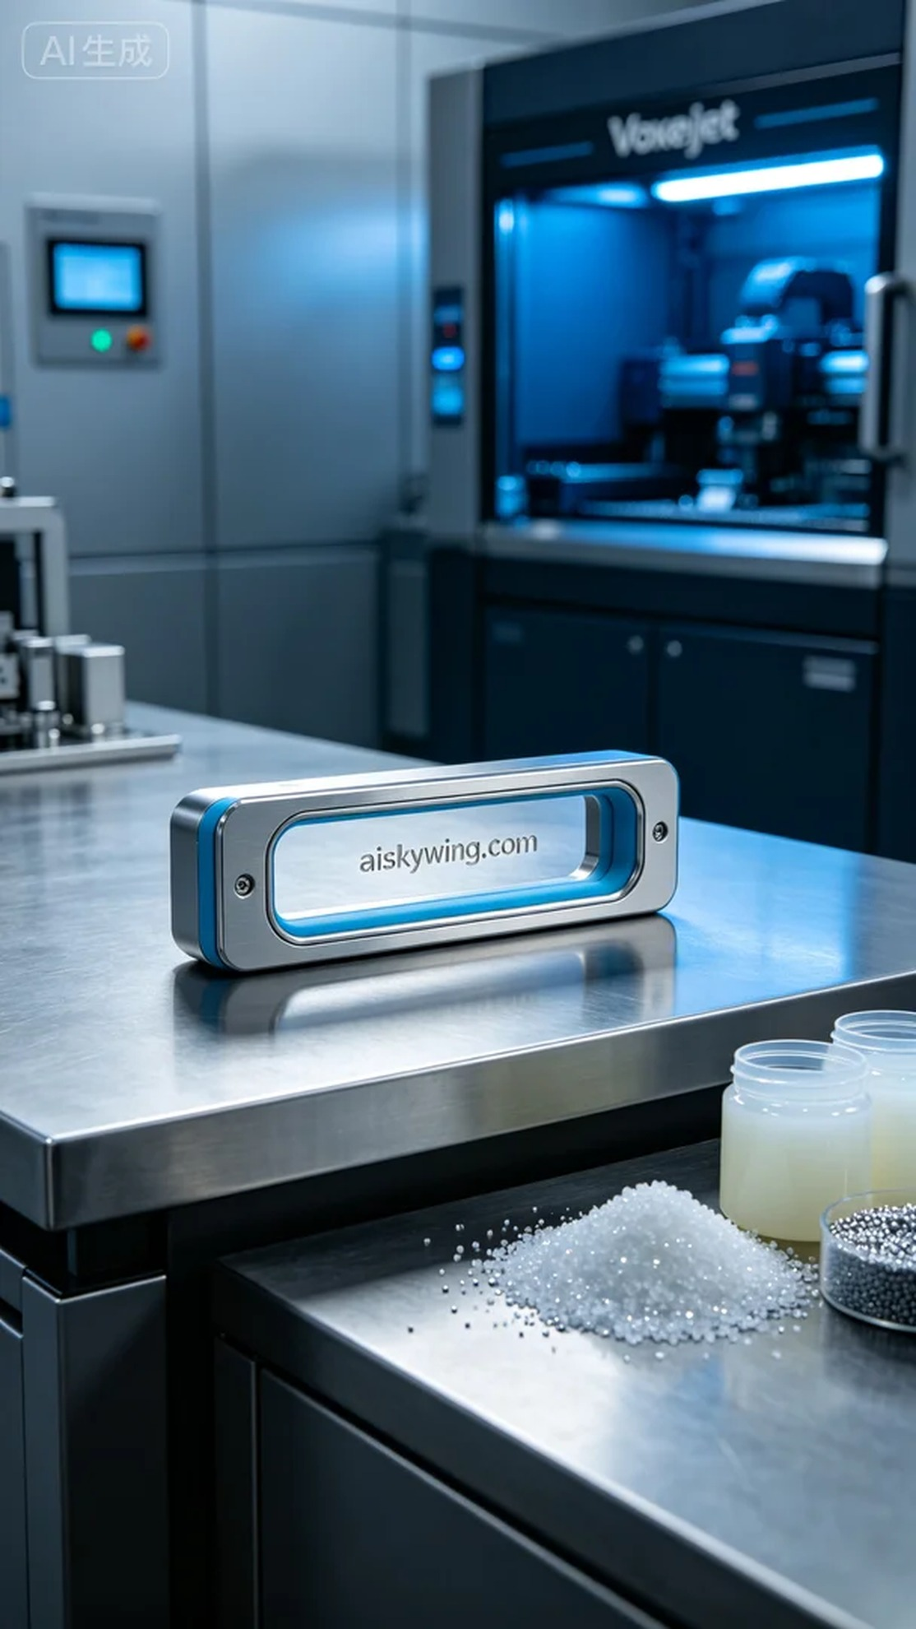
Aiskywing Industrial 3D Printing
Refrigerator door handle


