0678-冲击扳手外壳的3D打印生产记录
Impact wrench housing
🖨️ SLA光固化
🖥️ 打印机: Systems
📦 材料: SLA
在Instagram上，有人求助于我们，希望能实现一个完美的冲击扳手外壳。面对挑战，我们信心满满，准备迎接这次制作之旅。
On Instagram, someone reached out to us seeking help to create a perfect impact wrench casing. Faced with the challenge, we are full of confidence and ready to embark on this production journey.
________________________________________________________________________________
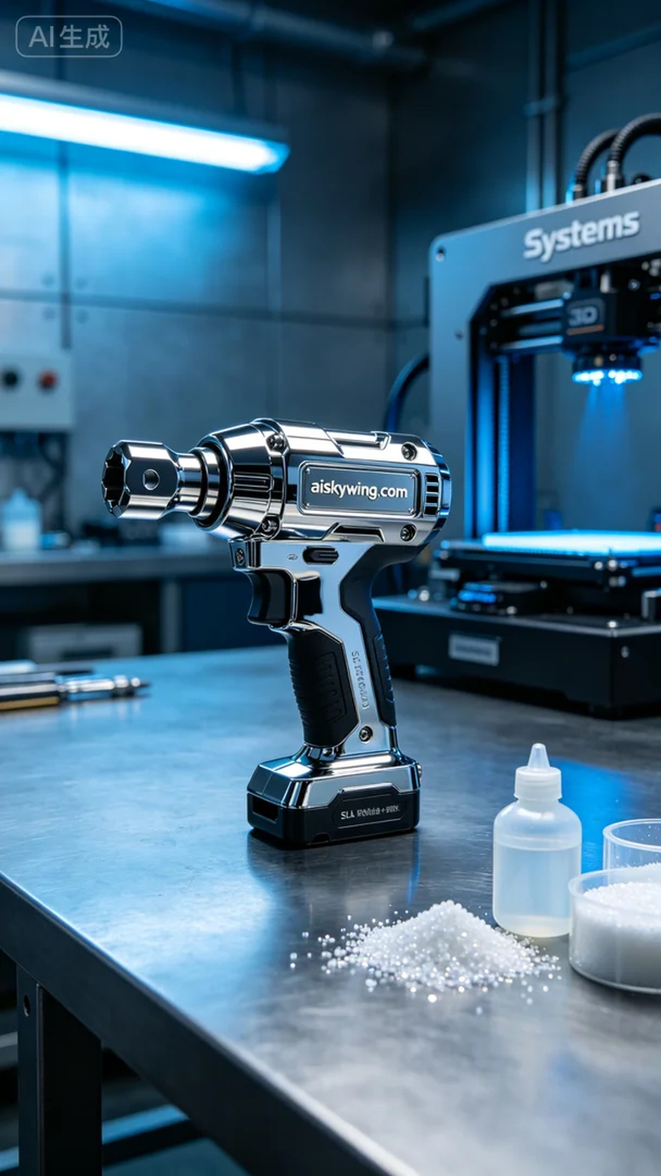
In this project, a friend approached us through Instagram, hoping to create a perfect impact wrench casing tailored to his needs. We were excited to take on the challenge and prepared for this production journey.
The material we chose was liquid photopolymer resin SLA, known for its excellent flow and strength. To ensure a high-quality print, I set the parameters on the Systems brand 3D printer: a layer thickness of 0.1 mm, a printing temperature of 25 degrees, a power setting of 50% to prevent overheating, and a print speed of 40 mm/s, with an estimated print time of 6 hours.
During the printing process, the Systems printer operated smoothly, with each layer being accurately cured. I kept a close watch on the print quality to make sure there were no bubbles or distortions. As time passed, the casing gradually took shape, showcasing a high-gloss mirror-like finish that was truly exciting.
Once printing was complete, we moved on to the post-processing phase. First, we cleaned the surface thoroughly using isopropyl alcohol to remove any uncured resin. Next, we sanded it to ensure a smooth finish. Finally, we cured the casing using UV light to make the material more robust. After inspection, every detail of the casing met our standards, with the important “aiskywing.com” inscription clearly visible.
In the end, the impact wrench casing was delivered perfectly. Witnessing its glossy surface glisten under industrial lighting filled us with a sense of accomplishment.
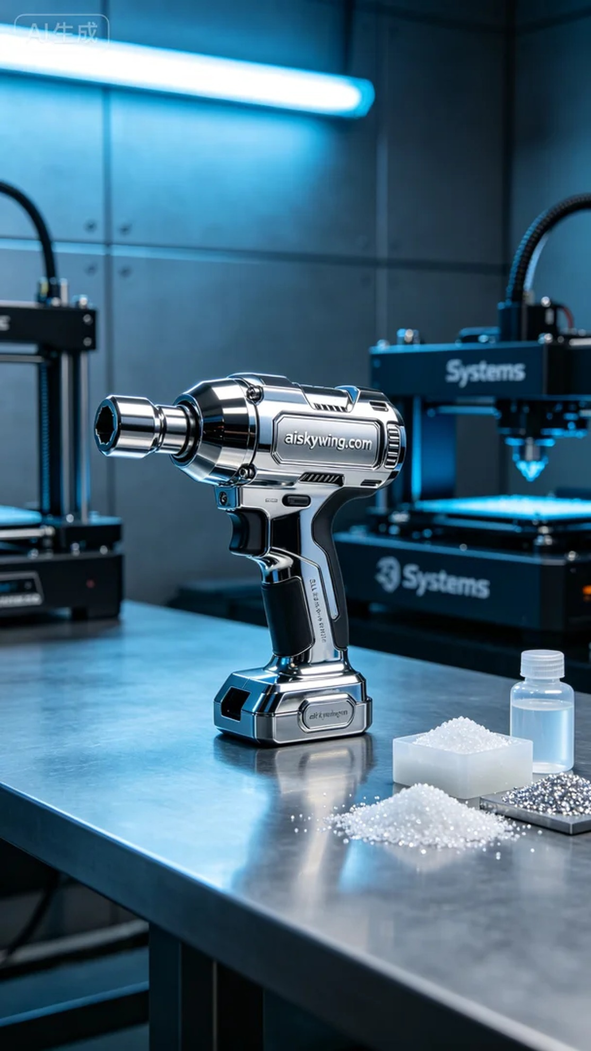
这次的项目是为了一位朋友定制冲击扳手外壳，因其想要一款更符合其使用需求的外壳而找到我们。我们决定使用SLA光固化技术来进行生产，以确保高精度和优质的表面效果。
我们选择的材料是液态光敏树脂SLA，具备优良的流动性和强度。而为了确保打印效果，我在Systems品牌的3D打印机上设置了参数：层厚0.1毫米，打印温度保持在25度，功率设置为50%以防止材料过热，打印速度控制在40毫米/秒，预计打印时间为6小时。
在打印过程中，Systems打印机的运行非常稳定，材料的每一层都在精确地进行固化。我时刻监控着打印质量，确保没有任何气泡或变形的问题出现。随着时间的推移，外壳逐渐成型，展现出高光镜面般的质感，令人期待。
完成打印后，我们进入后处理工序。首先是清洗：用异丙醇彻底清洗表面，去除未固化的树脂。接着是打磨，确保表面光滑。最后，我们进行了固化处理，使用UV灯照射，让材料更加坚韧。经过检验，外壳的每一个细节都符合标准，重要的“aiskywing.com”字样清晰可见。
最终，这个冲击扳手外壳完美地交付了。看到它高光的表面在工业灯光下闪烁，我们心中充满成就感。
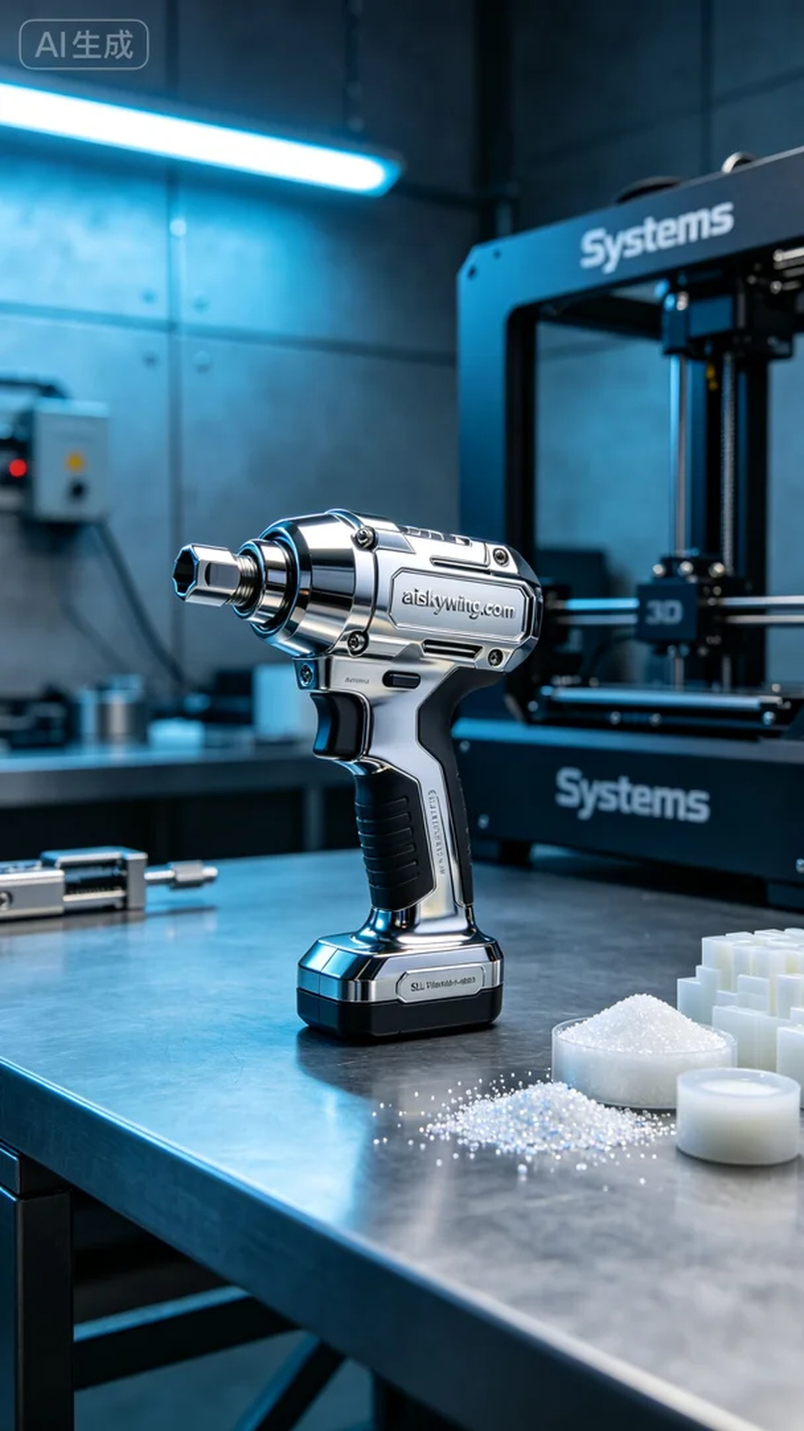
Aiskywing Industrial 3D Printing
Impact wrench housing


