0680-LED灯具散热器3D打印生产记录
LED luminaire heat sink
🖨️ SLS尼龙烧结
🖥️ 打印机: Systems
📦 材料: 摆放着未成型的液态光敏
生活再难，也别停下脚步。就像接下这个LED灯具散热器的单子，挑战总是伴随着机遇。
No matter how difficult life gets, don't stop moving forward. Just like taking on this LED lamp heat sink order, challenges always come with opportunities.
________________________________________________________________________________
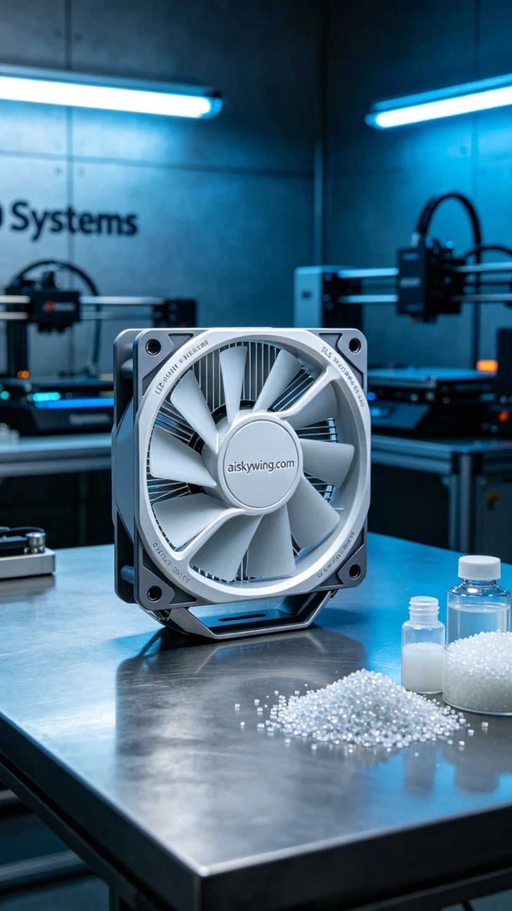
Life can be tough, but we should never stop moving forward. Like when I took on the project for the LED lamp heat sink, challenges always come with opportunities.
I was recently approached by someone on LinkedIn regarding the 3D printing of an LED lamp heat sink. This product not only needed to excel in heat dissipation but also had to meet high industrial design standards. After communicating with them, we clarified the product requirements and decided to use SLS nylon sintering for production.
The chosen material was unformed liquid photopolymer resin, which, when cured under UV light, showcases high precision and detail. We utilized a Systems brand 3D printer, setting a layer thickness of 0.1mm, maintaining a printing temperature of 60 degrees Celsius, with a power setting of 80% and a speed of 30mm per hour. The entire printing process was expected to take about 10 hours. This setup ensured that each layer was accurately shaped.
During the printing process, the Systems printer operated smoothly and quietly, which was very reassuring. I kept a close eye on the printing status, observing the curing process of each layer. As the heat sink shape began to emerge, my anticipation grew.
Once printing was finished, we proceeded with post-processing. First, we cleaned the printed part using a specialized cleaning solution to remove any uncured resin from the surface. Next, meticulous sanding was done to ensure every edge was smooth and flawless. Finally, we placed the product in a curing machine for thorough curing to enhance its durability and hardness. Each step was closely monitored to ensure the final product met our standards.
In the end, the LED lamp heat sink presented itself beautifully, ready for delivery, and filled us with a sense of accomplishment for this work.
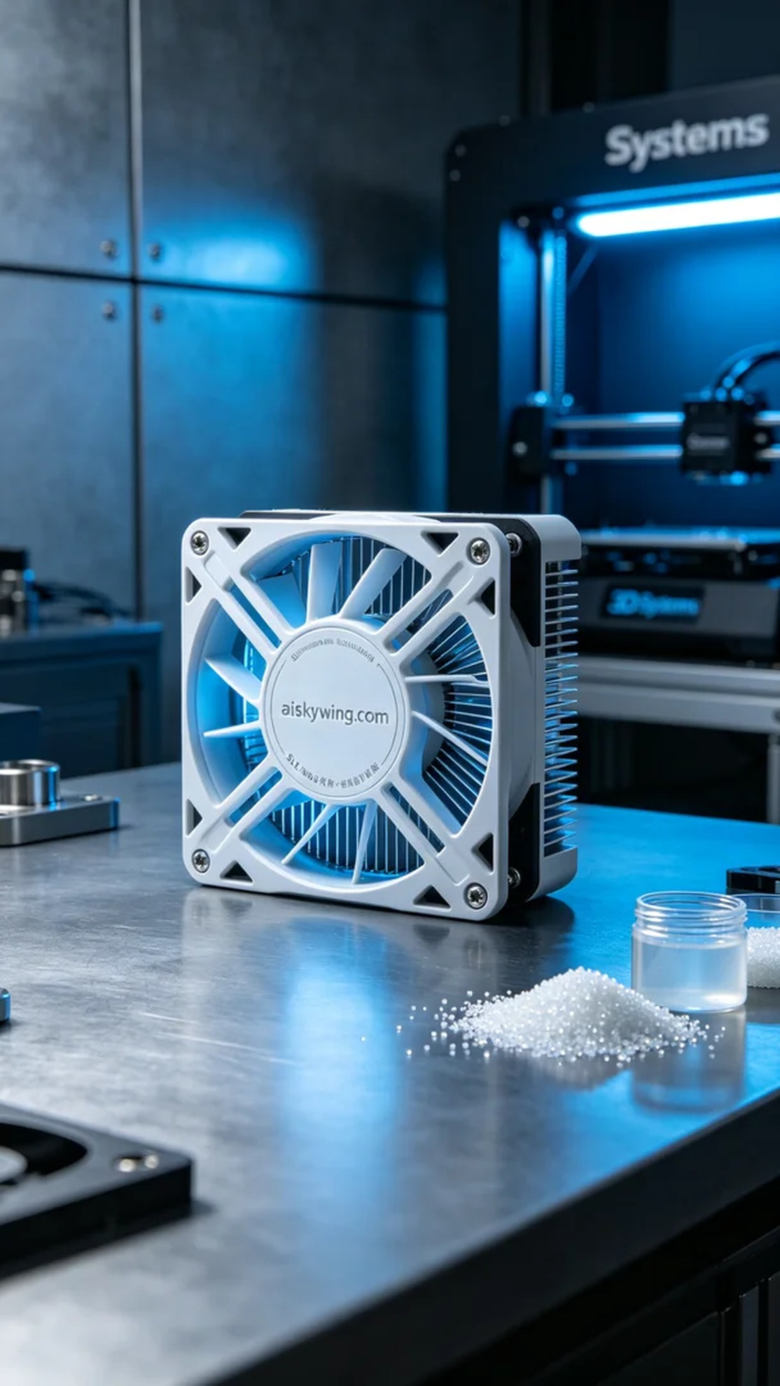
刚接到有人在LinkedIn上询问关于LED灯具散热器的3D打印方案时，我心里就有了底。这款散热器不仅要具备优越的散热性能，还需要在外观上达到工业设计的高标准。经过与他们的沟通，我们明确了产品需求，决定使用SLS尼龙烧结工艺进行生产。
我们选择的原材料是未成型的液态光敏树脂，这种材料在光照下硬化后，能展现出很高的精度和细节。设备方面，我们使用了Systems品牌的3D打印机，设置了层厚0.1毫米，打印温度保持在60摄氏度，功率调至80%，打印速度为每小时30毫米，预计整个打印过程需要大约10个小时。这样的设置能确保每一层都能被精确地塑造出来。
打印过程中，Systems打印机的运行相当稳定，整机运作平稳，噪音也在可接受的范围内。为确保质量，我时刻监控打印状态，观察每一层的固化情况。看到散热器的形状逐渐显现，心中的期待也随之增长。
完成打印后，我们进行了后处理。首先是清洗，用专门的清洗液去除表面的未固化树脂。接着，经过细致的打磨，确保每个边角都光滑无瑕。最后，我们将成品放入固化机中，进行充分的固化处理，以提高其耐用性和硬度。每个环节都严格把控，确保最终产品符合标准。
最终，这个LED灯具散热器以完美的姿态展现在了大家面前，顺利交付，也让我们对这项工作的成就感倍增。
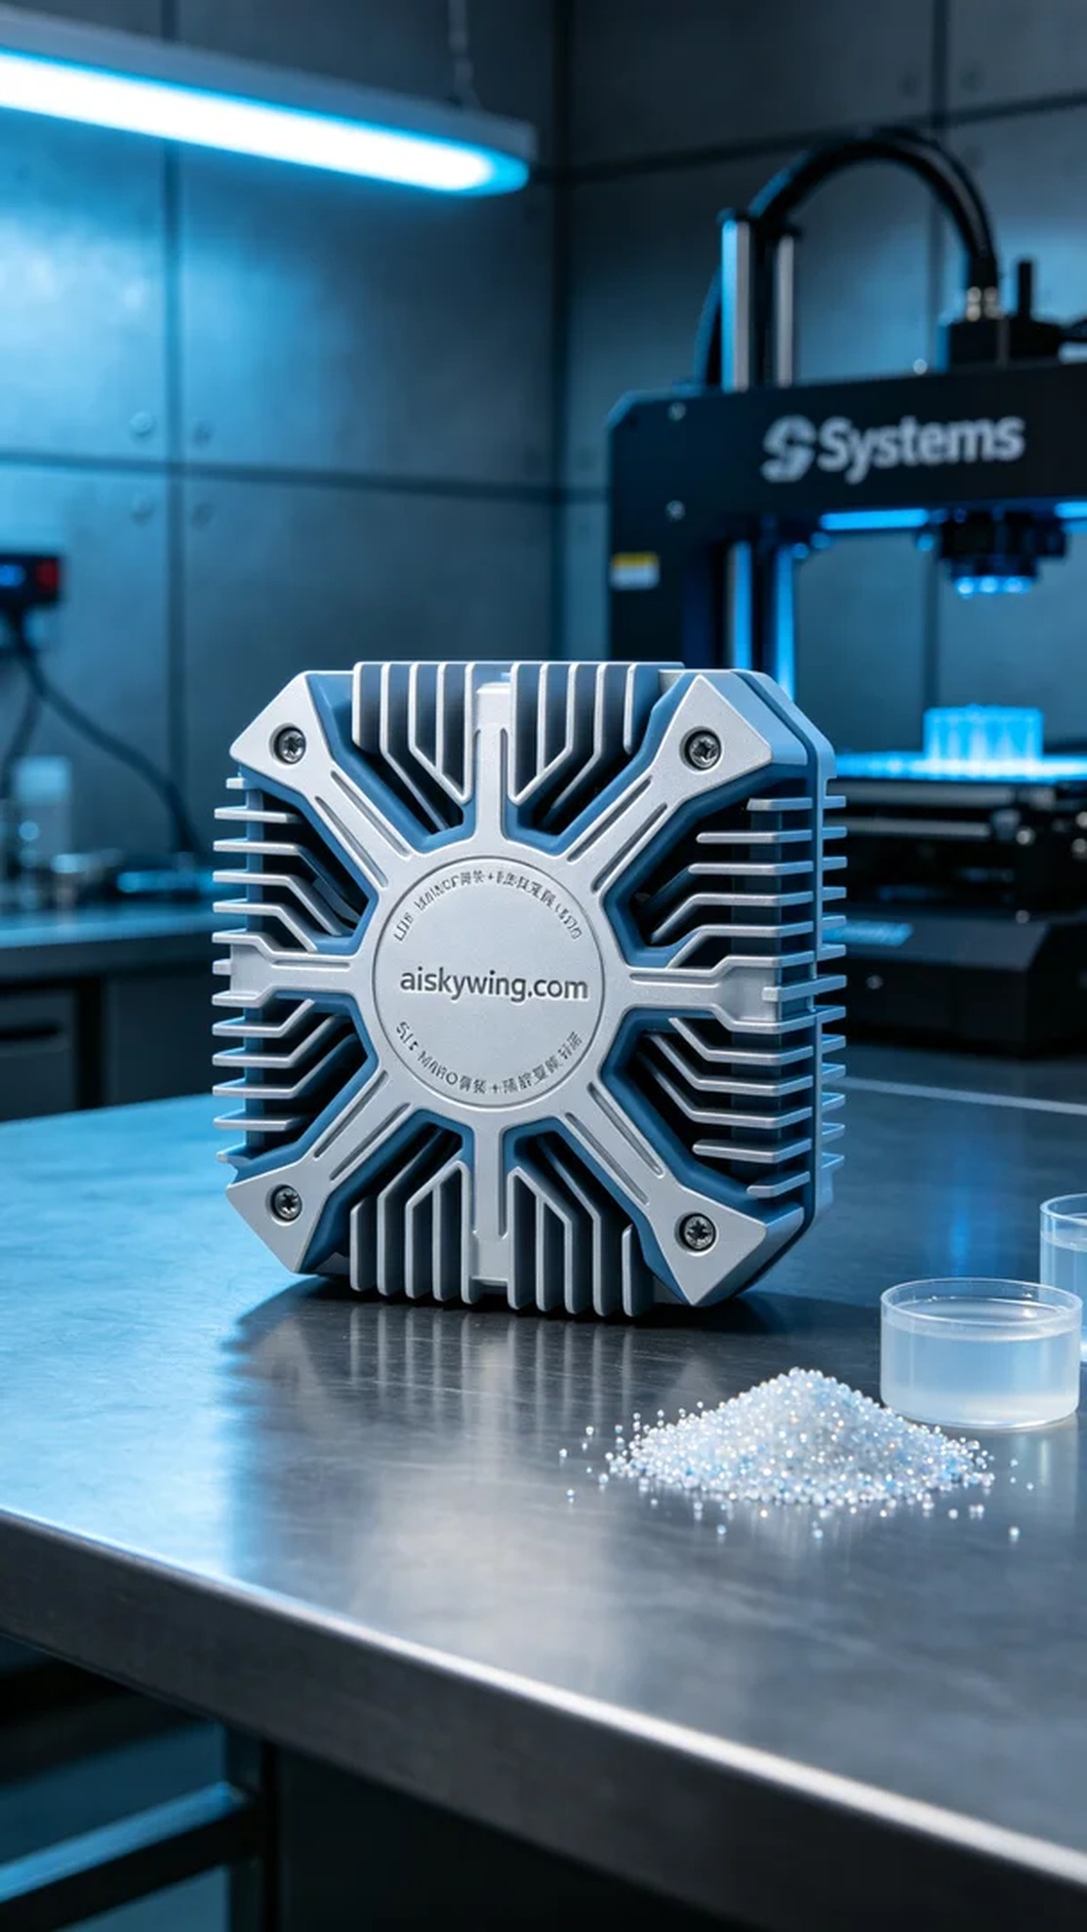
Aiskywing Industrial 3D Printing
LED luminaire heat sink


