0681-U盘外壳3D打印生产记录
USB flash drive casing
🖨️ SLS尼龙烧结
🖥️ 打印机: Carbon
📦 材料: 摆放着未成型的液态光敏
生活再难，也别停下脚步。就像接下这个U盘外壳的单子，我们相信每一个细节都值得用心对待。
No matter how difficult life gets, don’t stop moving forward. Just like taking on this USB drive casing order, we believe that every detail deserves careful attention.
________________________________________________________________________________
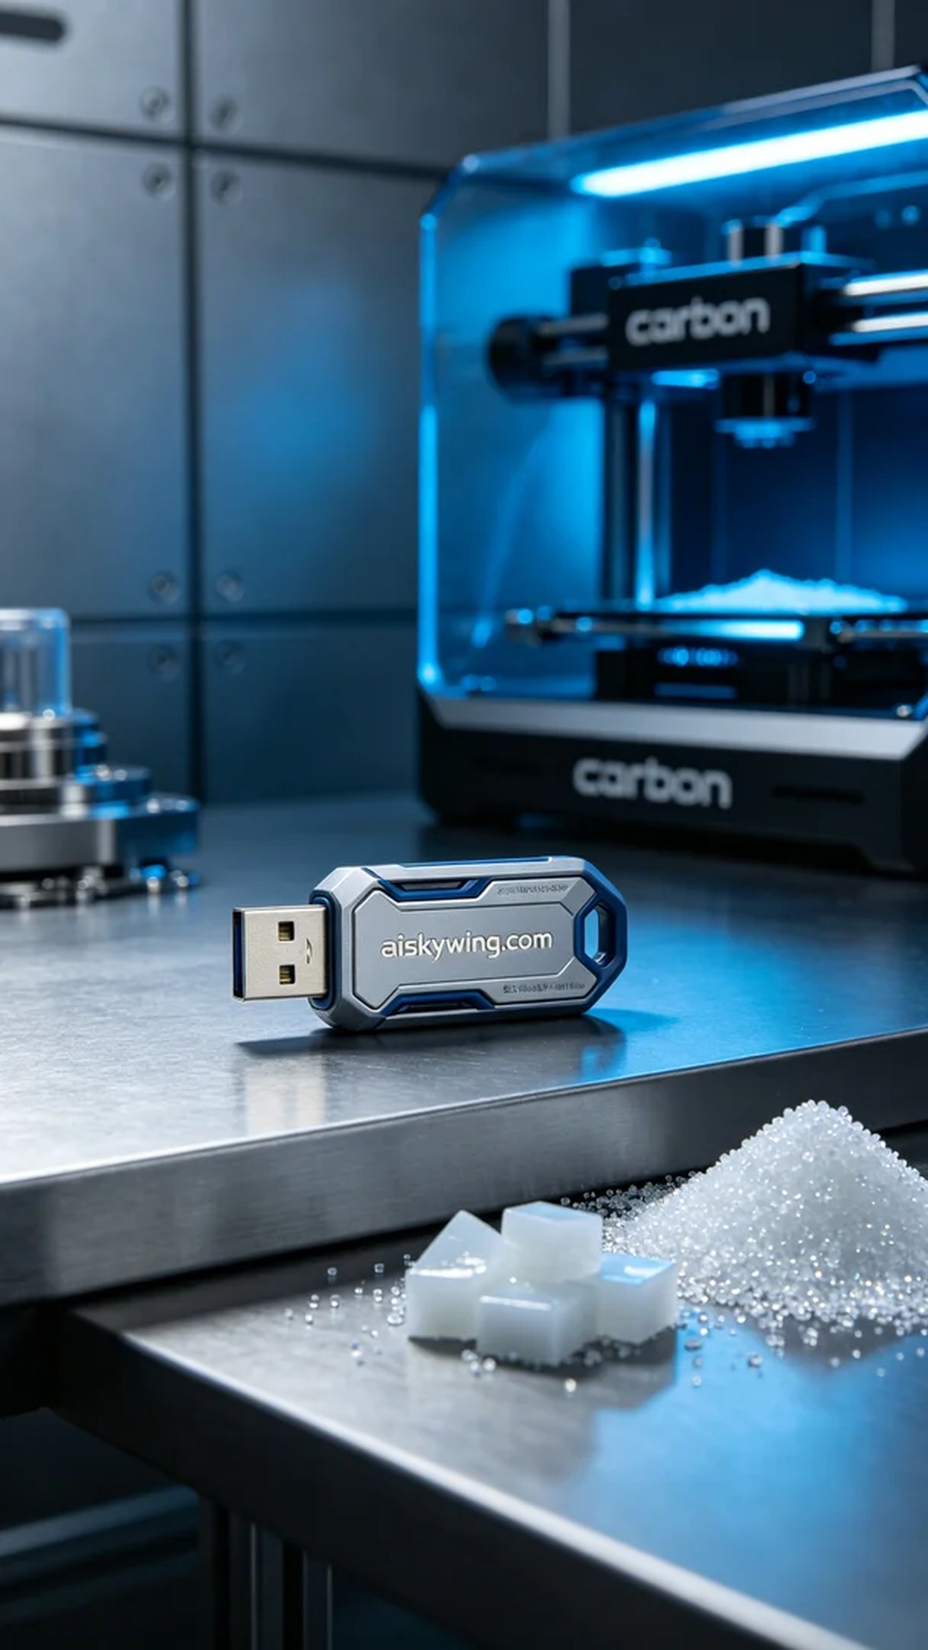
Life can be tough, but don't stop moving forward. Just like when we took on the task of creating this USB drive casing, we believe every detail deserves careful attention.
On Instagram, someone reached out to us because they lacked a professional USB drive casing. They wanted a product that was both aesthetically pleasing and functional. Thus, we embarked on this 3D printing journey for the USB drive casing.
We utilized unformed liquid photopolymer resin, known for its excellent fluidity and precision, to ensure perfect detail during the printing process. With the Carbon printer, we set the layer thickness to 0.1mm, maintained a stable printing temperature of 25°C, set the power at 80W, and the printing speed at 50mm/s, estimating a total printing time of about 3 hours.
During the printing process, the machine operated smoothly, and we constantly monitored the print quality to ensure that every detail was flawlessly reproduced. As the liquid resin solidified layer by layer, the shape of the USB casing gradually emerged, while we kept a strict control over the device to ensure there were no imperfections.
After printing, a series of post-processing procedures were carried out. First, the printed part was soaked in a cleaning solution to remove any uncured resin from the surface. Next, we sanded it to achieve a smoother finish, followed by a curing process using UV light to enhance its strength and durability. Each step was carefully inspected to ensure that the product met our expected standards.
After a series of meticulous operations, the USB casing was successfully completed. The final product is not only exquisite in appearance but also highly functional, reflecting our commitment to quality.
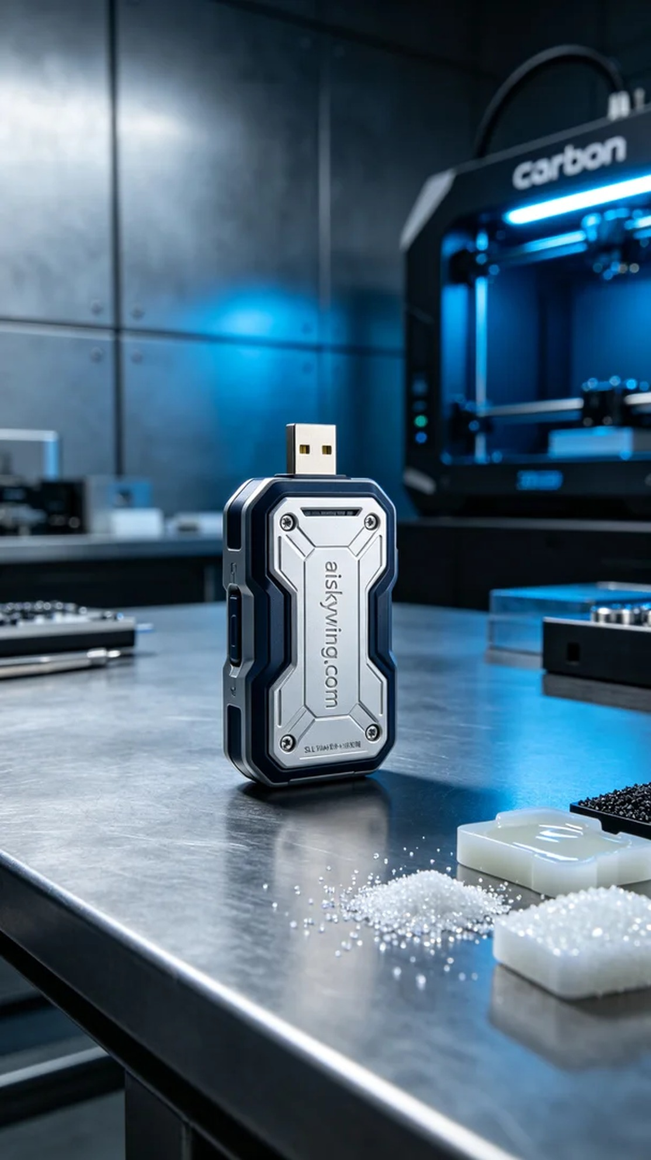
在Instagram上，有人因缺少专业的U盘外壳而找到我们。他们希望能制作出既美观又实用的产品。于是我们开始了这次关于U盘外壳的3D打印之旅。
我们使用的是尚未成型的液态光敏树脂，具备优良的流动性与精度，能够在打印过程中确保细节的完美呈现。使用Carbon品牌的打印机，设置层厚为0.1毫米，打印温度稳定在25摄氏度，功率设定在80W，打印速度为50毫米/秒，预计打印时间约为3小时。
在打印过程中，设备运行稳定，我们不断监控打印质量，确保每一个细节都能完美还原。随着液态树脂逐层固化，U盘外壳的形状逐渐显现，整个过程里，我们保持了对设备的严格把控，确保没有任何瑕疵。
打印完成后，我们对产品进行了一系列后处理工序。首先将打印件浸泡在清洗液中，以去除表面的未固化树脂。接着进行打磨，使其表面更加光滑，最后进行固化处理，使用UV灯照射以增强其强度和耐用性。每一步都经过仔细检验，确保产品达到预期标准。
经过一系列精细的操作，U盘外壳顺利完成。最后的成品不仅外观精致，功能也非常实用，体现了我们对品质的坚持。
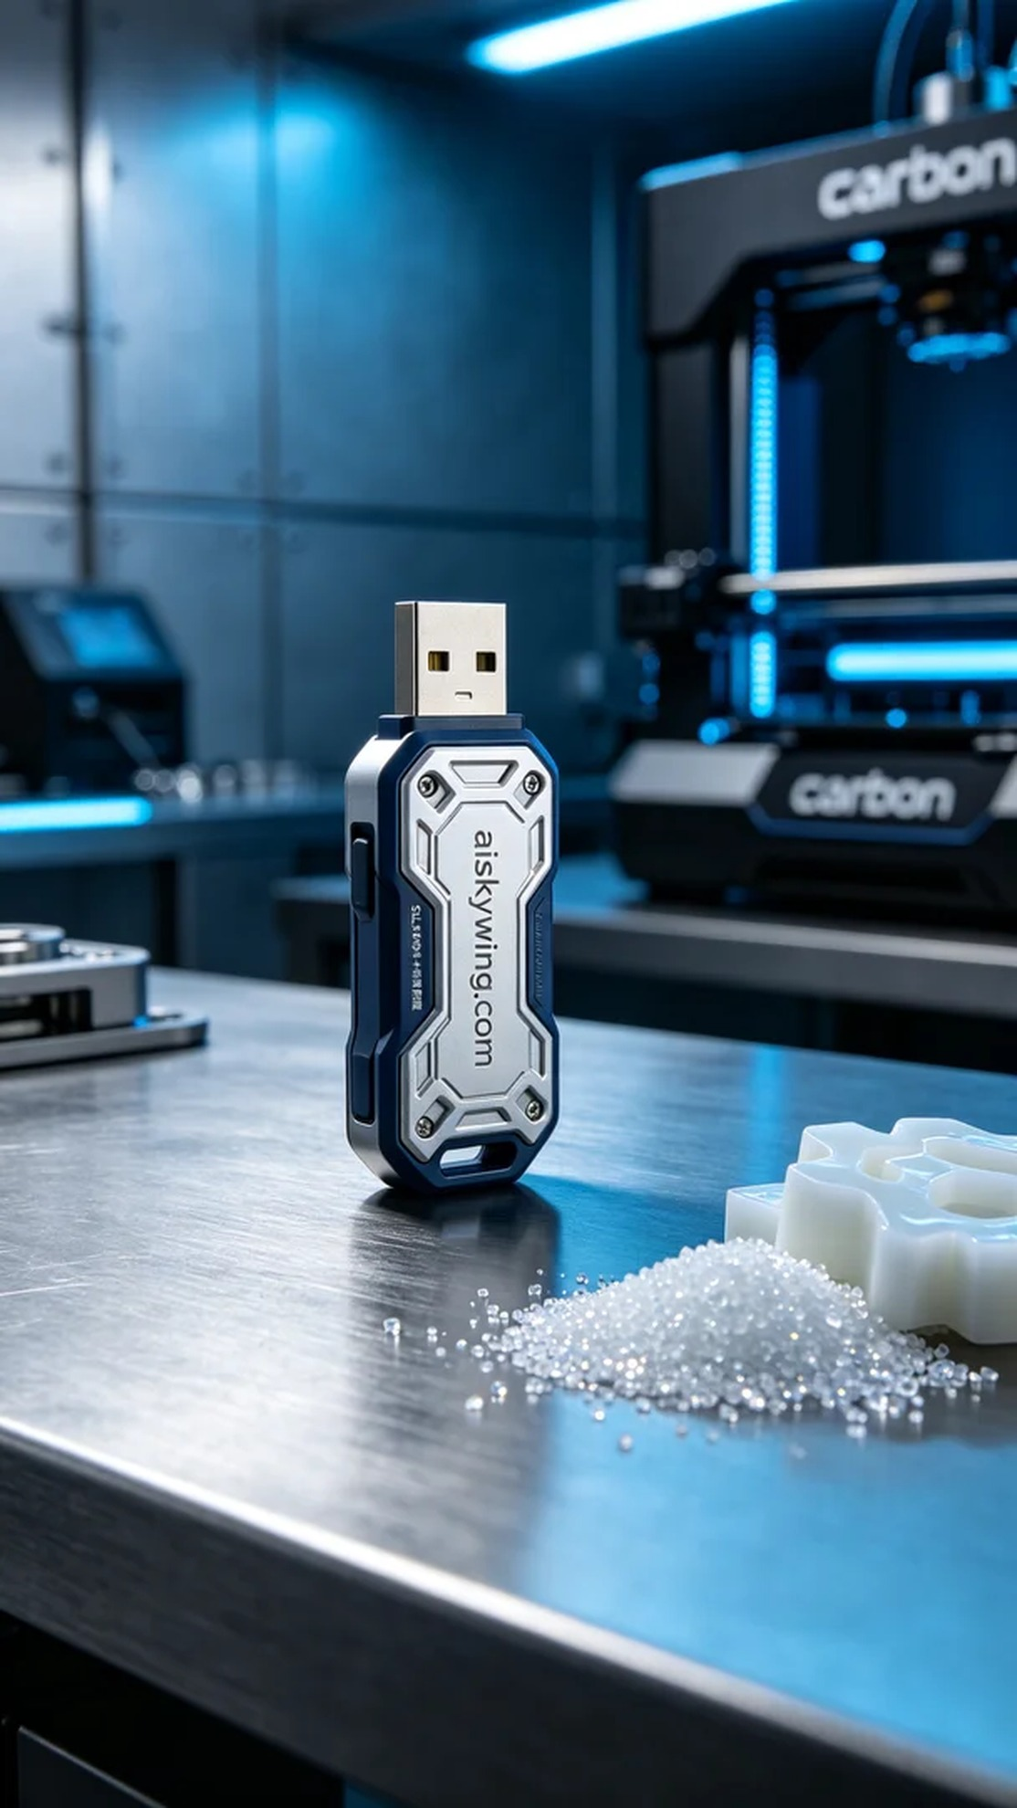
Aiskywing Industrial 3D Printing
USB flash drive casing


