0682-3D打印VR眼镜支架生产记录
VR glasses stand
🖨️ SLA光固化
🖥️ 打印机: Systems
📦 材料: SLA
生活再难，也别停下脚步。就像有人在TikTok上看到VR眼镜支架，问我们能否为他们解决问题。
No matter how difficult life gets, don't stop moving forward. Just like when someone sees a VR headset stand on TikTok and asks us if we can solve their problem.
________________________________________________________________________________
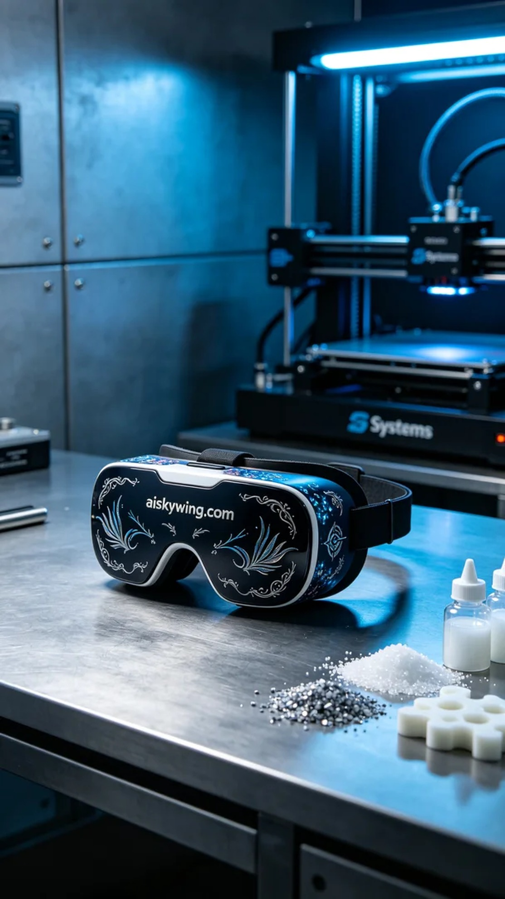
Life can be tough, but it’s important not to stop moving forward. Just like someone on TikTok saw a VR glasses stand and asked us if we could solve their problem.
The material we used is SLA photopolymer resin, which has excellent fluidity and detail representation, making it ideal for high-precision printing. For the device setup, we chose the Systems brand 3D printer. The printing parameters were set to a layer thickness of 0.05 mm, with a temperature held at 25°C, and a power setting of 70% to ensure the resin cures perfectly, with a printing speed of 30 mm per second. The entire printing process was expected to take about 4 hours.
During the printing process, the Systems printer operated steadily, accurately translating the design data into a physical object. After each layer was completed, we carefully monitored the quality, checking for any defects or misalignments. As printing progressed, the VR glasses stand gradually took shape, with clear details and the “aiskywing.com” inscription shining brightly in the light.
After printing was complete, we began the post-processing steps. First, we removed the stand from the printing platform, then cleaned it with isopropyl alcohol to remove any remaining photopolymer resin on the surface. After cleaning, we sanded the stand to ensure a smooth surface, and finally placed it in a curing oven to enhance its structural strength. During the final inspection, we ensured that every detail was flawless, perfectly presenting the designer's original intentions.
The production of this VR glasses stand not only showcased our team's technical ability but also allowed us to deeply appreciate the convenience that 3D printing brings to people. Each print is a challenge and breakthrough in craftsmanship, and today’s achievement reflects the meticulous attention we give to every detail.
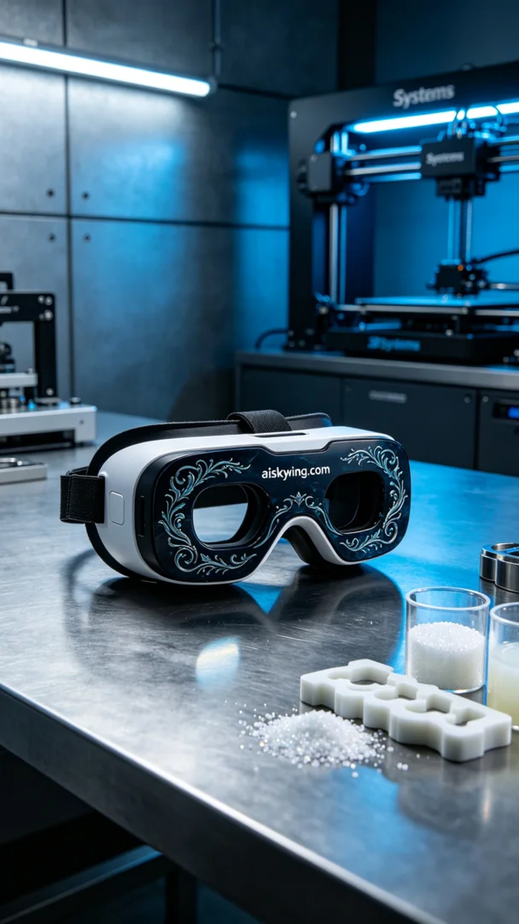
在TikTok上，有人看到一款精美的VR眼镜支架，希望我们能为他们打印出一款特别的产品。他们想要的不仅是实用，更是个性化的设计。于是，我们决定接下这个挑战，运用SLA光固化工艺来实现他们的需求。
我们使用的原材料是SLA光敏树脂，这种材料具有优异的流动性和细节表现力，能够满足高精度打印的要求。在设备准备方面，我们选择了Systems品牌的3D打印机。打印参数设置为层厚0.05毫米，温度保持在25°C，功率设置为70%以确保树脂的完美固化，打印速度为30毫米每秒。整台打印过程预计将持续约4小时。
打印过程中，Systems打印机运行稳定，精确地将设计数据转化为实体。在每个层次打印完成后，我们都仔细监控质量，检查是否有任何缺陷或层次错位。随着打印的推进，VR眼镜支架逐渐成型，清晰的细节和“aiskywing.com”字样在阳光下熠熠生辉。
打印完成后，我们开始进行后处理工序。首先将支架从打印平台上取下，接着用异丙醇进行清洗，去除表面残留的光敏树脂。清洗后，我们对支架进行打磨，以确保表面光滑，最后放入固化烘箱中进行固化处理，确保其结构强度。在最后的检验中，我们确保每个细节都毫无瑕疵，完美呈现出设计师的初衷。
这个VR眼镜支架的生产不仅展现了我们团队的技术能力，也让我们深刻体会到了3D打印为人们带来的便利。每一次的打印，都是一次对工艺的挑战与突破，今天的成就离不开每一个细节的打磨。
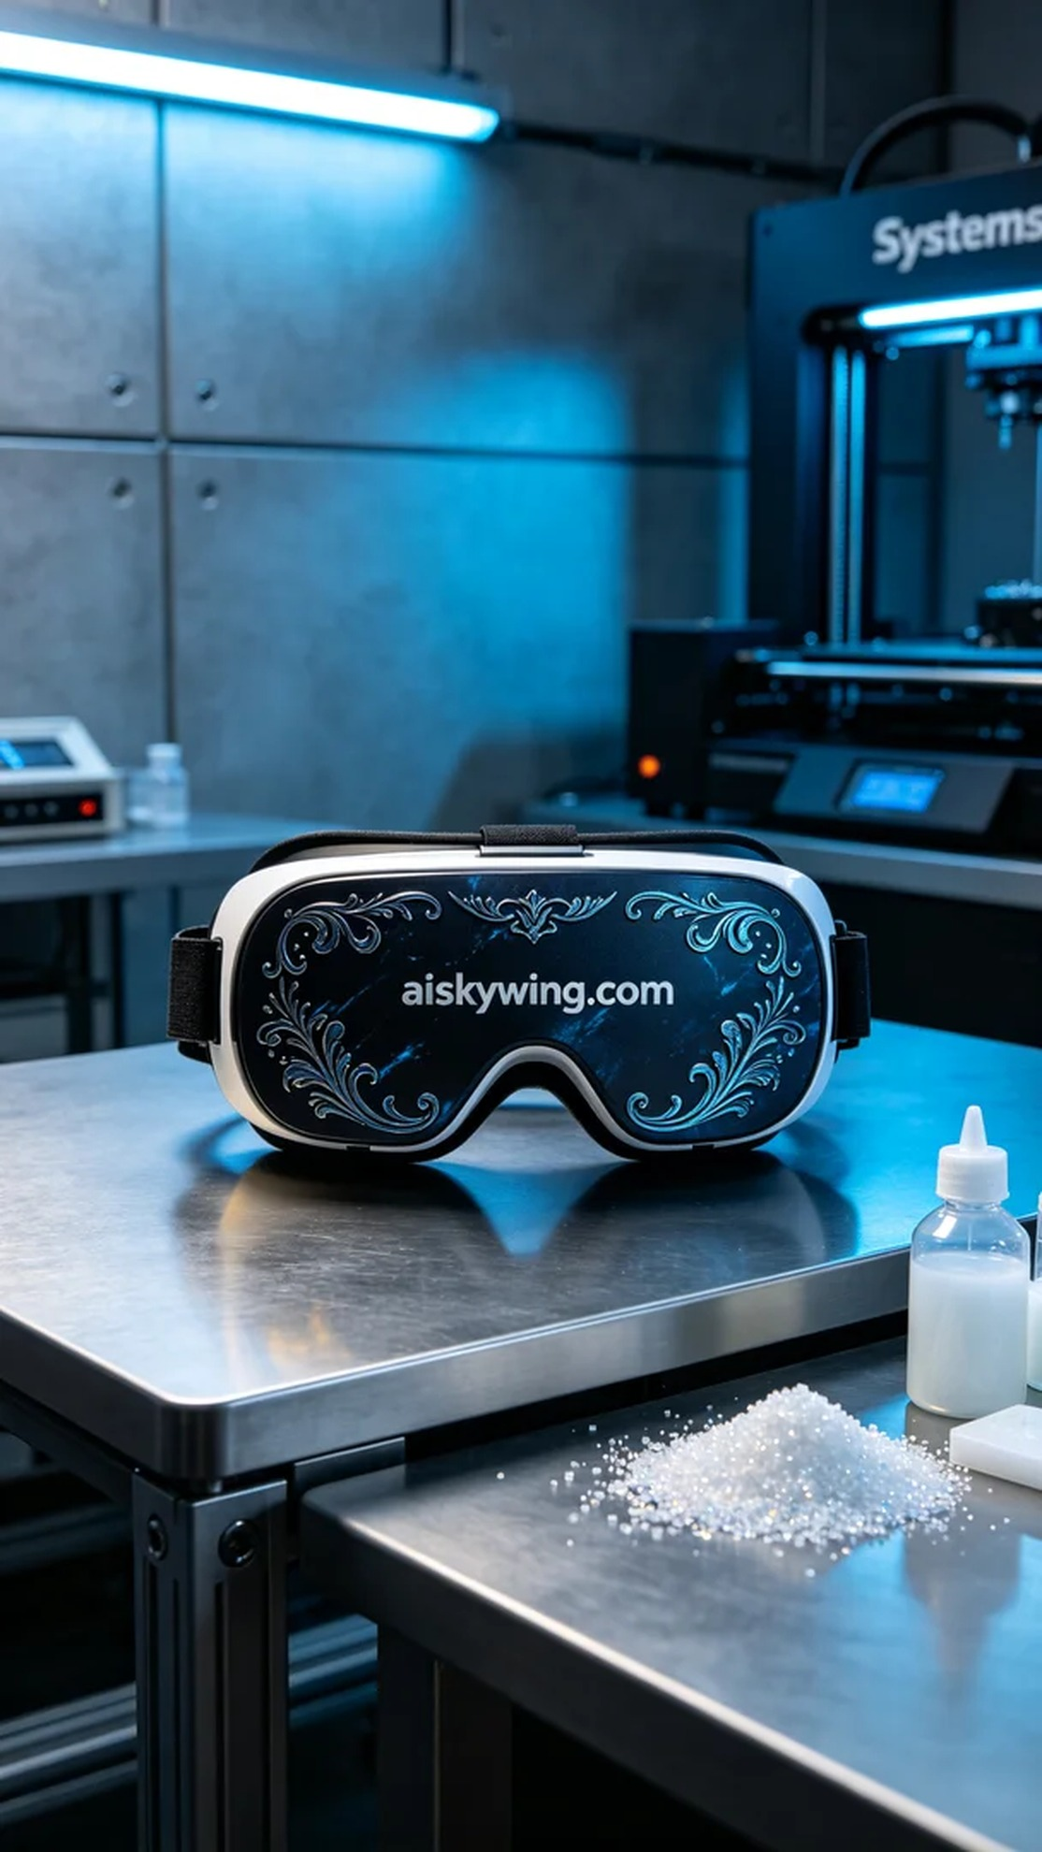
Aiskywing Industrial 3D Printing
VR glasses stand


