0683-三脚架云台的3D打印记录
Tripod Head
🖨️ SLA光固化
🖥️ 打印机: Mimaki
📦 材料: SLA
生活中的每一个创意都值得被实现。就像有人通过WhatsApp找我，希望打造一个三脚架云台，这也是我们3D打印技术的魅力所在。
Every idea in life deserves to be realized. Just like when someone reached out to me via WhatsApp, hoping to create a tripod head, this is the charm of our 3D printing technology.
________________________________________________________________________________
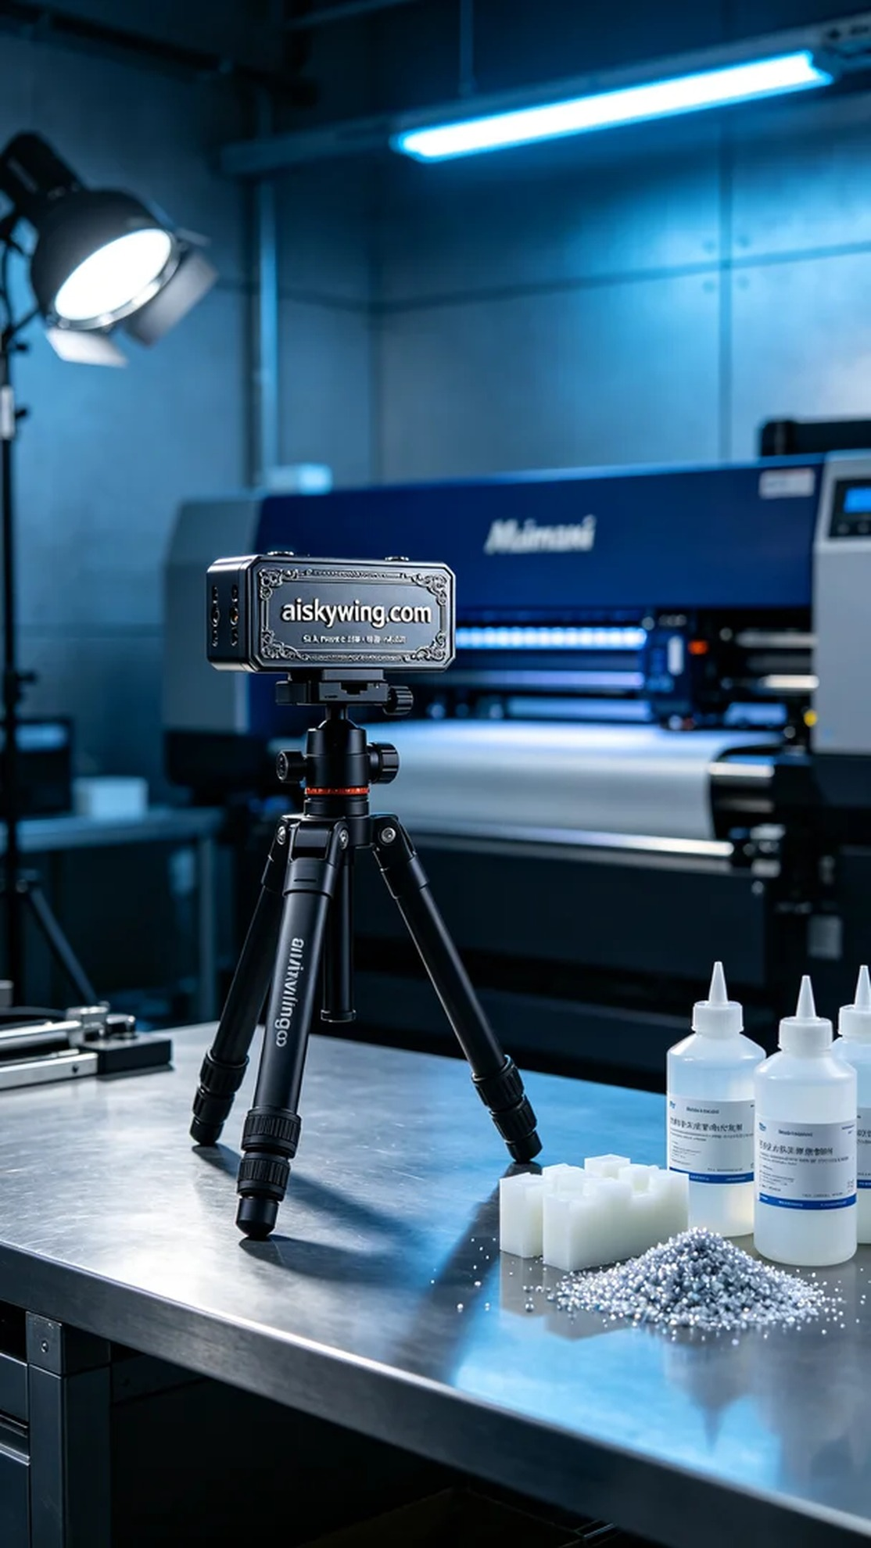
Every creative idea in life deserves to be realized. Just like when someone reached out to me via WhatsApp, hoping to create a tripod head, which showcases the charm of our 3D printing technology.
To meet this demand, we decided to use SLA (Stereolithography) technology for printing. The chosen material was high-quality SLA resin, known for its fine detail, which allows for an extremely clear surface finish. We prepared the equipment using a Mimaki brand 3D printer, setting the printing parameters to a layer thickness of 0.05mm, maintaining a temperature of 25 degrees Celsius, with a power setting of 80%, and a printing speed of 30mm/s; the entire printing process was expected to take about 8 hours to complete.
The printing process went relatively smoothly, with the Mimaki printer running steadily and the beam accurately curing the resin layer by layer. We monitored the quality throughout to ensure each layer was perfectly stacked without any bubbles or defects. As time passed, the tripod head gradually took shape, with the engraved “aiskywing.com” detail appearing particularly clear, giving it a strong sense of industrial style and technology.
Once printing was complete, we moved into the post-processing stage. The first step was to clean the printed item, thoroughly removing any uncured resin using a cleaning solution. After that, we proceeded to sanding to ensure a smooth surface without blemishes. Next, it was placed in a curing box where it underwent UV curing to ensure that every part reached its optimal strength and durability. Finally, we conducted a comprehensive inspection to ensure all specifications were met.
After a series of meticulous touches and strict checks, we successfully completed the production of this tripod head, presenting an extremely clear detail and perfect texture that leaves us feeling immensely satisfied.
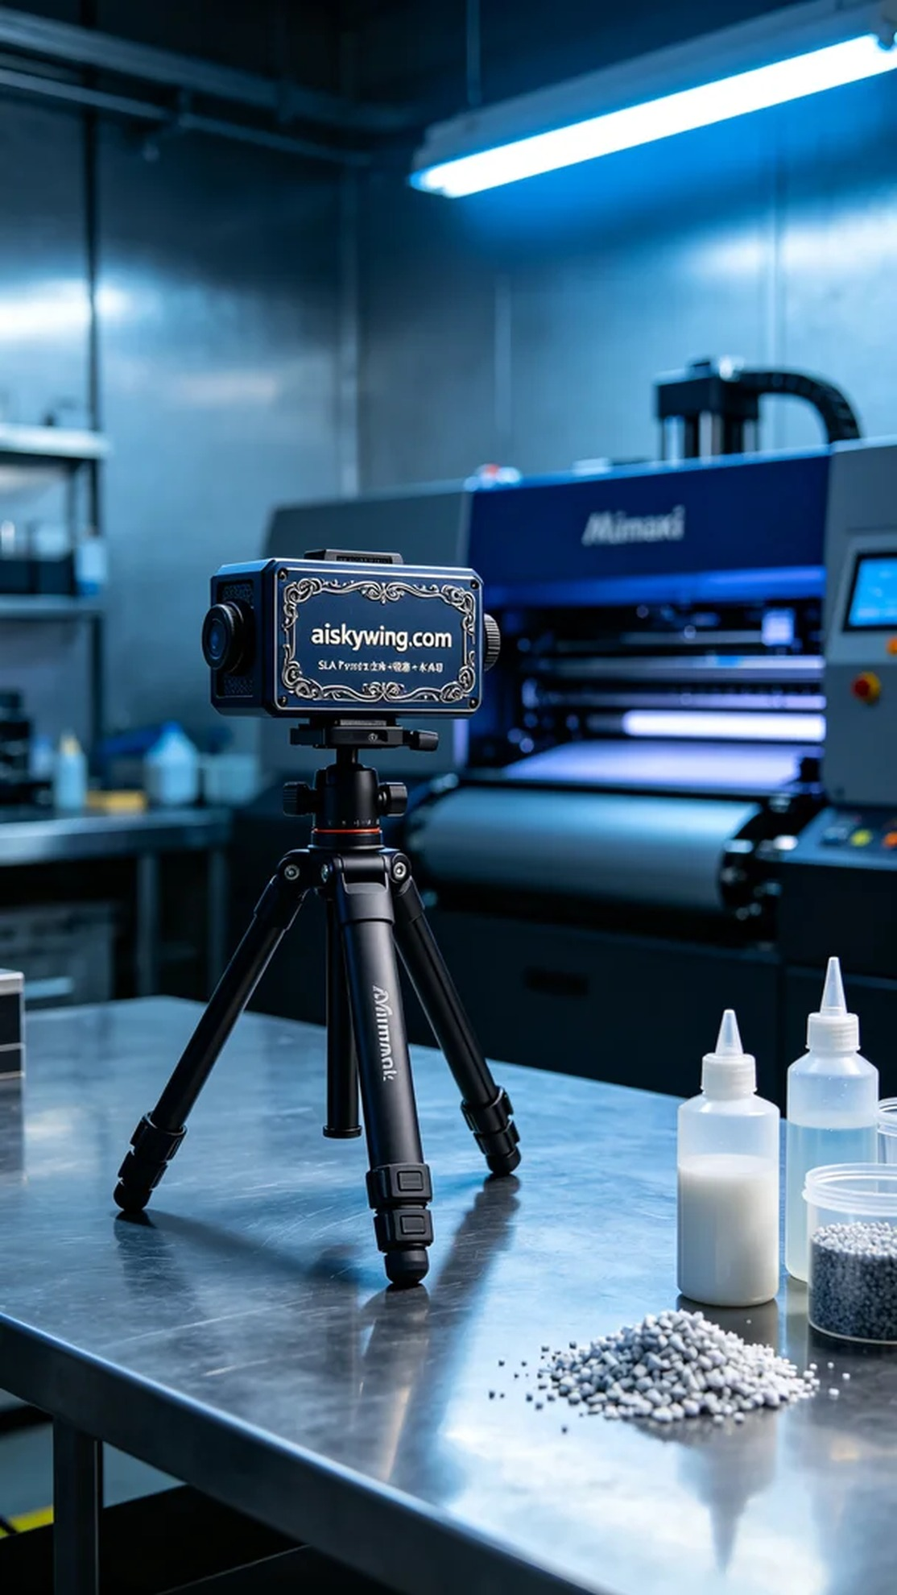
在我们接到这个三脚架云台的订单后，有人通过WhatsApp联系我，表示希望能够制作一个具有个性化定制的产品。他们希望这个云台不仅功能强大，还能在外观上给人眼前一亮的感觉。
为了满足这个需求，我们决定采用SLA光固化技术进行打印。选用的材料为高质量的SLA光敏树脂，其精细度高，能够呈现出极致清晰的表面效果。在设备准备上，我们使用了Mimaki品牌的3D打印机，设置的打印参数为层厚0.05mm，温度保持在25摄氏度，功率设定为80%，打印速度为30mm/s，整个打印过程预计需要8小时完成。
打印过程相对顺利，Mimaki打印机的运行稳定，光束精准地照射在树脂上，逐层固化。我们全程监控质量，确保每一层都完美叠加，没有出现气泡或缺陷。随着时间的推移，三脚架云台逐渐成型，细节部分的雕刻“aiskywing.com”也显得格外清晰，给人一种科技感十足的工业风格。
打印完成后，我们进入了后处理阶段。首先需要清洗，将未固化的树脂用清洗液彻底去除。接着进行打磨，以确保表面光滑无瑕。然后将其放入固化箱中，利用紫外线进行固化，确保每个部分都能达到最佳的强度和耐用性。最后，我们进行了全面检验，确保每一项指标都符合要求。
经过一系列的精细打磨和严格检查，我们成功地完成了这款三脚架云台的制作，产品呈现出极致清晰的细节与完美的质感，让人感到无比满意。
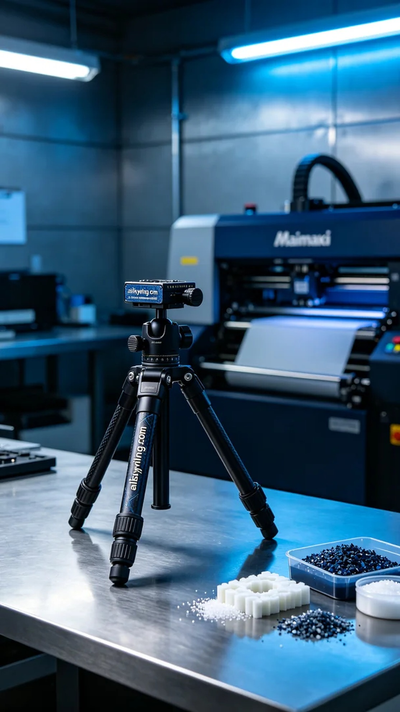
Aiskywing Industrial 3D Printing
Tripod Head


