0684-丝杠防护套的3D打印生产记录
Lead Screw Protective Sleeve
🖨️ SLA光固化
🖥️ 打印机: Voxeljet
📦 材料: SLA
“在3D打印的世界里，每一个细节都能改变你的未来。有人因为机器的保护需求，找到了我们做这个丝杠防护套…”
"In the world of 3D printing, every detail can change your future. Some people, due to the need for machine protection, have found us to create this lead screw protective cover..."
________________________________________________________________________________
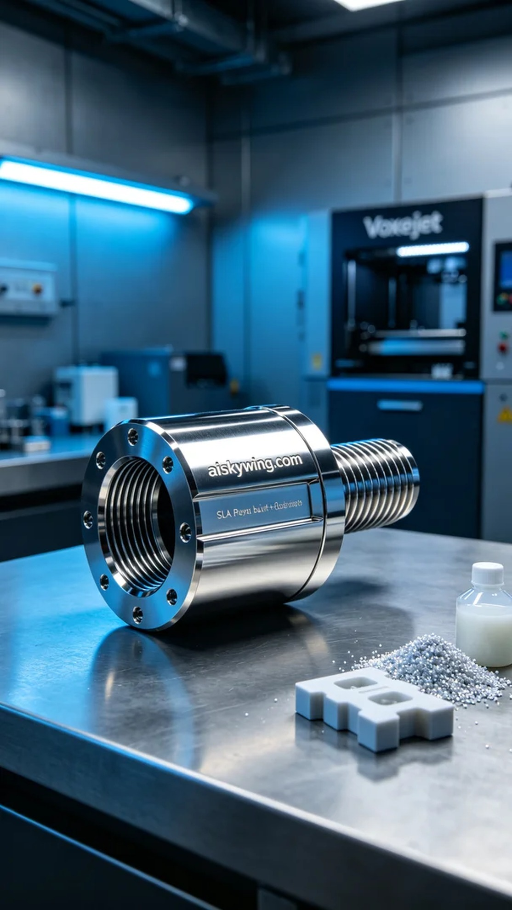
In a typical workday, someone reached out to us via Facebook looking to produce a lead screw protective cover to address potential issues arising from wear on equipment. They wanted the cover to be not only robust but visually appealing in an industrial way, so we decided to use SLA (Stereolithography) technology for the print.
We chose high-quality SLA resin as the raw material, known for its excellent flow properties and high-resolution output. Before starting the print, we thoroughly inspected and calibrated the Voxeljet printer. We set the layer thickness to 0.05mm, maintained a printing temperature of 25 degrees Celsius, adjusted the laser power to 50mW, and set the print speed at 60mm/s. After about three hours of setup, all parameters were finally confirmed.
The printing process proceeded as usual, with the Voxeljet printer humming a faint melody of industrial sounds. As the liquid resin cured layer by layer, the lead screw protective cover gradually took shape. Throughout the process, we kept a close watch on the print quality, ensuring that each layer cured evenly without defects, and we successfully completed the print.
After printing, we moved on to the post-processing phase. First, we placed the printed part into a cleaning tank, using a dedicated solvent to remove any uncured resin. Next, we used fine sandpaper to polish the surface to achieve the desired mirror finish. Finally, we placed the treated protective cover into a curing chamber and exposed it to UV light to ensure strength and durability. Every step of inspection was critical, and we meticulously checked every detail to guarantee there were no flaws.
In the end, this lead screw protective cover showcased its outstanding quality and exquisite appearance, perfectly presented to everyone. Through our efforts, it will effectively extend the machine's lifespan and provide a better working experience.
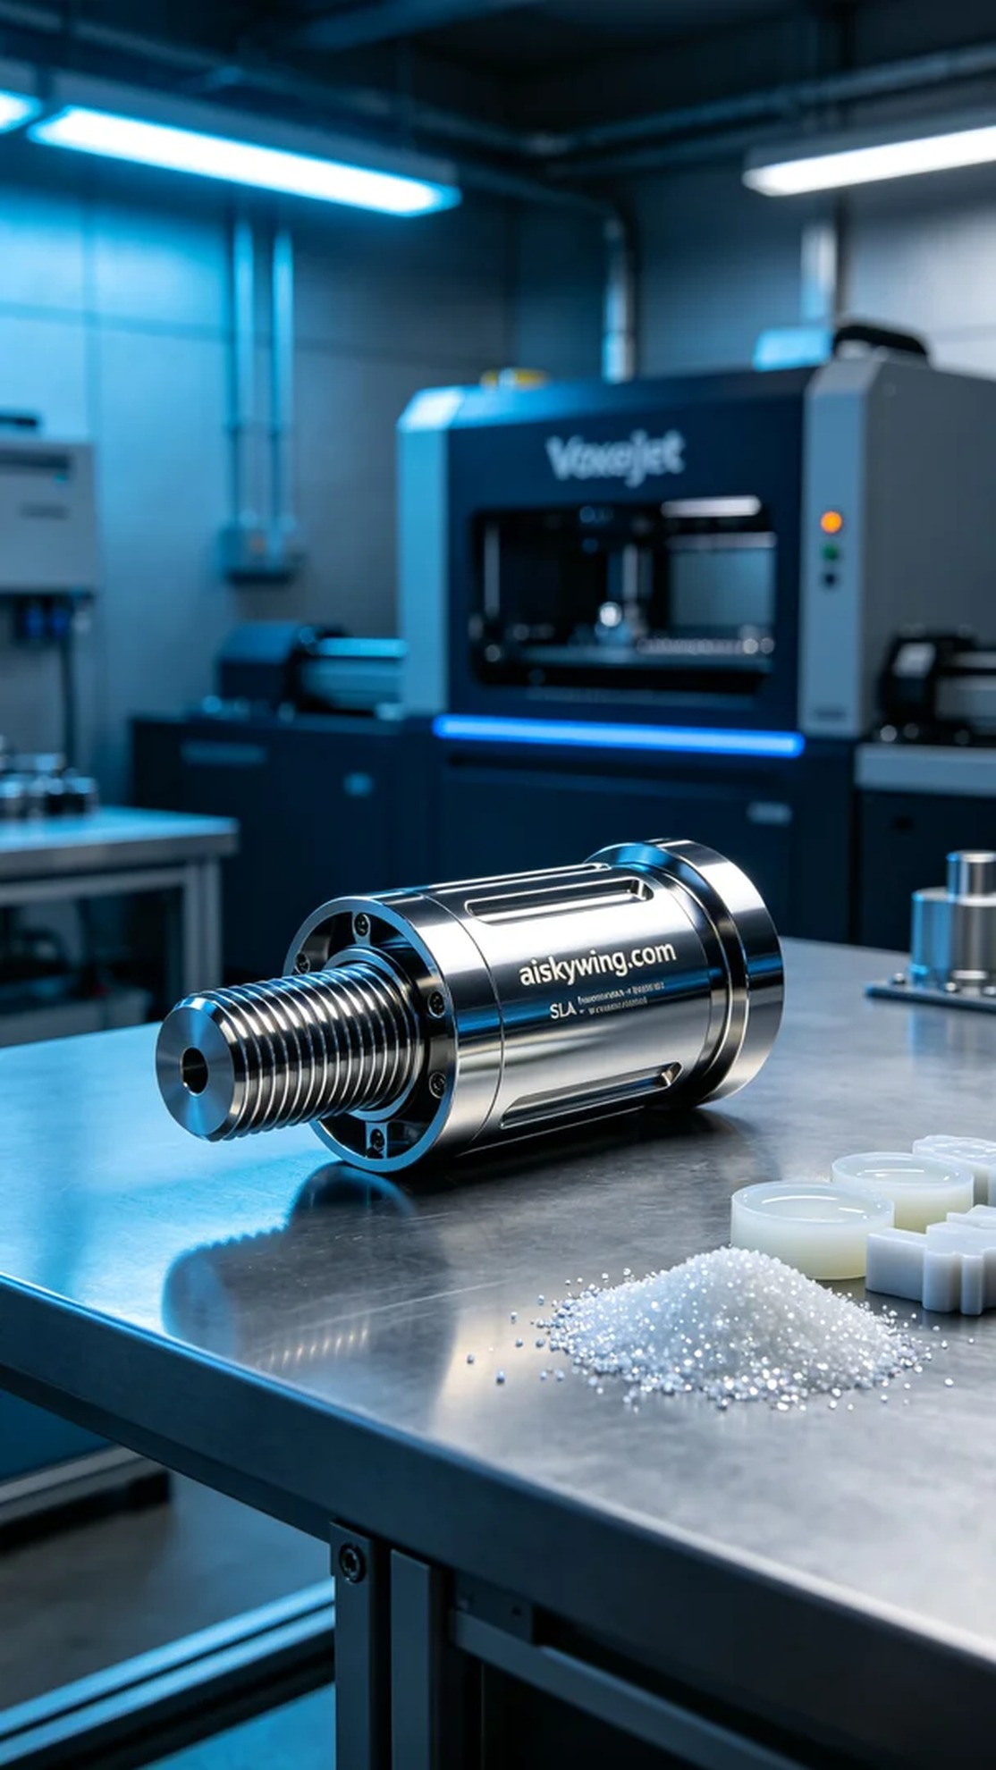
在某个工作日，有人通过Facebook找到我们，希望制作一款丝杠防护套，以应对设备因磨损而可能出现的故障问题。客户希望这个防护套不仅要坚固耐用，还要在视觉上具备工业美感，因此我们决定采用SLA光固化工艺进行打印。
我们选择了高品质的SLA光敏树脂作为原材料，具备良好的流动性和高分辨率输出。在准备打印之前，首先对Voxeljet打印机进行了全面的检查和校准。我们设定了层厚为0.05mm，打印温度维持在25摄氏度，激光功率设为50mW，打印速度为60mm/s。经历了3小时的准备工作，所有参数终于确认无误。
打印过程如常，Voxeljet打印机在工作中发出的轻微嗡嗡声如同一首工业乐曲。随着液态树脂逐层固化，丝杠防护套的形状逐渐成型。整个过程中，我们时刻监控打印质量，确保每一层的固化都均匀无误，最终顺利完成打印。
完成打印后，我们进入后处理环节。首先，我们将打印件放入清洗槽中，使用专用溶剂去除未固化的树脂。接下来，采用细砂纸对表面进行打磨，以达到客户要求的镜面效果。最后，将处理好的防护套放入固化箱内，通过紫外线进行固化，确保其强度和耐用性。每一步的检验都不容忽视，我们仔细检查了每个细节，确保没有缺陷。
最终，这个丝杠防护套以其卓越的品质和精致的外观，完美地呈现在大家面前。经过我们的努力，它将有效延长机器的使用寿命，带来更好的工作体验。
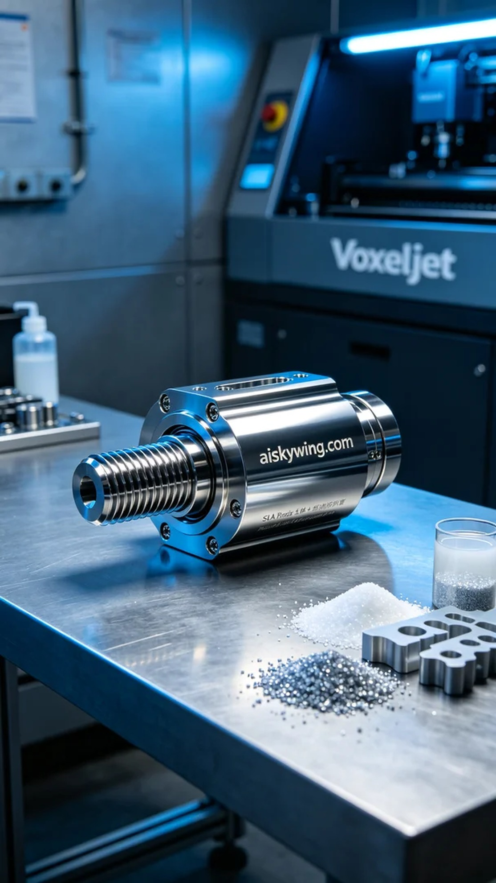
Aiskywing Industrial 3D Printing
Lead Screw Protective Sleeve


