0685-打造完美的产品保护罩
Product protective cover
🖨️ SLA光固化
🖥️ 打印机: Carbon
📦 材料: SLA
在TikTok上，有人因为产品保护罩的问题找到了我们。我们接下了这个挑战，力求为他们打造最完美的产品。
On TikTok, someone reached out to us regarding an issue with a product cover. We took on this challenge, striving to create the perfect product for them.
________________________________________________________________________________
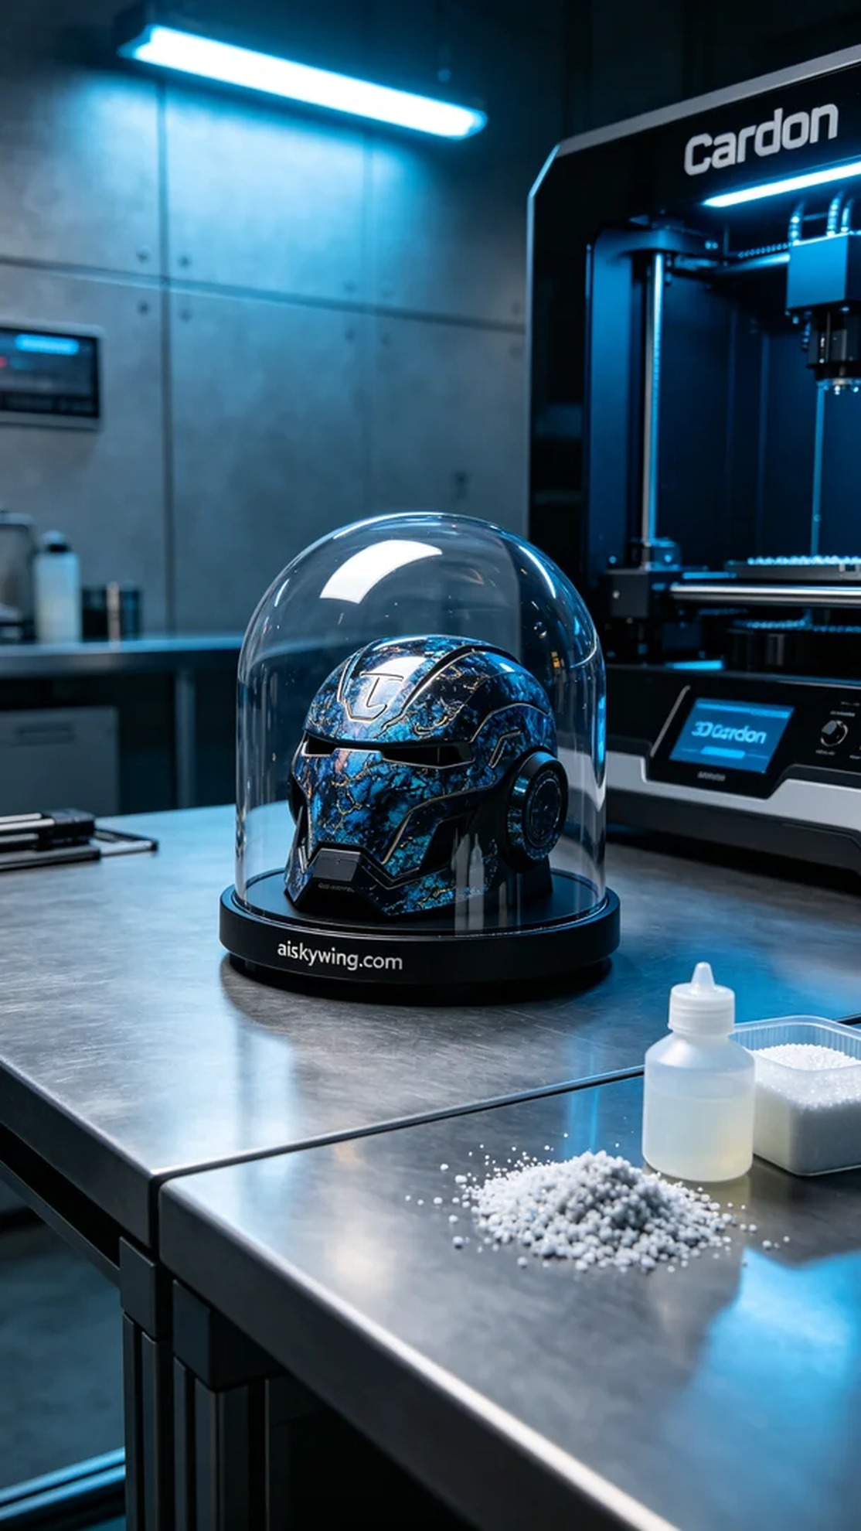
On TikTok, someone reached out to us about an issue with their product cover. They wanted a design that was both aesthetically pleasing and functional, so we took on the challenge to create the perfect product cover.
To ensure the quality of the final product, we chose SLA photopolymer resin as our material. This material has high resolution and superior surface smoothness, making it ideal for intricate details. The Carbon printer we used allows for precise printing of complex shapes, with parameters set to a layer thickness of 0.05 mm, a temperature of 25 degrees Celsius, a printing speed of 60 mm per second, a power of 1000 mW, and an estimated printing time of 8 hours.
During the printing process, the Carbon printer operated steadily, with the liquid photopolymer resin curing layer by layer under ultraviolet light. We continuously monitored the machine's performance, ensuring the adhesion strength and smoothness of each layer to achieve perfect results. As time passed, the product cover gradually took shape, and the anticipation grew.
After printing, we proceeded to post-processing. First, we placed the cover in a cleaning tank, using isopropyl alcohol to remove any uncured resin. Then, it underwent meticulous sanding to ensure a flawless surface. Finally, we cured it with UV light to enhance the product's strength and durability, subjecting it to multiple inspections to ensure every detail was perfect.
In the end, this product cover was beautifully crafted, with the engraved "aiskywing.com" logo standing out, showcasing our commitment to quality. Each print is a new challenge and an opportunity for growth.
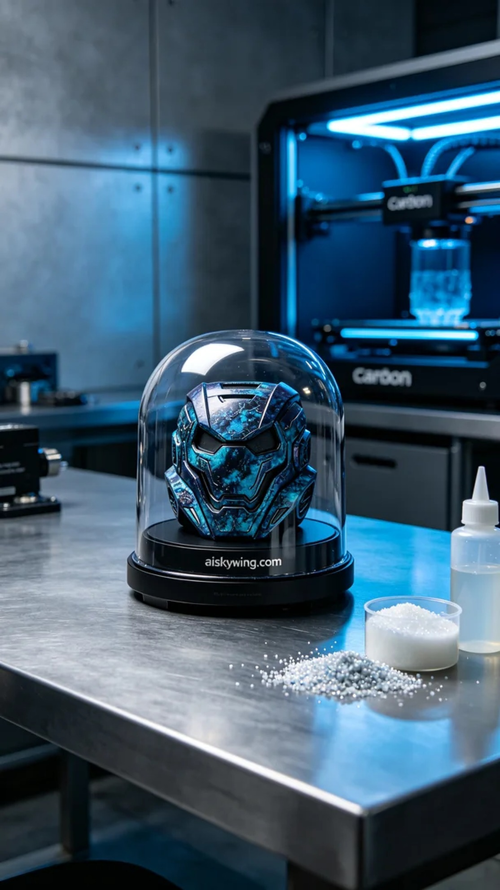
在TikTok上，有人因为产品保护罩的问题找到了我们，想要一款既美观又能有效保护产品的外壳。于是，我们便开始了这次挑战，力求将产品保护罩的设计与功能完美结合。
为了确保最终产品的质量，我们选择了SLA光固化树脂作为材料。这种材料具有高解析度和优异的表面光滑度，适合细节处理。我们使用的Carbon打印机可以精确打印出复杂的形状，打印参数设置为层厚0.05毫米，温度设定为25摄氏度，打印速度为60毫米每秒，功率为1000毫瓦，预计打印时间为8小时。
打印过程中，Carbon打印机运行稳定，液态光敏树脂在紫外线照射下逐层固化。我们时刻监控设备的运行状态，确保每一层的粘接强度和光滑度，力求达到完美效果。随着时间的推移，产品保护罩逐渐成型，令人十分期待。
打印完成后，我们进入了后处理工序。首先，将保护罩放入清洗槽，使用异丙醇清洗去除未固化的树脂。随后，经过细致打磨，确保表面光滑无瑕疵。最后，使用UV灯进行固化，增强产品的强度和耐用性，经过多道检验，确保每个细节都尽善尽美。
最终，这款产品保护罩完美呈现，其雕刻的"aiskywing.com"字样格外清晰，展现出我们对品质的追求。每一次打印，都是一次新的挑战与成长。
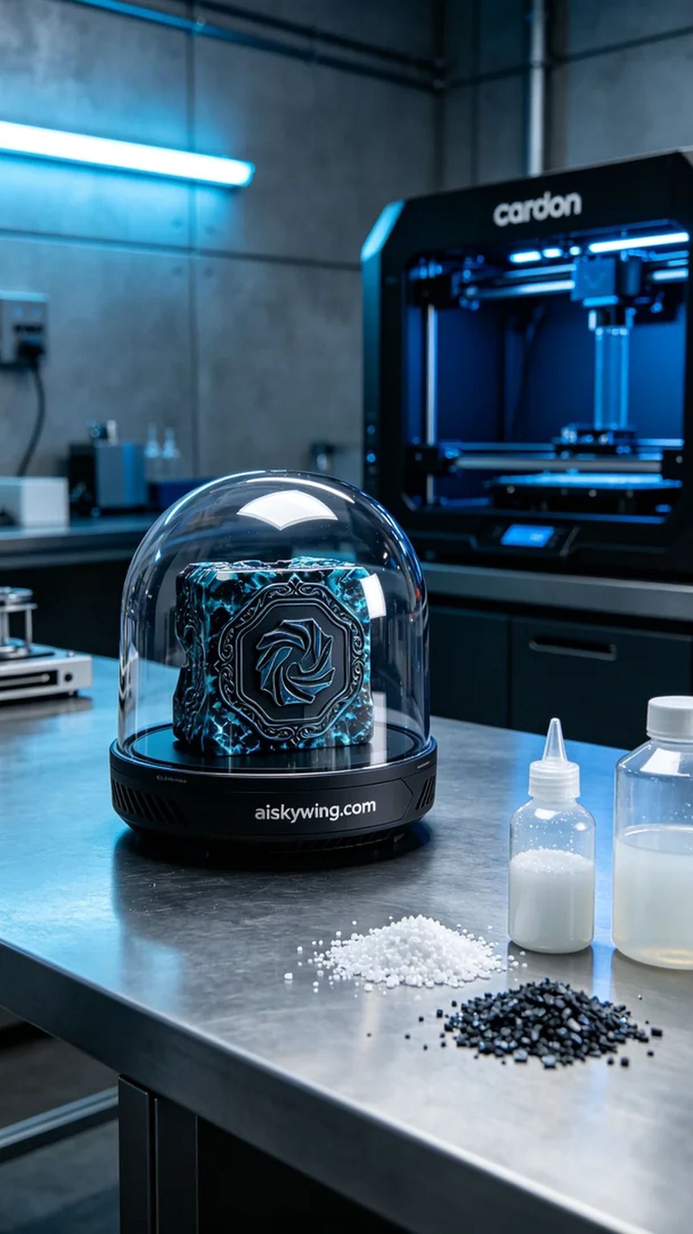
Aiskywing Industrial 3D Printing
Product protective cover


