0686-高精度3D打印产品外壳记录
Product shell
🖨️ SLS尼龙烧结
🖥️ 打印机: Systems
📦 材料: 摆放着未成型的液态光敏
生活就像3D打印，需要不断调整与尝试。最近，有人通过Twitter找到我们，希望能解决他们在制作产品外壳置于画面正中央时遇到的问题。
Life is like 3D printing; it requires constant adjustments and experimentation. Recently, someone reached out to us via Twitter, hoping to resolve the issue they encountered when trying to position their product casing in the center of the screen.
________________________________________________________________________________
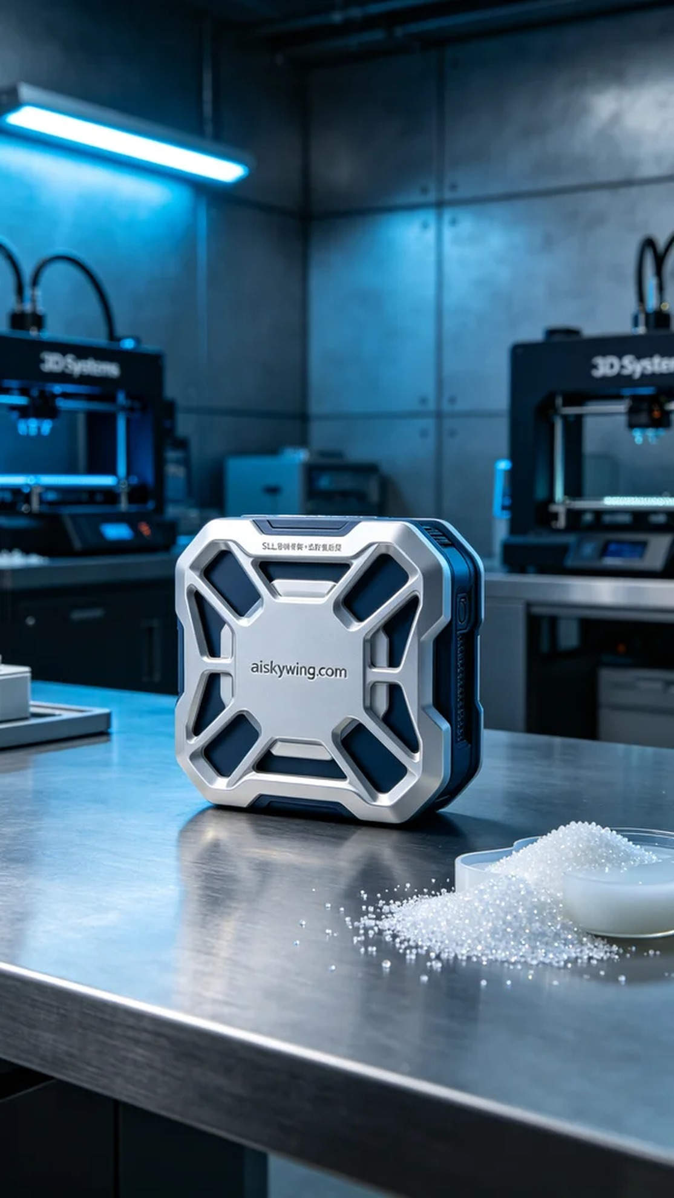
Life is like 3D printing, requiring constant adjustments and attempts. Recently, someone contacted us via Twitter seeking a solution to their issue with creating a product shell positioned at the center of the image.
The project involves the production of a product shell positioned at the center of the image. Someone reported on Twitter that they needed a shell that was both sturdy and aesthetically pleasing, capable of enduring daily wear and tear. We decided to use SLS nylon sintering to meet these requirements.
The raw material we chose was unformed liquid photopolymer resin, known for its excellent molding properties and fine surface characteristics. To ensure printing quality, we adjusted the parameters of the Systems printer: a layer thickness of 0.1mm, a temperature setting of 200 degrees Celsius, a laser power of 100 watts, and a print speed of 50mm per second, with an estimated total printing time of about 8 hours.
During the printing process, the Systems printer operated steadily, with the laser head sintering the nylon powder layer by layer. We continuously monitored the printing process to ensure uniform layer formation and avoid issues such as bubbles or misalignment. The printer's temperature control system was highly reliable, ensuring that the material was processed under optimal conditions.
After completing the print, we proceeded to post-processing. First, we removed the formed shell from the printing platform, then cleaned it to remove any uncured resin from the surface, followed by meticulous sanding to eliminate any potential burrs. Subsequently, we placed the shell in a UV curing machine to enhance its strength and durability. Finally, we conducted stringent quality inspections, ensuring that every detail met the standards.
After a series of precise manufacturing procedures, the results finally emerged. This product shell positioned at the center of the image displayed remarkable appearance and performance, satisfying the needs and earning recognition from everyone.
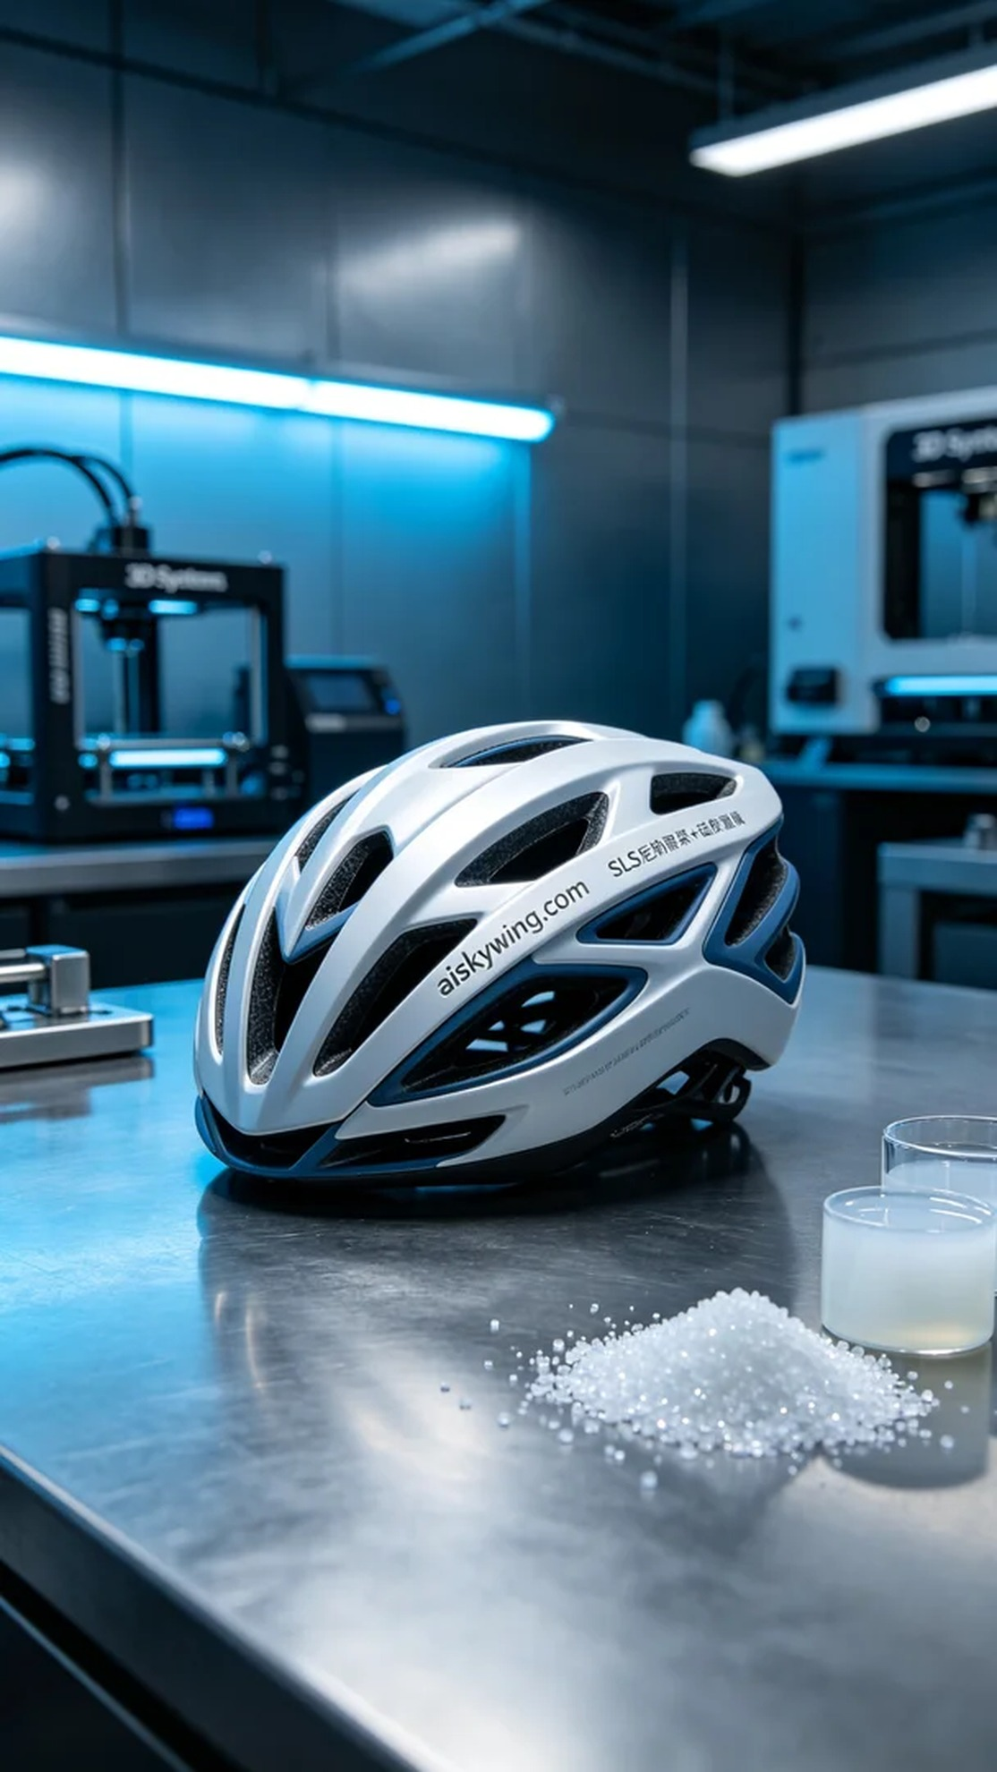
这次的项目是为一个产品外壳置于画面正中央的制作需求。有人在Twitter上反映，他们希望能得到一款外壳，既要坚固又要美观，能够承受日常使用中的各种磨损。我们决定使用SLS尼龙烧结法来满足这些要求。
我们选用的原材料为未成型的液态光敏树脂，这种材料具有极好的成型性能和细腻的表面特性。为了确保打印质量，我们调校了Systems打印机的参数：打印层厚为0.1毫米，温度设定在200摄氏度，激光功率为100瓦，打印速度为50毫米每秒，整个打印过程预计耗时约8小时。
打印过程中，Systems打印机稳稳地运行，激光头逐层烧结尼龙粉末。我们一直监控着打印进程，确保每一层都能均匀成型，避免出现气泡或错位的问题。打印机的温控系统非常可靠，保证了材料在最佳状态下被加工。
完成的打印后，我们进入后处理工序。首先将成型的外壳从打印平台上取下，然后清洗去除表面的未固化树脂，接着进行细致的打磨，以去掉可能存在的毛刺。随后，将外壳放入UV固化机中进行固化处理，确保其强度和耐用性达到最佳状态。最后，我们对成品进行了严格的质量检验，确认每个细节都符合标准。
经过一系列精密的制作程序，成果终于显现。这个产品外壳置于画面正中央，展现出出色的外观和性能，如此一来，不仅满足了需求，也赢得了大家的认可。
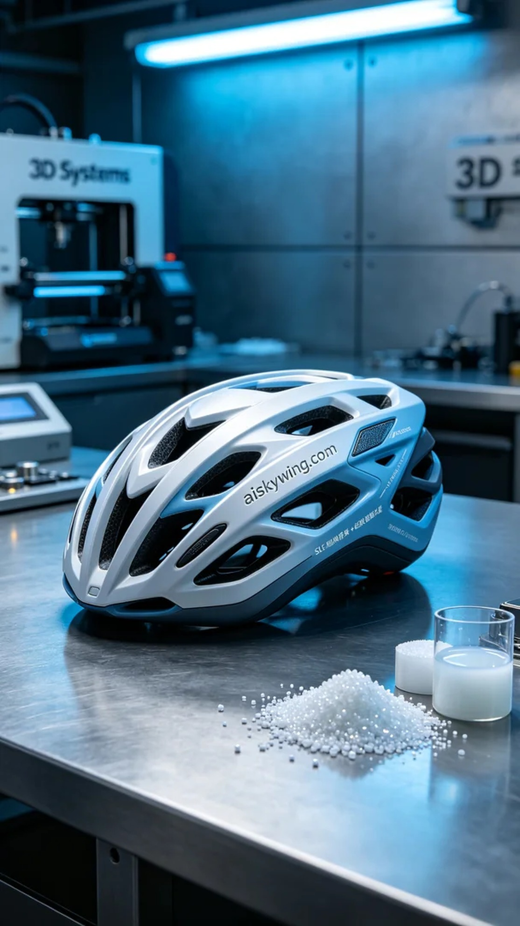
Aiskywing Industrial 3D Printing
Product shell


