0688-产品手柄的3D打印生产记录
Product handle
🖨️ SLA光固化
🖥️ 打印机: HP
📦 材料: SLA
在Instagram上看到有人因为缺乏个性化的产品手柄而烦恼，于是我们接下了这个项目，致力于打造出一款独特的产品手柄。
I saw on Instagram that someone was frustrated by the lack of personalized product handles, so we took on this project to create a unique product handle.
________________________________________________________________________________
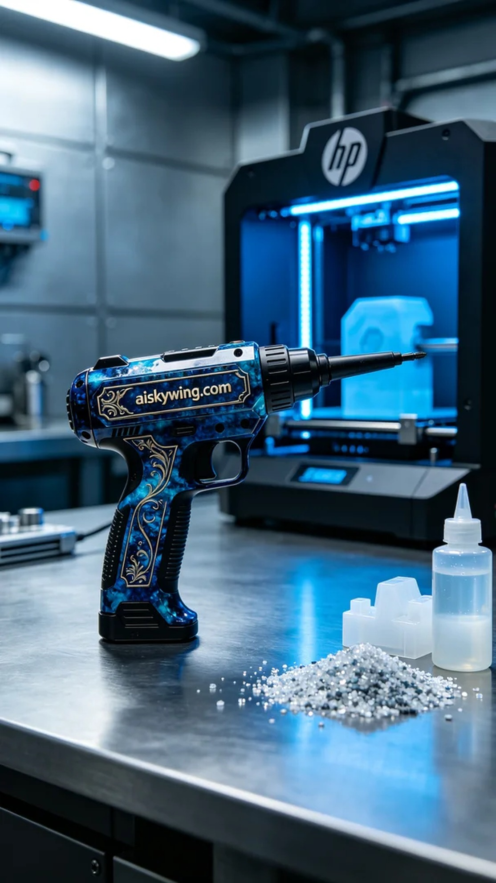
The project originated from a friend on Instagram who was struggling to find a personalized product handle in a market filled with sameness. After some discussion, we decided to use SLA (Stereolithography) technology combined with customized surface engraving to meet his needs.
For materials, we chose high-quality SLA photopolymer resin, known for its excellent detail and transparency after printing. We prepared the HP brand 3D printer, setting the parameters to a layer thickness of 0.05mm, a printing temperature of 25 degrees Celsius, a power level of 60%, and a printing speed of 30mm/s, estimating the print time to be about 3 hours. This setup ensures high-quality outputs for the handle.
During the printing process, the HP printer operated efficiently and steadily, allowing the resin to flow evenly, while monitoring showed good print quality. We kept a close watch on every detail to ensure there were no air bubbles or defects, ultimately achieving the desired design.
Post-processing was equally crucial. Once printing was complete, we placed the handle in a cleaning tank, using isopropyl alcohol to remove any uncured resin from the surface. After cleaning, the handle was carefully sanded to eliminate any possible flaws. Next, we proceeded with UV curing to ensure the surface reached optimal strength, followed by a thorough inspection to confirm that all details were flawless.
After a series of meticulous processes, we successfully completed the personalized product handle. It not only showcased our team’s technical prowess but also provided a unique user experience for our friend.
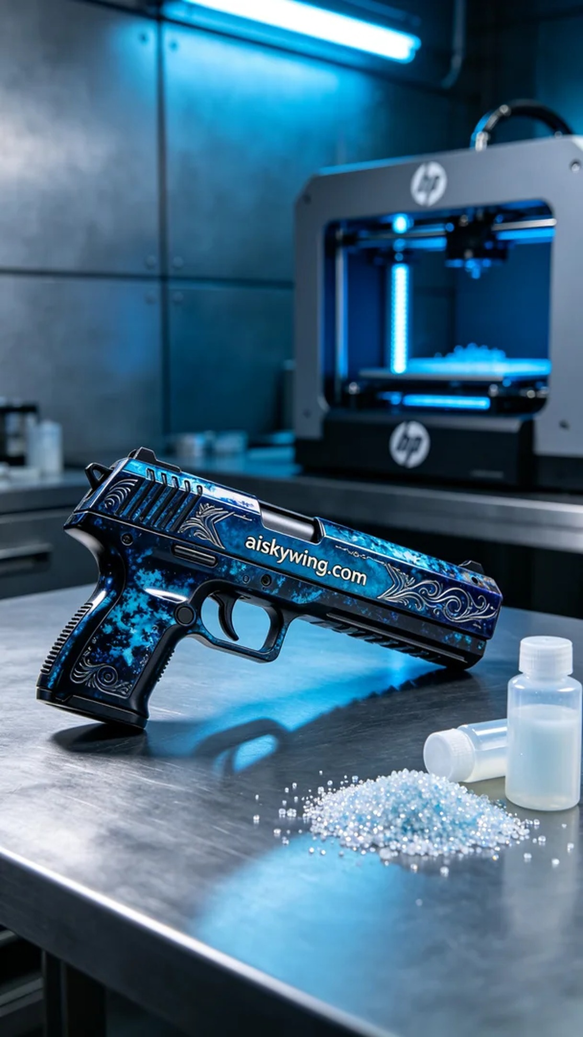
这次的项目源于Instagram上的一位朋友，他希望能够拥有一款个性化的产品手柄，面临着市场上同质化严重的问题。在经过沟通后，我们决定采用SLA光固化技术，结合个性化的表面雕刻，来满足他的需求。
原材料方面，我们选用了高质量的SLA光敏树脂，这种材料在打印后能展现出极佳的细节和透明感。准备好HP品牌的3D打印机，设置参数为层厚0.05mm，打印温度为25摄氏度，功率维持在60%，打印速度设为30mm/s，预计打印时间为约3个小时。这样的设置能确保打印出高质量的手柄。
打印过程中，HP打印机高效稳定地运行，树脂均匀流动，监控显示打印质量良好。我们时刻关注打印的每个细节，确保没有气泡和缺陷出现，最终完美还原了设计效果。
后处理工序同样至关重要。打印完成后，我们将手柄放入清洗槽，使用异丙醇进行清洗，以去除表面的未固化树脂。清洗完成后，手柄被取出，并小心地进行打磨，以消除任何可能的瑕疵。接下来，进行UV固化，确保手柄的表面达到最佳强度，最后进行检查，确保所有细节完美无缺。
经过一系列精细的工序，最终完成了这款个性化的产品手柄。它不仅展示了我们团队的技术实力，也为朋友带来了独特的使用体验。
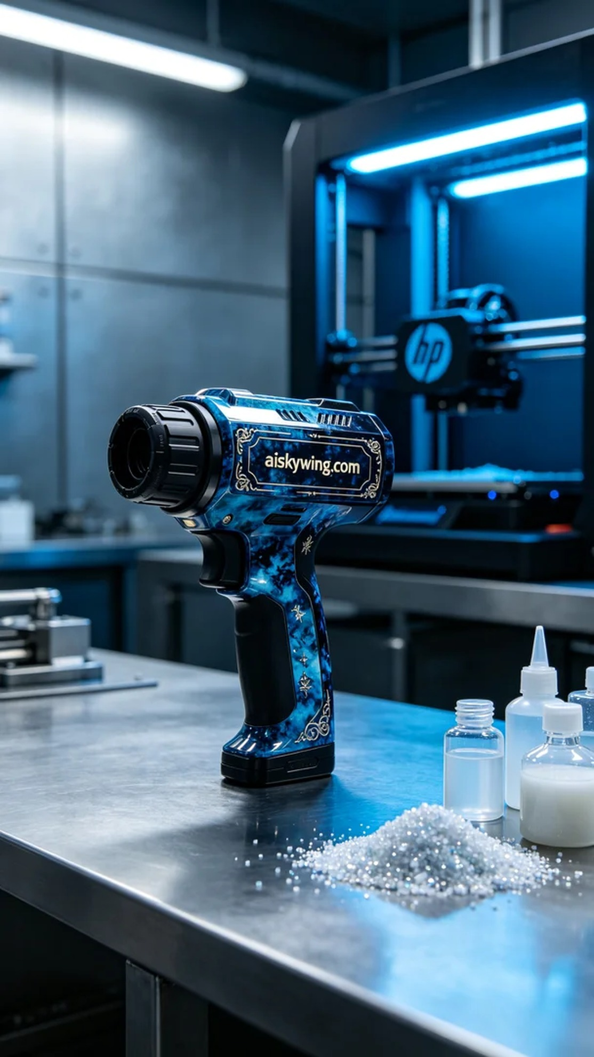
Aiskywing Industrial 3D Printing
Product handle


