0689-精准制作的产品支架
Product bracket
🖨️ SLA光固化
🖥️ 打印机: Mimaki
📦 材料: SLA
在Instagram上，有人因为寻找合适的展示方案而找到了我们。于是，我们开始了这次关于产品支架的制作之旅。
On Instagram, someone found us while searching for a suitable display solution. Thus, we embarked on this journey of creating product stands.
________________________________________________________________________________
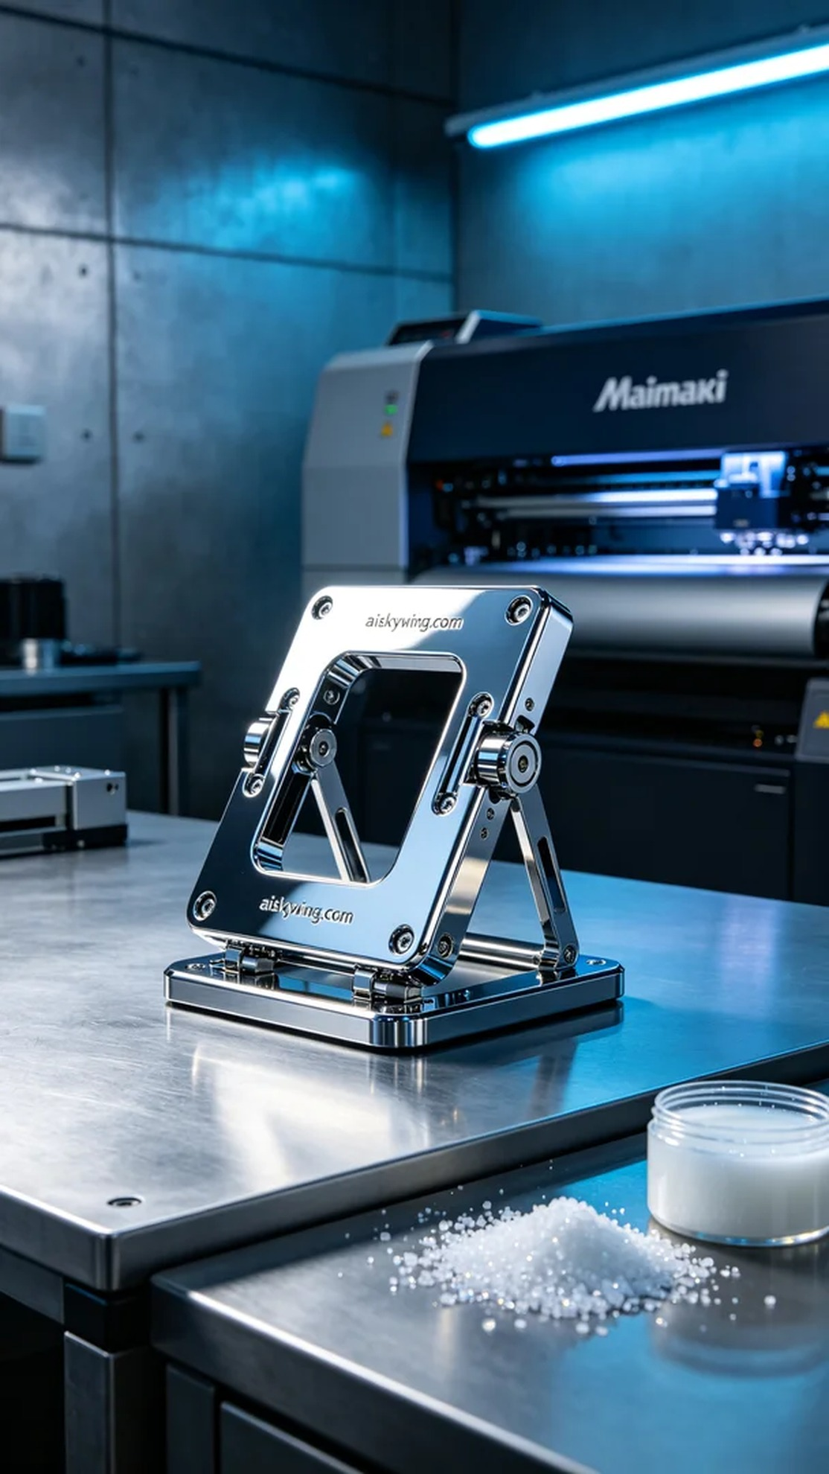
We received an interesting project where people were looking for a perfect display solution for their products. This product stand not only needed to be sturdy and durable but also had to provide a sophisticated visual appeal, so we decided to use SLA (Stereolithography) technology, which offers extreme detail and a smooth surface.
In our preparation, we selected the Mimaki 3D printer for the printing process, utilizing high-quality SLA resin. According to the design requirements of the product stand, we set the printing parameters to a layer thickness of 0.05mm, a printing temperature of 25°C, a power setting of 55%, and a printing speed of 20mm per second. The entire printing process was expected to take about 8 hours, ensuring we could achieve the fine details required.
During the printing process, the Mimaki printer operated steadily, and we continuously monitored the printing quality to ensure each layer was perfectly aligned. As time progressed, the stand gradually took shape, featuring a smooth surface and clear details, successfully reflecting every aspect of the design blueprint.
Once the printing was completed, we conducted a thorough post-processing procedure. First, we placed the printed piece in a cleaning tank, using specialized cleaning solutions to remove any residual liquid resin. After cleaning, we performed sanding to ensure that every edge of the product was smooth and flawless. Finally, the finished product was placed in a UV curing machine to enhance its strength and durability. After a series of rigorous inspections, we confirmed that the product stand met our high standards.
Ultimately, we successfully presented this product stand to those in need. Every detail was perfectly showcased, proving our expertise in the field of 3D printing.
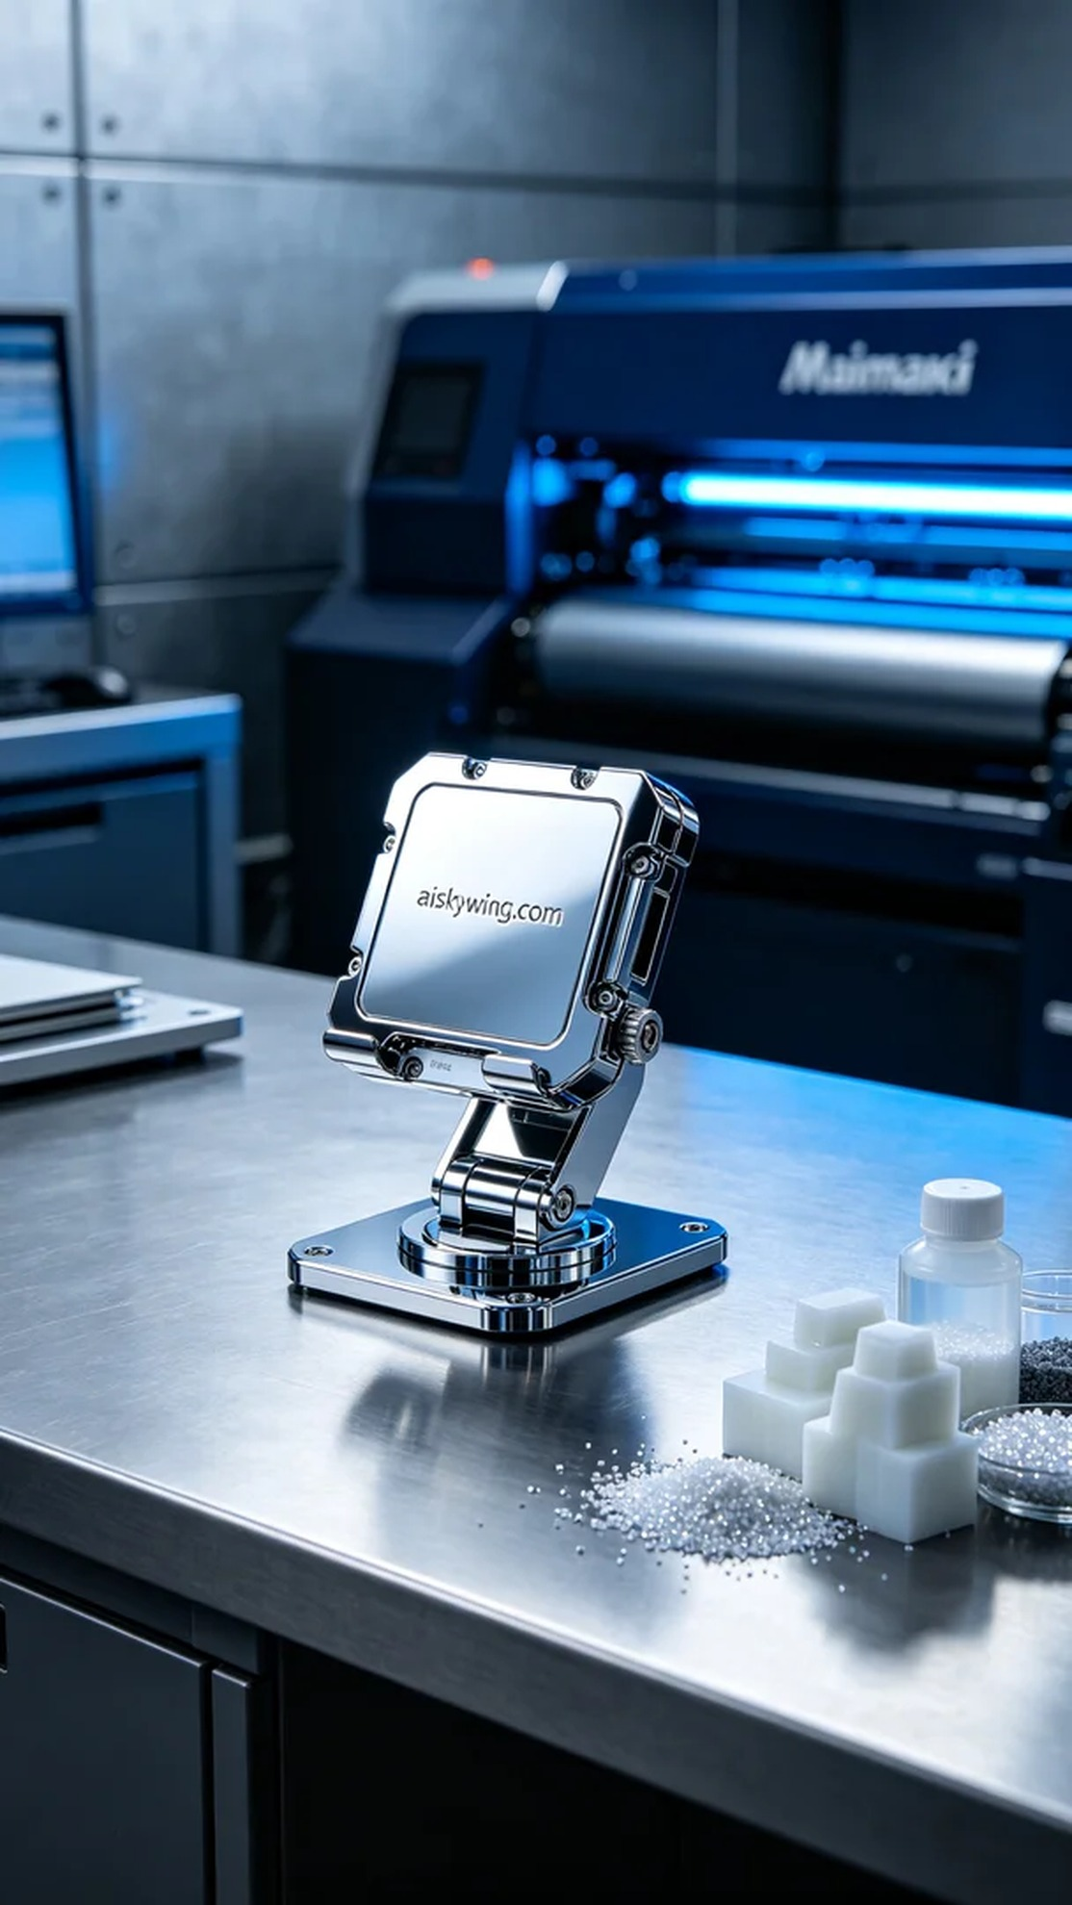
我们接到一个有趣的项目，人们希望制作一个能够完美展示他们产品的支架。这个产品支架不仅要坚固耐用，还要在视觉上给人一种高级感，因此，我们决定采用SLA光固化技术，这项技术能够提供极致的细节和光滑的表面。
在准备工作中，我们选择了Mimaki的3D打印机进行打印，使用的是高质量的SLA树脂。根据产品支架的设计需求，我们将打印参数设置为层厚0.05毫米，打印温度为25摄氏度，功率设定为55%，打印速度调整为20毫米每秒。整个打印过程预计耗时大约8小时，这确保了我们可以得到精细的产品细节。
打印过程中，Mimaki打印机稳定运行，我们时刻监控打印质量，确保每一层的完美叠加。随着时间的推移，支架逐渐成型，表面光滑，细节清晰，成功地反映出设计图纸的每一处细节。
完成打印后，我们进行了详细的后处理工序。首先，将打印件放入清洗槽中，使用专用清洗液去除残留的液态树脂。清洗完成后，我们进行打磨处理，确保产品的每个边缘都光滑无瑕。最后，将成品放在UV固化机中进行固化，以增强其强度和耐用性。经过一系列严格的检验后，我们确认产品支架的质量达到了我们的高标准。
最终，我们成功地将这个产品支架呈现给了有需求的人们。每一个细节都被完美呈现，证明了我们在3D打印领域的专业能力。
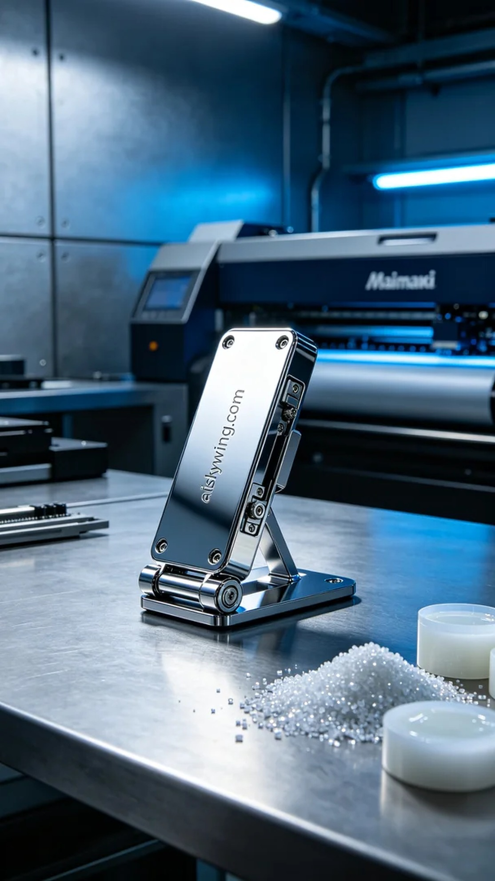
Aiskywing Industrial 3D Printing
Product bracket


