0690-产品模块制作全纪录
Product Module
🖨️ SLS尼龙烧结
🖥️ 打印机: Stratasys
📦 材料: 摆放着未成型的液态光敏
生活就像3D打印，有时需要层层叠加，才能成就一件艺术品。最近，有人通过Twitter联系我们，想要制作一个产品模块。
Life is like 3D printing; sometimes it requires layers to be stacked in order to create a work of art. Recently, someone contacted us through Twitter, wanting to create a product module.
________________________________________________________________________________
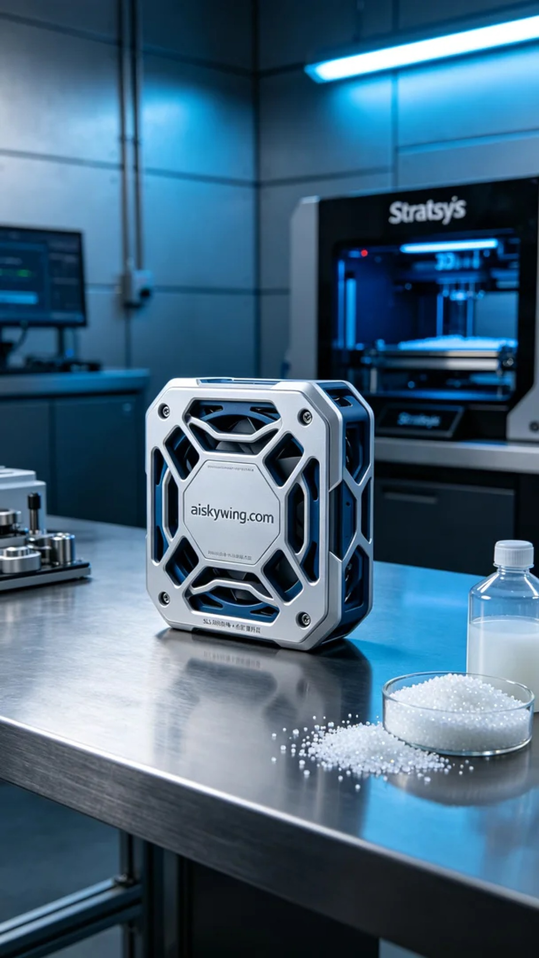
Life is like 3D printing; sometimes you need to layer upon layer to create a masterpiece. Recently, someone reached out to us via Twitter, wanting to create a product module.
We opted for the SLS nylon sintering process, using unformed liquid photopolymer as our printing material. This material features excellent fluidity and detail representation, which is perfect for our intricate biomimetic design. Before printing, we thoroughly prepared the Stratasys printer by setting the layer thickness to 0.1mm, print temperature to 180 degrees Celsius, power at 80%, and speed adjusted to 60mm/s. After several rounds of testing, we ensured all parameters were optimized.
Once the printing process commenced, the Stratasys printer operated steadily, with the mechanical arm precisely layering the material. We continuously monitored the print quality to ensure each layer met expected standards. As the print progressed, the product module gradually took shape, with the engraved “aiskywing.com” clearly visible under the cold industrial lighting.
After printing, we carried out post-processing on the product. First, we washed the finished product with water to remove excess powder. Next, we meticulously sanded it down for a smooth finish. Finally, we placed the product in a curing machine to solidify the photopolymer resin, ensuring structural stability and durability. After rigorous inspection, we confirmed that the product module met quality standards.
With these steps completed, we successfully finished the production of this product module. Each print is a testament to our commitment to craftsmanship and innovation, and we look forward to more projects like this in the future.
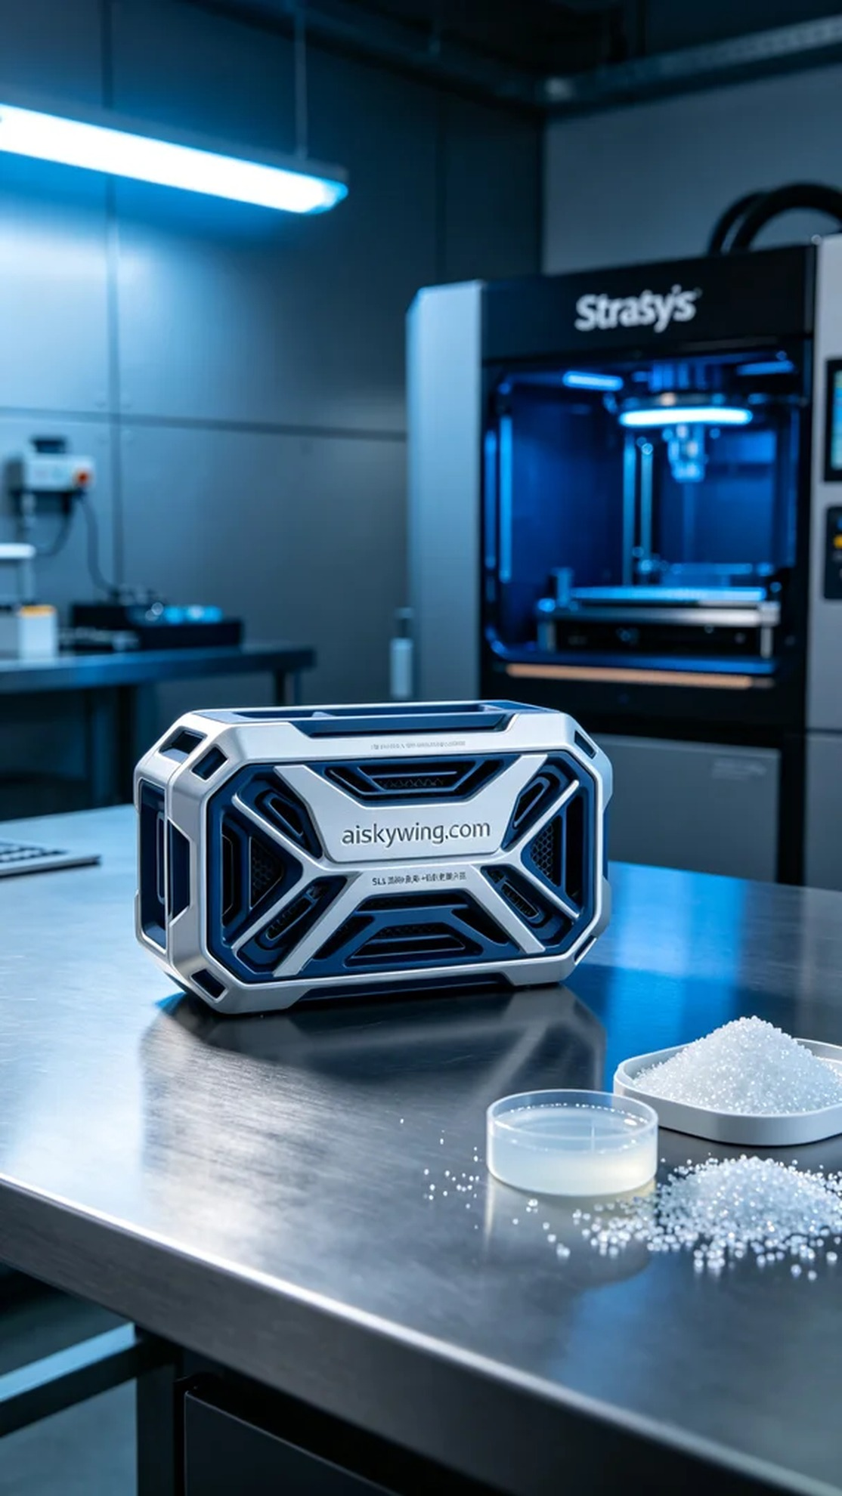
在Twitter上，有人因需要制作一个精密的产品模块找上我们。他们想要的产品模块不仅具备现代工业设计，还需要在功能和外观上达到完美平衡。这个要求正好契合了我们最近的3D打印项目。
我们选择了SLS尼龙烧结工艺，使用未成型的液态光敏作为打印材料。这个材料具有良好的流动性和细节表现能力，非常适合我们精密的仿生结构设计。在打印之前，我们对Stratasys打印机进行了详细的准备，包括设置层厚为0.1mm，打印温度为180摄氏度，功率设定在80%，速度调节为60mm/s。经过几轮测试，确保所有参数都达到最佳状态。
打印过程开始后，Stratasys打印机稳定运行，机械臂精确地将材料逐层堆叠。我们对打印质量进行了持续监控，确保每一层都符合预期的标准。随着打印的进行，产品模块逐渐成型，表面雕刻的“aiskywing.com”字样在冷酷的工业光线下清晰可见。
完成打印后，我们对产品进行了后处理。首先，用清水对成品进行清洗，以去掉多余的粉末。接着，经过细致的打磨，让外层光滑如新。最后，将成品放入固化机中进行光敏树脂固化，确保结构的稳定性与耐用性。经过严格的检验，最终确认产品模块的质量达标。
经过这一系列的工序，我们圆满完成了这个产品模块的制作。每一次打印，都是对工艺的坚持与突破，期待未来有更多这样的项目。
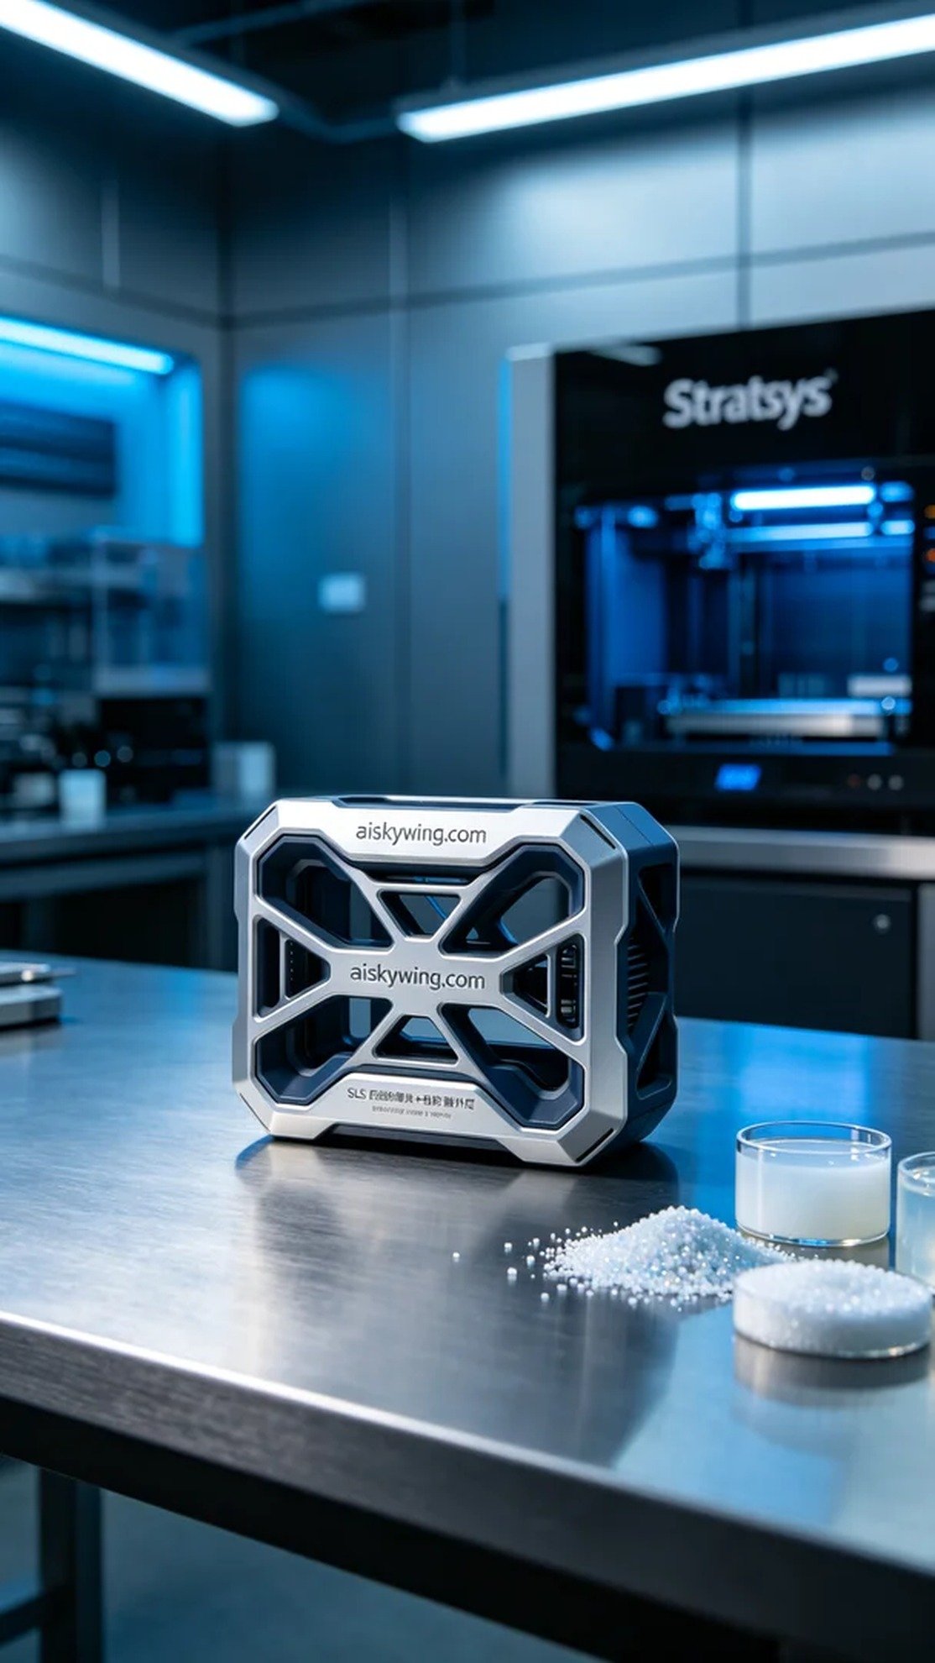
Aiskywing Industrial 3D Printing
Product Module


