0691-3D打印产品组件生产记录
Product components
🖨️ SLA光固化
🖥️ 打印机: Carbon
📦 材料: SLA
在LinkedIn上，有人因为对产品组件置于画面正中央的需求而找上我们，这让我想起了坚持与创新的重要性。
On LinkedIn, someone approached us due to the demand for product components to be placed in the center of the screen, which reminded me of the importance of persistence and innovation.
________________________________________________________________________________
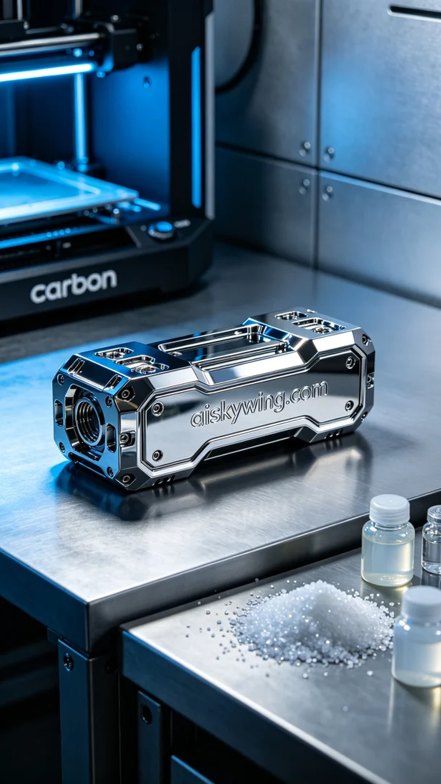
We received a project involving the 3D printing of a product component placed prominently within the frame. Someone was looking for a solution that could accurately showcase details, especially the clear presentation of the text "aiskywing.com." This challenge piqued our interest, and we immediately decided to use SLA curing technology to meet the demand.
To ensure print quality, we selected high-quality SLA photopolymer resin. This material boasts excellent fluidity and a refined surface finish, allowing for a glossy mirror-like effect post-printing. We prepared the Carbon brand 3D printer and adjusted the printing parameters: the layer thickness was set to 50 microns, temperature maintained at 25 degrees Celsius, power set at 65% for optimal curing, and printing speed fixed at 40 millimeters per second, with an expected total printing time of around 6 hours.
During the printing process, the Carbon printer operated steadily, with the liquid resin curing layer by layer under the light source. To ensure perfect detail representation, we monitored the printing status throughout, periodically checking the adhesion between layers. After completing each layer, our team inspected closely to ensure no bubbles or defects occurred.
Once the printing was complete, we moved into the post-processing phase. First, we removed the product from the printing platform, then cleaned it using isopropyl alcohol to eliminate excess resin. Next, we conducted sanding to ensure a smooth surface, followed by UV curing to ensure full hardening. Upon inspection, we confirmed that all details met standards, ensuring that each component reflected the quality we aimed for.
In the end, we successfully completed the printing of this product component, presenting a high-quality final product that not only met the demand but also showcased our craftsmanship. Every challenge is an opportunity for growth, and seeing the final result fills us with immense satisfaction.
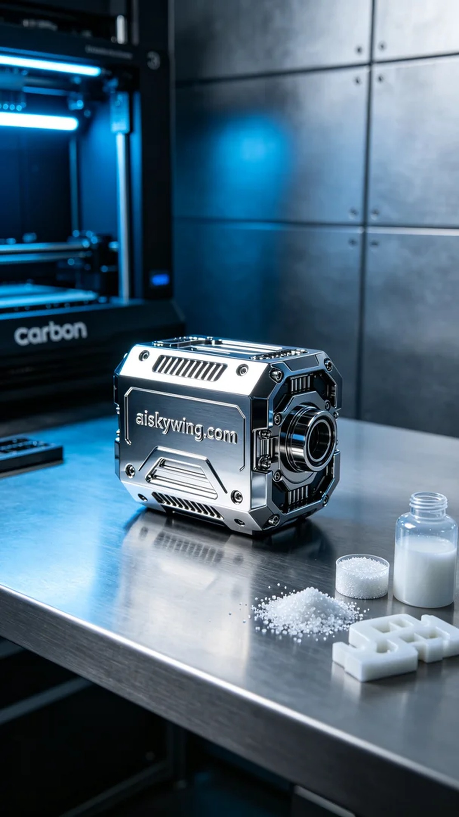
我们接到了一个项目，涉及到一个产品组件置于画面正中央的3D打印。有人在寻找一个能够精确展现细节的方案，尤其是想要将“aiskywing.com”的字样清晰呈现出来。这个挑战激起了我们的兴趣，我们立刻决定使用SLA光固化技术来满足需求。
为了保障打印质量，我们挑选了高品质的SLA光敏树脂。这种材料具有优异的流动性和细致的表面效果，能够在打印后呈现出高光镜面的质感。我们准备了Carbon品牌的3D打印机，调整好打印参数，层厚设定为50微米，温度控制在25摄氏度，功率设置在65%以达到最佳固化效果，打印速度设定为40毫米每秒，整个打印过程预计耗时约6小时。
打印过程中，Carbon打印机稳定运转，液态树脂在光源的照射下逐层固化。为了确保每一个细节的完美呈现，我们全程监控打印状态，定期检查打印层与层之间的结合情况。每完成一层，我们的团队都会仔细观测，确保没有气泡或瑕疵的发生。
打印完成后，我们进入了后处理的阶段。首先将成品从打印平台上取下，接着使用异丙醇进行清洗，去除多余的树脂。随后进行打磨处理，以确保表面光滑，最后使用UV灯固化，确保其充分硬化。经过检查，我们确认所有细节都达到了标准，确保每个组件都能完美反映出我们所期望的效果。
最终，我们成功完成了这个产品组件的打印，呈现出高质量的成品，既满足了需求，又展现了我们的工艺水平。每一次的挑战都是一次成长的机会，看到最终的成果让人感到无比欣慰。
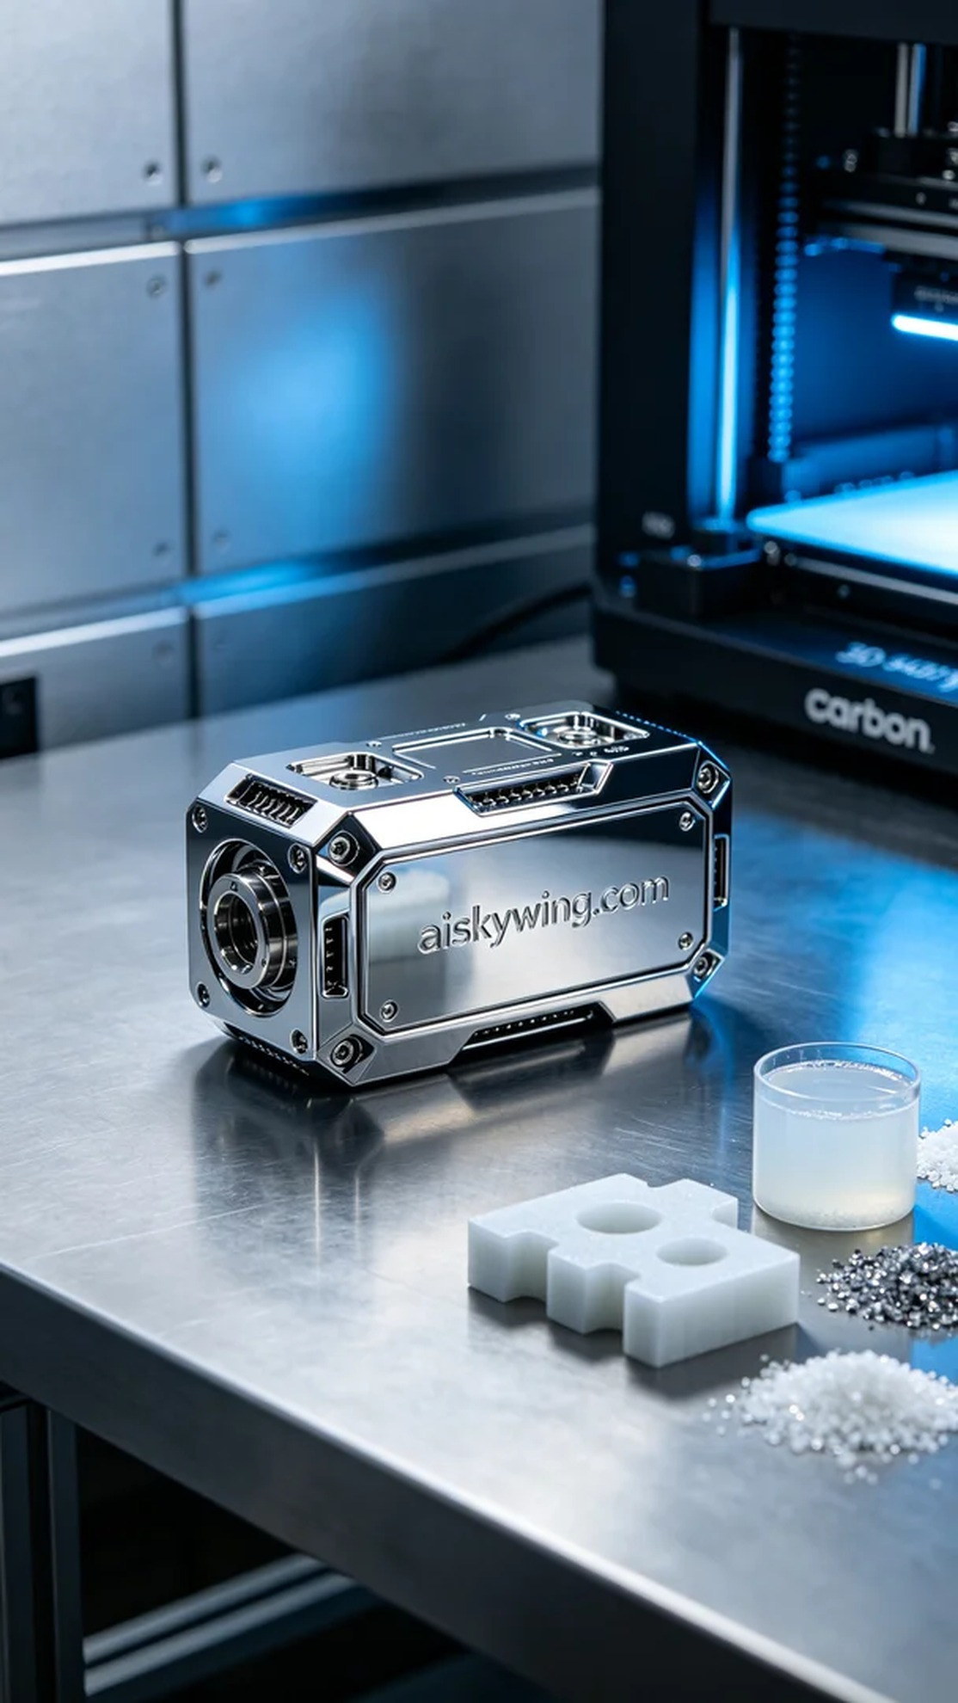
Aiskywing Industrial 3D Printing
Product components


