0692-产品连接件3D打印记录
Product connector
🖨️ SLM金属打印
🖥️ 打印机: Carbon
📦 材料: 摆放着未成型的液态光敏
生活再难，也别停下脚步。就像接下这个产品连接件的单子，灵感总在挑战中迸发。
No matter how difficult life gets, don't stop moving forward. Just like taking on the order for this product connector, inspiration always bursts forth in the face of challenges.
________________________________________________________________________________
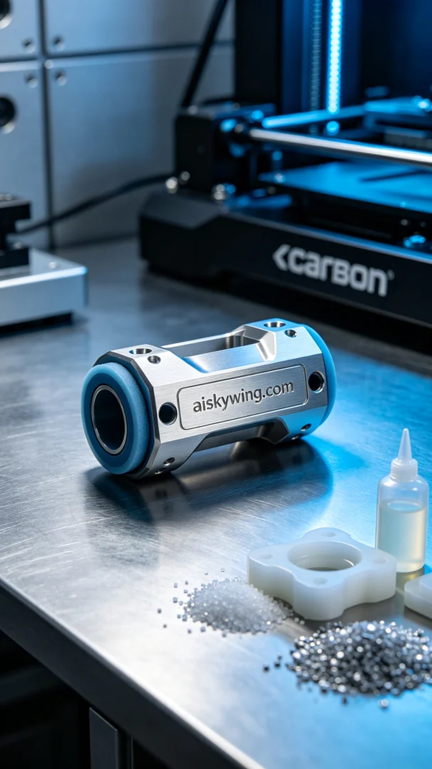
Recently, someone found us through YouTube, reporting issues with their product connector's application. They wanted us to help design and print a more durable and efficient connector. This is exactly our forte.
To ensure the quality of the final product, we chose to use unformed liquid photopolymer as our raw material, which has excellent flow properties and molding precision. With the Carbon printer, we set the layer thickness to 0.1 mm, maintained the temperature at 25°C, adjusted the power to 80%, and controlled the speed at 40 mm/s, estimating a printing time of 8 hours to ensure every detail is perfectly presented.
During the printing process, the Carbon printer operated smoothly, with the liquid photopolymer being precisely cured layer by layer through targeted light exposure, constructing the delicate connector. We monitored the quality throughout, ensuring there were no bubbles or defects, and kept a close eye on the printer's status and progress to maintain optimal working conditions.
After printing, we carried out detailed post-processing. First, the formed parts were placed in a washing tank with a cleaning solution to remove excess photopolymer from the surface. Then, we sanded the surface with fine sandpaper to ensure smoothness. Finally, we put them into a curing chamber, applying UV light curing to ensure strength and durability, confirming no issues before shipment.
The printed product connector received positive feedback, demonstrating our technical strength and rigorous attitude toward product quality. Each print is a new challenge, and we are always moving forward on this path.
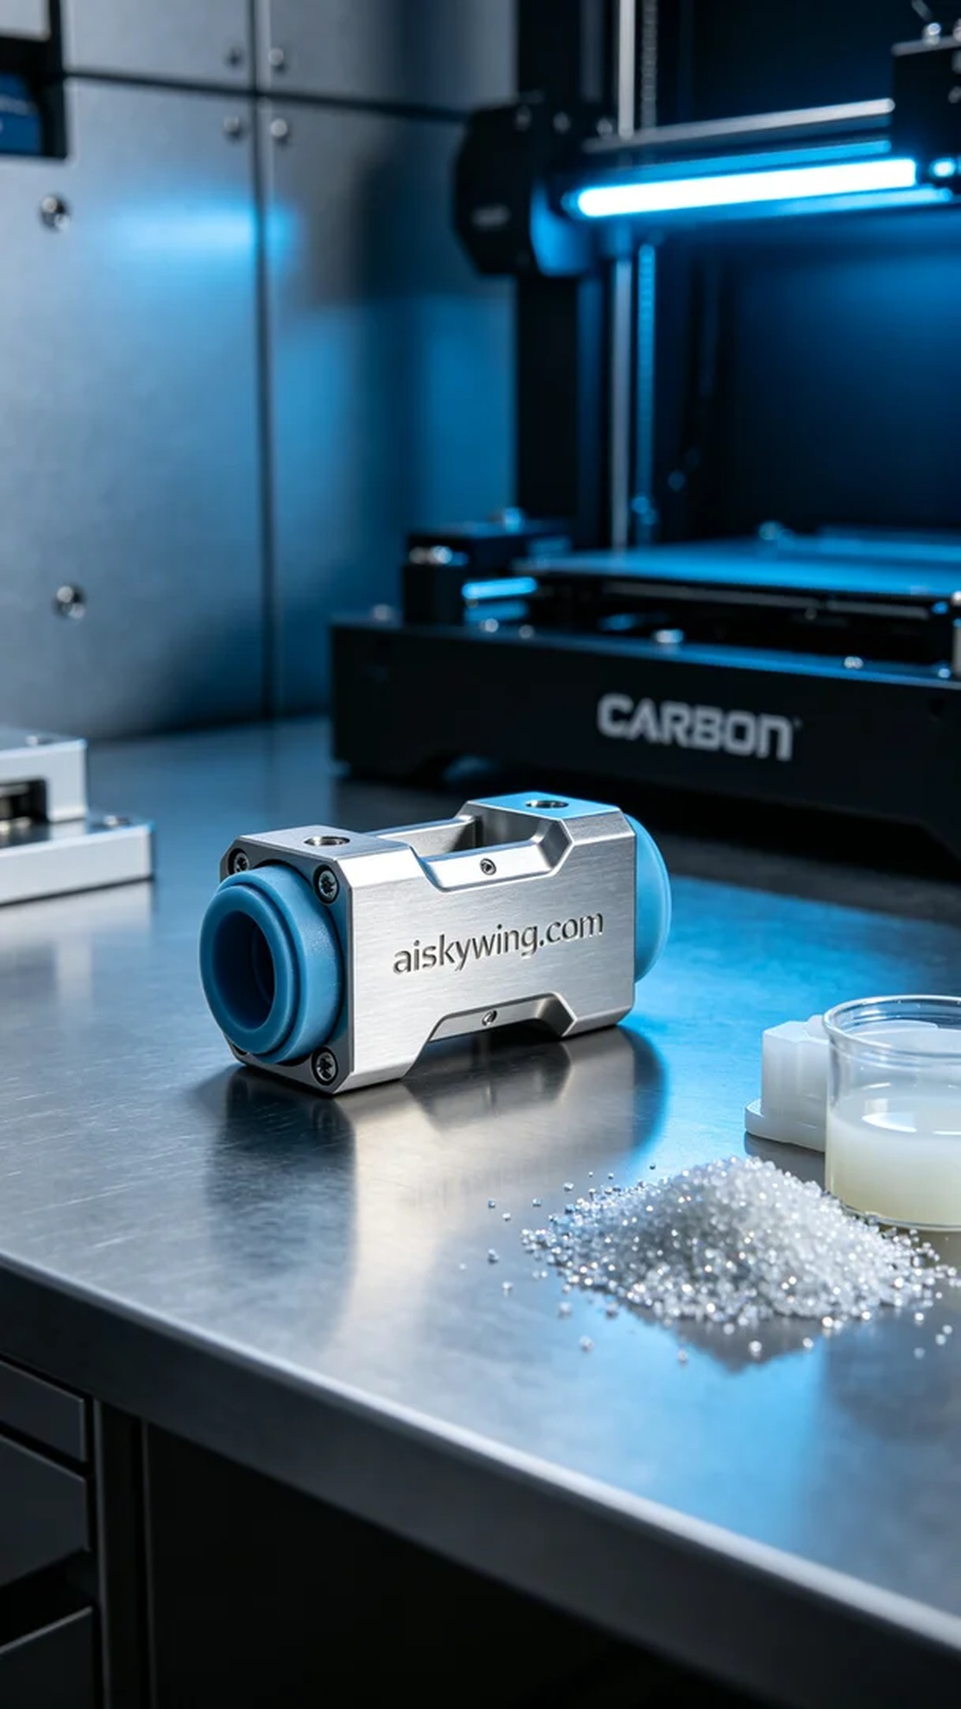
最近有人通过YouTube找到我们，反映他们在产品连接件的应用中遇到了一些问题，想要我们帮助设计和打印一款更为坚固且高效的连接件。这不就是我们的强项吗？
为了确保最终产品的质量，我们选择了摆放着未成型的液态光敏作为原材料，具备优良的流动性和成型精度。同时，使用Carbon打印机，设置层厚为0.1毫米，温度保持在25℃，功率调至80%，打印速度控制在40毫米/秒，预计打印时间为8小时，这样可以确保每一个细节都能完美呈现。
在打印过程中，Carbon打印机运行平稳，液态光敏树脂通过精准的光照固化，逐层构建出精致的连接件。我们全程进行质量监控，确保无任何气泡和瑕疵，观察打印机的状态和进度，确保机器始终处于最佳工作状态。
打印完成后，我们进行了详细的后处理工序。首先将成型件放在清洗槽中，用清洗液去除表面多余的光敏树脂，随后使用细砂纸进行打磨，确保表面平滑。最后，将其放入固化箱中，采用UV光固化技术进行全面固化，确保其强度和耐用性，通过检验确认无误后方可出货。
此次打印的产品连接件得到了很好的反馈，展现了我们的技术实力和对产品质量的严谨态度。每一次的打印都是一个新的挑战，而我们永远在这条路上不断前行。
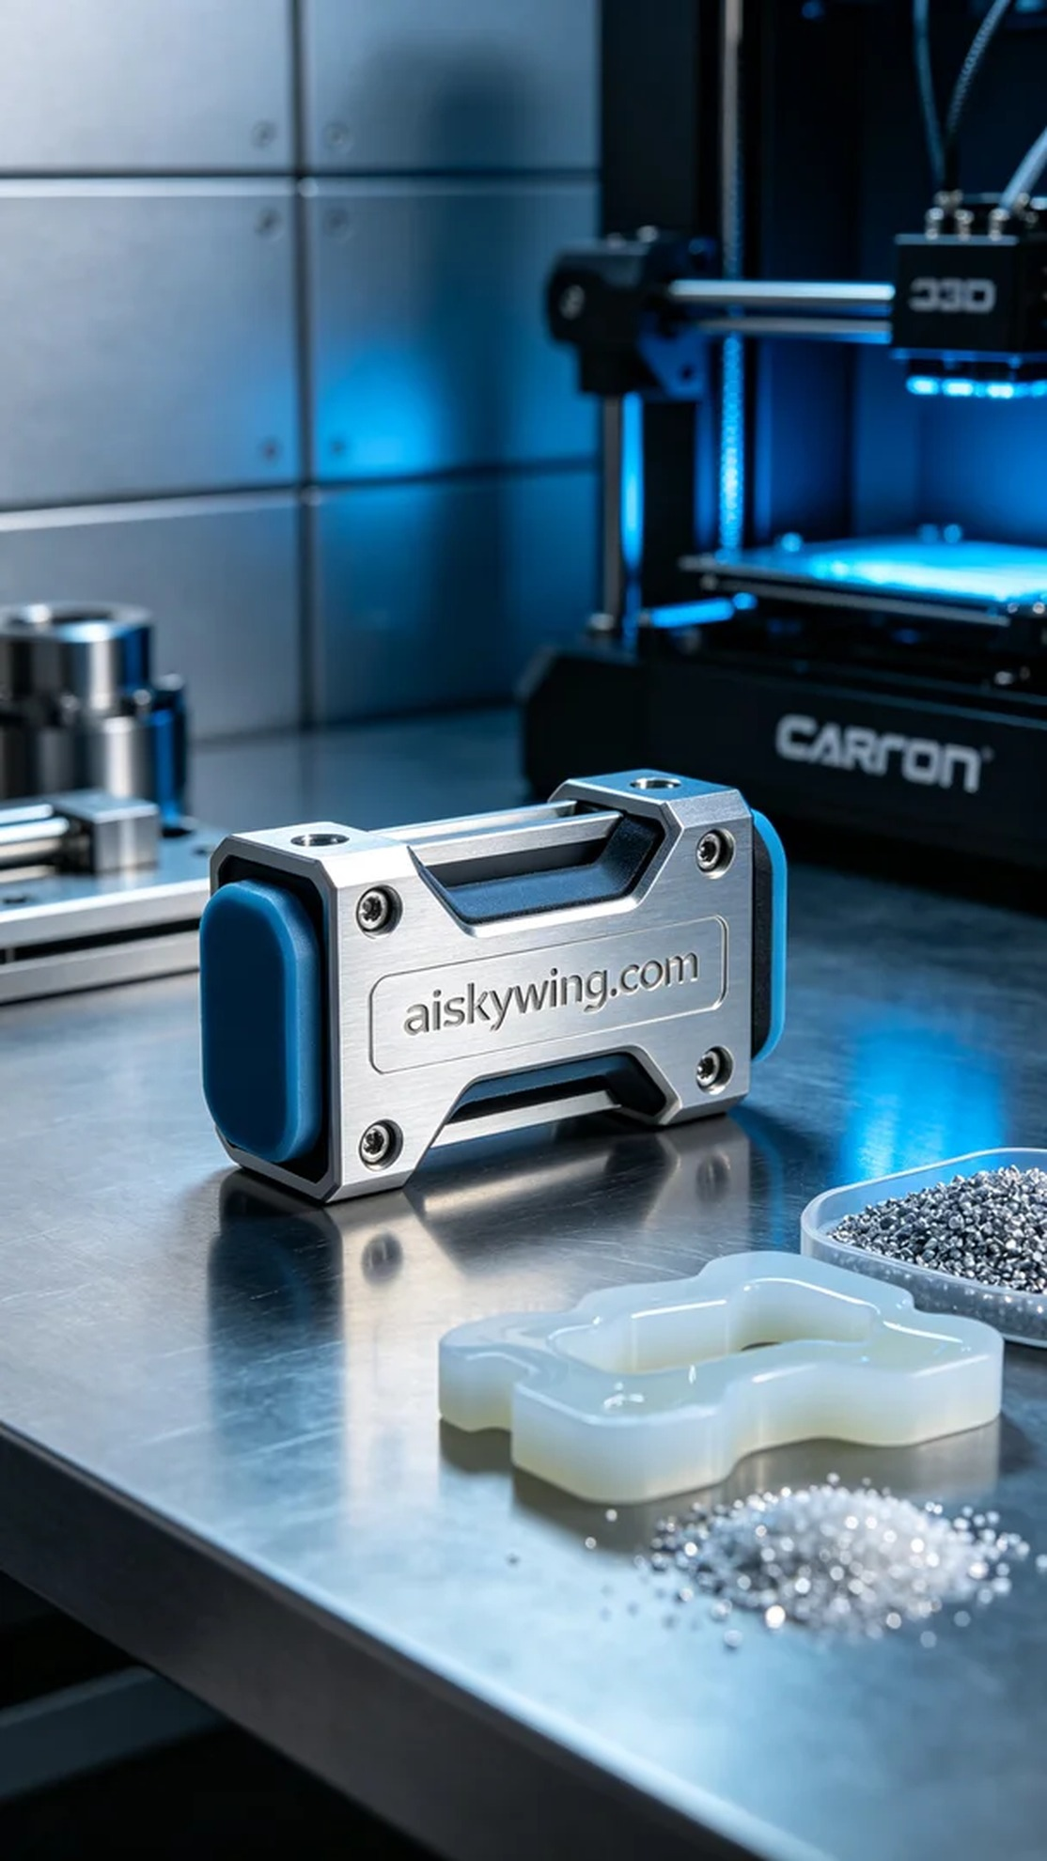
Aiskywing Industrial 3D Printing
Product connector


