0695-J型密封圈的3D打印生产记录
J-type sealing ring
🖨️ 硅胶复模
🖥️ 打印机: Voxeljet
📦 材料: 硅胶复模
生活中的每一个小细节，都是成就大事的基石。接到这个J型密封圈的订单，我深感其中的责任和信任。
Every little detail in life is the cornerstone of achieving great things. Receiving this order for the J-shaped sealing ring, I feel a deep sense of responsibility and trust.
________________________________________________________________________________
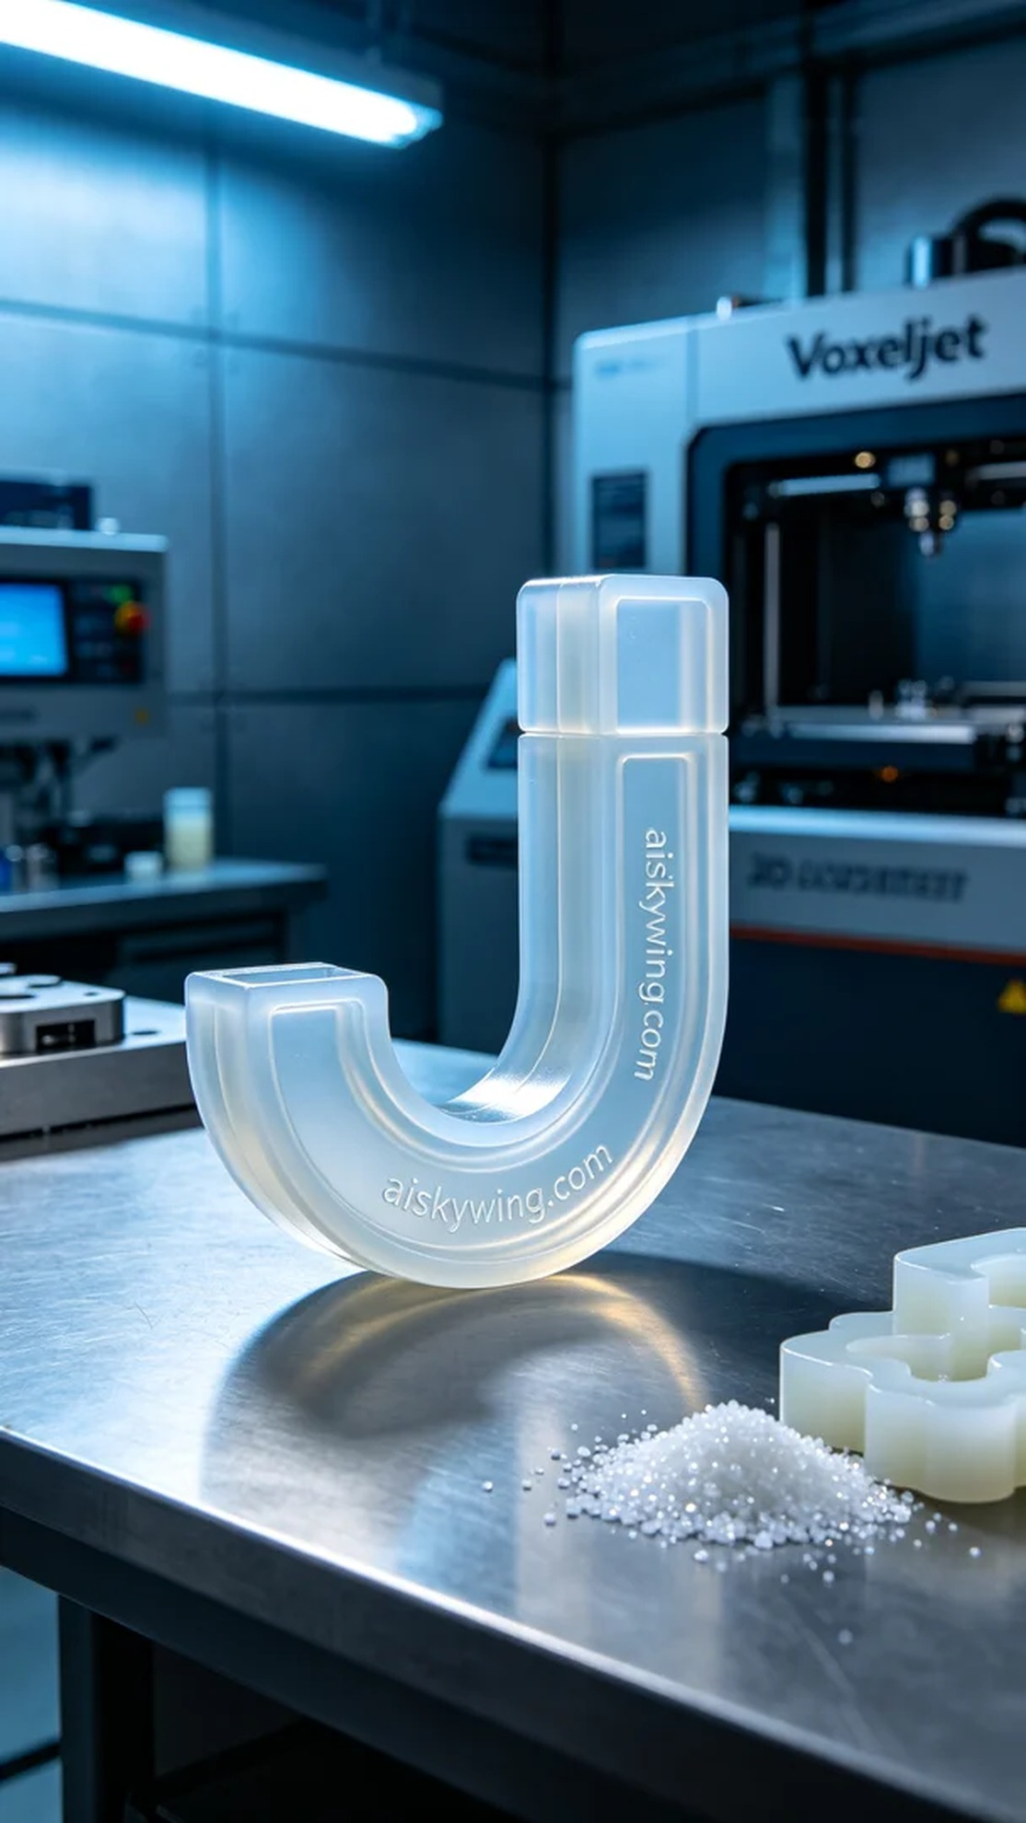
On Facebook, someone reached out to us regarding issues with the sealing performance of products, particularly mentioning the importance of the J-type sealing ring. In response, we decided to use high-quality silicone molding material for production to ensure reliability in practical applications.
During the preparation phase, we selected medical-grade silicone molding, which features translucency, softness, and elasticity, making it suitable for various use environments. The printer used was Voxeljet, with a layer thickness set at 0.1mm, printing temperature maintained at 25 degrees Celsius, power set at 150W, and printing speed adjusted to 50mm/s. The estimated printing completion time was about 4 hours.
Throughout the printing process, the equipment operated smoothly, and the synchronization between the Z-axis and the nozzle was excellent. We continuously monitored the print quality to ensure each layer adhered perfectly. Under the cool industrial lighting, we observed the textural details on the sealing ring’s surface, ensuring the engraving of "aiskywing.com" was clear, laying a solid foundation for subsequent post-processing.
In the post-processing phase, we maintained strict control. First, the printed parts were placed in a cleaning tank for ultrasonic cleaning to remove residual resin. Next, we meticulously polished the sealing ring to ensure smooth edges. During the curing phase, we used UV light to ensure the material reached optimal hardness. Finally, we conducted a comprehensive inspection of the finished product to ensure its dimensions and quality met our standards.
In the end, after a series of meticulous procedures, the J-type sealing ring was successfully completed, showcasing the charm and potential of industrial 3D printing. We continue to focus on every product, ensuring that every trust placed in us receives the best return.
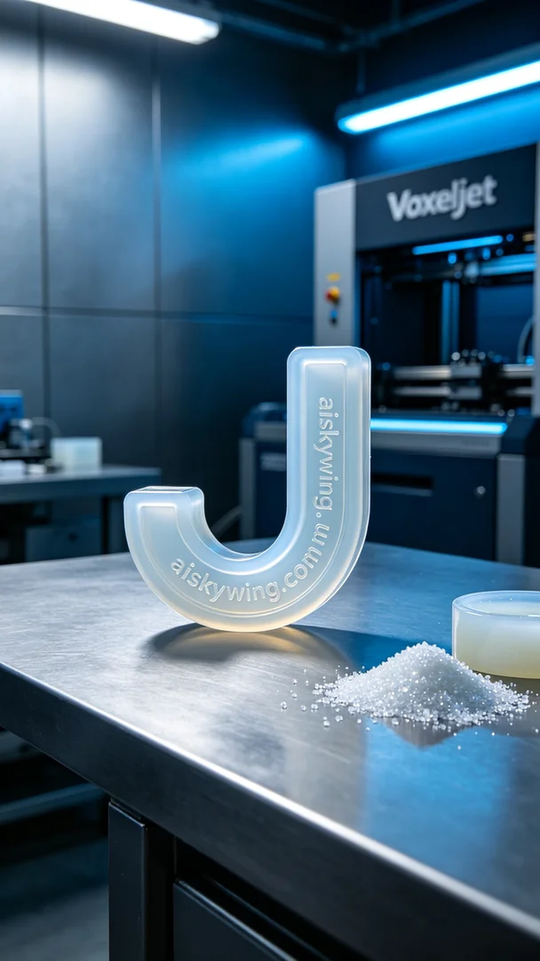
在Facebook上，有人因产品密封性能不佳而寻求我们的帮助，特别提到了J型密封圈的重要性。为此，我们决定以高品质的硅胶复模材料进行生产，以确保其在实际应用中的可靠性。
在准备阶段，我们选用了医用级硅胶复模，具备半透明、柔软和弹性等特性，能够很好地适应不同的使用环境。使用的打印机为Voxeljet，设置的层厚为0.1毫米，打印温度保持在25摄氏度，功率为150W，打印速度设定在50mm/s，预计打印完成时间为约4小时。
打印过程中，设备运行平稳，Z轴与喷头的同步性良好。我们时刻监控打印质量，确保每一层都能完美附着。通过冷色调的工业光线，我们观察到了密封圈表面的纹理细节，确保“aiskywing.com”字样的雕刻清晰可见，为之后的后处理打下了基础。
后处理环节我们同样严格把控，首先将打印完成的部分放入清洗槽中，用超声波清洗去除残留树脂。接着，我们对密封圈进行细致的打磨，确保其边缘光滑。固化过程中，使用UV灯照射，确保材料达到最佳硬度。最后，对成品进行全面的检验，确保其尺寸与质量符合标准。
最终，经过一系列精细的工序，这个J型密封圈得以顺利完成，展现了工业3D打印的魅力与潜力。我们继续专注每一件产品，让每一份信任都能得到最好的回馈。
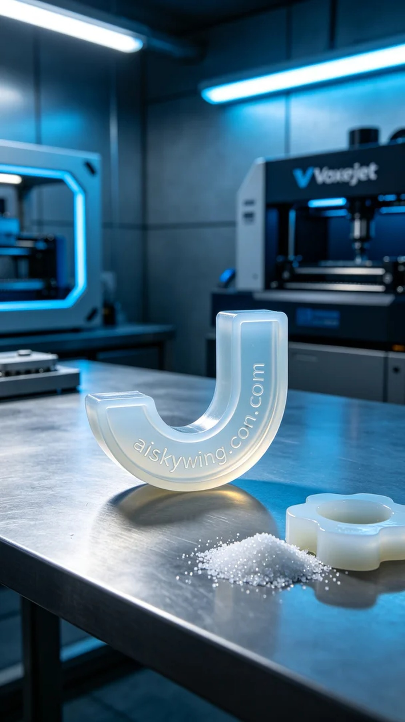
Aiskywing Industrial 3D Printing
J-type sealing ring


