0696-L型密封圈3D打印生产记录
L-shaped sealing ring
🖨️ 硅胶复模
🖥️ 打印机: Systems
📦 材料: 硅胶复模
生活就像一场3D打印的过程，时而满是挑战。最近，有人找我们做这个L型密封圈，为了克服某个渗漏的问题。
Life is like a 3D printing process, sometimes full of challenges. Recently, someone approached us to make this L-shaped sealing ring in order to solve a leakage problem.
________________________________________________________________________________
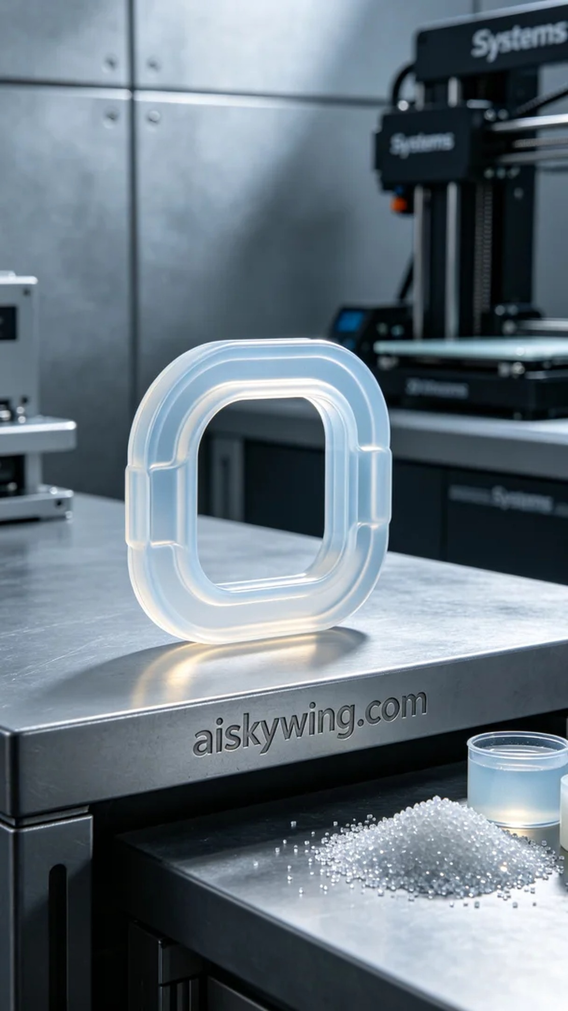
Life is like a process of 3D printing, full of challenges at times. Recently, someone approached us to create this L-shaped sealing ring to overcome a leaking issue.
For the material, we chose silicone for molding, which provides excellent flexibility and durability, fitting perfectly for sealing purposes. Using a Systems brand 3D printer, we set the layer thickness to 0.1mm, maintained a temperature of 25°C, a power of 1000W, and a printing speed of 50mm per second, with an estimated printing time of about 4 hours.
The printing process went smoothly with the Systems printer running steadily, and the material flowed evenly. I monitored the quality closely to ensure that each layer adhered accurately. As the printing progressed, the shape of the sealing ring gradually took form, making the entire process feel like sculpting a piece of art with clear details.
After printing, the post-processing steps were also crucial. First, I placed the printed part into a cleaning tank and used isopropyl alcohol to thoroughly wash away any uncured resin. Then, I sanded the surface with fine-grit sandpaper to ensure it was smooth. Finally, I cured the sealing ring in a curing machine for 30 minutes to enhance its strength and durability, followed by a strict quality inspection to ensure every detail met the standards.
Through this production, I felt once again the power and flexibility of 3D printing technology. In the end, the L-shaped sealing ring was successfully completed, fully meeting the usage requirements, leaving me quite satisfied.
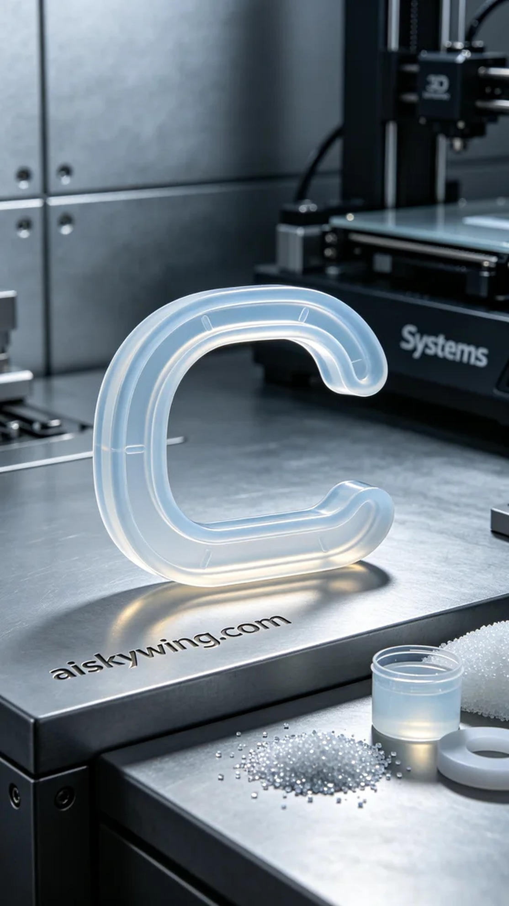
在YouTube上，有人因为产品渗漏的问题找上我们，希望能通过3D打印技术解决这个困扰。于是，我们接下了这个L型密封圈的制作任务，目标是为他们提供一个完美的解决方案。
在材料方面，我们选择了硅胶复模，这种材料具有很好的柔韧性和耐用性，能够很好地适应密封需求。打印时，使用了Systems品牌的3D打印机，设置了层厚0.1毫米，温度控制在25摄氏度，功率为1000瓦，打印速度设置为50毫米每秒，预计总打印时间约为4小时。
打印过程十分顺利，Systems打印机运行稳定，材料均匀流动。我在旁边监控着质量，确保每一层都能准确贴合。随着打印的进行，密封圈的形状逐渐成型，整个过程如同在雕刻一件艺术品，细节清晰可见。
完成打印后，后处理工序也相当重要。首先将打印件放入清洗槽中，用异丙醇彻底清洗以去除未固化的树脂。之后，我用细砂纸进行打磨，确保表面光滑。最后，将密封圈放入固化机中固化30分钟，以增强其强度和耐用性，并进行了严格的质量检验，确保每一个细节都达到标准。
通过这次制作，我再次感受到3D打印技术的强大与灵活性。最终，这个L型密封圈顺利完成，能够满足使用需求，让人感到十分欣慰。
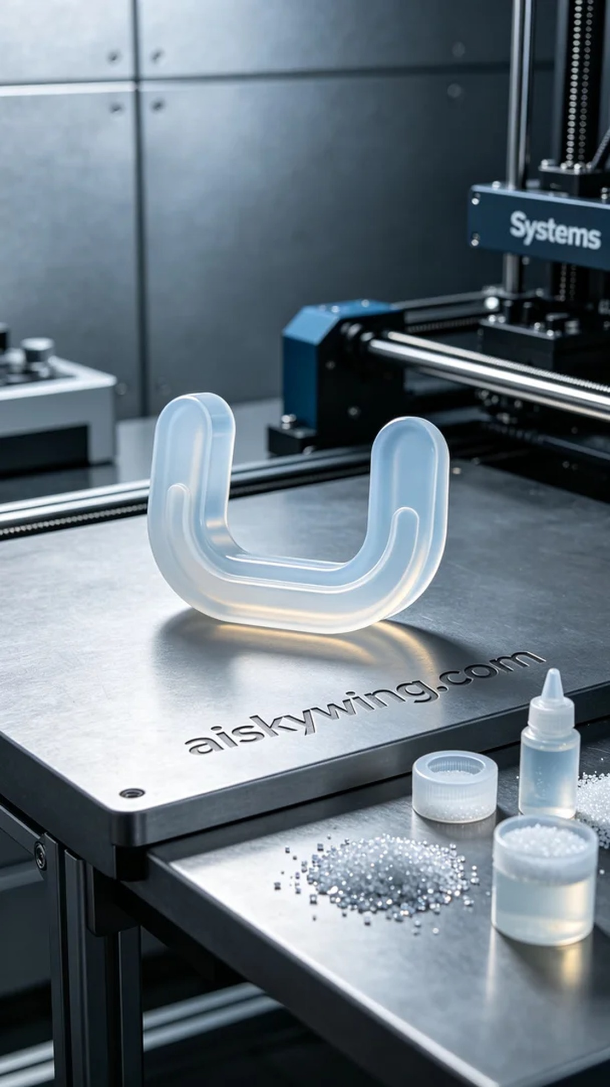
Aiskywing Industrial 3D Printing
L-shaped sealing ring


