0697-O型密封圈的3D打印生产记录
O-ring
🖨️ 硅胶复模
🖥️ 打印机: Carbon
📦 材料: 硅胶复模
生活再难，也别停下脚步。就像接下这个O型密封圈的活，让我再次感受到了3D打印的魅力。
No matter how difficult life gets, don't stop moving forward. Just like taking on the job of this O-ring, it让我再次感受到了3D打印的魅力.
________________________________________________________________________________
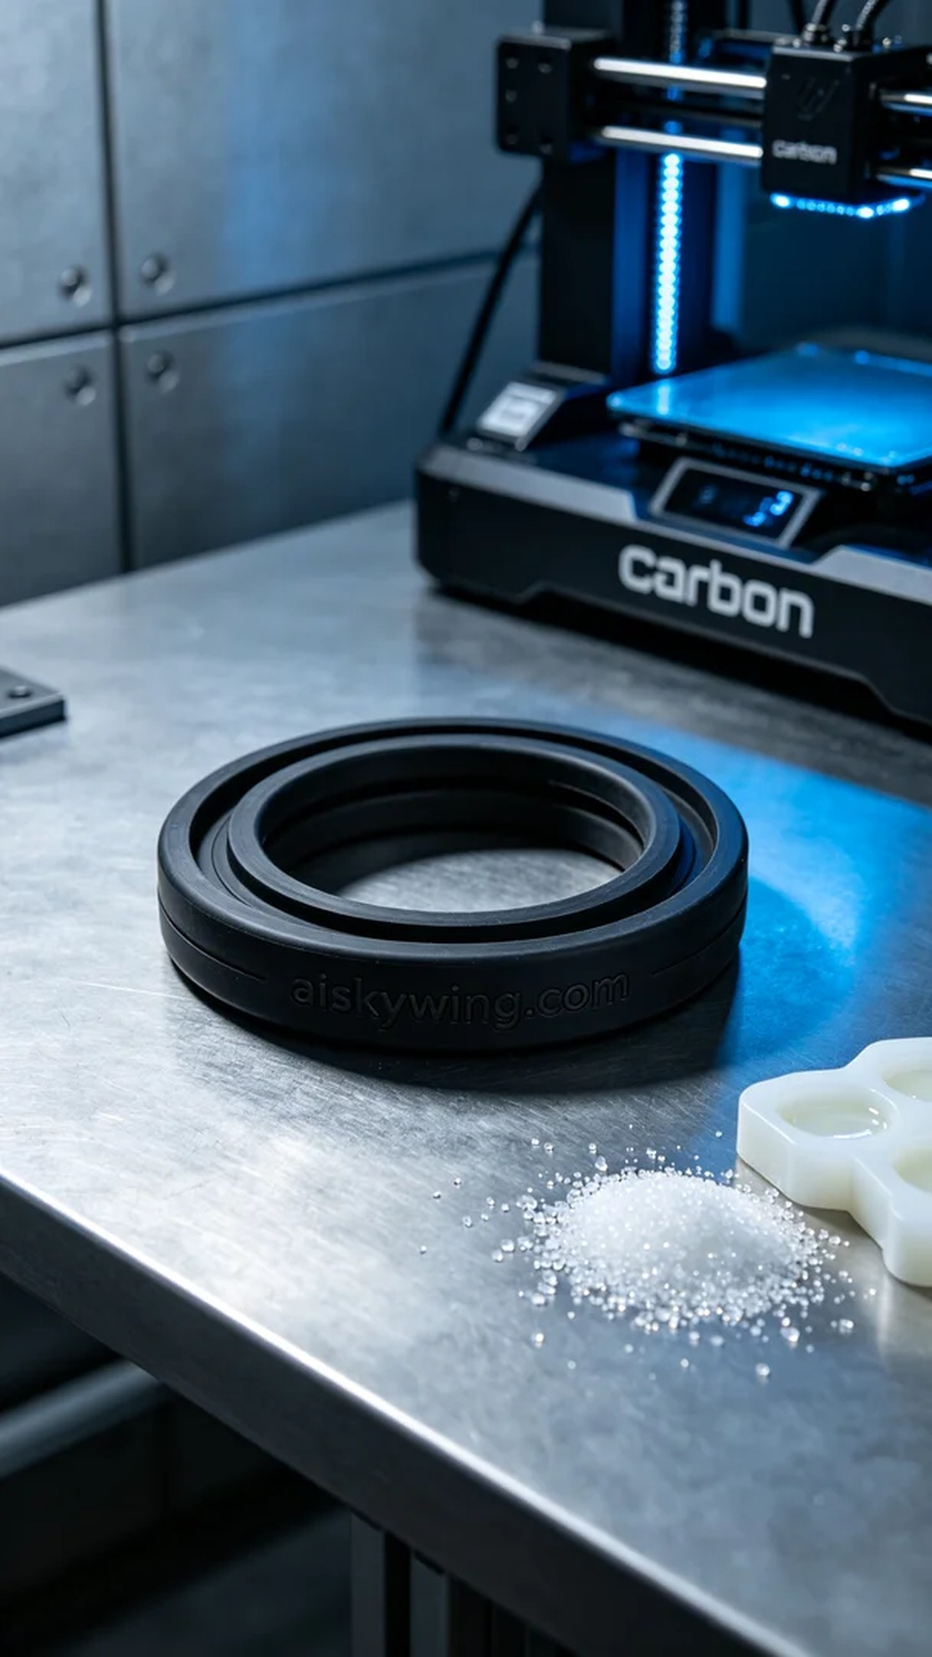
Life can be tough, but we shouldn't stop moving forward. Just like taking on the task of creating this O-ring, I rediscovered the charm of 3D printing.
On Facebook, someone approached us with an issue regarding inadequate sealing. They needed a high-quality O-ring to ensure their project progressed smoothly and safely. This prompted us to begin our 3D printing process.
For this O-ring, we opted for silicone molding material. This material is soft and durable, featuring flexible anti-slip textures that are ideal for industrial environments. To guarantee print quality, we utilized the Carbon 3D printer, setting a layer thickness of 0.05mm, a printing temperature of 25°C, a speed of 30mm/s, and maintaining power at 60% to ensure material stability.
During the printing process, the Carbon printer operated efficiently. We closely monitored print quality to ensure each layer fused perfectly. Thanks to the properties of the silicone molding material, we encountered minimal issues, successfully completing the O-ring print.
The post-processing phase was crucial. First, we cleaned the printed piece with a cleaning agent to remove surface residues and impurities. Next, we sanded the edges to smooth them out and proceeded with curing to enhance durability and sealing performance. In the inspection phase, each printed piece underwent rigorous testing to ensure they were flawless and defect-free.
Overall, the production process for this O-ring went smoothly, resolving the issue while showcasing the limitless potential of 3D printing.
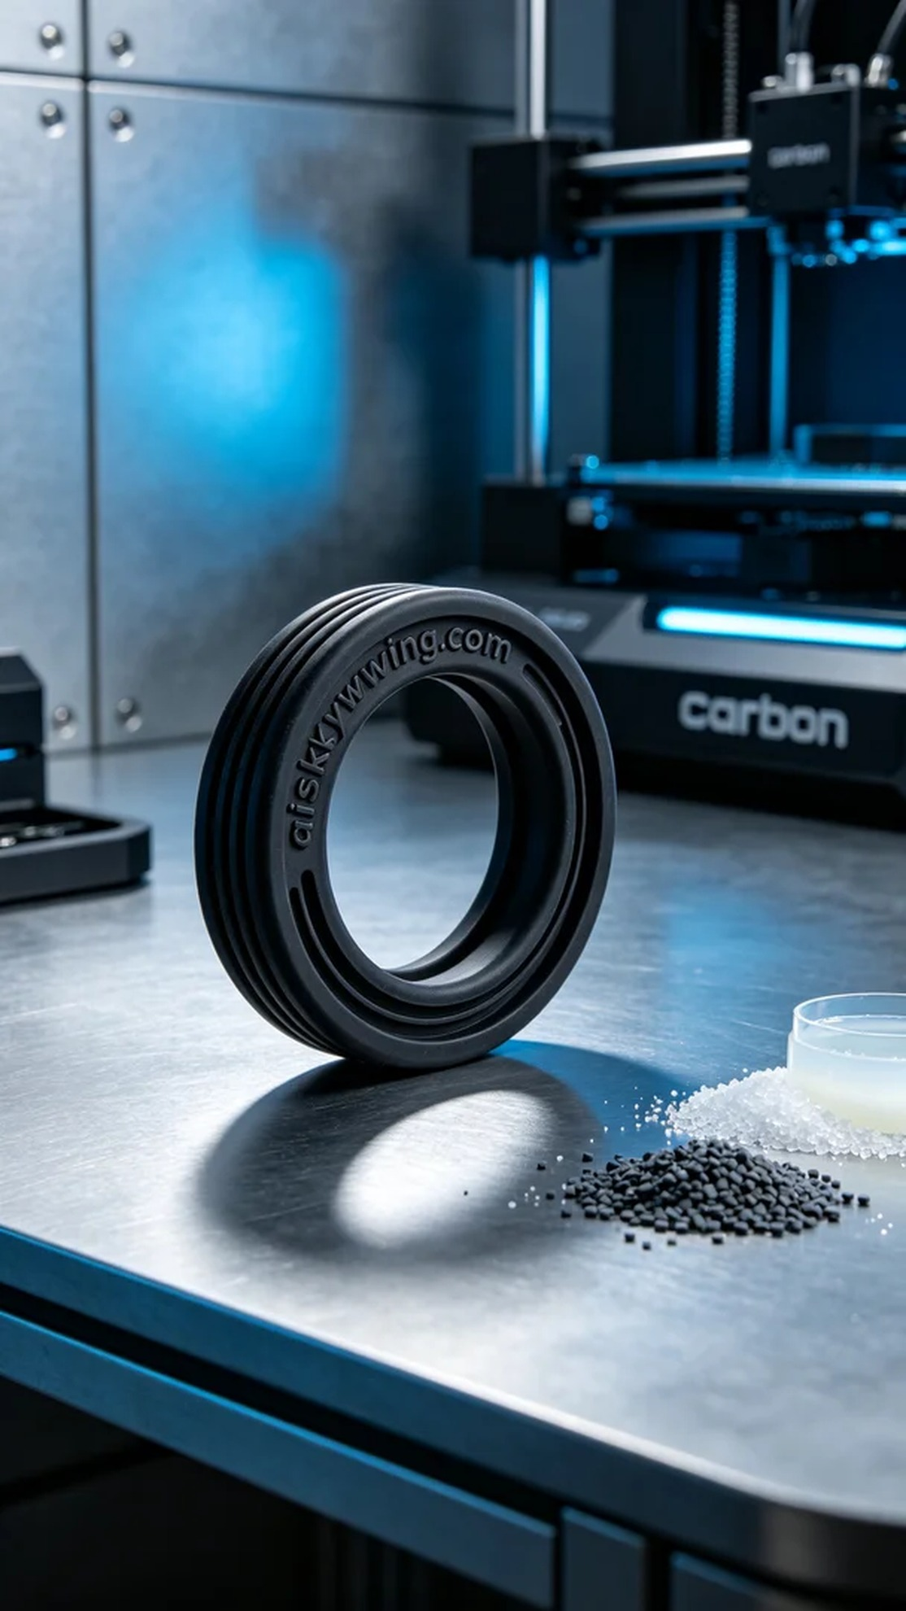
在Facebook上，有人因为密封性差的问题找上我们，希望能够制作出一款高质量的O型密封圈。这个单子不仅关系到他们的项目进展，还关乎到使用安全。于是，我们开始了这次的3D打印制作。
制作这款O型密封圈，我们选用了硅胶复模材料。这种材料柔软耐用，具有灵活的防滑纹理，适合在工业环境中使用。为了确保打印的质量，我们使用了Carbon品牌的3D打印机，设置了层厚为0.05毫米，打印温度为25摄氏度，速度为30毫米/秒，功率则控制在60%以保持材料稳定性。
在打印的过程中，Carbon打印机一直在高效运转。我们密切关注打印质量，确保每一层都能够完美结合。由于硅胶复模材料的特性，使得打印过程中很少出现问题，最终顺利完成了O型密封圈的打印工作。
后处理环节是关键，我们首先用清洗剂对打印件进行清洗，去除表面的残留物和杂质。随后再进行打磨，使其边缘光滑，最后进行固化，以提升其耐用性和密封性能。在检验阶段，我们对每个打印件进行了严格检测，确保无瑕疵、无缺陷。
总的来说，这次的O型密封圈制作过程顺利，达到了预期的效果，既解决了问题，也展现了3D打印的无限可能。
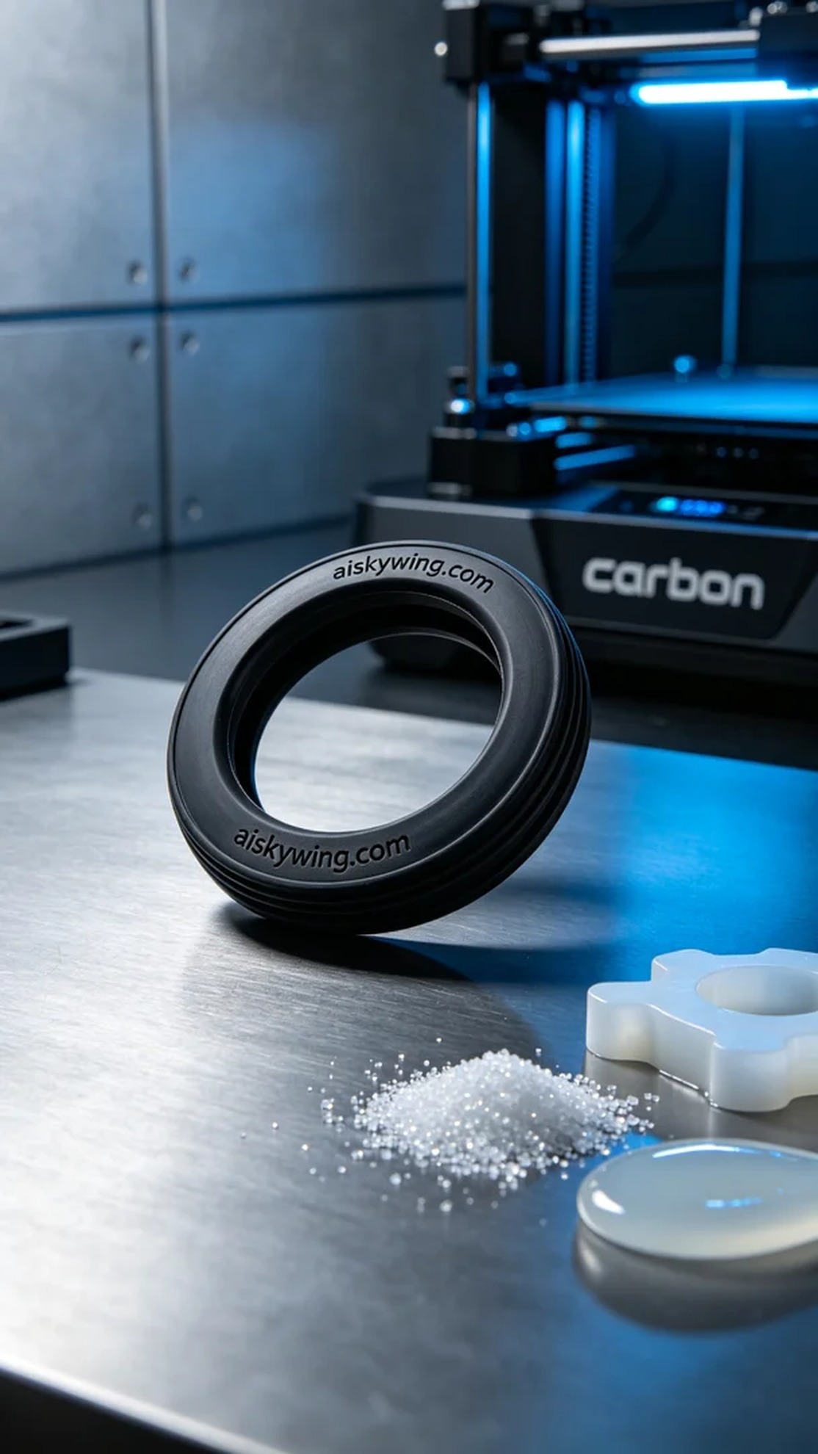
Aiskywing Industrial 3D Printing
O-ring


