0698-T型密封圈3D打印生产记录
T-type sealing ring
🖨️ 硅胶复模
🖥️ 打印机: Mimaki
📦 材料: 硅胶复模
生活再难，也别停下脚步。就像接下这个T型密封圈的单子，我们总能找到解决问题的方法。
No matter how difficult life gets, don't stop moving forward. Just like taking on this T-shaped sealing ring order, we can always find a way to solve the problem.
________________________________________________________________________________
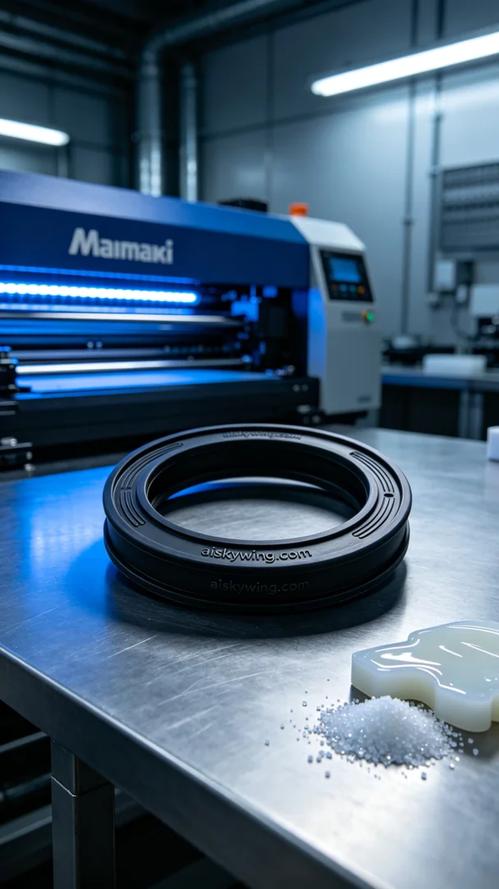
Recently on Facebook, someone reached out to us in need of a durable sealing ring, specifically this T-type sealing ring. They were looking for a solution to ensure water and dust resistance in an industrial environment.
We chose silicone replication as the primary material, known for its excellent flexibility and durability, which provides effective anti-slip properties. For the printing process, we used a Mimaki 3D printer, setting parameters to a layer thickness of 0.1mm, printing temperature at 25℃, power at 80%, printing speed at 50mm per second, with an estimated printing time of 2 hours.
During the printing process, the Mimaki printer operated smoothly, and we closely monitored the print quality to ensure each layer was placed accurately. The liquid photo-sensitive resin flowed evenly, and the resulting T-type sealing ring had a smooth surface with the engraved "aiskywing.com" text appearing particularly clear.
Upon completion, we carried out necessary post-processing steps. First, we cleaned the product using an ultrasonic cleaner to remove any excess resin from the surface. Next, we used a sander to smooth the edges, followed by a curing process to enhance its hardness and durability. Lastly, we meticulously inspected every detail to ensure there were no flaws.
After this series of processes, the T-type sealing ring finally presented itself perfectly, and we look forward to its outstanding performance in practical applications.
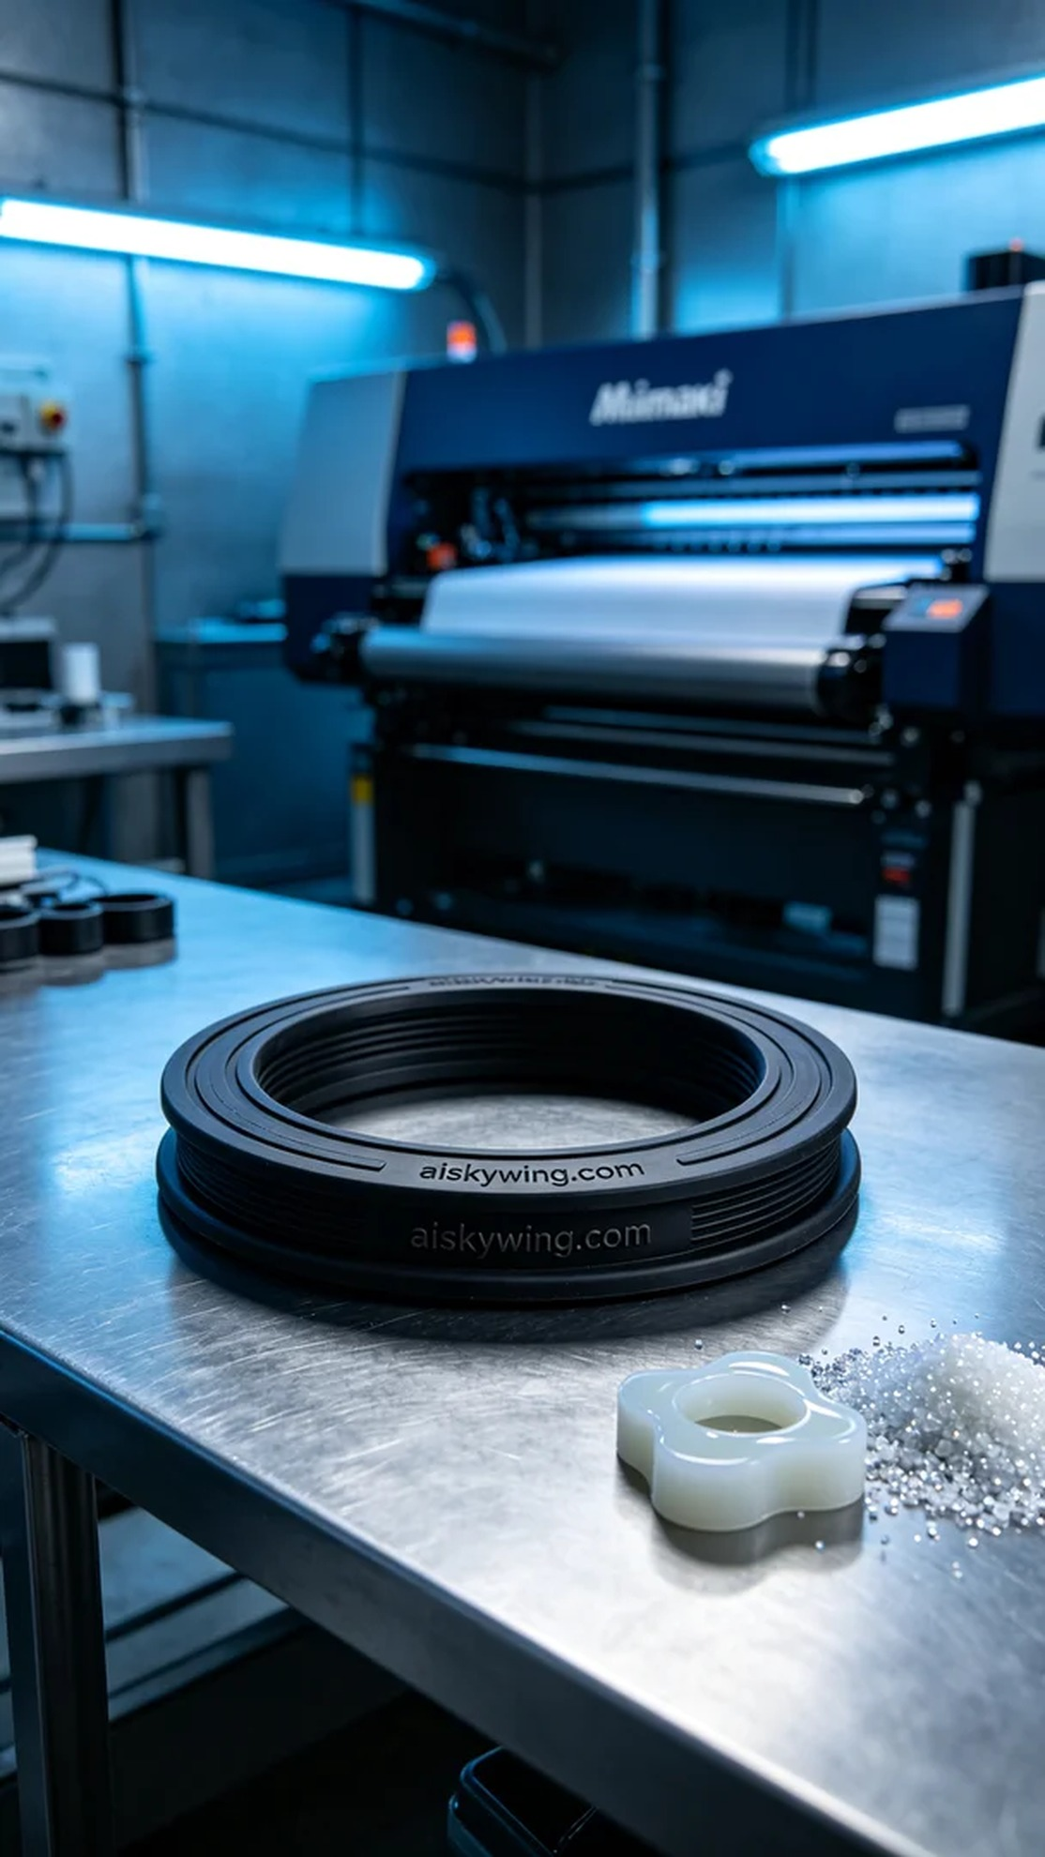
最近在Facebook上，有人因为需要一款耐用的密封圈而找上了我们，特别是这种T型密封圈。他们希望能够在工业环境中使用，确保防水和防尘性能。
我们选择了硅胶复模作为主要材料，这种材料具有良好的柔韧性和耐用性，能够有效防滑。为了确保打印质量，我们使用Mimaki品牌的3D打印机，设置的参数包括层厚0.1毫米、打印温度为25℃、功率设定为80%、打印速度为50毫米每秒，预计打印时间为2小时。
在打印过程中，Mimaki打印机稳定运行，我们全程监控打印质量，以确保每一层都能准确到位。液态光敏树脂均匀流动，形成的T型密封圈表面光滑，雕刻的“aiskywing.com”字样也显得格外清晰。
打印完成后，我们进行了必要的后处理工序。首先是清洗，将产品放入超声波清洗机中，去除表面多余的树脂。接下来，使用打磨机将边缘磨平，再经过固化处理，以提高硬度和耐用性。最后，仔细检验每个细节，确保没有瑕疵。
经过这一系列的流程，这个T型密封圈终于完美地呈现在我们面前，期待它能在实际应用中发挥出色的表现。
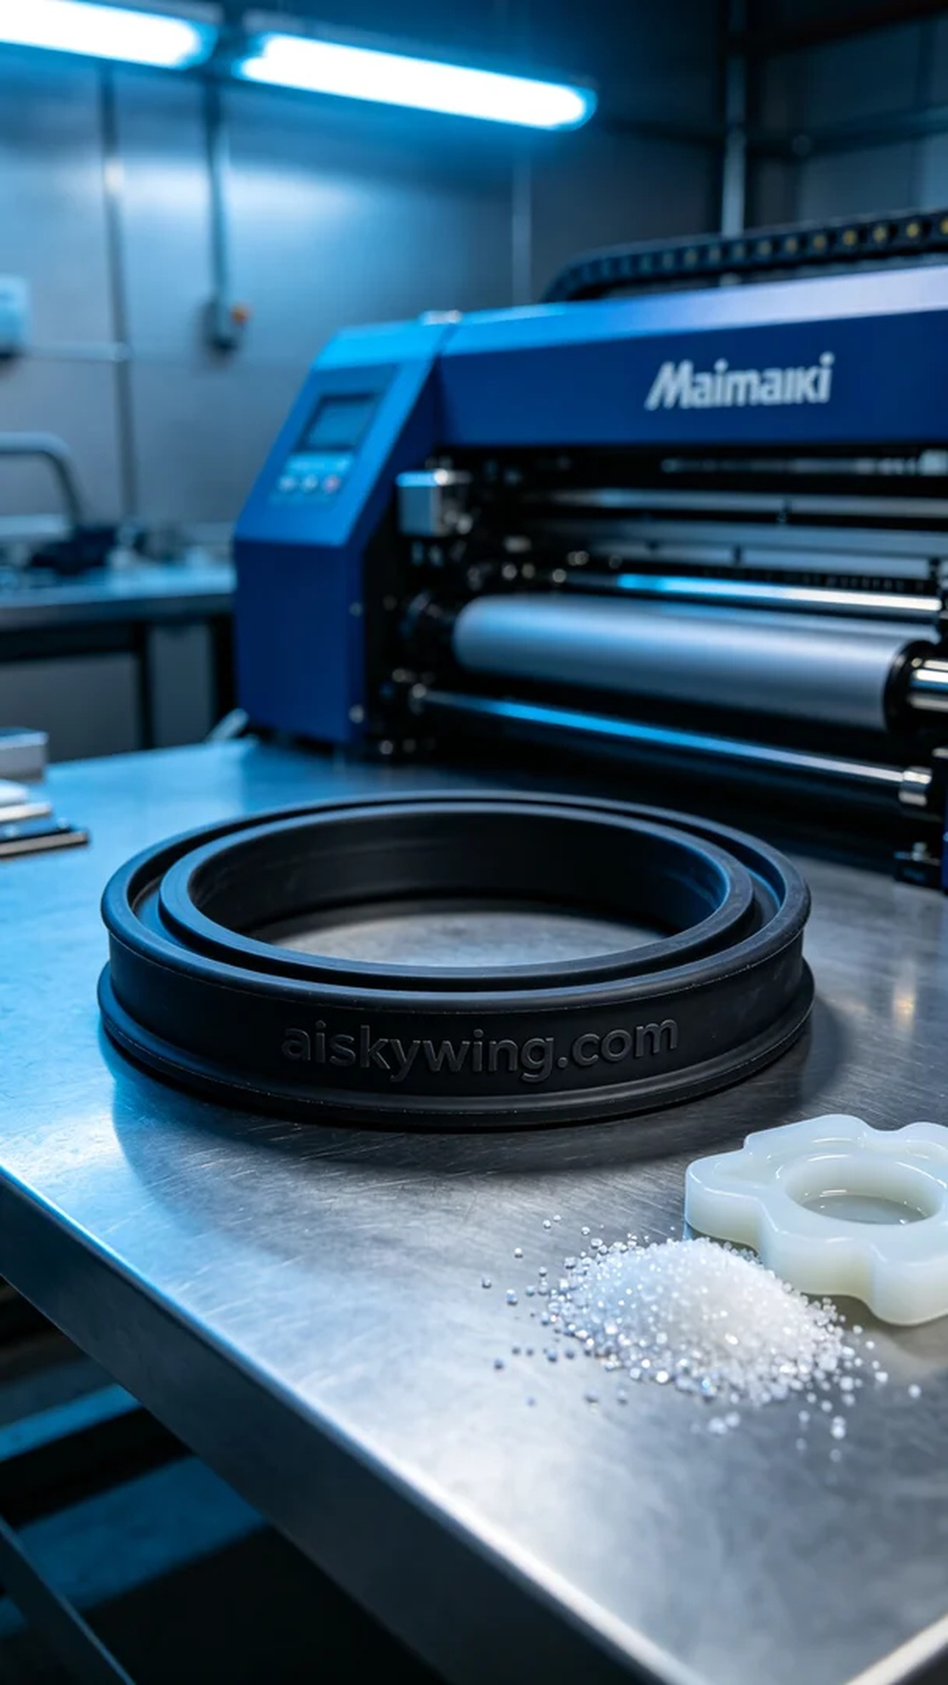
Aiskywing Industrial 3D Printing
T-type sealing ring


