0699-U型密封圈的3D打印生产日志
U-shaped seal ring
🖨️ 硅胶复模
🖥️ 打印机: HP
📦 材料: 硅胶复模
生活就像3D打印，有时候需要调整，有时候需要细致打磨。就像这次做的U型密封圈，有人找到我们，解决了他们面临的问题。
Life is like 3D printing; sometimes it requires adjustments, and sometimes it needs meticulous polishing. Just like the U-shaped sealing ring we made this time, someone reached out to us to solve the problem they were facing.
________________________________________________________________________________
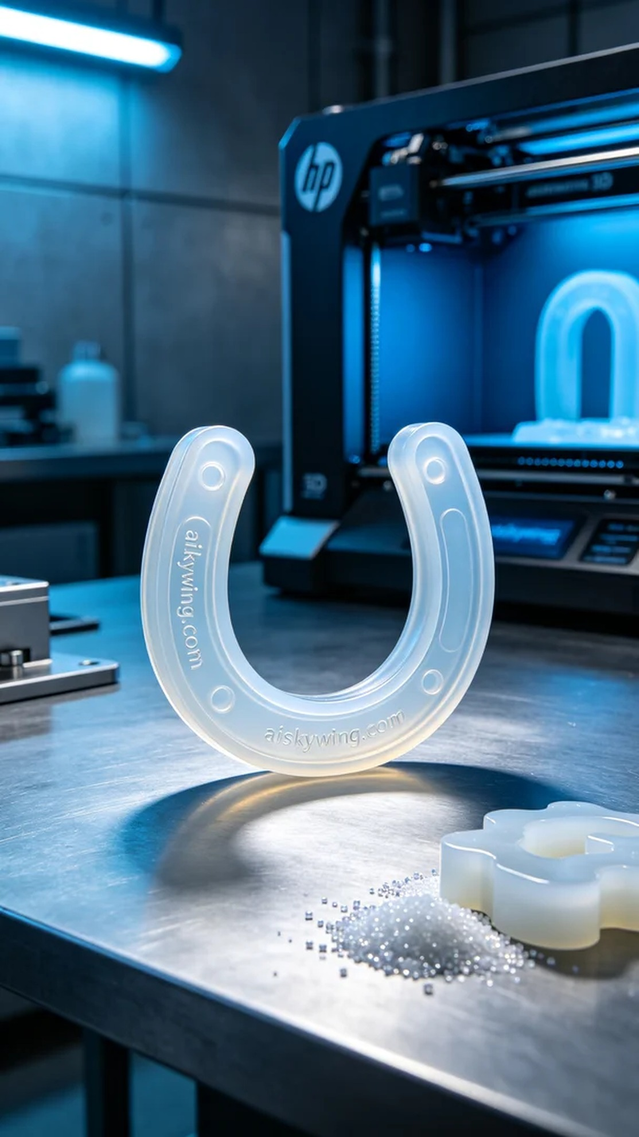
On Instagram, someone reached out to us looking for a custom U-shaped sealing ring to solve their water leakage issue. This seemingly simple problem is essential for every household's daily life.
We selected medical-grade silicone for the material, which offers excellent sealing properties due to its soft, translucent, and elastic characteristics. To ensure the quality of the print, we utilized an HP 3D printer, setting the parameters to a layer thickness of 0.1mm, printing temperature of 25°C, power at 60%, printing speed of 30mm/s, with an estimated printing time of 3 hours.
During the printing process, the device operated stably, as the print head precisely laid down the liquid photopolymer resin. Each layer formed quietly, and we continuously monitored the print quality to ensure good adhesion between layers, avoiding bubbles or defects.
After printing, the U-shaped sealing ring required a series of post-processing steps. First, we cleaned the finished product with a specialized cleaning solution to remove any resin residue from the surface. Next, we meticulously sanded it to ensure a smooth and flawless finish. Then, the product was placed in a curing machine to harden, ensuring optimal strength and elasticity. Finally, a strict inspection was conducted to make sure every detail met the standards.
After a series of meticulous operations, the U-shaped sealing ring was perfectly presented. Every detail reflects our dedication, and the person's problem was perfectly resolved.
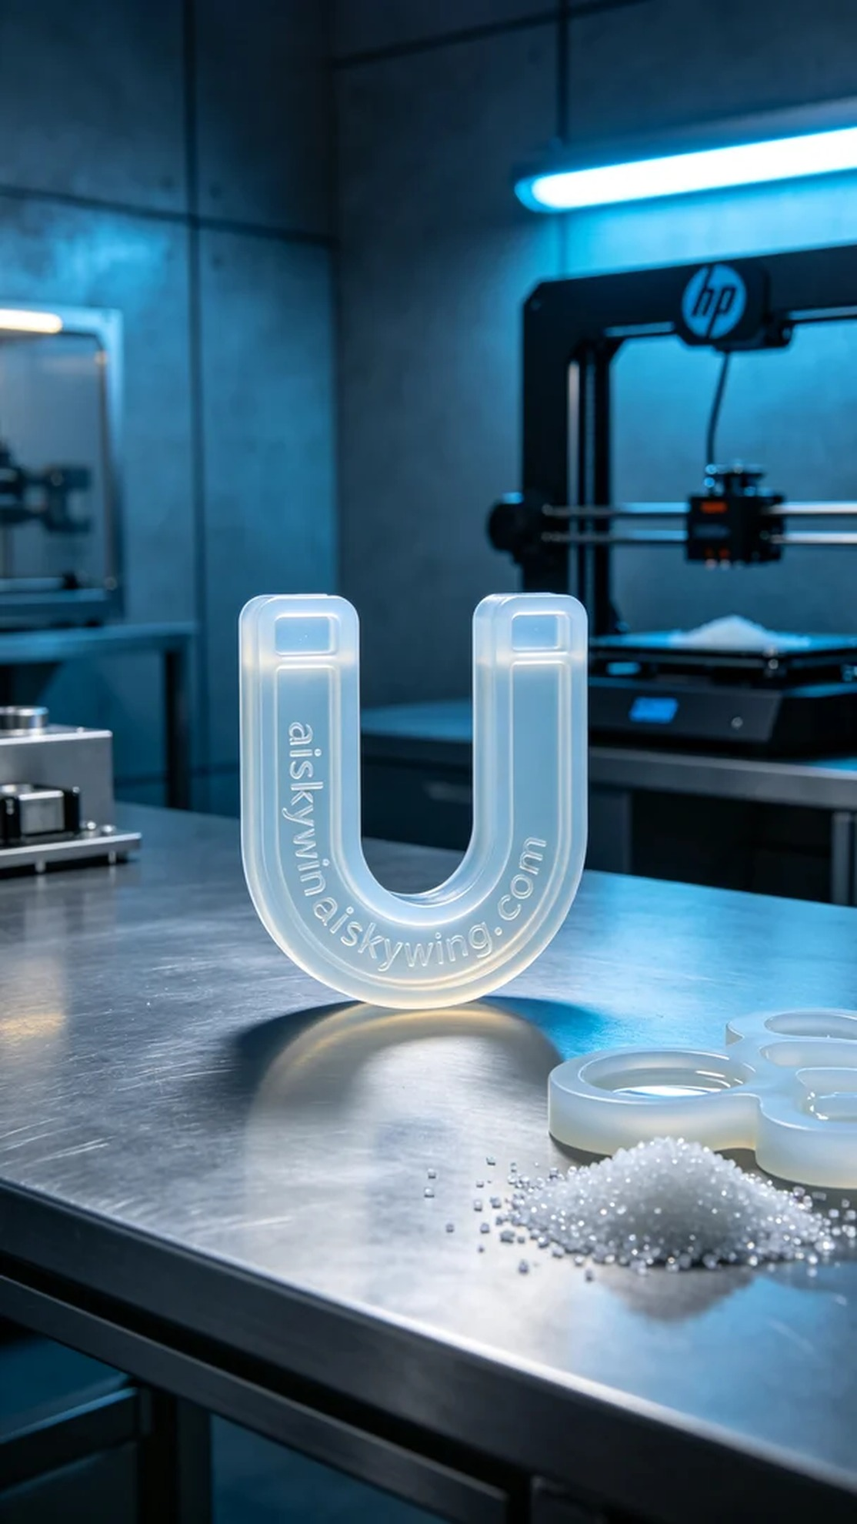
在Instagram上，有人因为漏水问题找到我们，希望能定制一个U型密封圈，以解决他们的烦恼。这个问题看似简单，却关乎每个家庭的日常生活。
我们选用了医用级硅胶复模作为原材料，其半透明柔软弹性特性为产品提供了优秀的密封性能。为了确保打印质量，我们使用了HP 3D打印机，设置的打印参数为：层厚0.1mm，打印温度为25°C，打印功率为60%，打印速度为30mm/s，预计打印时间为3小时。
打印过程中，设备稳定运行，打印头精准地将液态光敏树脂铺展，每一层都在悄无声息中形成。我们时刻监控打印质量，确保每一层的粘合性良好，避免出现气泡或瑕疵。
打印完成后，U型密封圈需要经过一系列后处理工序。首先，我们使用专用清洗液对成品进行清洗，去除表面残留的树脂。然后，进行细致的打磨，确保表面光滑无瑕。接下来，产品被放入固化机中固化，确保其硬度和弹性达到最佳状态。最后，我们还进行了严格的检验，确保每一个细节都符合标准。
经过一系列的精细操作，这个U型密封圈终于完美呈现。每一个细节都凝聚了我们的努力，客户的问题也得到了完美解决。
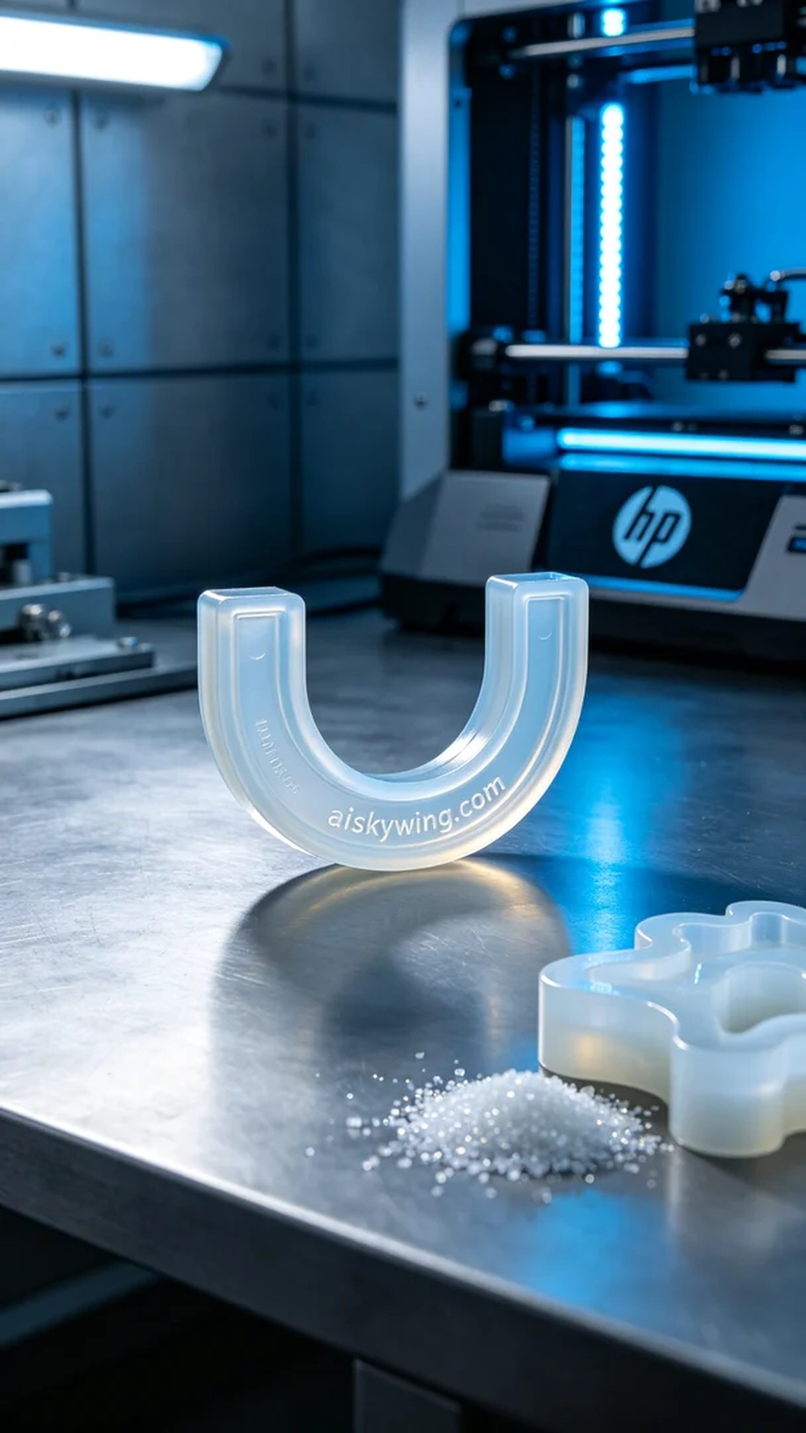
Aiskywing Industrial 3D Printing
U-shaped seal ring


