0706-三元催化器隔热罩的3D打印记录
Three-way catalytic converter heat shield
🖨️ CNC机加工
🖥️ 打印机: Systems
📦 材料: 高透明高耐温
在WhatsApp上，有人因为引擎升温问题找到了我们，想要我们制作一个三元催化器隔热罩。我们接下这个挑战，开始了这次的3D打印之旅。
On WhatsApp, someone reached out to us regarding an engine overheating issue and requested us to create a heat shield for the catalytic converter. We accepted this challenge and embarked on this 3D printing journey.
________________________________________________________________________________
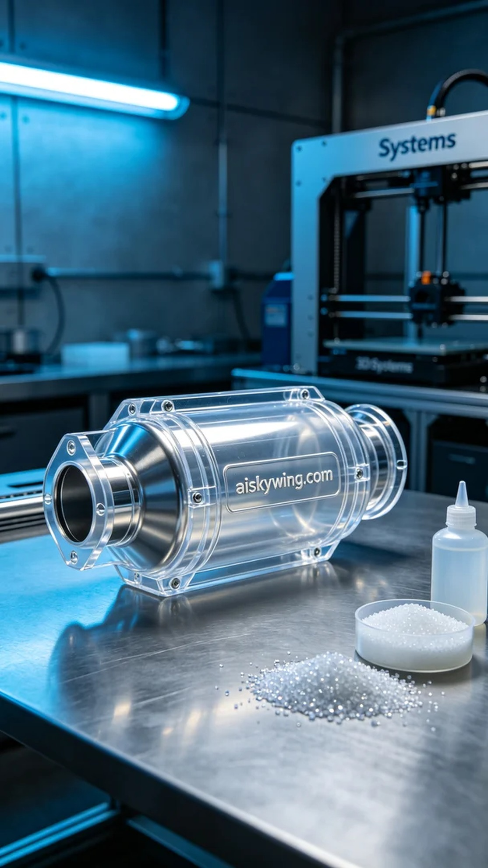
On WhatsApp, someone reached out to us regarding an engine overheating issue, requesting a 3D printed catalytic converter heat shield. We took on this challenge and embarked on this 3D printing journey.
For this project, we chose high transparent, high-temperature PC engineering plastic as our raw material. This material not only offers high transparency but also excellent temperature resistance, making it suitable for high-temperature environments. To ensure product quality, we conducted a thorough material inspection and prepared the Systems 3D printer, setting the appropriate printing parameters.
During the printing process, we set the layer thickness to 0.1mm, the temperature to 220 degrees Celsius, and the printing speed to 50mm per second. Throughout the entire printing process, we monitored the machine's operation to ensure everything ran smoothly. The printer worked steadily for about 4 hours, successfully completing the printing of the catalytic converter heat shield.
In the post-processing phase, we first placed the printed part in a cleaning solution to remove any residual liquid resin on the surface. After cleaning, we sanded the surface with sandpaper to ensure smoothness. Next, we placed the part in a curing chamber to finalize its heat resistance. Finally, we conducted a rigorous inspection to ensure it met quality standards.
After a series of meticulous operations, the catalytic converter heat shield was finally completed. Each step presented challenges, but seeing the finished product filled me with a sense of accomplishment.
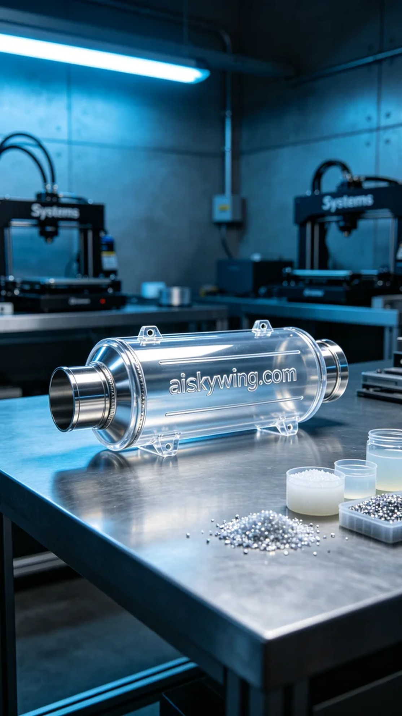
这次我们选用了高透明高耐温的PC透明工程塑料作为原材料，这种材料不仅透明度高，还具有良好的耐温性能，适合在高温环境下使用。为了确保成品的质量，我们首先进行了详细的材料检验，并准备好了Systems 3D打印机，设定了合适的打印参数。
打印的时候，我们将层厚设置为0.1毫米，温度定在220摄氏度，打印速度为50毫米每秒。在整个打印过程中，我们监控了设备的运行状况，确保没有出现任何故障。打印机稳定工作了大约4小时，最终完成了三元催化器隔热罩的打印。
后处理阶段，我们首先将打印好的工件放入清洗液中进行清洗，以去除表面的液态树脂残留。清洗完成后，使用砂纸对表面进行打磨，确保其光滑度。接着，将工件放入固化箱中进行固化处理，确保其耐温性能达到要求。最后，我们对产品进行了严格的检测，确保符合质量标准。
经过一系列的精细操作，这个三元催化器隔热罩终于完成了。每一步都充满挑战，但看到成品的时候，心里满是成就感。
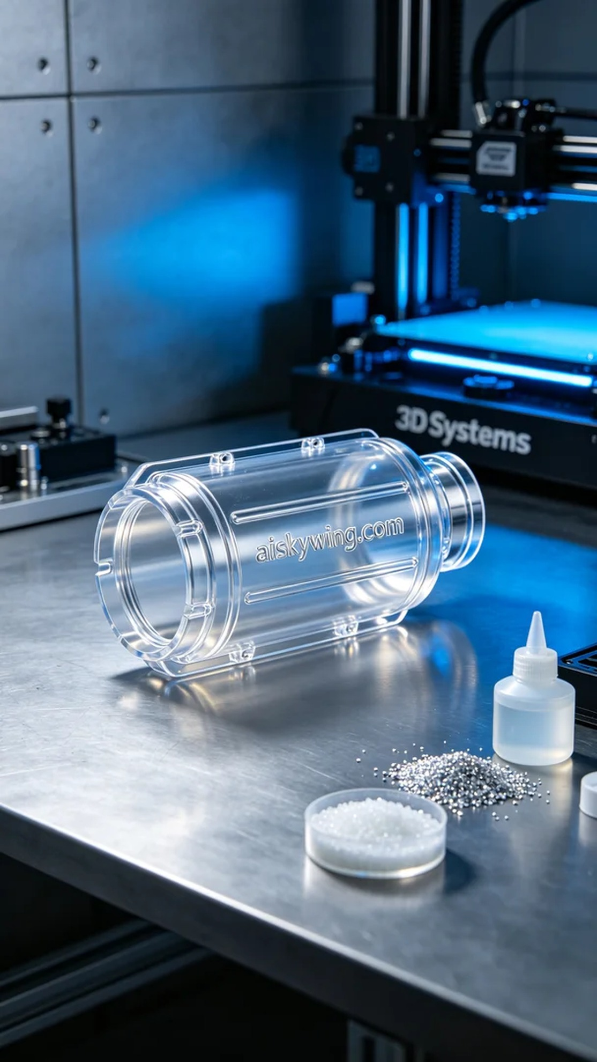
Aiskywing Industrial 3D Printing
Three-way catalytic converter heat shield


