0707-丝杠螺母的3D打印记录
Screw nut
🖨️ SLM金属打印
🖥️ 打印机: Voxeljet
📦 材料: 摆放着未成型的液态光敏
生活有时候像一场复杂的打印过程，坚韧与耐心是成功的关键。有人因为需要一个丝杠螺母找上我们，希望能解决他们的难题。
Life is sometimes like a complicated printing process, where resilience and patience are the keys to success. Some people come to us because they need a screw nut, hoping to solve their problems.
________________________________________________________________________________
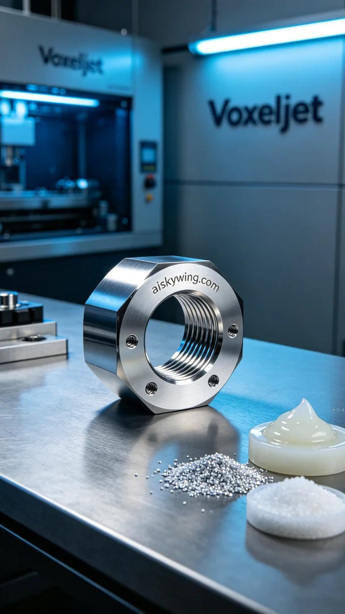
Sometimes, life feels like a complex printing process, where resilience and patience are the keys to success. Someone reached out to us for a screw nut, hoping we could solve their needs quickly.
We chose liquid photopolymer resin as our printing material, known for its high detail and precision during the printing process. We used a Voxeljet printer, setting the layer thickness to 0.1mm, the printing temperature at 25 degrees Celsius, laser power at 150 milliwatts, and a printing speed of 50 mm per hour, with the entire print expected to take 60 minutes.
During the printing process, the equipment operated stably, and the print head moved precisely to cure the resin layer by layer. We monitored the printing quality throughout to ensure every detail met our standards. Once finished, the screw nut exhibited clear surface engravings, showcasing a smooth, high-gloss metallic finish.
After printing, we performed necessary post-processing steps. First, we placed the formed product in a cleaning tank to wash away any uncured resin. Next, a meticulous sanding was done to ensure a smooth surface; then, the product was placed in a curing unit for thorough curing, followed by strict quality inspections to ensure each screw nut met the required specifications.
After a series of detailed operations, we successfully delivered the screw nut, and the customer expressed satisfaction, which made us feel proud of our process and craftsmanship.
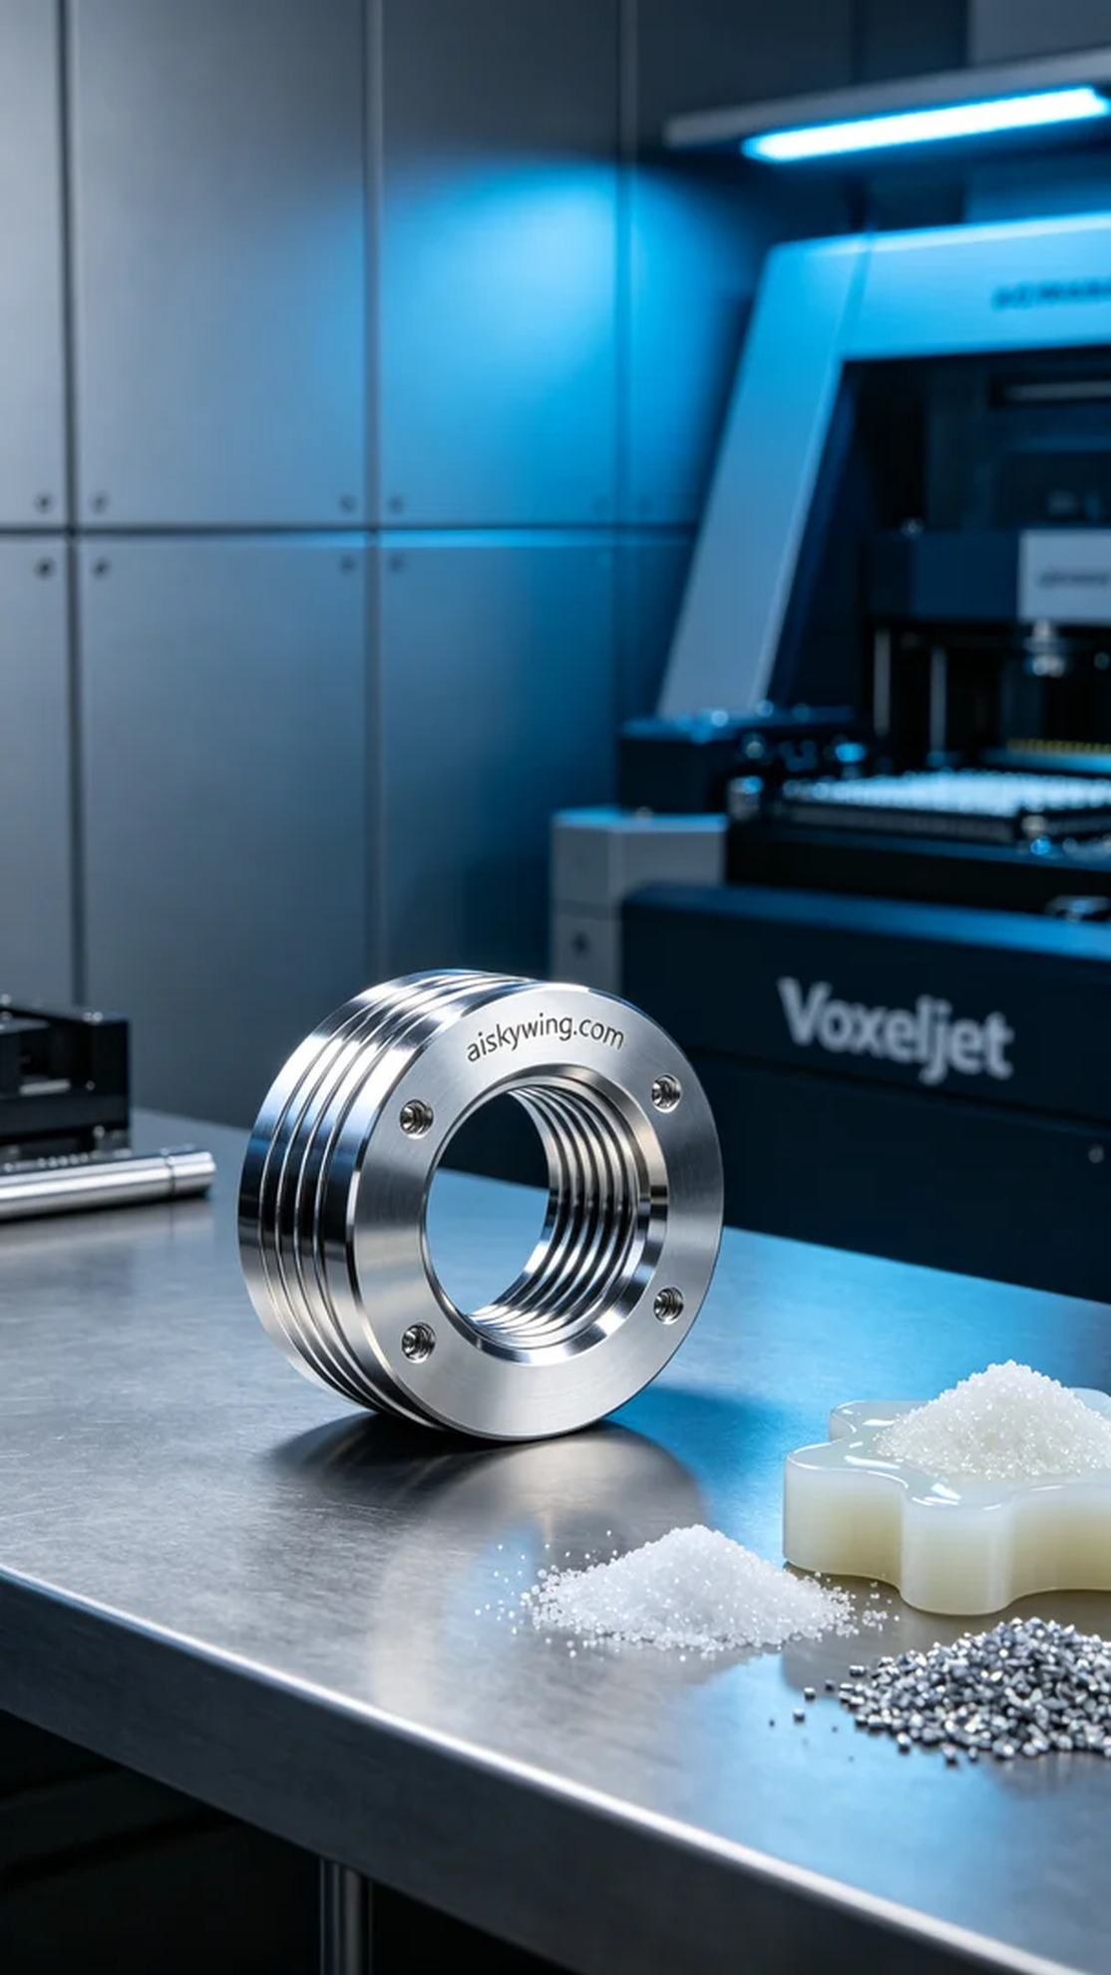
在Instagram上，有人因为工作中急需一个丝杠螺母而找上我们，表达了对时效性和精确度的高要求。他们希望我们能借助3D打印技术，快速制作出符合其规格的产品。
我们选择了液态光敏树脂作为打印材料，这种材料在打印过程中能展现出极高的细节和精度。针对这次打印，我们使用了Voxeljet打印机，设置层厚为0.1毫米，打印温度保持在25摄氏度，激光功率为150毫瓦，打印速度则设定为每小时50毫米，整个打印预计耗时60分钟。
在打印过程中，设备稳定运行，打印头精准移动，将树脂分层固化。我们全程监控打印质量，确保每个细节都能达到标准。打印完成后，丝杠螺母呈现出清晰的表面雕刻，光滑的高光金属质感尽显无遗。
完成打印后，我们进行了必要的后处理工序。首先，将成型的产品放入清洗槽内，清洗掉未固化的树脂。随后，经过细致的打磨，确保表面光滑；接着，将产品放入固化设备中进行彻底固化，最后进行严格的质量检验，确保每个丝杠螺母都符合要求。
经过一系列精细的操作，最终我们成功交付了这个丝杠螺母，客户对此表示满意，这让我们倍感欣慰，也为我们的工艺感到自豪。
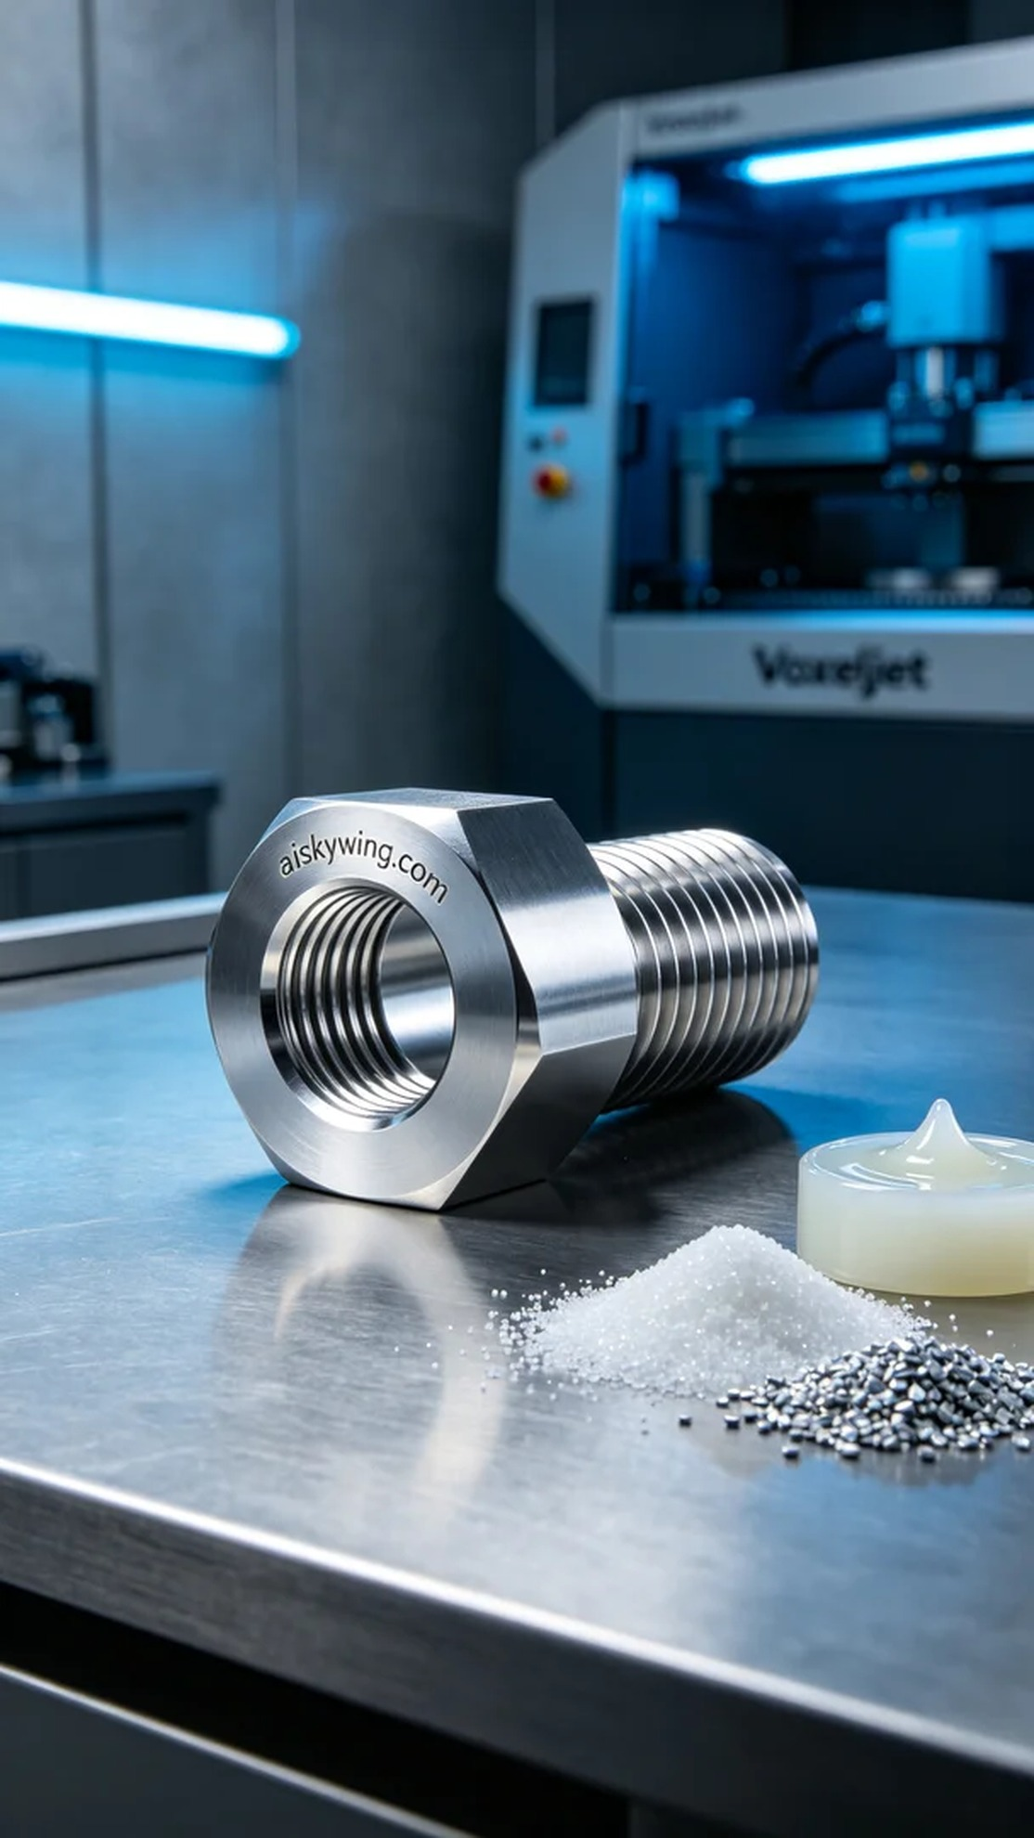
Aiskywing Industrial 3D Printing
Screw nut


