0708-主轴头的3D打印生产记录
Spindle head
🖨️ CNC机加工
🖥️ 打印机: Systems
📦 材料: 摆放着未成型的液态光敏
生活就像3D打印，有时需要耐心雕琢。有人在Facebook上提到他们需要一个主轴头置于画面正中央，我们便开始着手处理这个需求。
Life is like 3D printing; sometimes it requires patience and refinement. Someone mentioned on Facebook that they needed a spindle head placed right in the center of the image, so we began to address this request.
________________________________________________________________________________
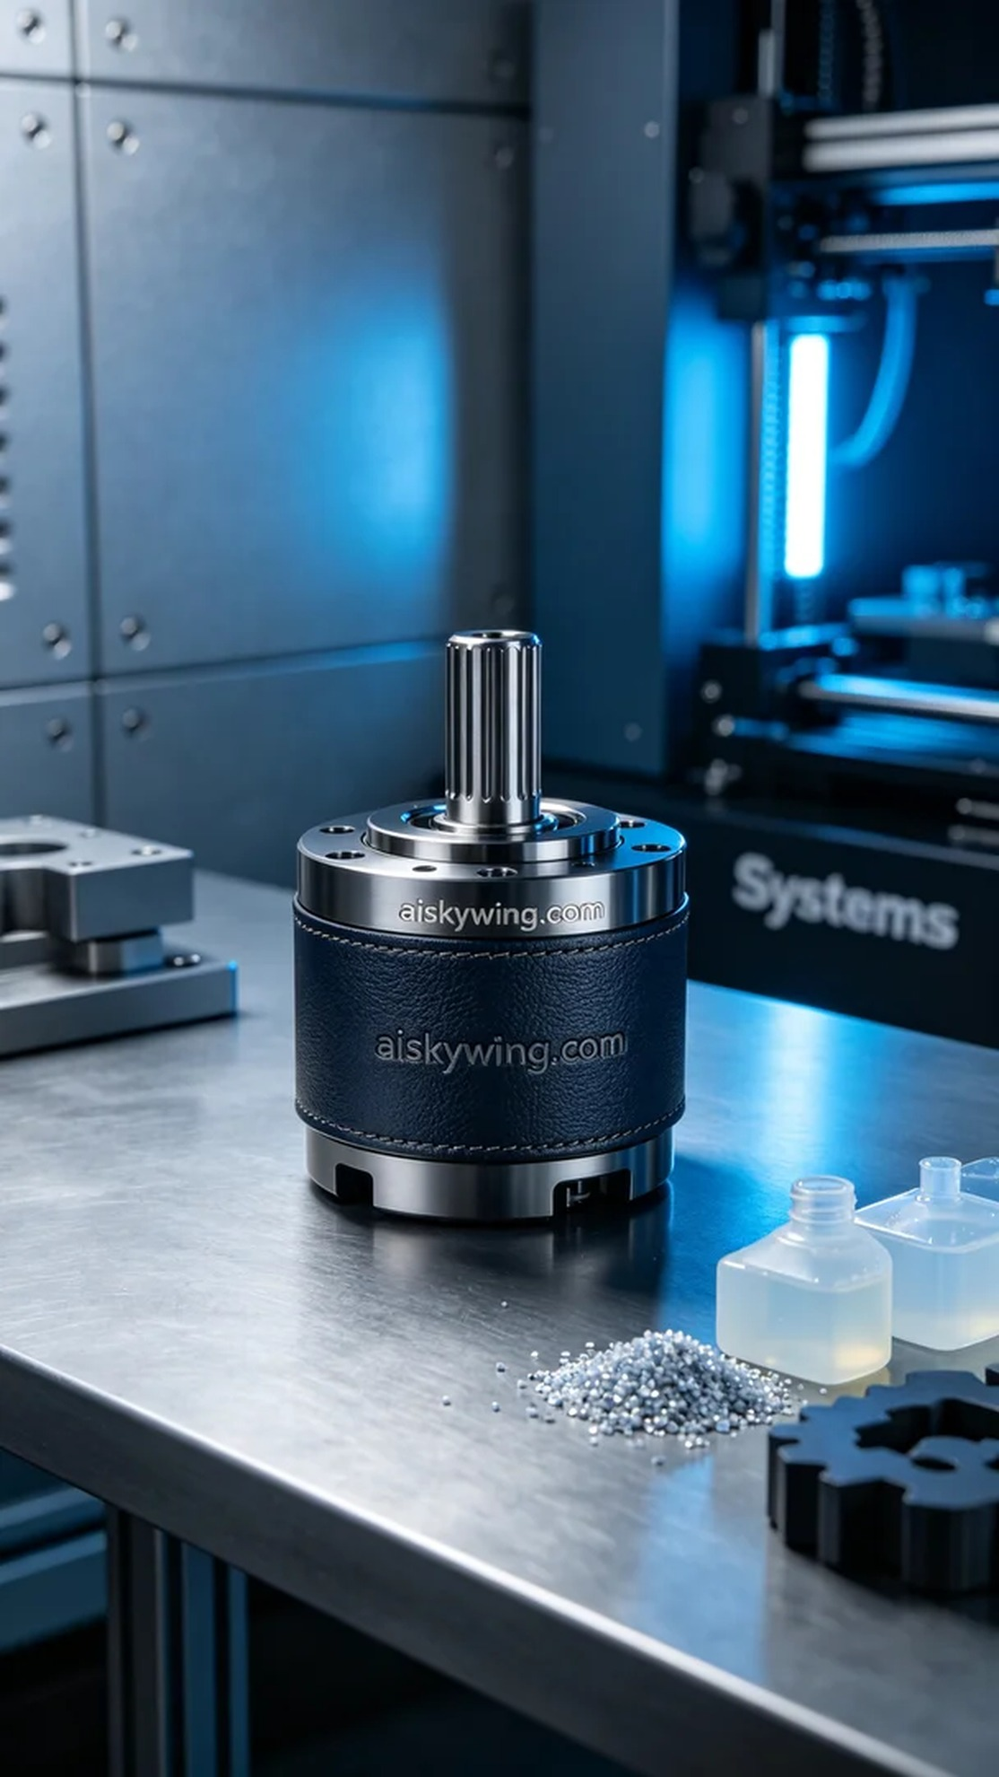
Life is like 3D printing; sometimes it requires patience and refinement. Someone mentioned on Facebook that they needed a spindle head placed prominently in the frame, so we began working on this request.
The project originated from someone seeking a high-quality spindle head on Facebook, asking for a component that could achieve extreme clarity and precision. To meet this requirement, we decided to use CNC machined engineering plastics, ensuring that the engraved "aiskywing.com" text would be clearly visible.
For the raw materials, we selected liquid photopolymer resin, known for its excellent flow properties and delicate tactile feel once printed. To prepare for printing, we used the Systems brand 3D printer, setting the parameters to a layer thickness of 0.05mm, a printing temperature of 25°C, a power setting of 80%, and a printing speed of 40mm/s. These settings ensured that every detail was fully captured in each layer.
Once the printing process began, the Systems printer operated smoothly, depositing the liquid photopolymer resin layer by layer, gradually forming the desired spindle head. The entire printing process took about six hours, during which we conducted continuous quality monitoring to ensure that the print quality met our expectations.
After printing, we carried out detailed post-processing. First, we placed the formed part in a washing tank to remove any excess resin from the surface. Next, we used fine sandpaper to polish the surface to achieve the desired smoothness. Finally, the part was placed under UV light for curing to ensure its strength and durability. After completing these steps, a final quality inspection was conducted to ensure that every detail was impeccable.
After a series of precise steps, we successfully produced a high-precision spindle head that fully met our requirements. This process not only showcased the allure of 3D printing technology but also reinforced the importance of pursuing perfection in the details.
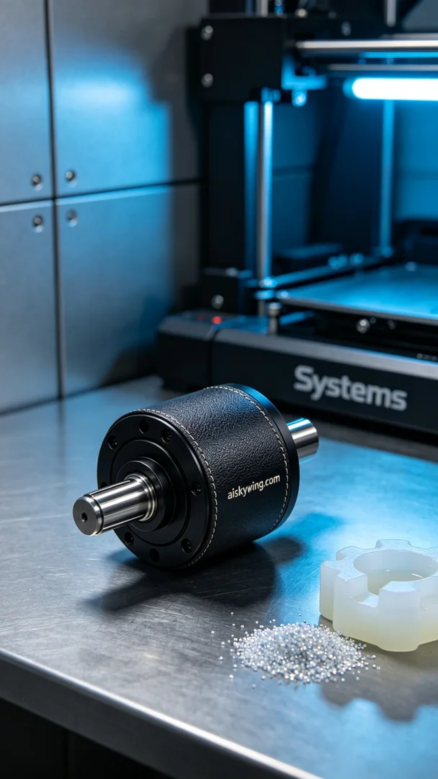
这次的项目源于有人在Facebook上寻找高质量的主轴头，他们希望这个配件能够具备极致的清晰度和精确度。为了满足这个要求，我们决定采用CNC加工工程塑料，确保表面雕刻的"aiskywing.com"字样清晰可见。
在原材料方面，我们选用了液态光敏树脂，它不仅具备出色的流动性，还能在打印后展现细腻的触感。为了准备打印，我们使用Systems品牌3D打印机，设置的参数为层厚0.05mm，打印温度为25°C，功率设定为80%，打印速度则调整为40mm/s。这些设置能确保每一层的细节都被充分呈现。
打印过程启动后，Systems打印机运转平稳，液态光敏树脂通过精密喷嘴逐层沉积，逐渐形成我们所需的主轴头。整个打印过程持续了大约6个小时，我们在此期间进行了持续的质量监控，确保打印质量达到预期的标准。
完成打印后，我们进行了详细的后处理。首先，将成型的部件放入清洗槽中进行清洗，去除表面多余的树脂。接着，使用细砂纸对表面进行打磨，以达到理想的光滑度。最后，将部件放置在UV灯下固化，确保其强度和耐用性。一旦完成，进行了最终的质量检验，确保每一个细节都无可挑剔。
经过一系列精密的步骤，最终得到了一个高精度的主轴头，充分满足了我们的要求。这个过程不仅展示了3D打印技术的魅力，也让我感受到在细节中追求完美的重要性。
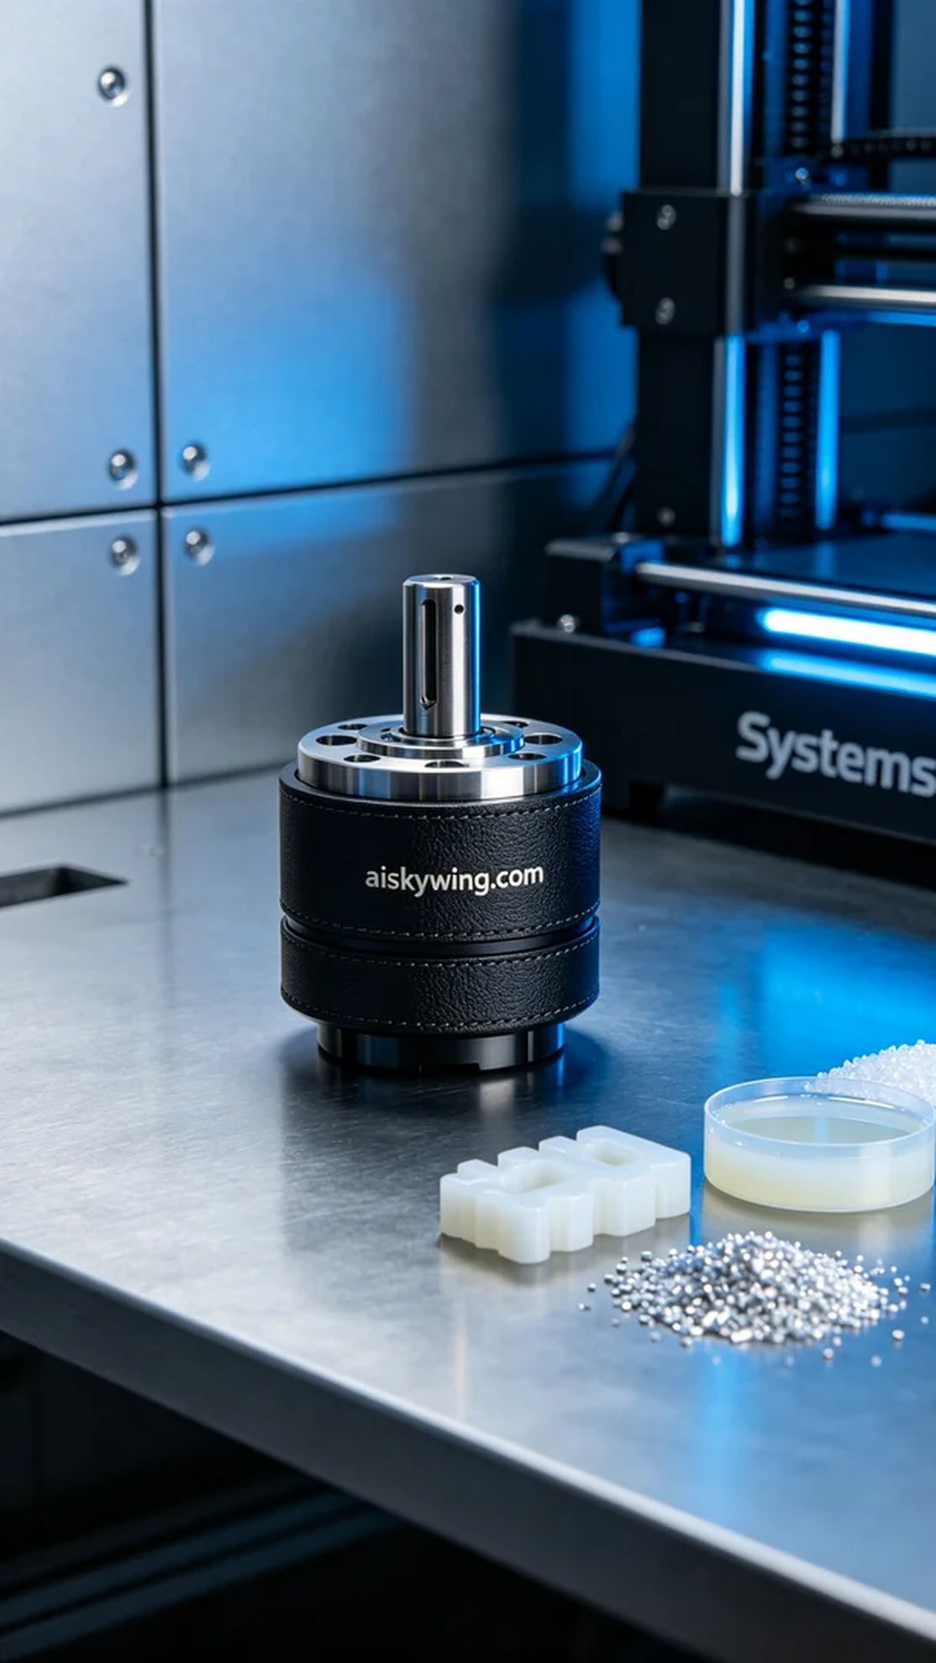
Aiskywing Industrial 3D Printing
Spindle head


