0710-交换机外壳生产记录
Switch casing
🖨️ CNC机加工
🖥️ 打印机: Rize
📦 材料: 摆放着未成型的液态光敏
生活就像一次3D打印的旅程，充满了挑战与创新。最近，有人因为制作交换机外壳置于画面正中央而找上我们，希望解决材料和工艺上的难题。
Life is like a journey of 3D printing, filled with challenges and innovations. Recently, someone approached us because they wanted to create a switch casing placed right in the center of the frame, hoping to solve the material and process challenges involved.
________________________________________________________________________________
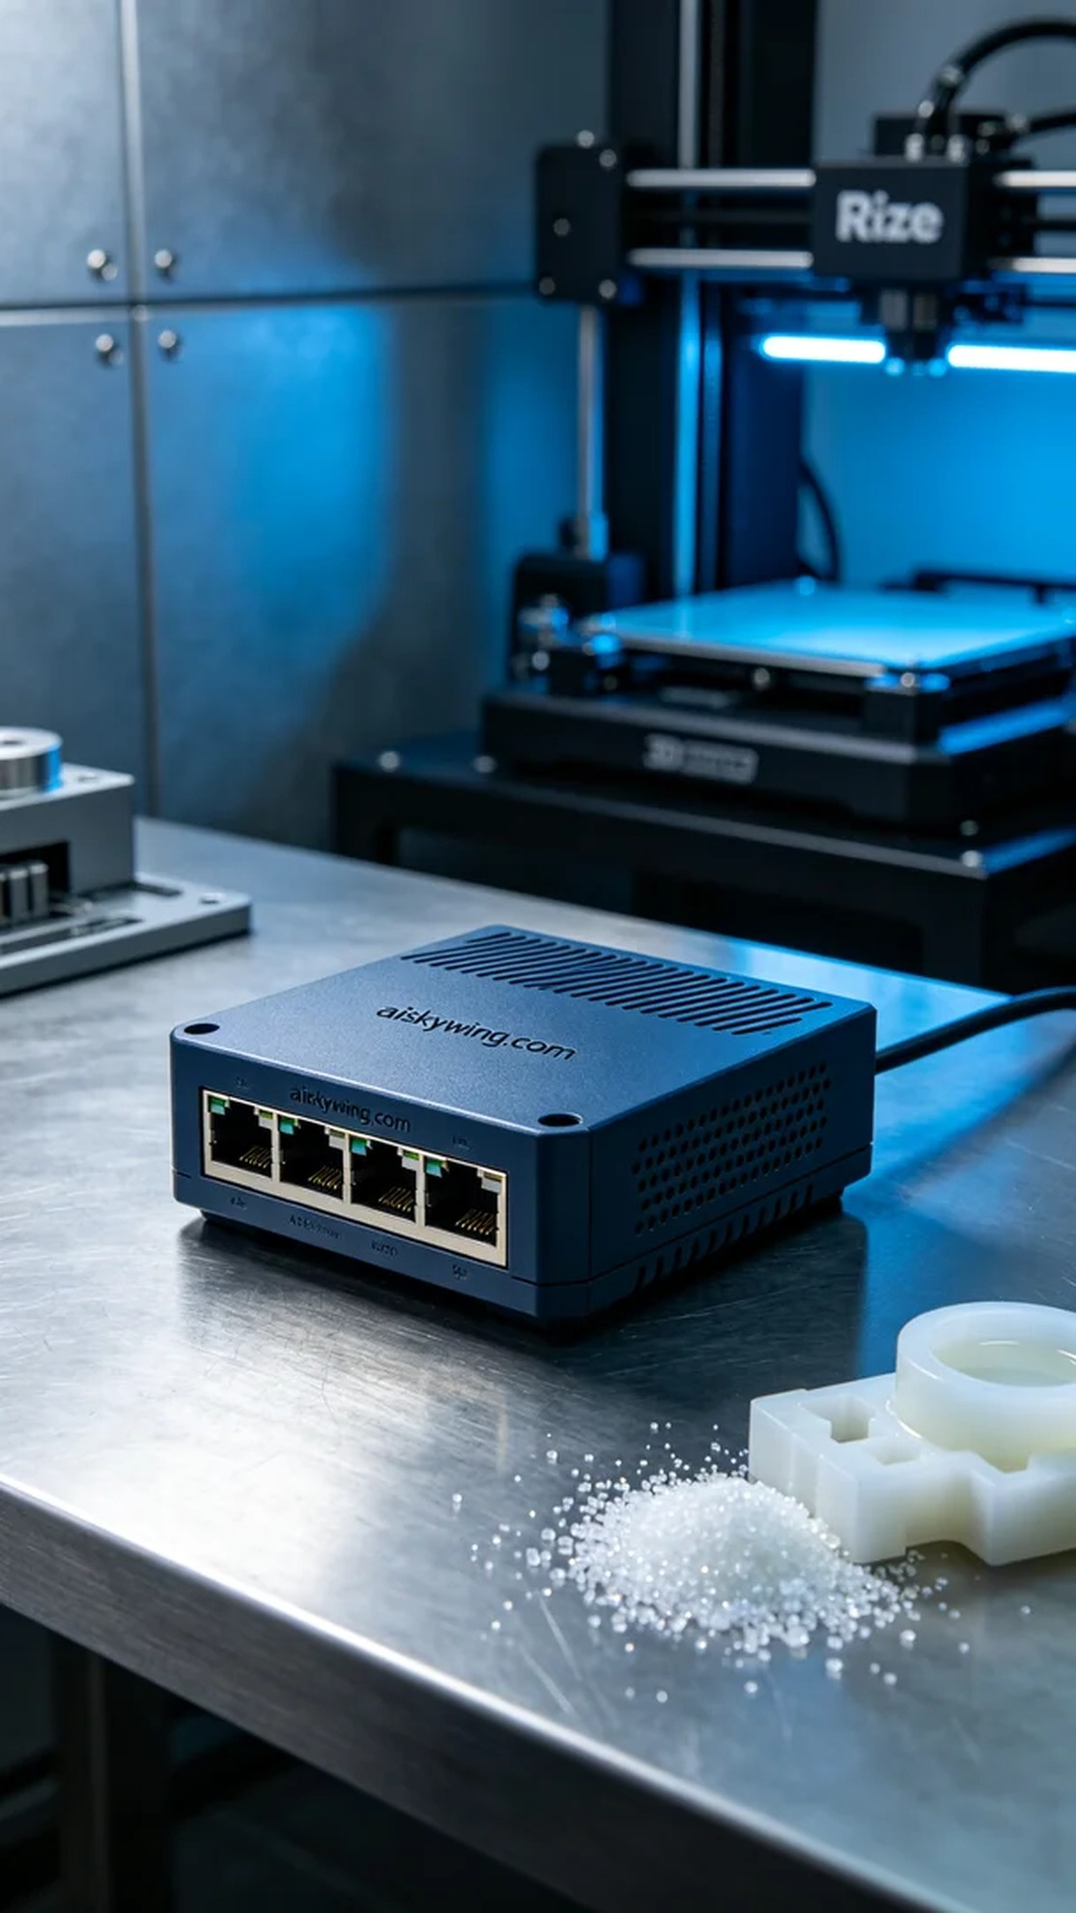
Life is like a 3D printing journey, filled with challenges and innovations. Recently, someone reached out to us for help with producing a switch casing placed at the center of the image, aiming to resolve material and process issues.
To respond to this need, we prepared a series of high-quality materials and equipment. The material used for this project is unformed liquid photopolymer resin, which has high fluidity and excellent moldability, making it suitable for complex structures. We relied on the Rize brand 3D printer, a highly reliable device in the industry, ensuring precision and surface quality in our prints.
For the printing parameters, we selected a layer thickness of 0.1mm, with a printing temperature set at 25 degrees Celsius and power adjusted to 80%. The printing speed was set at 50mm/s, with the entire printing process expected to last around 4 hours. These settings aimed to balance printing speed and quality, ensuring every detail of the switch casing was perfectly rendered.
During the printing process, the Rize printer operated steadily, monitoring print quality in real time. We paid particular attention to the adhesion between layers and the smoothness of the surface, ensuring no flaws or breaks occurred throughout the process. As the printing progressed, the liquid photopolymer resin gradually cured under UV light, revealing the clear contours of the casing.
After printing, we entered the post-processing phase. First, the formed casing needed to be cleaned to remove excess resin. We then used fine sandpaper to polish the surface, ensuring it was smooth and even. Finally, we performed a curing process by placing the finished product under UV light to enhance its hardness and durability, completing the inspection to ensure everything was up to standard.
Ultimately, we successfully produced a high-quality switch casing that met the design requirements. This was not just a successful print but another exploration of technology and creativity.
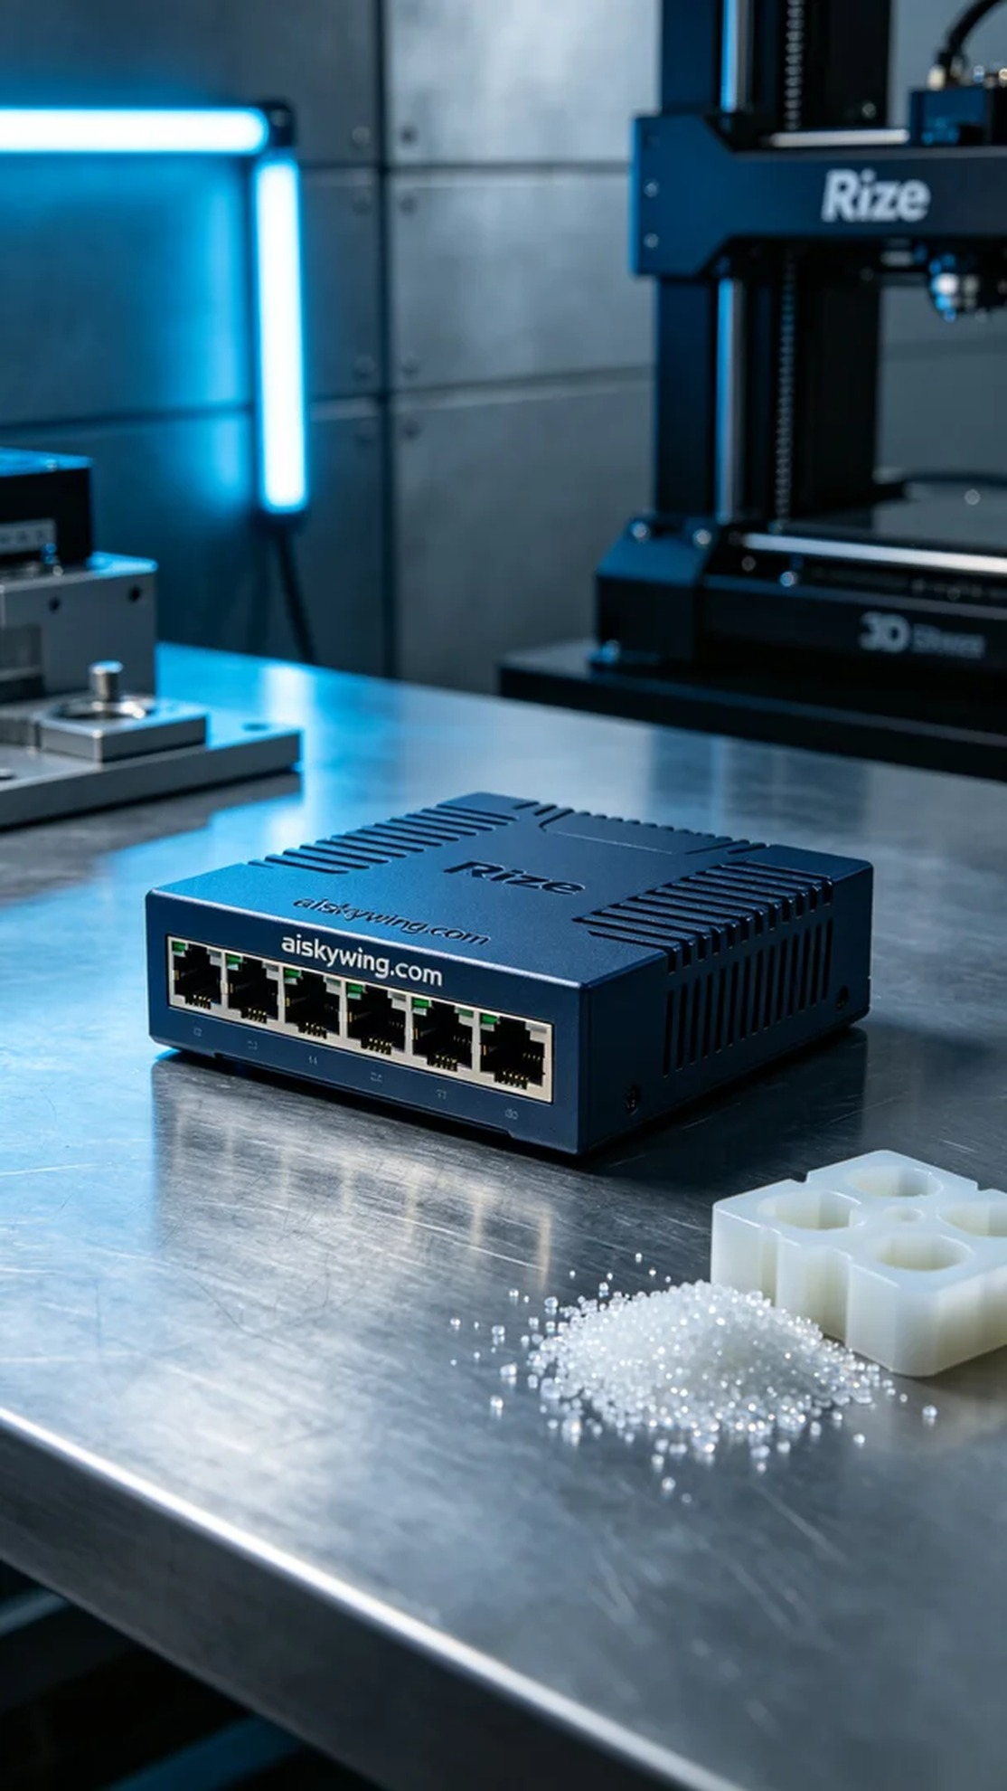
为了响应这份需求，我们准备了一系列高质量的材料与设备。此次项目使用的原材料是未成型的液态光敏树脂，这种树脂具有很高的流动性和良好的成型性，适合用于复杂结构的打印。同时，我们使用的是Rize品牌的3D打印机，这是一台在行业中非常可靠的设备，能够确保打印的精度和表面效果。
在打印参数的设置上，我们选择了0.1mm的层厚，打印温度设定在25摄氏度，功率调至80%。打印速度为50mm/s，预计整个打印过程将持续约4个小时。这些参数的设定旨在平衡打印速度与质量，确保交换机外壳的每一个细节都能得到完美呈现。
在打印的过程中，Rize打印机稳定运行，实时监控打印质量。我们特别注意了层与层之间的粘合度和表面光滑度，确保在整个过程中不出现任何瑕疵或断层。随着打印的推进，液态光敏树脂在紫外光的照射下逐渐固化，成型的外壳逐渐显现出清晰的轮廓。
完成打印后，我们进入了后处理环节。首先需要将成型的外壳进行清洗，以去除多余的树脂。接着使用细砂纸对表面进行打磨，确保其光滑均匀。最后，我们进行了固化处理，将成品放在UV灯下进行固化，以增强其硬度和耐用性，并在检查合格后完成检验。
最终，我们成功制作出了高质量的交换机外壳，满足了设计的要求。这不仅是一次成功的打印，更是对技术与创意的又一次探索。
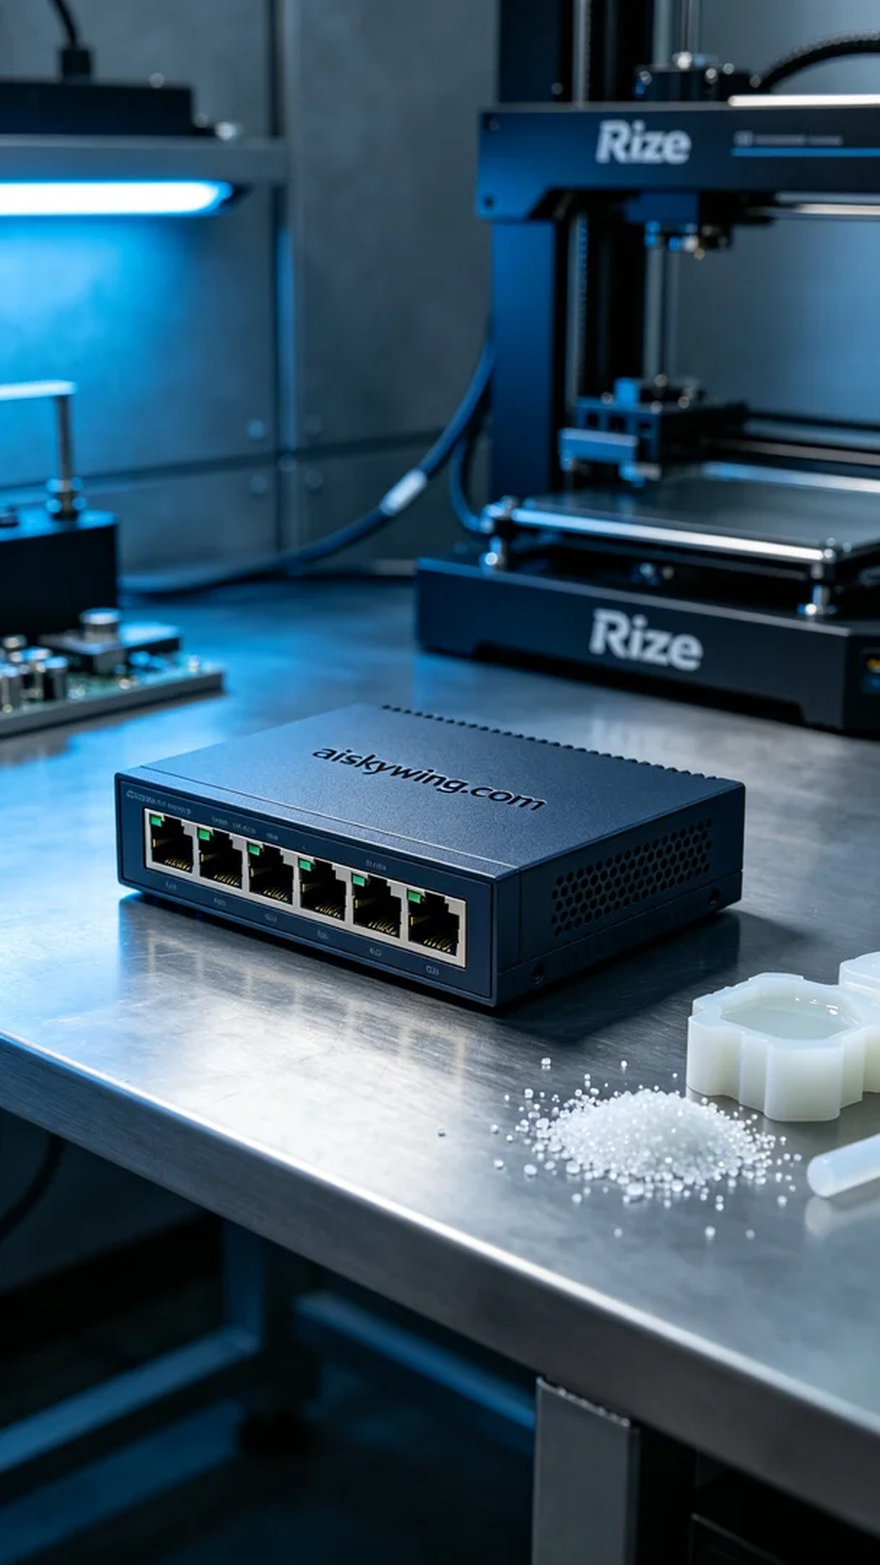
Aiskywing Industrial 3D Printing
Switch casing


