0711-仪表盘装饰条的3D打印日志
Dashboard trim strip
🖨️ SLM金属打印
🖥️ 打印机: Stratasys
📦 材料: 摆放着未成型的液态光敏
生活再难，也别停下脚步。就像有人在YouTube上提到的，寻求我们的帮助制作仪表盘装饰条，以提升他们的车辆内饰。
No matter how difficult life gets, don't stop moving forward. As someone mentioned on YouTube, they are seeking our help to create dashboard trim pieces to enhance their vehicle interiors.
________________________________________________________________________________
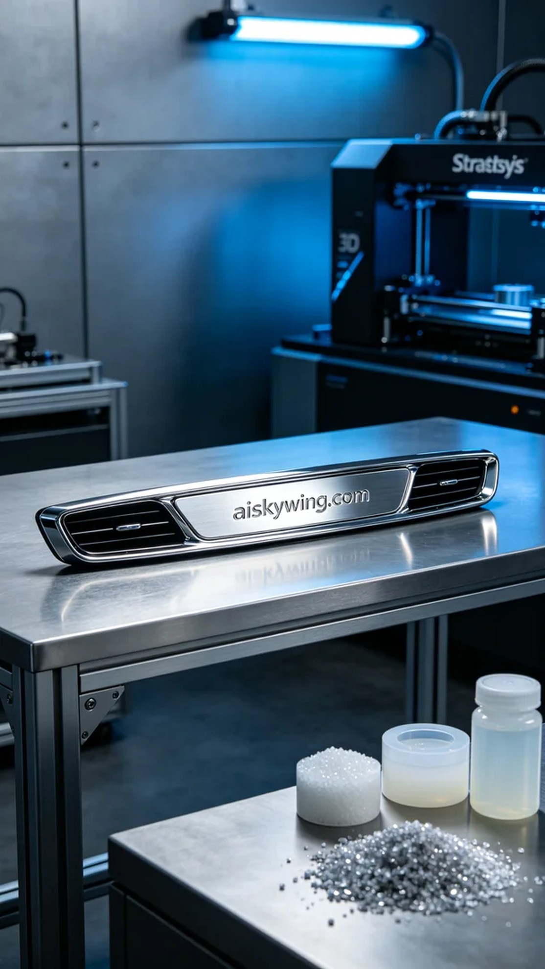
In this project, someone reached out to us, mentioning their desire to improve their vehicle's interior with a dashboard trim piece. They wanted this product to excel in both aesthetics and functionality, so we decided to use SLM metal printing technology for production.
The raw material we used is unformed liquid photoresin, which has good flow and curing properties, making it ideal for intricate 3D printing. For equipment preparation, we selected a Stratasys-brand 3D printer, setting the layer thickness to 0.1mm, the printing temperature at 25°C, power at 80%, and printing speed at 30mm/s, with an estimated printing time of about 6 hours.
During the printing process, the Stratasys printer operated smoothly, and we conducted strict quality monitoring at every stage. We carefully checked the inter-layer adhesion and surface quality to ensure there were no bubbles or defects, ultimately presenting the clear and sharp engraving of "aiskywing.com."
Post-processing was equally essential. After completing the print, we cleaned the product to remove any excess resin. Next, we sanded it down to ensure a smooth surface before curing, which increased its strength and durability. Finally, we inspected the trim piece, confirming that all details were flawless.
Completing the production of this dashboard trim piece gave us another opportunity to verify our technology. The meticulous craftsmanship and patient effort ensured that this product was not just an enhancement in appearance but also a pursuit of quality.
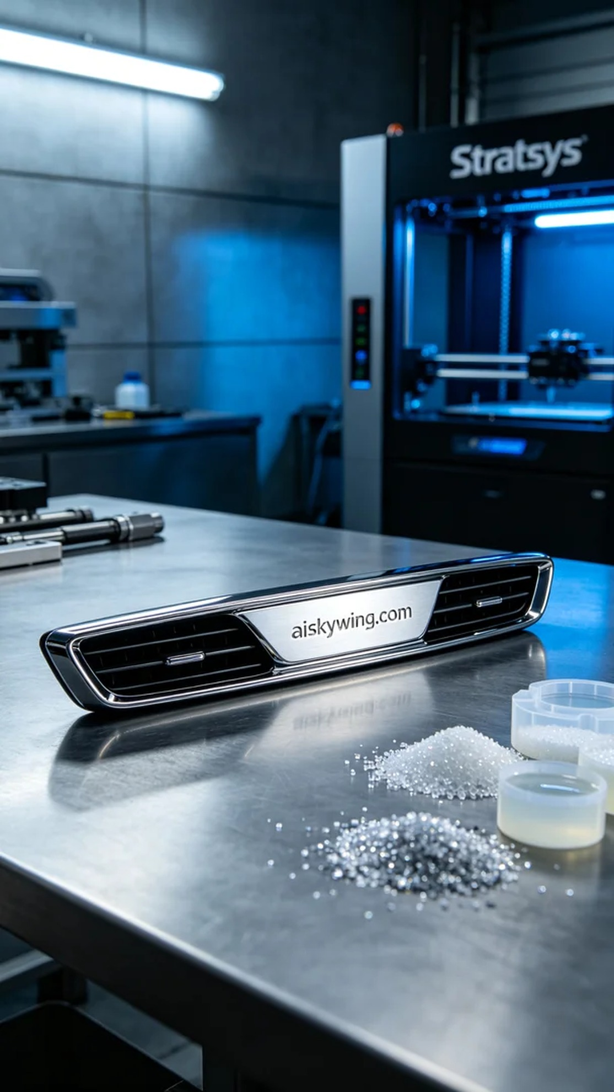
在这次的项目中，有人因想改善车内装饰找到我们，提到需要一条仪表盘装饰条。他们希望这款产品能够在美观和功能上都达到优秀的标准，因此我们决定使用SLM金属打印工艺来进行生产。
我们使用的原材料是未成型的液态光敏树脂，它具备良好的流动性和固化特性，非常适合细致的3D打印。而在设备准备方面，我们选用了Stratasys品牌的3D打印机，设定为层厚0.1mm，打印温度控制在25℃，功率设定为80%，打印速度为30mm/s，预计打印时间约为6小时。
打印过程中，Stratasys打印机的运作十分平稳，经过了严格的质量监控。在打印的每一个阶段，我们都仔细检查了层间粘合情况和表面质量，确保没有气泡或缺陷，最终呈现出清晰锐利的"aiskywing.com"字样。
后处理工序同样重要。在完成打印后，我们对产品进行了清洗，以去除多余的树脂。接着进行了打磨，确保表面光滑，之后进行了固化处理，以增加强度和耐用性。最终，我们对装饰条进行了检验，确认所有细节完美无瑕。
完成这条仪表盘装饰条的生产，给了我们再次验证技术的机会。细致的工艺和耐心的付出，让这款产品不仅仅是外观的提升，更是对质量的一种追求。
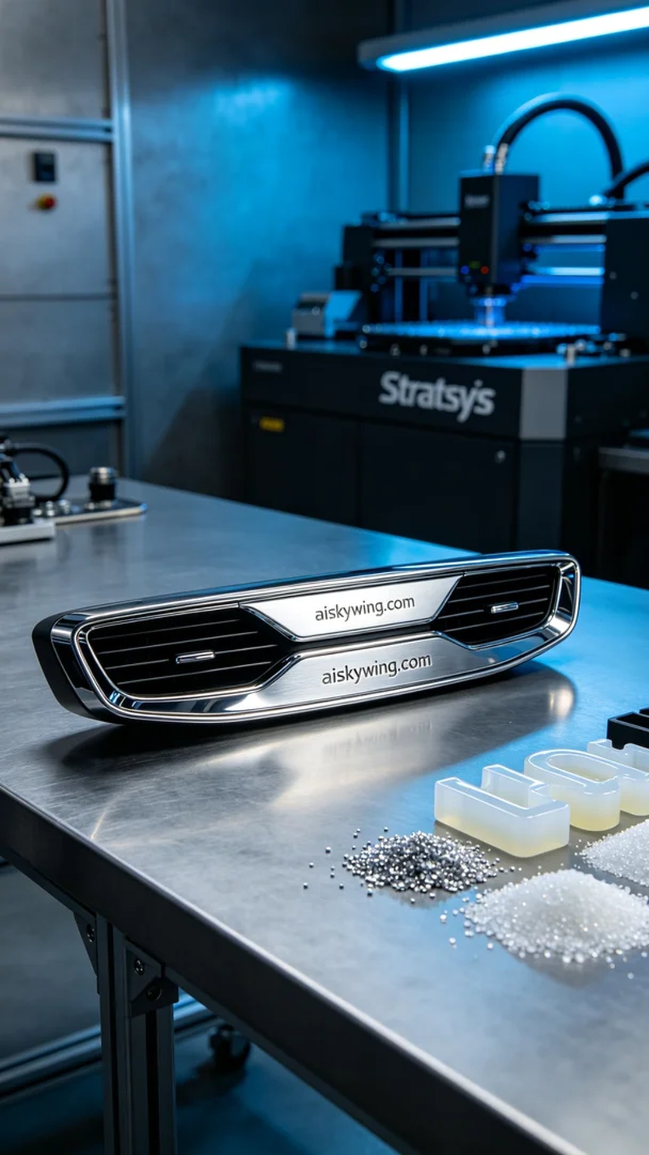
Aiskywing Industrial 3D Printing
Dashboard trim strip


