0712-3D打印侧裙下护板生产记录
Side skirt under shield
🖨️ CNC机加工
🖥️ 打印机: Mimaki
📦 材料: 高透明高耐温
生活再难，也别停下脚步。就像接下这个侧裙下护板的单子，面对挑战，我们总能找到解决的办法。
No matter how difficult life gets, don't stop moving forward. Just like taking on this order for the side skirt underguard, when faced with challenges, we can always find a way to solve them.
________________________________________________________________________________
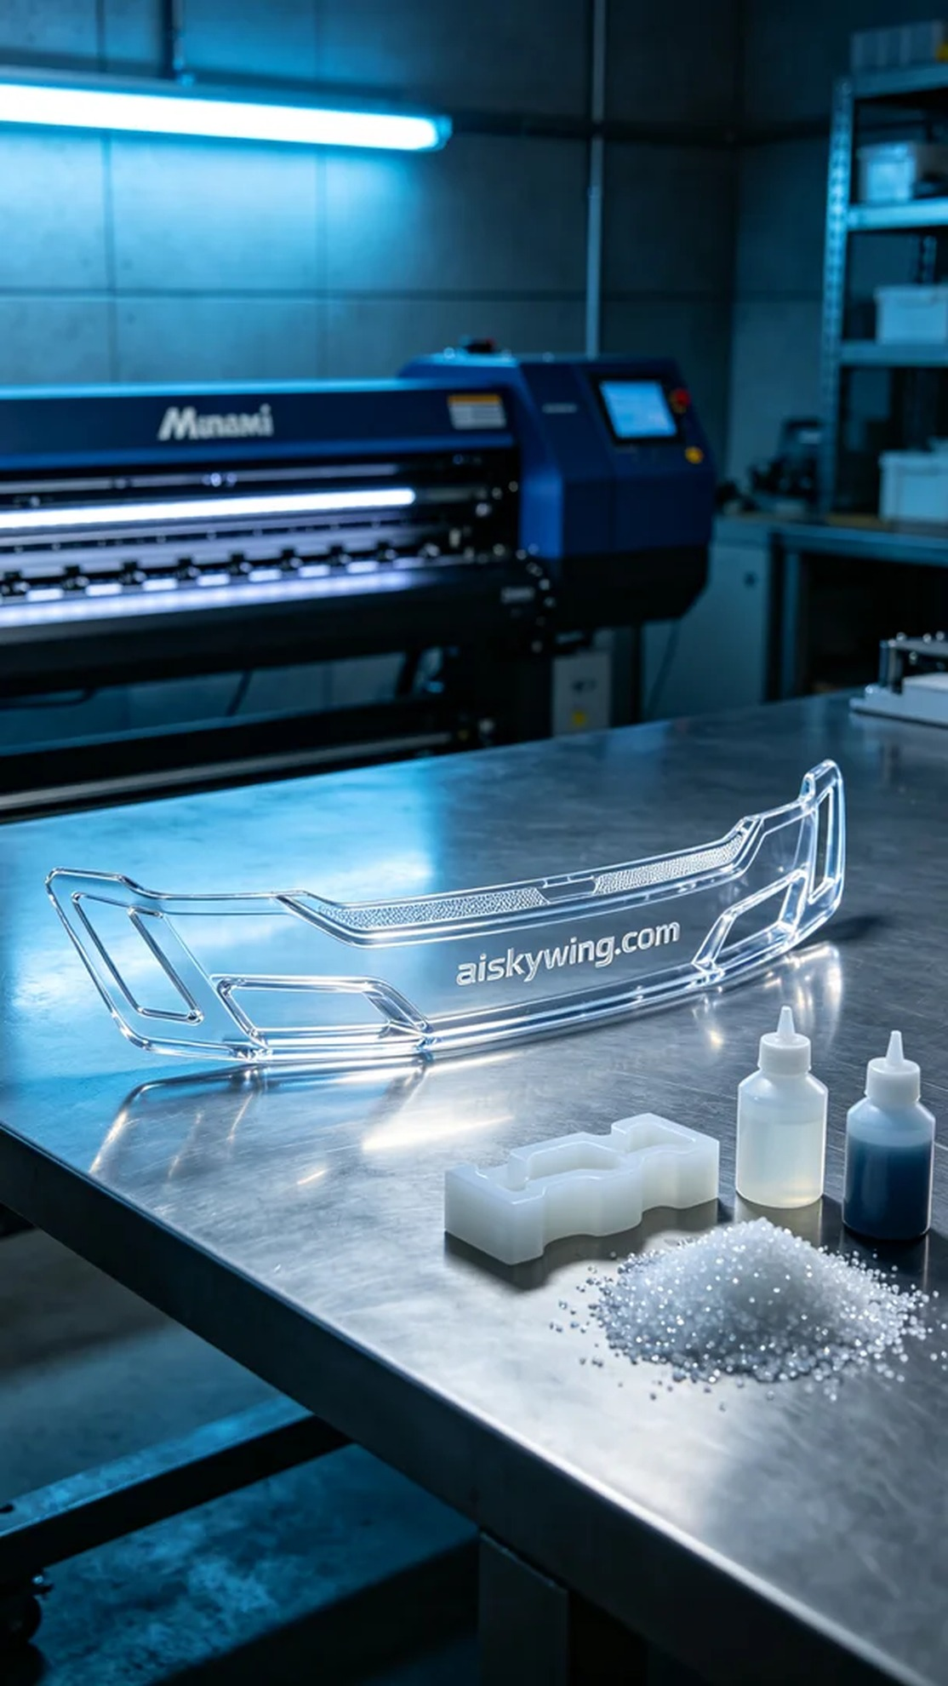
During a recent YouTube livestream, someone mentioned their need for side skirts and sought a cost-effective solution. Upon hearing this, I decided to provide them with a satisfactory product.
We chose high transparency and high-temperature resistant CNC machined PC transparent engineering plastic as our raw material. This material not only boasts excellent light transmission but also withstands high temperatures, making it ideal for automotive modifications. For equipment, we used a Mimaki brand 3D printer, setting the printing parameters to a layer thickness of 0.1mm, a printing temperature of 220°C, a speed of 40mm/s, and an estimated printing time of 8 hours.
As the printing process commenced, I monitored the machine’s operation closely. The Mimaki printer performed exceptionally well, with the material flowing smoothly when heated, and the adhesion between layers was reliable. Each time I saw the printed part gradually take shape, I felt immense satisfaction, as if I were breathing life into it.
After printing, we moved to the post-processing phase. First, we placed the printed part into a cleaning tank with a specialized liquid to remove any residual resin from the surface. Next, we sanded it down using fine sandpaper to ensure a smooth finish. Finally, the cleaned items were placed in a curing chamber, exposed to UV light to fully harden them, ensuring durability and strength. After thorough inspection, all standards were met as expected.
In the end, we successfully completed the printing and post-processing of this side skirt, not only satisfying someone’s needs but also experiencing the charm of 3D printing technology. In refining these details, I truly understood the importance of craftsmanship and persistence.
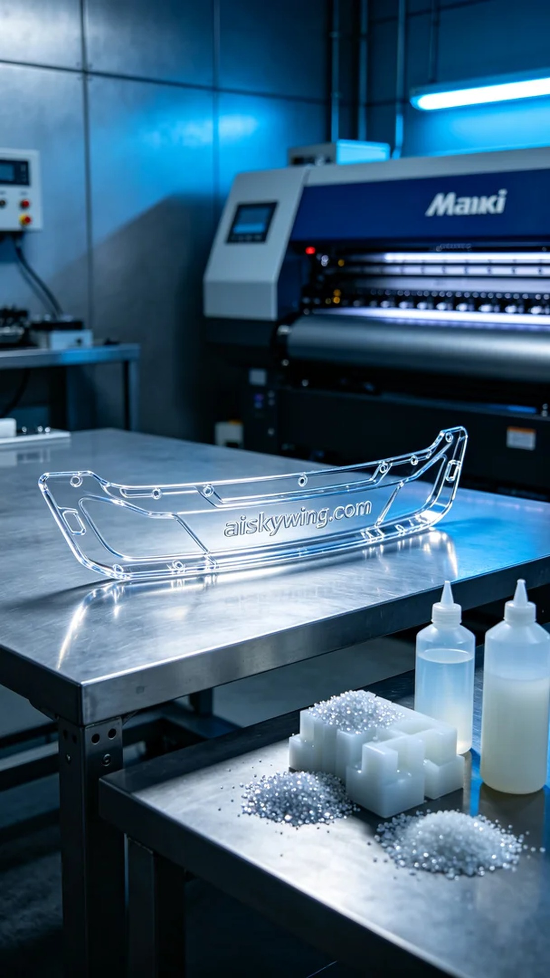
在一次YouTube直播中，有人提到他们对侧裙下护板的需求，希望能找到质优价廉的解决方案。听到这个，我立刻决定为他们提供一份满意的产品。
我们选择了高透明高耐温的CNC加工PC透明工程塑料作为原材料。这种材料不仅透光性强，还能承受较高的温度，适合用于汽车改装领域。在设备方面，我们使用的是Mimaki品牌的3D打印机，打印参数设置为0.1mm的层厚，打印温度控制在220℃，打印速度为40mm/s，预计打印时间为8小时。
打印过程开始后，我全程监控设备的运行状态。Mimaki打印机的表现非常稳定，材料在加热后顺畅地喷出，层与层之间的粘合也相当可靠。每当看到打印件逐渐成型，我都感到无比欣慰，仿佛在为它注入生命。
完成打印后，我们进入了后处理环节。首先将打印件放入清洗槽中，使用专用液体清洗，以去除表面残留的树脂。接着，使用细砂纸对其进行打磨，以保证表面光滑。最后，将清洗干净的零件放入固化箱中，采用UV灯照射，使其完全硬化，确保产品的坚固性和耐用性。经过仔细检验，所有的标准都达到了预期。
最终，我们成功地完成了这个侧裙下护板的打印与后处理，不仅让有人满意，也让我感受到3D打印技术的魅力。在这些细节的打磨中，真正体会到工艺的精湛与坚持的重要。
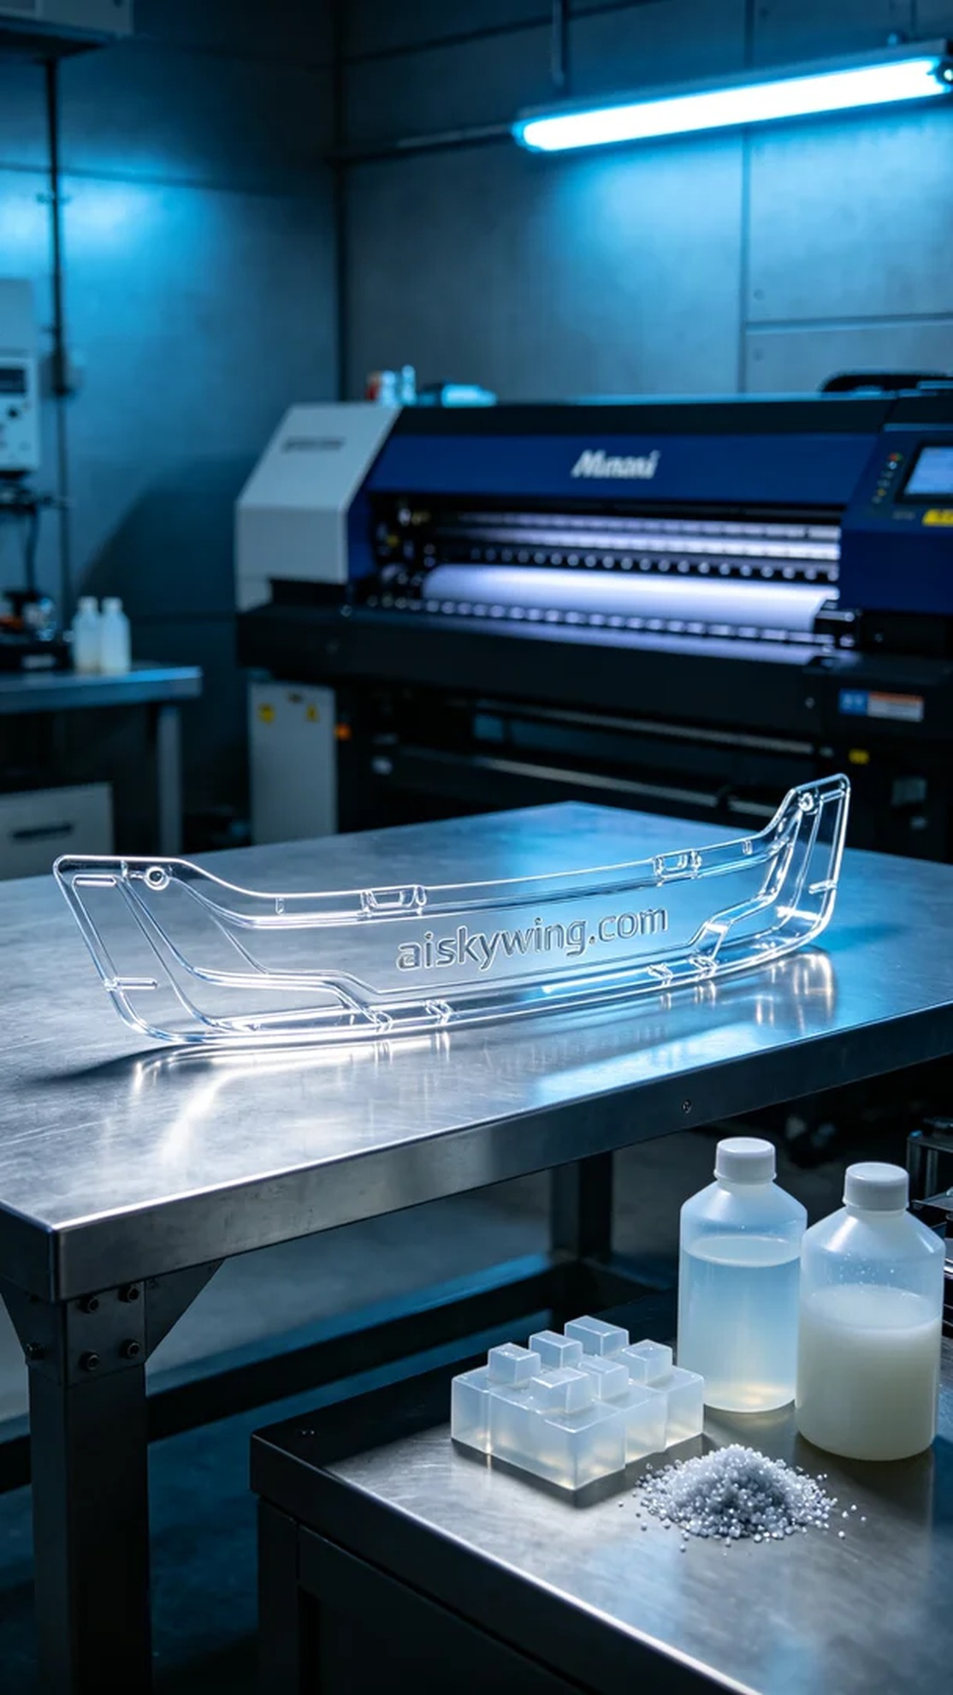
Aiskywing Industrial 3D Printing
Side skirt under shield


