0713-侧裙装饰条3D打印生产记录
Side skirt decorative strip
🖨️ SLM金属打印
🖥️ 打印机: Voxeljet
📦 材料: 摆放着未成型的液态光敏
有时候咬牙坚持，不是为了证明什么。就像做这个侧裙装饰条时，有人因为追求完美找上了我，让我再次体会到3D打印的魅力。
Sometimes, gritting your teeth and persevering isn't about proving anything. It's like when I was working on this side skirt trim; someone approached me in pursuit of perfection, allowing me to once again experience the charm of 3D printing.
________________________________________________________________________________
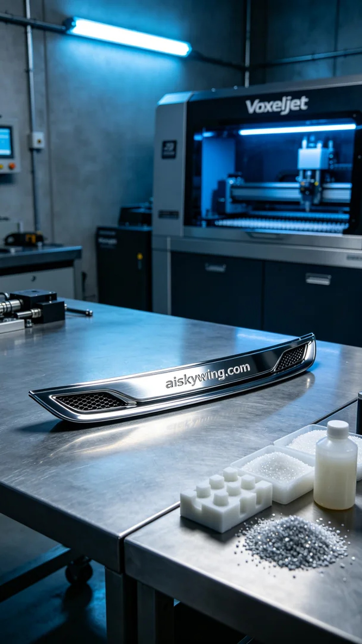
Sometimes, enduring challenges is not about proving anything. Just like when making this side skirt trim, someone sought me out for perfection, reminding me of the magic of 3D printing once again.
We prepared to use liquid photopolymer resin as our raw material for printing, ensuring the final product's precision and gloss. The equipment used was the Voxeljet printer, set to a layer thickness of 50 microns, with a printing temperature of 25 degrees Celsius, a power setting of 80%, and a speed of approximately 60mm/s. This combination of parameters would ensure that the printing details, precision, and surface smoothness all met our expectations.
The printing process went smoothly, with the Voxeljet device operating stably, and the liquid photopolymer resin curing layer by layer, revealing the clear engraved lettering on the surface. I monitored the print quality closely to ensure that each layer's thickness and precision was up to standard. As the printing progressed, the outline of the side skirt trim became clearer, fueling my anticipation.
Once printing was complete, we moved on to the post-processing steps. The formed trim was removed and placed in a cleaning tank, using cleaning solution to thoroughly remove any excess material from the surface. After cleaning, it underwent detailed sanding to ensure every edge was smooth and even. Finally, it was placed in a curing machine for solidification, ensuring the material's strength and durability, followed by rigorous quality inspection to ensure that every product met the standards.
After a series of meticulous processes, this side skirt trim finally presented itself to us, shining with a high-gloss metallic texture, as if showcasing the extraordinary charm of 3D printing. Every print is a new journey, and today, this journey has taken on a new excitement.
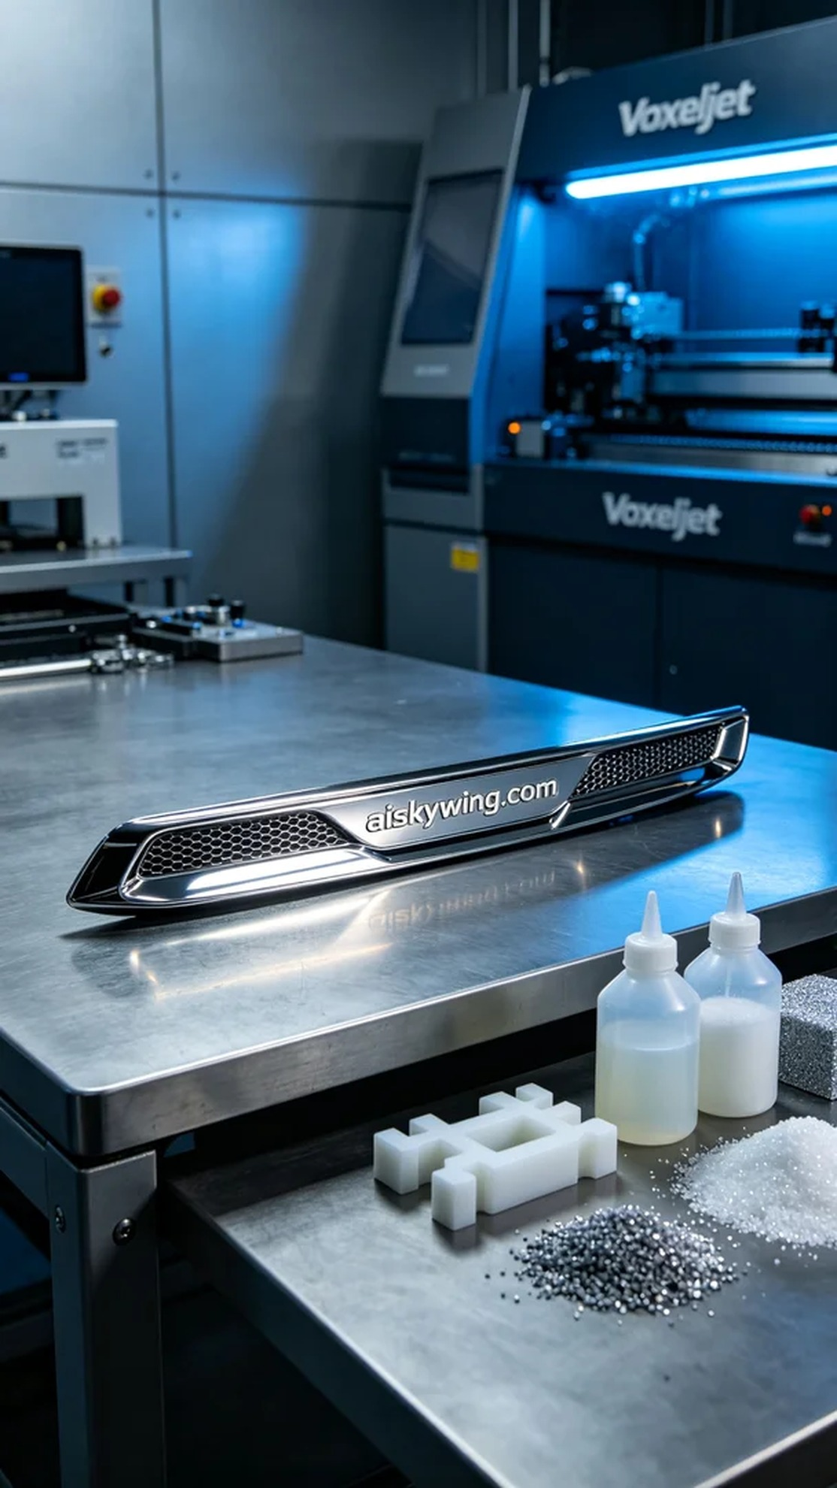
在TikTok上，有人因为想要一款独特的侧裙装饰条而找上我。他们希望这款装饰条不仅美观，还要在外观和质感上达到最佳效果。这让我想起了3D打印的无限可能，于是我们开始了这个项目。
我们准备使用摆放着未成型的液态光敏材料来进行打印，确保最终产品的精细度和光泽度。使用的设备是Voxeljet打印机，层厚设定为50微米，打印温度保持在25摄氏度，功率设定为80%，速度约为60mm/s。这样的参数组合能够确保打印的细节、精度与表面光滑度都达到理想状态。
打印过程非常顺利，Voxeljet设备工作稳定，液态光敏材料在打印过程中逐层固化，清晰的雕刻字样在表面显现出来。我时刻监控打印质量，确保每一层的厚度和精度符合要求。随着打印的逐步完成，侧裙装饰条的轮廓逐渐清晰，我的心中也逐渐充满了期待。
打印完成后，进入了后处理工序。首先将成型的装饰条取出，放入清洗槽中，使用清洗液彻底去除表面多余的材料。清洗完后，进行了细致的打磨，确保每个边角都圆滑平整。最后，将其放入固化机中进行固化，确保材料的强度和耐用性，最终进行了严格的质量检验，保证每一件产品都能达到标准。
经过一系列精细的工序，这款侧裙装饰条终于呈现在我们面前，闪耀着高光金属的质感，仿佛在向我展示3D打印的非凡魅力。每一次打印都是一段新的旅程，而今天，这段旅程又有了新的精彩。
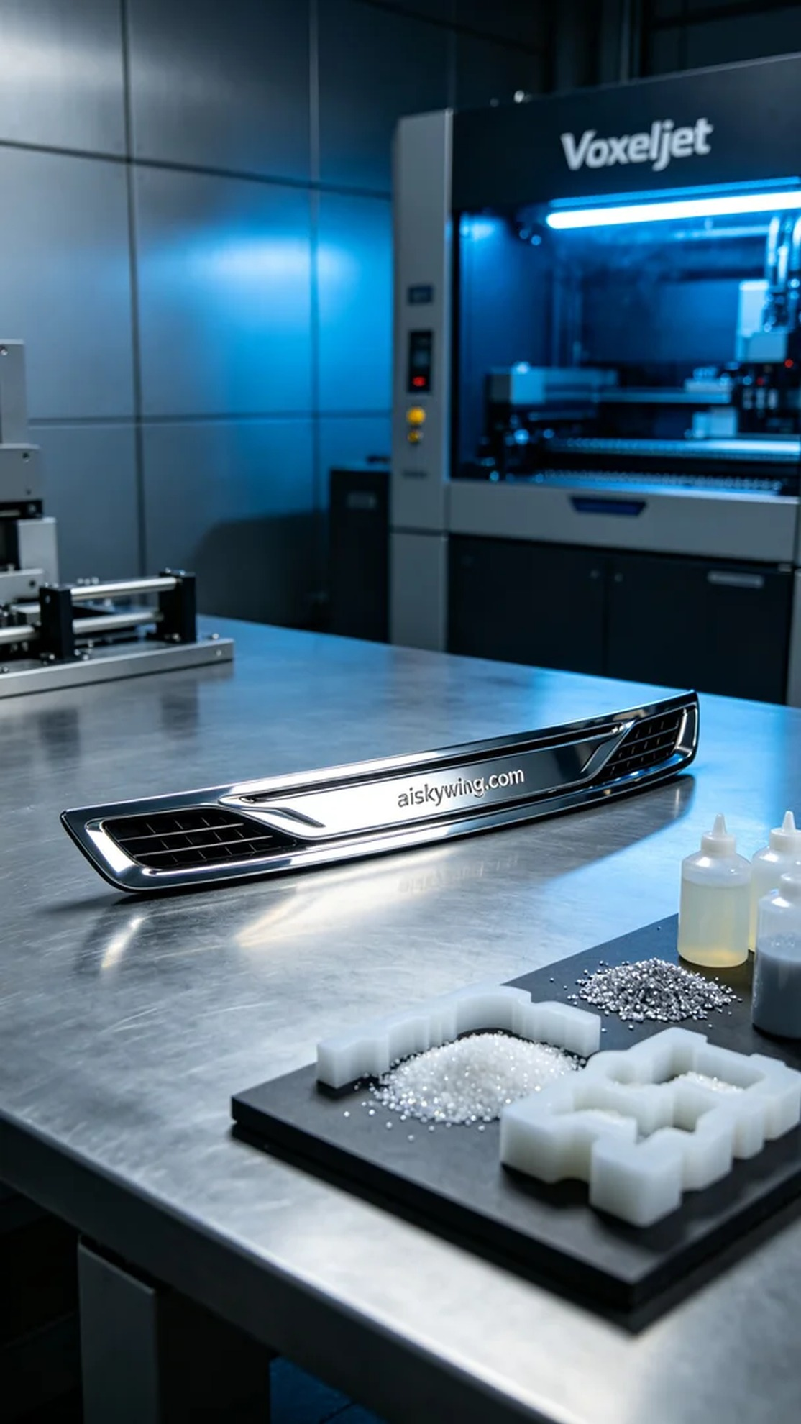
Aiskywing Industrial 3D Printing
Side skirt decorative strip


