0714-保护模块外壳生产记录
Protective module shell
🖨️ CNC机加工
🖥️ 打印机: Stratasys
📦 材料: 摆放着未成型的液态光敏
生活就像3D打印，每一步都至关重要。最近，有人通过WhatsApp联系我，询问关于保护模块外壳的生产问题。
Life is like 3D printing; every step is crucial. Recently, someone contacted me via WhatsApp to inquire about production issues related to protecting the module shell.
________________________________________________________________________________
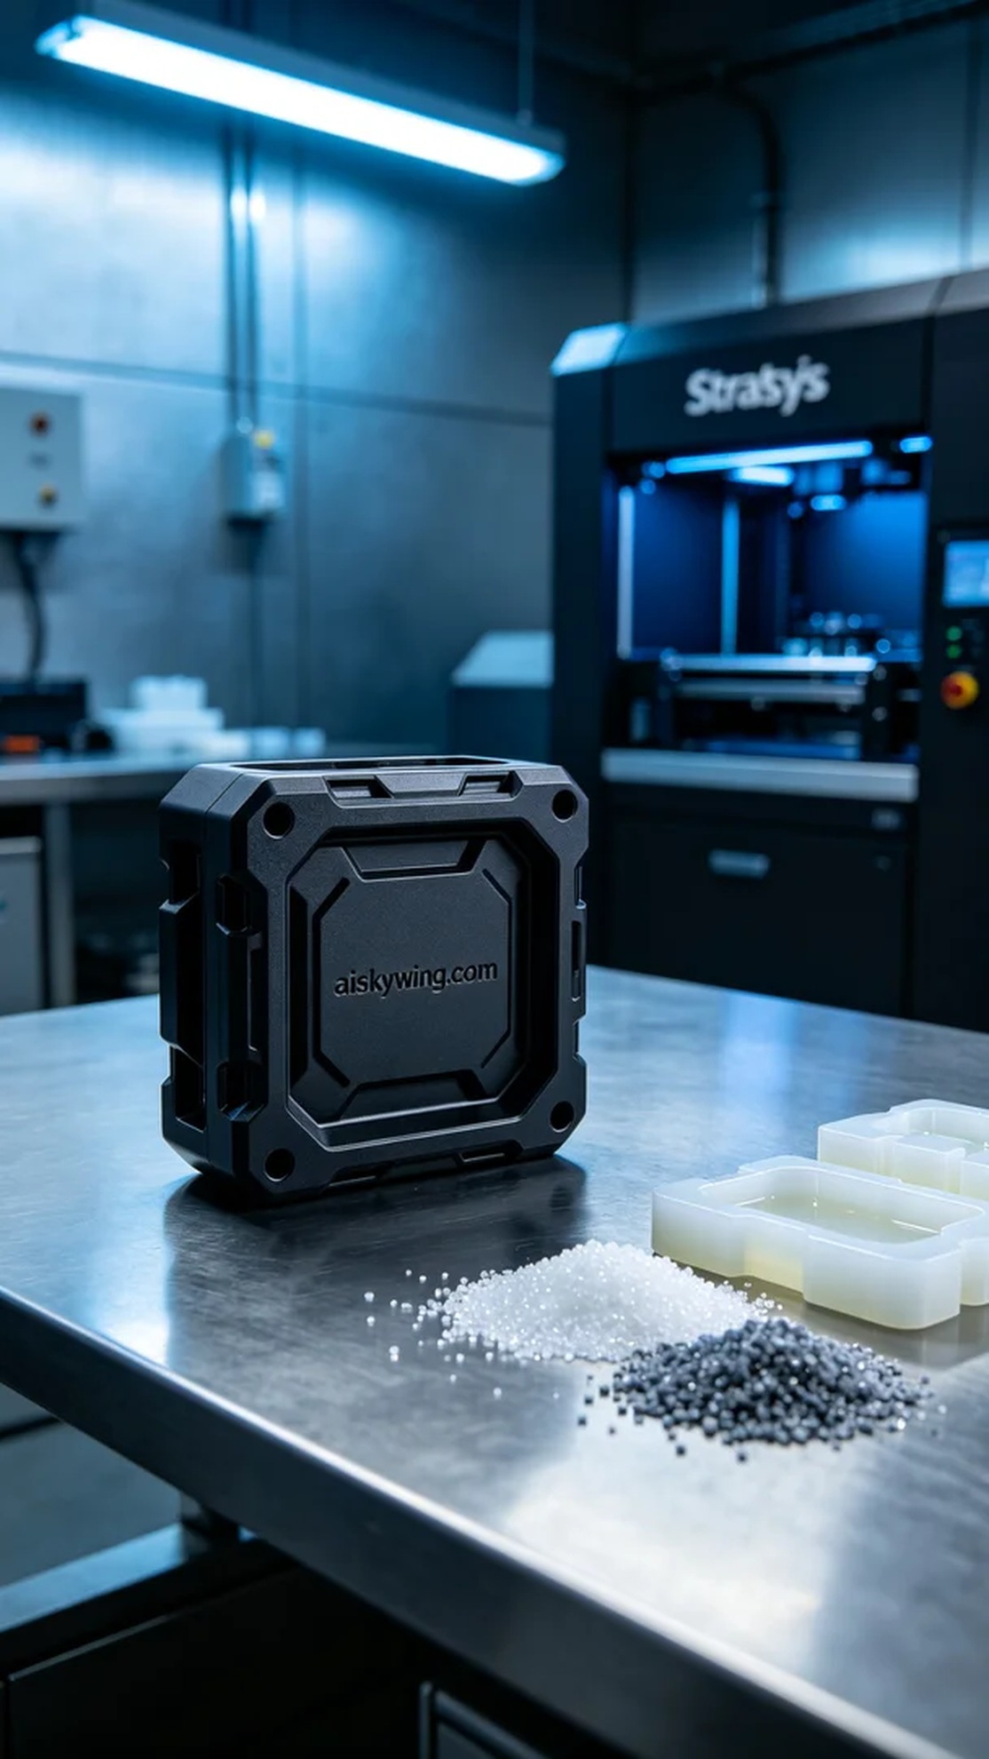
Life is like 3D printing; every step is crucial. Recently, someone contacted me via WhatsApp to inquire about the production of a protective module shell.
We selected unformed liquid photopolymer resin as the primary material. This material offers excellent transparency and impact resistance, making it ideal for the production of protective shells. To ensure printing accuracy, we configured the Stratasys 3D printer with the following parameters: layer thickness of 0.1mm, printing temperature at 25 degrees, power set at 80%, printing speed of 30mm per second, with an expected printing time of 8 hours.
During the printing process, the equipment ran smoothly, and the monitoring system tracked print quality in real-time. Each layer cured perfectly, ensuring a smooth surface and intricate texture for the shell. I closely monitored the progress, ensuring there were no issues, and ultimately completed the entire printing process without any hitches.
After printing, we moved into post-processing. First, we cleaned the formed shell to remove excess resin, followed by sanding to ensure a smooth surface. Then, we proceeded with the curing process to further enhance the shell's durability, followed by a rigorous inspection to ensure all specifications and quality standards were met.
After a series of meticulous procedures, the protective module shell was finally completed as desired. It not only provided excellent protective features but also showcased outstanding industrial aesthetics.
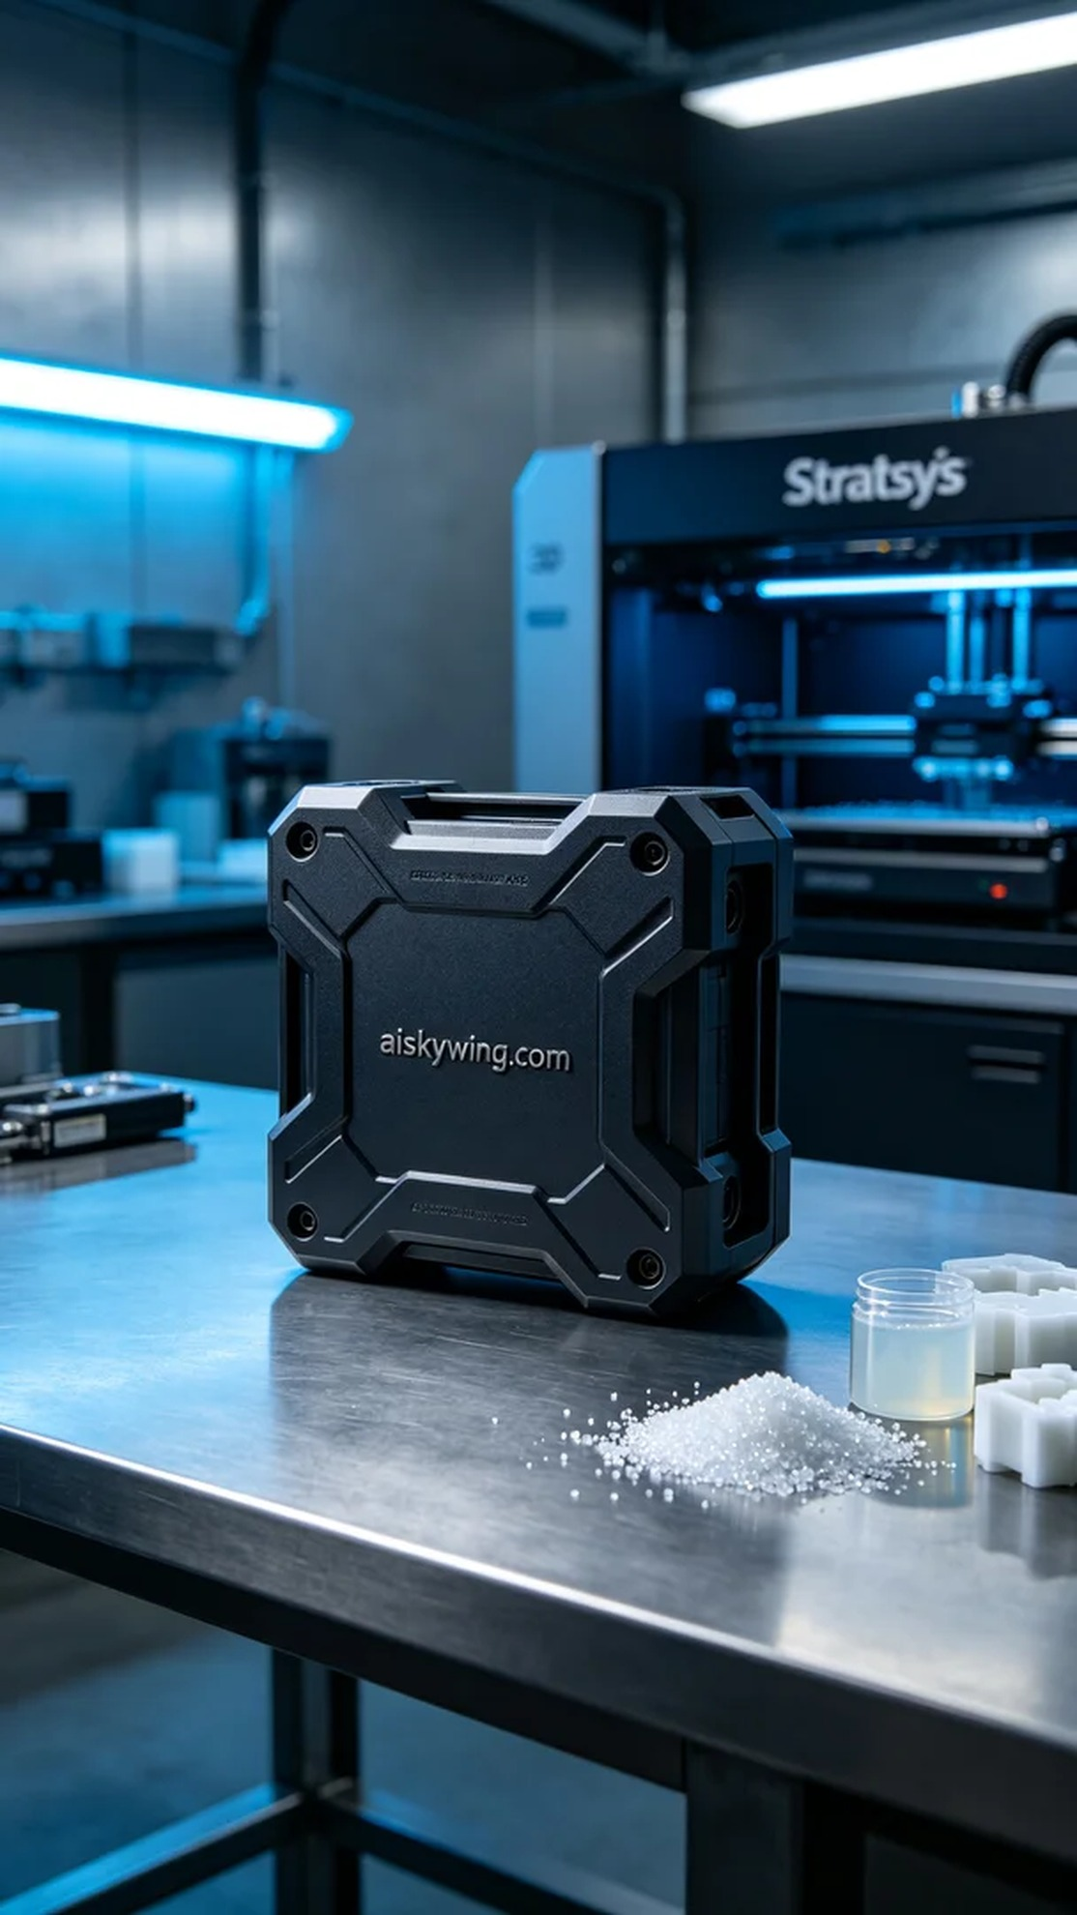
在最近的一次工作中，有人找我询问有关保护模块外壳的生产方案。他们需要这个外壳来保护重要的电子设备，因此希望我们能提供高质量的解决方案。
我们选用了摆放着未成型的液态光敏树脂作为主要原材料。这种材料具有优良的透明度和抗冲击性，非常适合用于保护外壳的生产。为了确保打印精度，我们设置了Stratasys 3D打印机的参数：层厚0.1毫米，打印温度为25度，功率设定在80%，打印速度为30毫米每秒，预计打印时间为8小时。
在打印过程中，设备平稳运行，监测系统实时跟踪打印质量。每一层的固化都非常到位，确保了外壳的表面光滑和纹理细腻。我时刻关注着打印进度，确保没有出现任何异常情况，最终顺利完成了整个打印过程。
完成打印后，我们进入后处理阶段。首先对成型的外壳进行清洗，去除多余的树脂，然后进行打磨处理，以保证表面光滑。接着进行了固化处理，以进一步增强外壳的耐用性，最后进行严格的检验，确保所有规格和质量符合要求。
经过一系列精细的工序，这个保护模块外壳终于如愿完成。经过我们的努力，它不仅具备了极佳的保护性能，还展现了出色的工业美感。
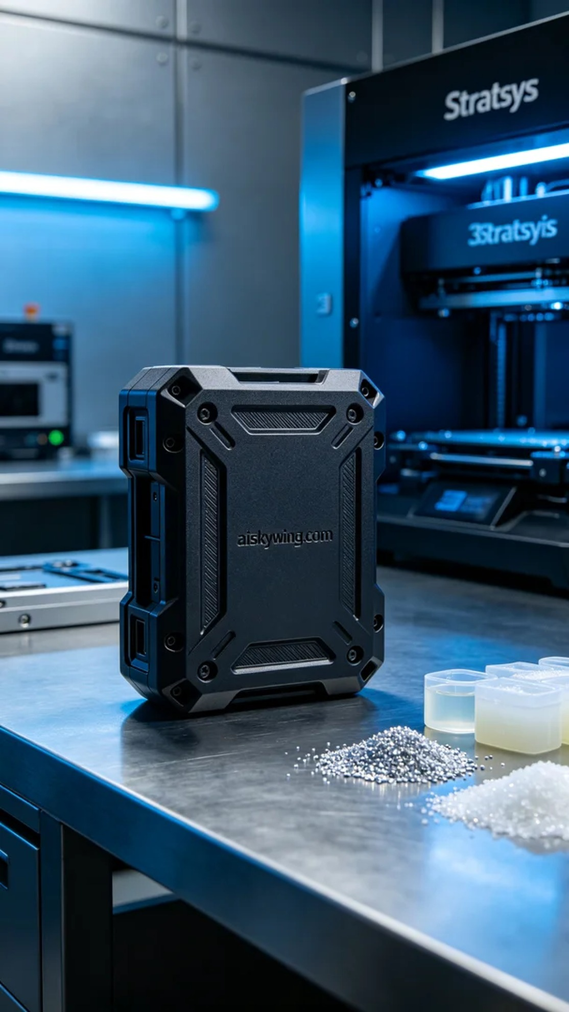
Aiskywing Industrial 3D Printing
Protective module shell


