0719-储物盒底垫3D打印生产记录
Storage box bottom mat
🖨️ SLM金属打印
🖥️ 打印机: Stratasys
📦 材料: 摆放着未成型的液态光敏
在这个充满创意的时代，储物盒底垫在TikTok上被广泛讨论，有人希望通过3D打印来解决存放问题，恰好我们接下了这个单子。
In this creative era, storage box mats have been widely discussed on TikTok, with some hoping to solve storage problems through 3D printing. Coincidentally, we have taken on this project.
________________________________________________________________________________
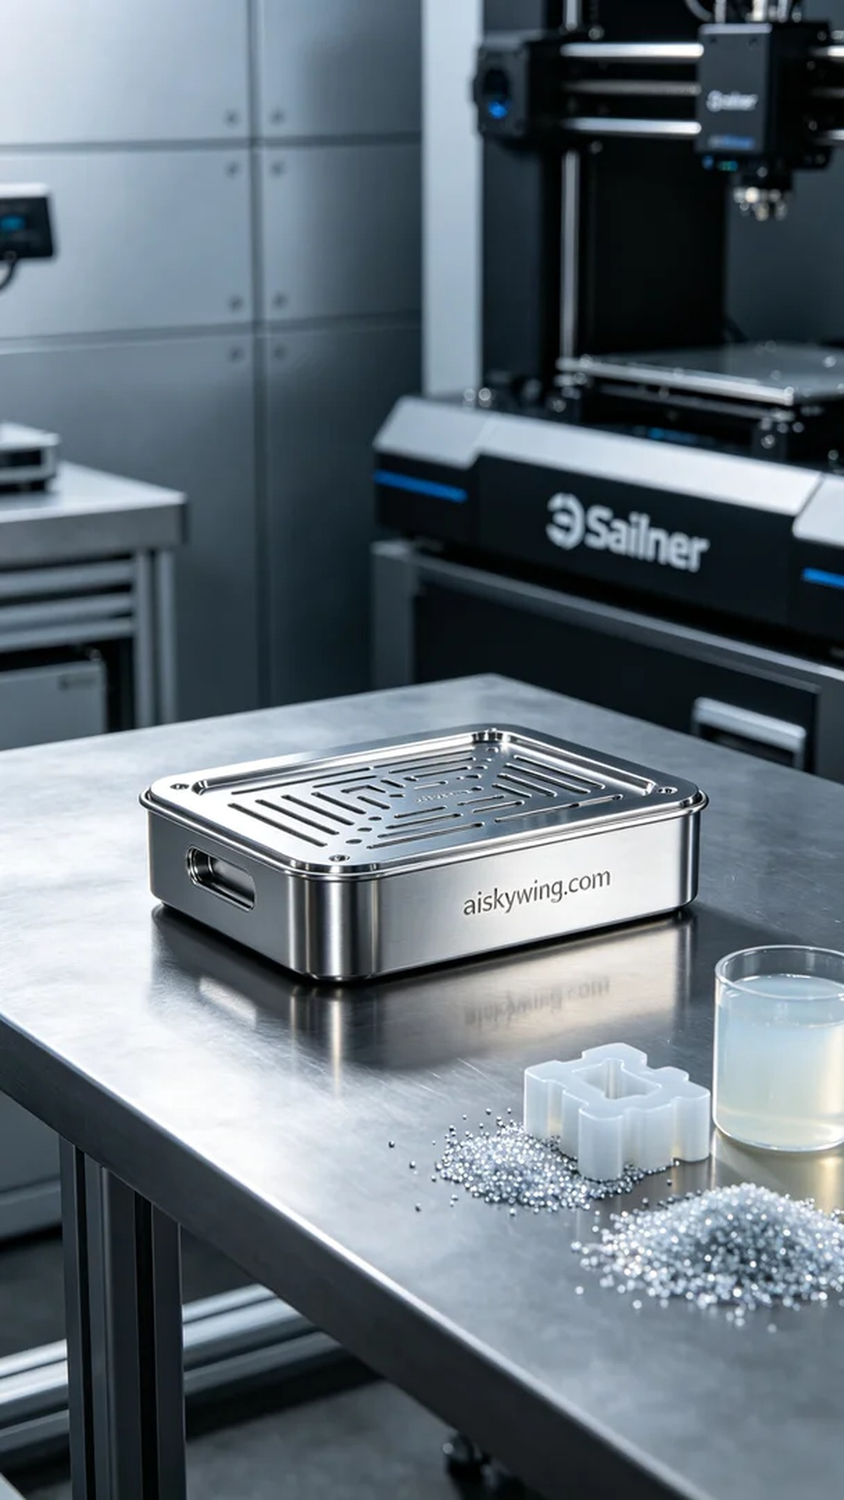
This project originated from a request on TikTok, where someone expressed a need for a storage box mat. They wanted a solution that was both aesthetically pleasing and practical, and we happily took on the task.
We prepared to use liquid photo-curable resin as the raw material, which offers excellent fluidity and detail representation, making it perfect for fine printing. For the equipment, we chose a Stratasys 3D printer, setting the layer thickness to 0.1mm, printing temperature at 25°C, power at 80%, and a speed of about 30mm per second. The entire printing process is expected to take approximately six hours.
As the printing process commenced, the machine ran smoothly, and we regularly monitored the print quality to ensure that each layer adhered perfectly. The liquid resin gradually cured under the light source, and the formed parts became increasingly defined. Over time, the details of the mat emerged, and the engraved "aiskywing.com" logo became even more prominent against the glossy metallic texture.
Once printing was complete, we immediately began processing the finished product. First, we submerged it in a cleaning tank with isopropyl alcohol to remove excess resin. Next, we gently sanded the surface with sandpaper to ensure smoothness. Afterward, we placed it in a UV curing chamber for hardening, which enhances stability and durability. Finally, we conducted a thorough inspection of the product to ensure every detail was flawless.
After a series of precise processes, we successfully completed the storage box mat, eager to see its performance in the market. This project not only allowed us to experience the charm of 3D printing but also became a journey of creativity and innovation.
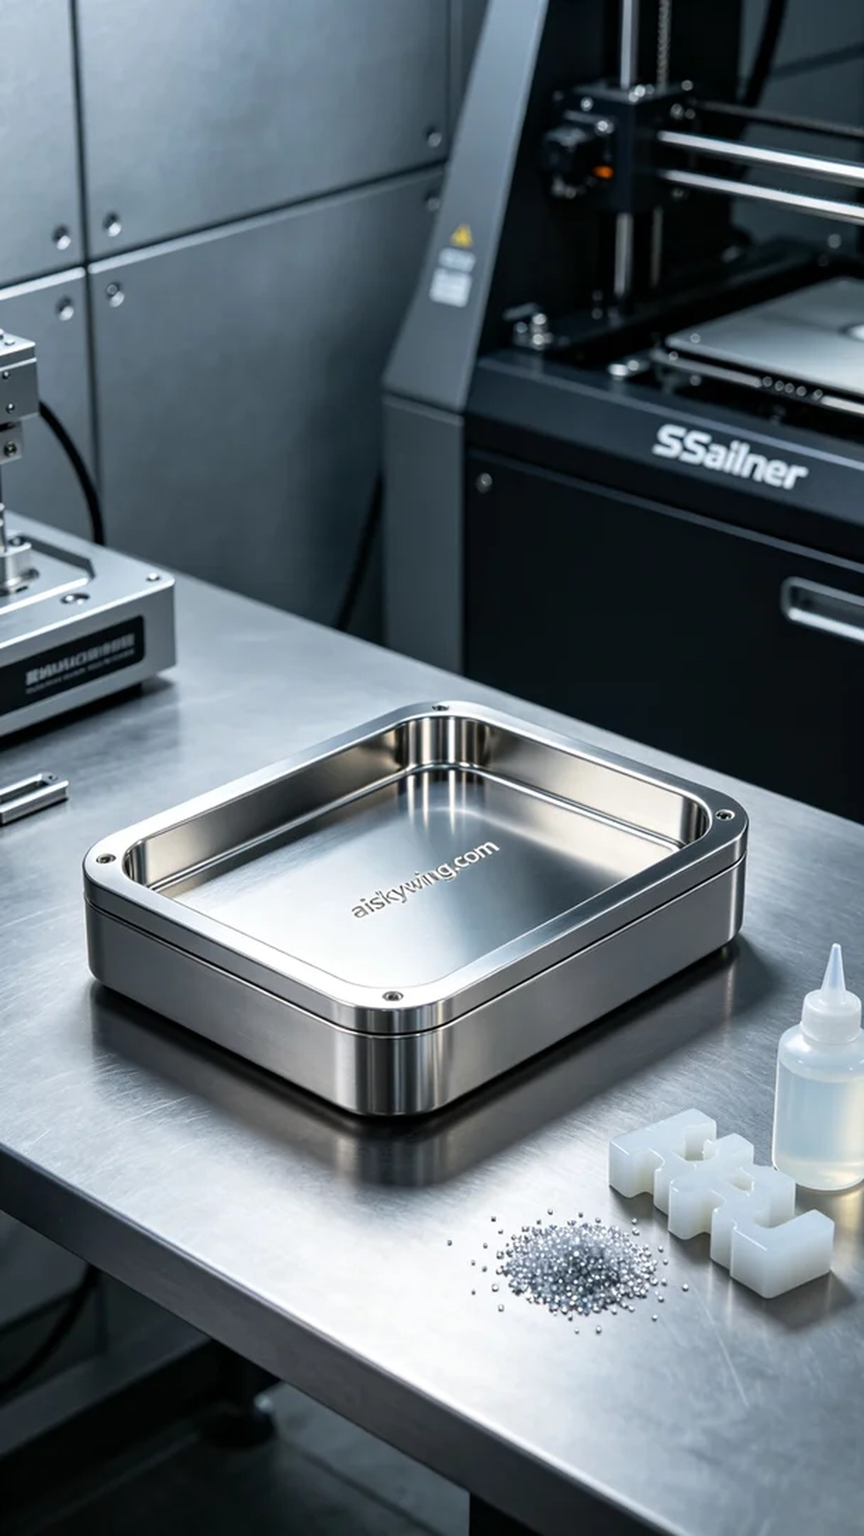
这次的项目源于TikTok上有人对储物盒底垫的需求，想要一个既美观又实用的解决方案。经过沟通，他们希望能利用3D打印技术，制作出符合他们想法的产品。
我们准备使用液态光敏树脂作为原材料，这种材料具有很好的流动性和细节表现力，非常适合精细打印。设备方面，我们选择了Stratasys的3D打印机，设置了层厚为0.1毫米，打印温度为25摄氏度，功率控制在80%，打印速度大约为30毫米每秒，预计整个打印过程将持续约六小时。
打印过程开始后，机器平稳运行，我们定期监控打印质量，确保每层都能完美贴合。液态光敏树脂在光源照射下逐渐固化，成型的部分越来越清晰。随着时间的推移，底垫的细节也逐步显现，雕刻的"aiskywing.com"字样在高光金属质感的映衬下更加鲜明。
打印完成后，我们立即对成品进行后处理。首先，将其放入清洗槽中，用异丙醇清洗，以去除多余的树脂。接着用砂纸轻轻打磨表面，确保光滑度。之后，将其放入UV固化箱中，进行固化处理，以增强稳定性和耐用性。最后，我们对成品进行详细检验，确保每个细节都无可挑剔。
经过一系列精准的工序，我们顺利完成了储物盒底垫的制作，期待它在市场上的表现。这样的项目不仅让我们感受到3D打印的魅力，更是一次与创意碰撞的旅程。
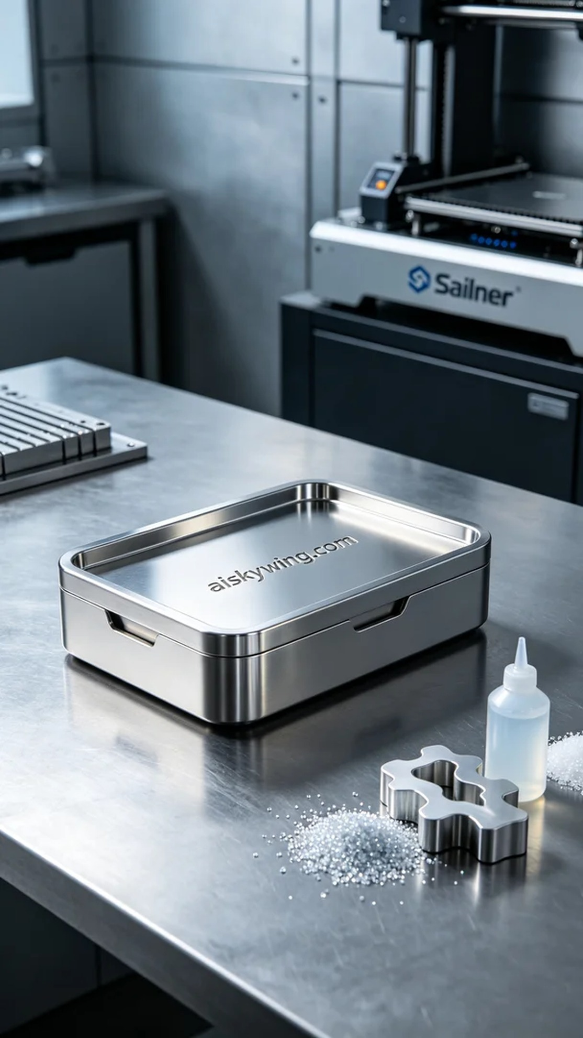
Aiskywing Industrial 3D Printing
Storage box bottom mat


