0720-储物盒隔垫生产记录
Storage box divider
🖨️ SLM金属打印
🖥️ 打印机: Mimaki
📦 材料: 摆放着未成型的液态光敏
生活的每一步都要充满勇气，就像我们接到的这个储物盒隔垫的订单，挑战了自我，但也收获了成长。
Every step in life must be filled with courage, just like the order we received for these storage box pads, which challenged us but also brought us growth.
________________________________________________________________________________
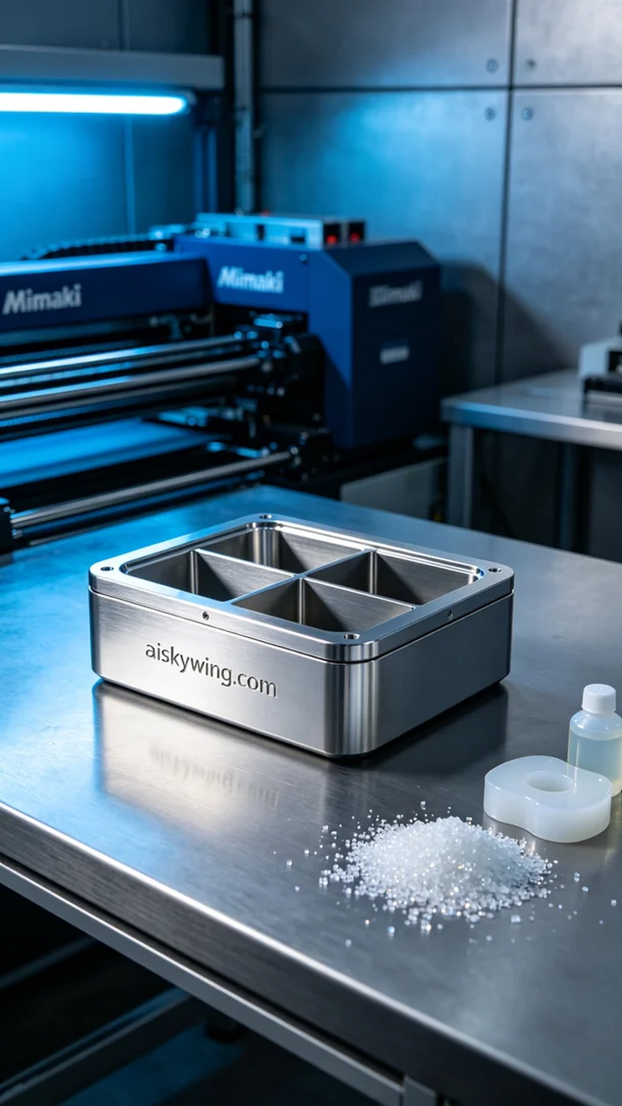
Life is a journey that requires courage at every step, just like the order we received for this storage box pad, which challenged us but also allowed us to grow.
Recently on TikTok, someone approached us needing a custom storage box pad that is both aesthetically pleasing and practical. They wanted this product to not only fulfill storage needs but also provide a unique visual experience.
We selected liquid photopolymer resin as the raw material, which showcases extremely high clarity and detail once cured. In preparation, we configured the Mimaki 3D printer with a layer thickness of 0.1mm, set the nozzle temperature to 60°C, the exposure power to 40%, and the printing speed to 30mm/s, with an estimated printing time of two hours to ensure every detail is fully realized.
During the printing process, the Mimaki printer performed exceptionally well, and we continuously monitored the device's status. The liquid photopolymer resin cured layer by layer under ultraviolet light, with each detail gradually coming to life. To ensure quality, we set up a monitoring system to check the printing status and adjust parameters in real time.
After printing, the storage box pad underwent several post-processing steps. First, we placed it in a cleaning tank and used ultrasonic cleaning to remove excess resin. Next, we sanded the surface with fine sandpaper to ensure every edge was smooth and flawless. Finally, the finished product was placed in a curing device for post-curing, enhancing its durability and hardness. During inspection, we ensured the "aiskywing.com" inscription was clearly visible, and the final result was satisfying.
After a series of strict production and inspection processes, the storage box pad was finally completed, showcasing a perfect high-gloss metallic finish that fully met the user's needs.
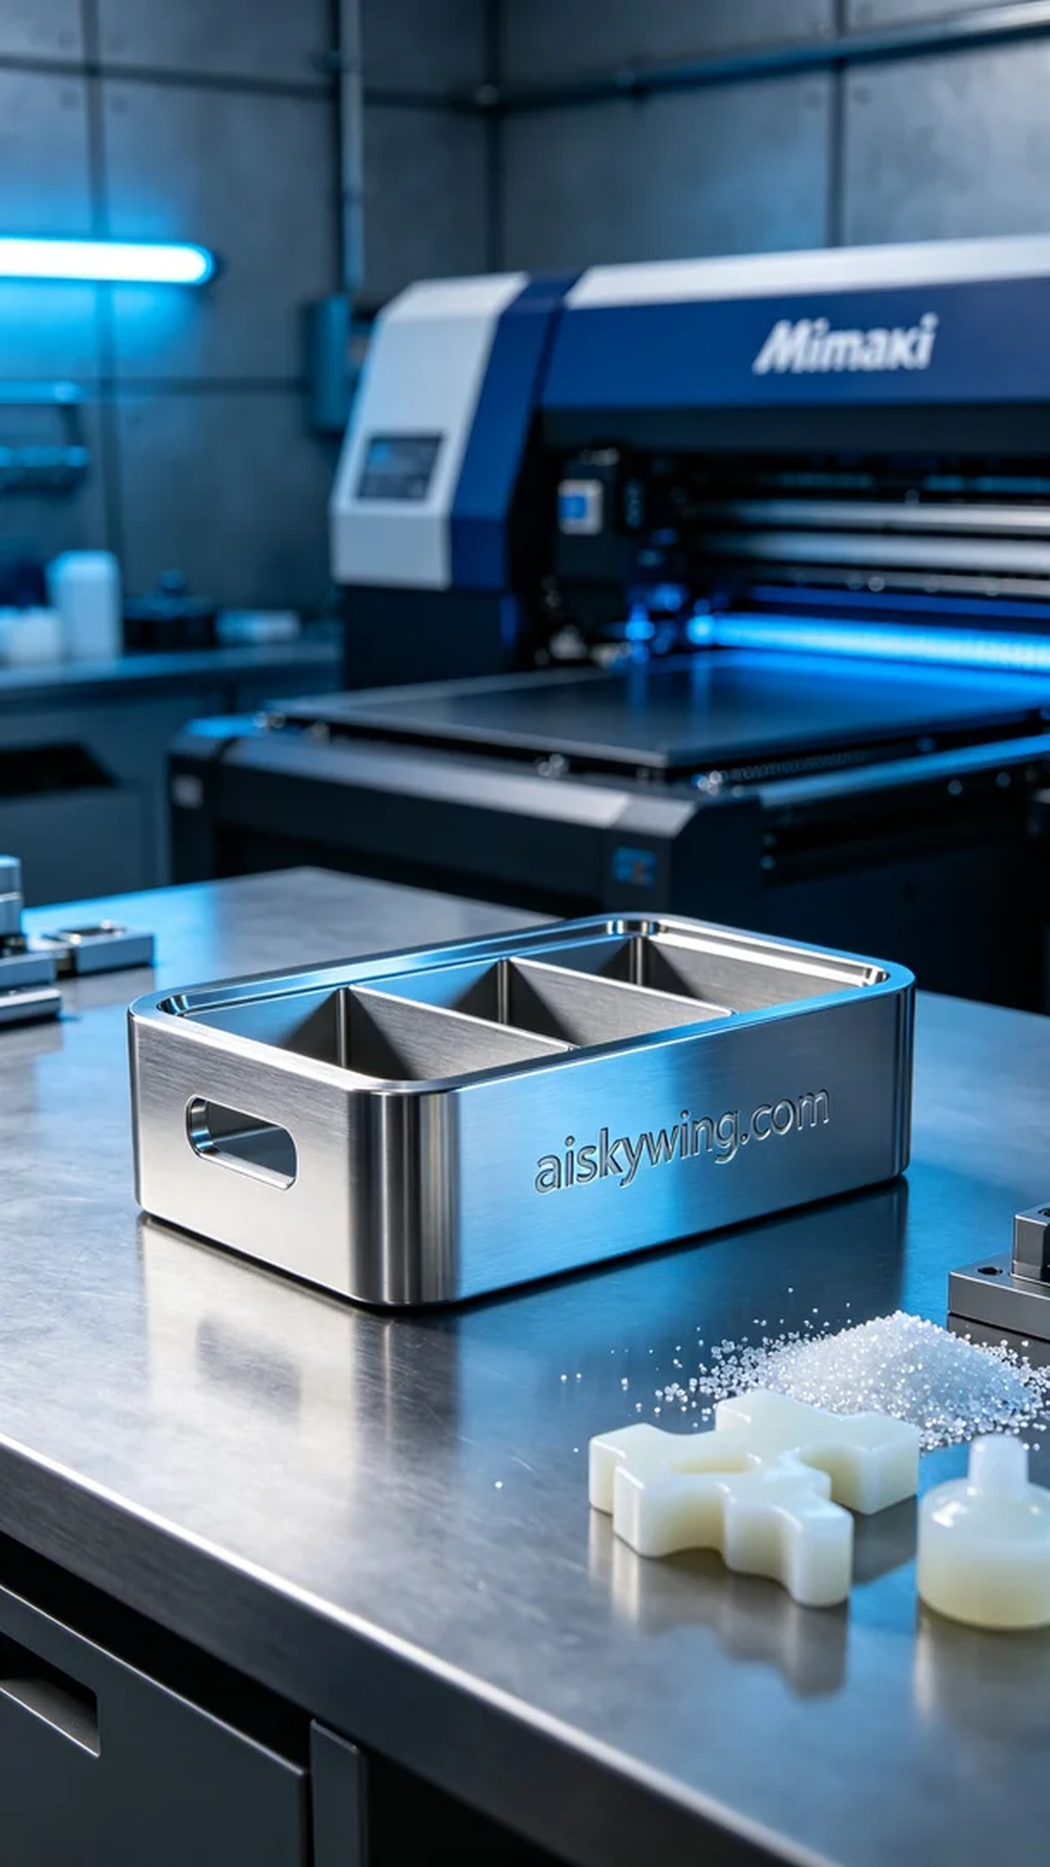
最近在TikTok上，有人因为需要定制一个既美观又实用的储物盒隔垫而找到了我们。他们希望这个产品不仅能满足储物需求，同时在视觉上也能带来不一样的体验。
我们选用了液态光敏树脂作为原材料，这种材料在固化后能展现出极高的清晰度和细致感。准备工作中，我们把Mimaki 3D打印机设定为0.1mm的层厚，喷嘴温度调整到60°C，照射功率设定为40%以及打印速度为30mm/s，预计打印时间为两小时，这样可以确保每一个细节都能充分呈现。
在打印过程中，Mimaki打印机的表现相当稳定，运行期间我们持续监控设备状态。液态光敏树脂通过紫外光照射逐层固化，每一层的细节都在逐步显现。为了确保质量，我们还专门设置了监控系统，随时检查打印状态，及时调整参数。
打印完成后，储物盒隔垫还需经过几个后处理工序。首先，我们将其放入清洗槽中，用超声波清洗去除多余的树脂。接着，使用细砂纸对表面进行打磨，确保每个边角都光滑无瑕。最后，将成品放入固化设备中进行后固化，提升其耐用性和硬度。检验过程中，确保了“aiskywing.com”字样清晰可见，最终效果令人满意。
经过一系列严格的制作和检验过程，储物盒隔垫终于完成，展现出完美的高光金属质感，充分满足了用户的需求。
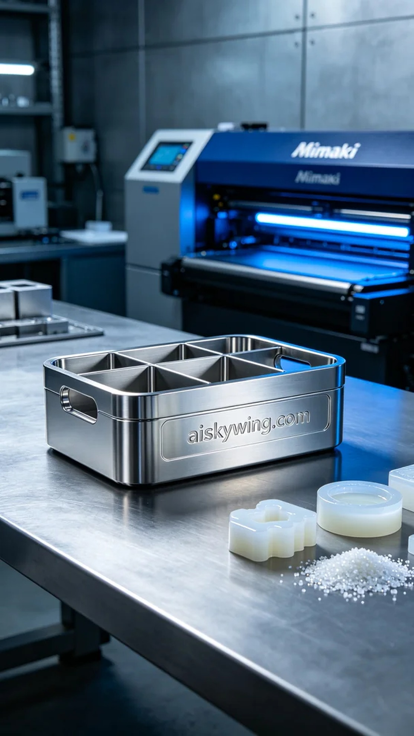
Aiskywing Industrial 3D Printing
Storage box divider


