0721-储物盒隔板生产记录
Storage box divider
🖨️ CNC机加工
🖥️ 打印机: Systems
📦 材料: 摆放着未成型的液态光敏
在Twitter上，有人因为整理空间的烦恼找到我们。就像做这个储物盒隔板一样，生活总会给予我们新的挑战。
On Twitter, someone reached out to us because they were struggling with organizing their space. Just like creating this storage box divider, life always presents us with new challenges.
________________________________________________________________________________
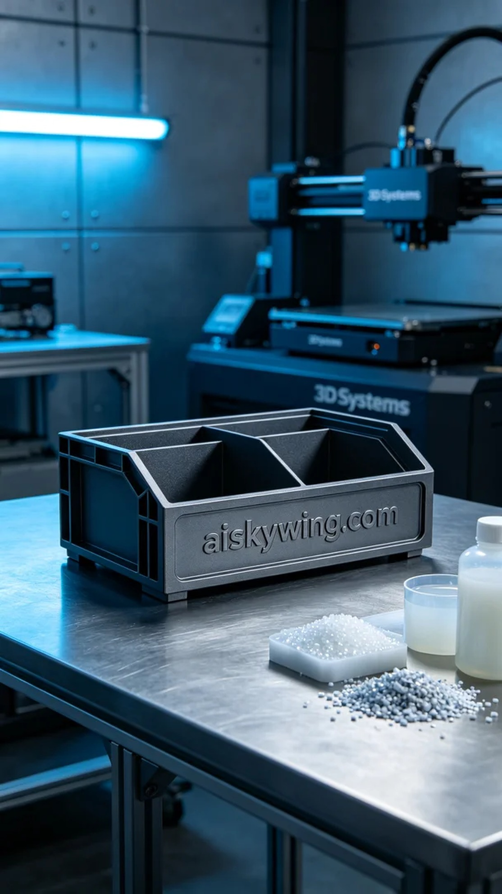
To solve the problem of limited space, someone reached out to us to make a storage box divider. This divider not only needed to be functional but also visually appealing, so we decided to employ CNC five-axis machining to ensure every detail was perfectly executed.
We chose unformed liquid photo-sensitive resin as the raw material, which possesses excellent flow and forming capabilities, making it ideal for high-precision printing. Using the Systems brand 3D printer, we set the layer thickness to 0.05mm, maintained the printing temperature at 25°C, set the power at 80%, and the printing speed at 50mm/s, with an estimated total printing time of about 10 hours.
During the printing process, the machine operated smoothly, and the liquid photo-sensitive resin was evenly distributed through intelligent control, ensuring that each layer was applied uniformly. We monitored the print quality throughout the process, paying close attention to surface effects and detail representation to ensure that every corner of the storage box divider met our expected standards.
Post-processing is crucial for ensuring product quality. After printing, we first placed the divider in a cleaning tank and used an ultrasonic cleaner to remove any residual resin. Next, we sanded the surface to ensure a smooth touch. It was then placed in a UV curing machine to enhance the strength and durability of the material. Finally, we conducted an inspection to confirm that the product was free from defects.
After a series of production processes, the storage box divider was finally completed. Every detail was meticulously crafted, achieving the expected results in both functionality and aesthetics.
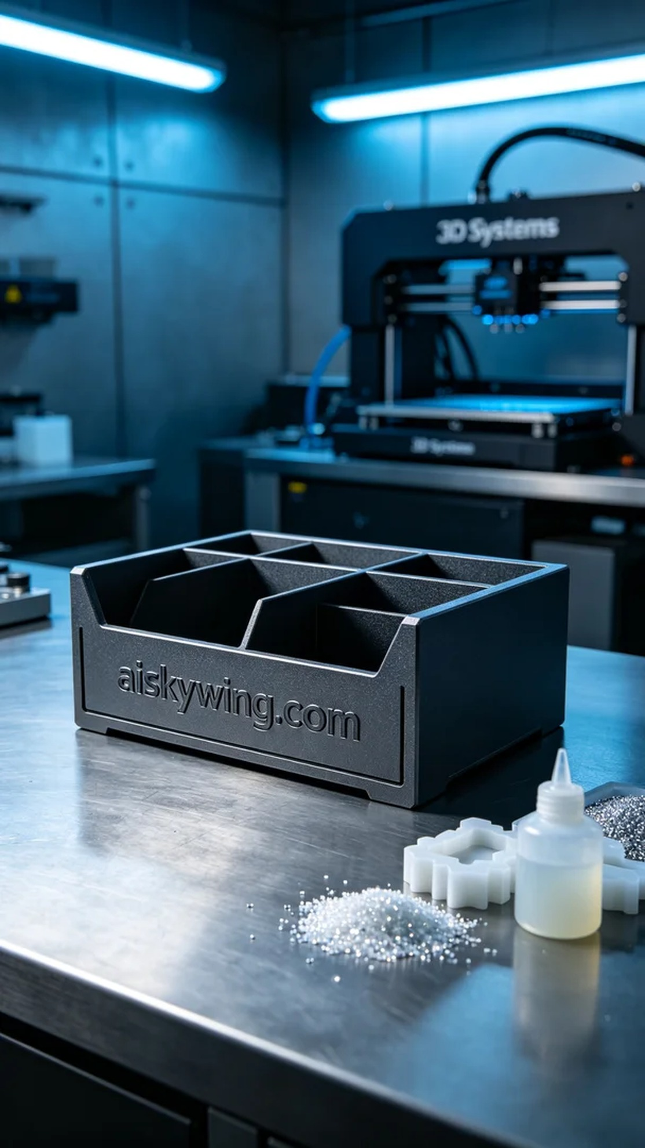
为了解决空间不足的问题，有人找到我们，要求制作一款储物盒隔板。这个隔板不仅要实用，还要在视觉上给人以美感，因此我们决定采用CNC五轴加工技术进行制造，确保每个细节都完美呈现。
我们选择了未成型的液态光敏树脂作为原材料，这种材料具有极好的流动性和成型能力，适合高精度打印。使用Systems品牌3D打印机，我们将层厚设定为0.05mm，打印温度保持在25°C，功率设定为80%以及打印速度为50mm/s，整个打印过程预计耗时约10小时。
打印过程中，设备运转稳定，液态光敏树脂通过系统智能控制，确保每一层都能均匀涂布。我们全程监控打印质量，观察表面效果和细节表现，确保储物盒隔板的每个角落都能达到预期的标准。
后处理工序是保证产品质量的关键。打印完成后，我们首先将隔板放入清洗槽，使用超声波清洗器去除残留的树脂。接着，我们用砂纸对表面进行打磨，确保其触感光滑。随后，将其置于UV固化机中进行固化，增强材料的强度和耐久性。最后，我们进行检验，确认产品无瑕疵。
经过一系列的生产流程，储物盒隔板终于完成。每一个细节都经过精心打磨，无论是实用性还是美观性，都达到了预期效果。
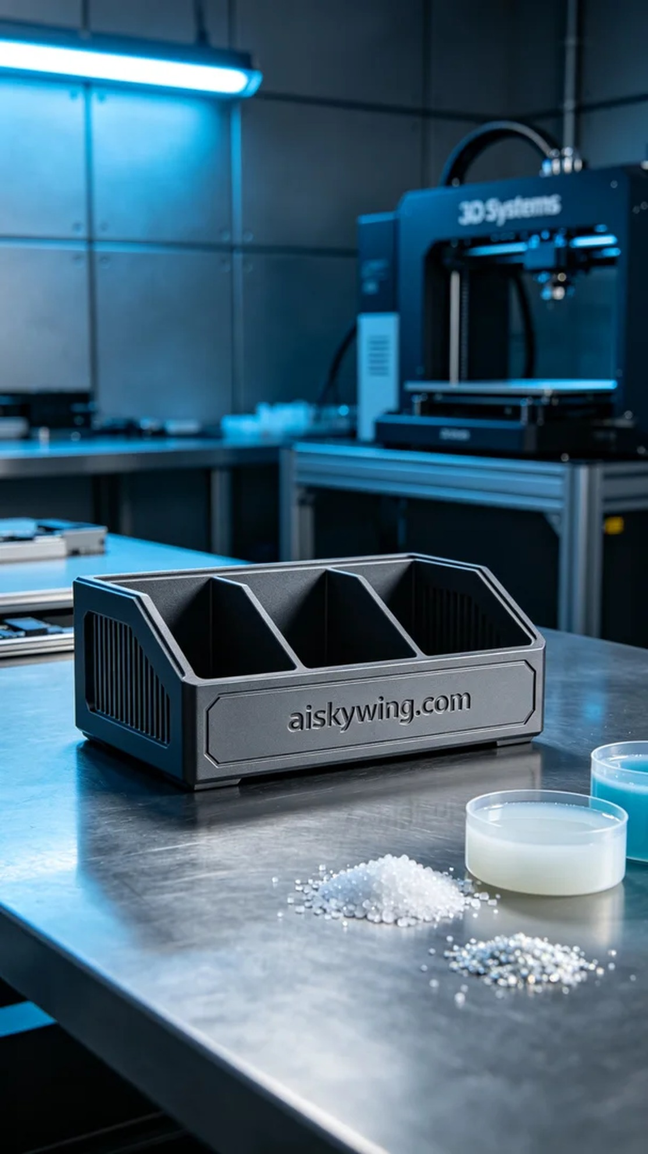
Aiskywing Industrial 3D Printing
Storage box divider


